SPSRF-GENERAL INFORMATION - The special surfaces (SPSRF) section describes the establishment and manipulation of specialized surface definitions which may be attached to the existing lens database surfaces. This special surfaces database is stored with the lens database. Some of the commands described here are CMD level commands issued at the CMD level. These CMD level commands are described here instead of in the CMD section because they act to modify or in other ways manipulate the special surfaces database. The other commands described here are SPSRF input level and UPDATE SPSRF level commands which can only be issued at one or both of these levels. The special surfaces database provides a tool with which to modify, replace or augment the lens database surface profile definitions. Each special surface type is unique unto itself and is described at the end of this section. There is no limit to the maximum number of special surface types which eventually will be contained in the program. By checking the table of contents for this section, it will be clear as to how many special surface types are currently defined. Surfaces which have been defined as Deformable Surfaces in the Lens Input or Lens Update levels may not be defined as Special surfaces.

CREATING A NEW SPSRF DATABASE

SPSRF - The "SPSRF" command causes the program to leave the CMD level and enter the SPSRF input level. The special surfaces database is wiped clean and is ready for new input. Between "SPSRF" and "EOS" or "END", any SPSRF input level command may be entered.

EOS or END - The "EOS" or "END"command, issued from the SPSRF level, causes the program to return to the CMD level. The special surfaces database is left in memory and is ready for analysis.

MODIFYING AN SPSRF DATABASE

UPDATE SPSRF or U SP - The "UPDATE SPSRF" command, or its abbreviated form "U SP", causes the program to leave the CMD level and enter the UPDATE SPSRF level. The special surfaces database is opened and is ready for modification. Between "UPDATE SPSRF" or "U SP" and "EOS" or "END", any SPSRF level command may be entered.

EOS or END - The "EOS" or "END" command, issued from the UPDATE SPSRF level, causes the program to return to the CMD level. The special surface database is left in memory and is ready for analysis.

SPSRF SPECIFIC COMMANDS

SPECIAL or GENL , i , j - The "SPECIAL" or "GENL" command, issued from the SPSRF or UPDATE SPSRF level, designates that the lens database surface "i" will be defined as a type "j" special surface. All coefficient values for surface "i" are initialized to 0.0. Valid values for "j" range from "1" to the current maximum number of special surfaces implemented in the program.

C1 , i , c through C96 , i , c - The "C1" through "C96" commands are used to assign coefficient values to any of the 96 special surface coefficients. "i" specifies the surface number and "c" is the coefficient value. Not every surface uses all 96 coefficients.

SPDEL , i - The "SPDEL" command deletes special surface definitions from surface "i".

SPSRF ON , i - The "SPSRF ON" command causes a lens database surface "i", which has a special surface definition, to have that special surface definition considered during CMD level ray tracing and other analysis. "SPSRF ON" is the default condition when a special surfaces definition is applied to a surface.

SPSRF OFF , i - The "SPSRF OFF" command causes a lens database surface "i", which has a special surface definition, NOT to have that special surface definition considered during CMD level ray tracing and other analysis.

SPSRF CMD LEVEL COMMANDS

SPSRF ON , i - The "SPSRF ON" command causes a lens database surface "i", which has a special surface definition, to have that special surface definition considered during CMD level ray tracing and other analysis. "SPSRF ON" is the default condition when a special surfaces definition is applied to a surface. This command behaves exactly the same as it does at the SPSRF or UPDATE SPSRF level.

SPSRF OFF , i - The "SPSRF OFF" command causes a lens database surface "i", which has a special surface definition, NOT to have that special surface definition considered during CMD level ray tracing and other analysis. This command behaves exactly the same as it does at the SPSRF or UPDATE SPSRF level.

PRSPR ALL or PRSPR , i - The "PRSPR" command produces a display of the surface number, the special surface type and the value of the 96 coefficients C1 through C96. "ALL" produces a full listing for the entire lens. Input of the surface number "i" generates output for just surface "i".

PHASE SURFACES - The special surface TYPES 6, 7, 9, 10 and 15 have similar functional forms to surface TYPES 1, 8, 2, 3 and 14 but represent ray phase changes rather than surface sag changes. These are not to be confused with the diffractive phase terms used with special surface type 12 . TYPE 6, 7, 9, 10, 11, 15 and 20 phase surfaces may only be placed on flat, dummy surfaces. The units of the "phase" are initially evaluated in "waves" at the current "control wavelength". This phase in waves is converted to optical path length in "lens units" by multiplying the phase in waves by the wavelength of the control wavelength measured in the current "lens units". When a ray is traced through a phase surface, the optical path length corresponding to the phase is added to the optical path length of the ray according to the following equation:

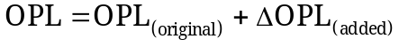

The changes to the direction cosines of the ray are calculated by taking the derivatives of this added phase term.

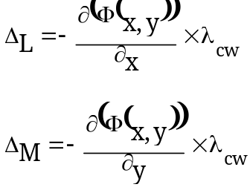

The new direction cosines are just:

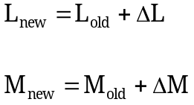

The N direction cosine is calculated by re-normalization. Phase surfaces deflect a ray but they can not deflect the ray through more than 90 degrees from its original propagation direction. For all special surface types except TYPE 9, TYPE 10 and TYPE 15 phase surfaces, the "x" and "y" arguments in the descriptive equations are just the "x" and "y" ray coordinates at the lens database surface. For special surface TYPE 9, 10 and 15, the "x" and "y" terms in the descriptive equations are the "x" and "y" ray coordinates at the lens database surface, each divided by the "inr" value assigned to that surface. The "inr" value and the "INR" command are fully described in the LENS section of this manual. "inr" provides a way of normalizing the TYPE 9, TYPE 10 and TYPE 15 phase surfaces over a unit radius since that is how Zernike polynomials are defined. Even though TYPE 15 is not a true Zernike polynomial, it is similar enough to one to warrant the use of the "inr" value for coordinate normalization. For TYPE 9, 10 and 15 phase surfaces, the direction cosines are first computed at the "inr" normalized coordinate and then scaled up by the reciprocal of the "inr" value. This correctly adjusts the direction cosine so as to be representative of the phase being added to the ray. The "inr" value at a lens database surface may be explicitly set by the user using the LENS or UPDATE LENS level command "INR". If "inr" is not set explicitly, the default "inr" value will be determined either from existing clear aperture assignments at the surface or from the paraxial ray trace, if no clear apertures are assigned. In general, special surface coefficients are not scaled during a lens scaling operation unless there is explicit mention of coefficient scaling included in the description of that particular special surface type.

ZERNIKE SURFACES - The special surface TYPES 2, 3 and 14 comprise Zernike or Zernike-like polynomials. For these surface deformation special surface types, the "x" and "y" coordinates in the descriptive equations, when used to evaluate the polynomials, are the "x" and "y" ray coordinates at the surface divided by the "inr" value described above. The regular surface "sag" equations for the non-Zernike part of the surface evaluation are just the "x" and "y" ray coordinates at the surface. This normalization is performed automatically by the program.

ZERNREPT , i - The "ZERNREPT" is a CMD level command. It causes a lens database surface "i", which has been previously defined as a type 3 or type 10 special surface to be used as the basis of a 37-tern Fringe Zernike Report. The report displays RMS surface (type 3) or wavefront (type 10) values, based not upon a ray trace, but upon the special surface coefficient values. The calculation is based on the equations in Appendix 2 of "Optical Shop Testing" by Daniel Malacara.

COEFFICIENTS - Many of the special surface coefficients which appear in the following description of specific special surface types will not be set explicitly by the user but will be determined automatically during the optimization process. When this is the intended way in which these special surface coefficients are to achieve a specific value, simple enter these coefficients as variables in the optimization process.

THE TYPE 1 SPECIAL SURFACE (Polynomial-1) - The TYPE 1 special surface is a rotationally symmetric polynomial defined by the following equation:

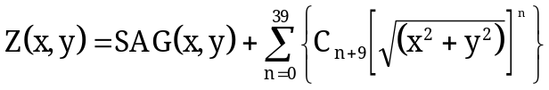

SAG(x,y) is the original surface sag due to radius, conic, aspheric terms, etc. Coefficients C1 to C8 are not used for this surface type as they would cause the surface to be poorly behaved at the surface vertex. Terms with values of n=4, 6, 8 and 10 are already represented by the rotationally symmetric aspheric surface type.

THE TYPE 2 SPECIAL SURFACE (Zernike-1) - The TYPE 2 special surface is a 66-term Zernike polynomial defined by the following equation:

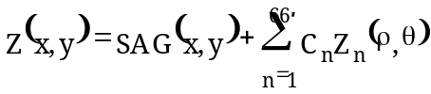

where:
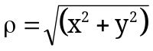
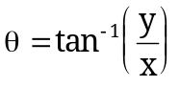
SAG(x,y) is the original surface sag due to radius, conic, aspheric terms, etc.
(All ambiguities in θ are resolved in the program internals)

and:

Z₁ (ρ,θ) = 1 {constant}
Z₂ (ρ,θ) = ρ cos(θ) {x-tilt}
Z₃ (ρ,θ) = ρ sin(θ) {y-tilt}

Z₄ (ρ,θ) = ρ² cos(2θ) {0 degree astigmatism}
Z₅ (ρ,θ) = 2ρ² - 1 {focus + constant}
Z₆ (ρ,θ) = ρ² sin(2θ) {45 degree astigmatism}

Z₇ (ρ,θ) = ρ³ cos(3θ) {x-clover}
Z₈ (ρ,θ) = (3ρ³ - 2ρ) cos(θ)
Z₉ (ρ,θ) = (3ρ³ - 2ρ) sin(θ)
Z₁₀ (ρ,θ) = ρ³ sin(3θ) {y-clover}

Z₁₁ (ρ,θ) = ρ⁴ cos(4θ)
Z₁₂ (ρ,θ) = (4ρ⁴ - 3ρ²) cos(2θ)
Z₁₃ (ρ,θ) = 6ρ⁴ - 6ρ²+1
Z₁₄ (ρ,θ) = (4ρ⁴ - 3ρ²) sin(2θ)
Z₁₅ (ρ,θ) = ρ⁴ sin(4θ)

Z₁₆ (ρ,θ) = ρ⁵ cos(5θ)
Z₁₇ (ρ,θ) = (5ρ⁵ - 4ρ³) cos(3θ)
Z₁₈ (ρ,θ) = (10ρ⁵ - 12ρ³ + 3ρ) cos(θ)
Z₁₉ (ρ,θ) = (10ρ⁵ - 12ρ³ + 3ρ) sin(θ)
Z₂₀ (ρ,θ) = (5ρ⁵ - 4ρ³) sin(3θ)
Z₂₁ (ρ,θ) = ρ⁵ sin(5θ)

Z₂₂ (ρ,θ) = ρ⁶ cos(6θ)
Z₂₃ (ρ,θ) = (6ρ⁶ - 5ρ⁴) cos(4θ)
Z₂₄ (ρ,θ) = (15ρ⁶ - 20ρ⁴ + 6ρ²) cos(2θ)
Z₂₅ (ρ,θ) = 20ρ⁶ - 30ρ⁴ + 12ρ² - 1
Z₂₆ (ρ,θ) = (15ρ⁶ - 20ρ⁴ + 6ρ²) sin(2θ)
Z₂₇ (ρ,θ) = (6ρ⁶ - 5ρ⁴) sin(4θ)
Z₂₈ (ρ,θ) = ρ⁶ sin(6θ)
Z₂₉ (ρ,θ) = ρ⁷ cos(7θ)
Z₃₀ (ρ,θ) = (7ρ⁷ - 6ρ⁵) cos(5θ)
Z₃₁ (ρ,θ) = (21ρ⁷ - 30ρ⁵ + 10ρ³) cos(3θ)
Z₃₂ (ρ,θ) = (35ρ⁷ - 60ρ⁵+ 30ρ³ - 4ρ) cos(θ)
Z₃₃ (ρ,θ) = (35ρ⁷ - 60ρ⁵+ 30ρ³ - 4ρ) sin(θ)
Z₃₄ (ρ,θ) = (21ρ⁷ - 30ρ⁵ + 10ρ³) sin(3θ)
Z₃₅ (ρ,θ) = (7ρ⁷ - 6ρ⁵) sin(5θ)
Z₃₆ (ρ,θ) = ρ⁷ sin(7θ)

Z₃₇ (ρ,θ) = ρ⁸ cos(8θ)
Z₃₈ (ρ,θ) = (8ρ⁸ - 7ρ⁶) cos(6θ)
Z₃₉ (ρ,θ) = (28ρ⁸ - 42ρ⁶ + 15ρ⁴) cos(4θ)
Z₄₀ (ρ,θ) = (56ρ⁸ - 105ρ⁶+ 60ρ⁴ - 10ρ²) cos(2θ)

Z₄₁ (ρ,θ) = 70ρ⁸ - 140ρ⁶+ 90ρ⁴ - 20ρ² + 1
Z₄₀ (ρ,θ) = (56ρ⁸ - 105ρ⁶+ 60ρ⁴ - 10ρ²) sin(2θ)
Z₄₃ (ρ,θ) = (28ρ⁸ - 42ρ⁶ + 15ρ⁴) sin(4θ)
Z₄₄ (ρ,θ) = (8ρ⁸ - 7ρ⁶) sin(6θ)
Z₄₅ (ρ,θ) = ρ⁸ sin(8θ)

Z₄₆ (ρ,θ) = ρ⁹ cos(9θ)
Z₄₇ (ρ,θ) = (9ρ⁹ - 8ρ⁷) cos(7θ)
Z₄₈ (ρ,θ) = (36ρ⁹ - 56ρ⁷ + 21ρ⁵) cos(5θ)
Z₄₉ (ρ,θ) = (84ρ⁹ - 168ρ⁷+ 105ρ⁵ - 20ρ³) cos(3θ)
Z₅₀ (ρ,θ) = (126ρ⁹ - 280ρ⁷+ 210 ρ⁵ - 60ρ³ + 5ρ) cos(θ)
Z₅₁ (ρ,θ) = (126ρ⁹ - 280ρ⁷+ 210 ρ⁵ - 60ρ³ + 5ρ) sin(θ)
Z₅₂ (ρ,θ) = (84ρ⁹ - 168ρ⁷+ 105ρ⁵ - 20ρ³) sin(3θ)
Z₅₃ (ρ,θ) = (36ρ⁹ - 56ρ⁷ + 21ρ⁵) sin(5θ)
Z₅₄ (ρ,θ) = (9ρ⁹ - 8ρ⁷) sin(7θ)
Z₅₅ (ρ,θ) = ρ⁹ sin(9θ)

Z₅₆ (ρ,θ) = ρ¹⁰ cos(10θ)
Z₅₇ (ρ,θ) = (10ρ¹⁰ - 9ρ⁸) cos(8θ)
Z₅₈ (ρ,θ) = (45ρ¹⁰ - 72ρ⁸ + 28ρ⁶) cos(6θ)
Z₅₉ (ρ,θ) = (120ρ¹⁰ - 252ρ⁸+ 168ρ⁶ - 35ρ⁴) cos(4θ)
Z₆₀ (ρ,θ) = (210ρ¹⁰ - 504ρ⁸+ 420 ρ⁶ - 140ρ⁴ + 15ρ²) cos(θ)

Z₆₁ (ρ,θ) = 252ρ¹⁰ - 630ρ⁸+ 560ρ⁶ - 210ρ⁴ + 30ρ² - 1
Z₆₂ (ρ,θ) = (210ρ¹⁰ - 504ρ⁸+ 420 ρ⁶ - 140ρ⁴ + 15ρ²) sin(θ)
Z₆₃ (ρ,θ) = (120ρ¹⁰ - 252ρ⁸+ 168ρ⁶ - 35ρ⁴) sin(4θ)
Z₆₄ (ρ,θ) = (45ρ¹⁰ - 72ρ⁸ + 28ρ⁶) sin(6θ)
Z₆₅ (ρ,θ) = (10ρ¹⁰ - 9ρ⁸) sin(8θ)
Z₆₆ (ρ,θ) = ρ¹⁰ sin(10θ)

THE TYPE 3 SPECIAL SURFACE (Zernike-2) - The TYPE 3 special surface is the 37-term Fringe Zernike polynomial defined by the following equation:

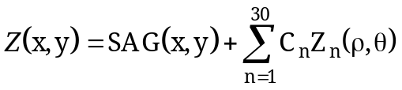
where:
SAG(x,y) is the original surface sag due to radius, conic, aspheric terms, etc.
(All ambiguities in θ are resolved in the program internals) and:
Z₁ (ρ,θ) = 1 {constant}
Z₂ (ρ,θ) = ρ cos(θ) {x-tilt}
Z₃ (ρ,θ) = ρ sin(θ) {y-tilt}
Z₄ (ρ,θ) = 2ρ² - 1 {focus + constant}
Z₅ (ρ,θ) = ρ² cos(2θ) {0 degree astigmatism}
Z₆ (ρ,θ) = ρ² sin(2θ) {45 degree astigmatism}
Z₇ (ρ,θ) = (3ρ³ - 2ρ) cos(θ)
Z₈ (ρ,θ) = (3ρ³ - 2ρ) sin(θ)
Z₉ (ρ,θ) = 6ρ⁴ - 6ρ²+1
Z₁₀ (ρ,θ) = ρ³ cos(3θ) {x-clover}
Z₁₁ (ρ,θ) = ρ³ sin(3θ) {y-clover}
Z₁₂ (ρ,θ) = (4ρ⁴ - 3ρ²) cos(2θ)
Z₁₃ (ρ,θ) = (4ρ⁴ - 3ρ²) sin(2θ)
Z₁₄ (ρ,θ) = (10ρ⁵ - 12ρ³ + 3ρ) cos(θ)
Z₁₅ (ρ,θ) = (10ρ⁵ - 12ρ³ + 3ρ) sin(θ)
Z₁₆ (ρ,θ) = 20ρ⁶ - 30ρ⁴ + 12ρ² - 1
Z₁₇ (ρ,θ) = ρ⁴ cos(4θ)
Z₁₈ (ρ,θ) = ρ⁴ sin(4θ)
Z₁₉ (ρ,θ) = (5ρ⁵ - 4ρ³) cos(3θ)
Z₂₀ (ρ,θ) = (5ρ⁵ - 4ρ³) sin(3θ)
Z₂₁ (ρ,θ) = (15ρ⁶ - 20ρ⁴ + 6ρ²) cos(2θ)
Z₂₂ (ρ,θ) = (15ρ⁶ - 20ρ⁴ + 6ρ²) sin(2θ)
Z₂₃ (ρ,θ) = (35ρ⁷ - 60ρ⁵ + 30ρ³ - 4ρ) cos(θ)
Z₂₄ (ρ,θ) = (35ρ⁷ - 60ρ⁵ + 30ρ³ - 4ρ) sin(θ)
Z₂₅ (ρ,θ) = 70ρ⁸ - 140ρ⁶ + 90ρ⁴ - 20ρ² + 1
Z₂₆ (ρ,θ) = ρ⁵ cos(5θ)
Z₂₇ (ρ,θ) = ρ⁵ sin(5θ)
Z₂₈ (ρ,θ) = (6ρ⁶ - 5ρ⁴) cos(4θ)
Z₂₉ (ρ,θ) = (6ρ⁶ - 5ρ⁴) sin(4θ)
Z₃₀ (ρ,θ) = (21ρ⁷ - 30ρ⁴ + 10ρ³) cos(3θ)
Z₃₁ (ρ,θ) = (21ρ⁷ - 30ρ⁴ + 10ρ³) sin(3θ)
Z₃₂ (ρ,θ) = (56ρ⁸ - 105ρ⁶ + 60ρ⁴ - 10ρ² ) cos(2θ)
Z₃₃ (ρ,θ) = (56ρ⁸ - 105ρ⁶ + 60ρ⁴ - 10ρ² ) sin(2θ)
Z₃₄ (ρ,θ) = (126ρ⁹ - 280ρ⁷+ 210ρ⁵ - 60ρ³ + 5ρ) cos(θ)
Z₃₅ (ρ,θ) = (126ρ⁹ - 280ρ⁷+ 210ρ⁵ - 60ρ³ + 5ρ) sin(θ)
Z₃₆ (ρ,θ) = 252ρ¹⁰ - 630ρ⁸ + 560ρ⁶ - 210ρ⁴ + 30ρ² - 1
Z₃₇ (ρ,θ) = 924ρ¹² -2772ρ¹⁰ + 3150ρ⁸ - 1680ρ⁶ + 420ρ⁴ - 42ρ² + 1

THE TYPE 4 SPECIAL SURFACE (Sinusoidal Error Surface) - The TYPE 4 special surface is a 2D Sinusoidal Error Surface. It is used to add to a standard optical surface (flat, sphere, conic, aspheric, cylinder, or anamorphic aspheric) up to five rectangularly distributed, sinusoidal surface perturbations. In the absence of detailed knowledge of surface deformation, this special surface type may be used to simulate manufacturing errors on an optical surface. The SAG of the surface is represented by the following equations:

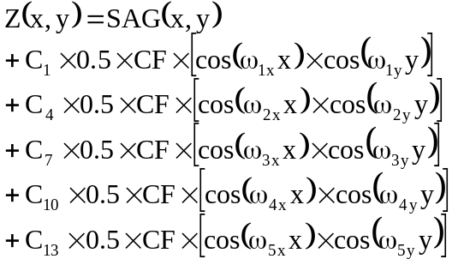
where:

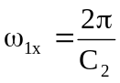
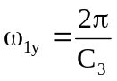
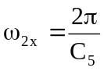
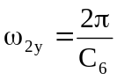
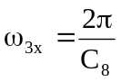
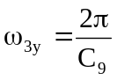
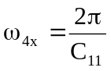
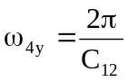
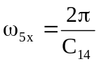
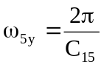

SAG(x,y) is the surface sag before the sinusoidal disturbance is added. C1, C4, C7, C10 and C13 are the peak-to-valley added surface sags in waves referenced to the wavelength of the currently defined reference wavelength. CF is the program supplied conversion factor from waves at the reference wavelength to current lens units. ω_{x} and ω_{y} are the spatial frequencies of the disturbance distributions in the local coordinate system of the surface for the five distributions. C2/C3, C5/C6, C8/C9, C11/C12 and C14/C15 are the periods of these five distrbances in the x and y-directions.
THE TYPE 5 SPECIAL SURFACE (User-Defined #1) - The TYPE 5 special surface is a user-defined surface defined by the following equation:

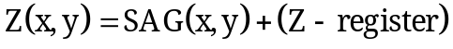

The TYPE 5 special surface is a user-defined surface type. The TYPE 5 special surface may use none, any or all of the coefficients C1 to C96. The additional surface sag added to the surface by the TYPE 5 special surface is defined by the user in macro function FUN10. If FUN10 does not exist, the added surface sag, Z, is 0.0. If FUN10 exists, the additional surface sag will be whatever is left in the Z-storage register after FUN10 finishes its execution. FUN10 may not call any other macros or macro functions when used in special surface definitions. The values of the 96 coefficients are passed via general purpose storage registers 301 through 396. The current X-ray coordinate is passed via the X-register and the current Y-ray value is passed via the Y-register. The surface number is passed via the T-register. The LASTX-register remembers the previous value of the X-register as usual.

THE TYPE 6 SPECIAL SURFACE (Polynomial-1 Phase) - The TYPE 6 special surface is a rotationally symmetric polynomial similar to a TYPE 1 surface except that the polynomial represents a variation in phase rather than surface profile. It may only be applied to a flat dummy surface. It is defined by the following equation:

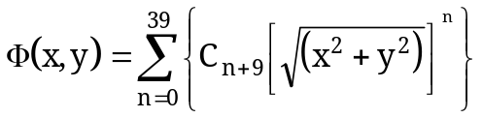

The phase, in terms of OPD with respect to the control wavelength, is added to the phase of the ray being traced. The ray direction cosines are modified appropriately.

THE TYPE 7 SPECIAL SURFACE (Rectangular Polynomial Phase) - The TYPE 7 special surface is a rectangular polynomial similar to a TYPE 8 surface, except that the polynomial represents a variation in phase rather than surface profile. It may only be applied to a flat dummy surface. It is defined by the following equation:

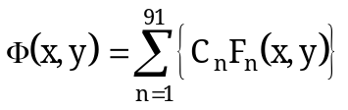

The phase, in terms of OPD with respect to the control wavelength, is added to the phase of the ray being traced. The ray direction cosines are modified appropriately. The terms F1 to F91 are the same as those listed in the TYPE 8 surface description.

THE TYPE 8 SPECIAL SURFACE (Rectangular Polynomial) - The TYPE 8 special surface is a rectangular polynomial surface. It is defined by the following equation:

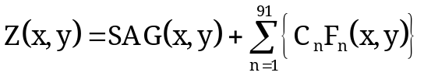
where:

SAG(x,y) is the original surface sag due to radius, conic, aspheric terms, etc.

and:

F₁ (X,Y) = 1

F_{2,3} (x,y) = x,y
F_{4,5,6} (x,y) = x²,xy,y²
F_{7,8,9,10} (x,y) = x³,x²y,xy²,y³
F_{11,12,13,14,15} (x,y) = x⁴,x³y,x²y²,xy³,y⁴
F_{16,17,18,19,20,21} (x,y) = x⁵,x⁴y,x³y²,x²y³,xy⁴,y⁵
F_{22,23,24,25,26,27,28} (x,y) = x⁶,x⁵y,x⁴y²,x³y³,x²y⁴,x¹y⁵,y⁶
F_{29,30,31,32,33,34,35,36} (x,y) = x⁷,x⁶y,x⁵y²,x⁴y³,x³y⁴,x²y⁵,xy⁶,y⁷
F_{37,38,39,40,41,42,43,44,45} (x,y) = x⁸,x⁷y,x⁶y²,x⁵y³,x⁴y⁴,x³y⁵,x²y⁶,xy⁷,y⁸
F_{46,47,48,49,50,51,52,53,54,55} (x,y) = x⁹,x⁸y,x⁷y²,x⁶y³,x⁵y⁴,x⁴y⁵,x³y⁶,x²y⁷,xy⁸,y⁹
F56,57,58,59,60,61,62,63,64,65,66 (x,y) = x¹⁰,x⁹y,x⁸y²,x⁷y³,x⁶y⁴,x⁵y⁵,x⁴y⁶,x³y⁷,x²y⁸,xy⁹,y¹⁰

F67,68,69,70,71,72,73,74,75,76,77,78 (x,y) = x¹¹,x¹⁰y,x⁹y²,x⁸y³,x⁷y⁴,x⁶y⁵,x⁵y⁶,x⁴y⁷,x³y⁸,x²y⁹,xy¹⁰,y¹¹
F79,80,81,82,83,84,85,86,87,88,89,90,91 (x,y) = x¹²,x¹¹y,x¹⁰y²,x⁹y³,x⁸y⁴,x⁷y⁵,x⁶y⁶,x⁵y⁷,x⁴y⁸,x³y⁹,x²y¹⁰,xy¹¹,y¹²
THE TYPE 9 SPECIAL SURFACE (Zernike-1 Phase) - The TYPE 9 special surface is a 66-term Zernike polynomial similar to a TYPE 2 surface except that the polynomial represents a variation in phase rather than surface profile. It may only be applied to a flat dummy surface. It is defined by the following equation:

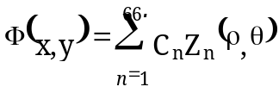
where:

All ambiguities in θ are resolved in the program internals. The phase, in terms of OPD with respect to the control wavelength, is added to the phase of the ray being traced. The ray direction cosines are modified appropriately. The "x" and "y" values used in the TYPE 9 phase surface equations are the "x" and "y" ray coordinates at the surface, each divided by the "inr" value assigned to that surface. The terms Z1 to Z66 are the same as those listed in the TYPE 2 surface description.

THE TYPE 10 SPECIAL SURFACE (Zernike-2 Phase) - The TYPE 10 special surface is a 37-term Fringe Zernike polynomial similar to a TYPE 3 surface except that the polynomial represents a variation in phase rather than surface profile. It may only be applied to a flat dummy surface. It is defined by the following equation:

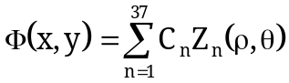

where:

All ambiguities in θ are resolved in the program internals. The phase, in terms of OPD with respect to the control wavelength, is added to the phase of the ray being traced. The ray direction cosines are modified appropriately. The "x" and "y" values used in the TYPE 10 phase surface equations are the "x" and "y" ray coordinates at the surface, each divided by the "inr" value assigned to that surface. The terms Z1 to Z37 are the same as those listed in the TYPE 3 surface description.

THE TYPE 11 SPECIAL SURFACE (User-Defined Phase) - The TYPE 11 special surface is a user-defined phase surface defined by the following equation:

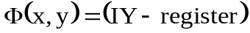

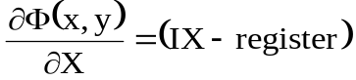

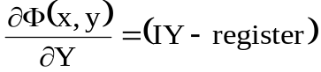

It may only be applied to a flat dummy surface. The TYPE 11 special surface may use none, any or all of the coefficients C1 to C96. The phase contribution of the TYPE 11 special surface, in terms of OPD with respect to the control wavelength, is defined by the user in macro function FUN09. If FUN09 does not exist, the added phase is 0.0. If FUN09 exists, the additional phase will be whatever is left in the IZ-storage register after FUN09 finishes its execution. The derivatives of the phase with respect to X and Y must be returned in the IX and IY-registers. These derivative values are needed to calculate the change in the ray direction cosine due to the phase change. FUN09 may not call any other macros or macro functions when used in special surface definitions. The values of the 96 coefficients are passed via general purpose storage registers 201 through 296. The current X-ray coordinate is passed via the X-register and the current Y-ray value is passed via the Y-register. The surface number is passed via the T-register. The LASTX-register remembers the previous value of the X-register as usual.

THE TYPE 12 SPECIAL SURFACE (HOE) - The TYPE 12 special surface is a Holographic Optical Element (HOE) with optional phase deformation terms. The HOE diffraction equation used for ray tracing is just::

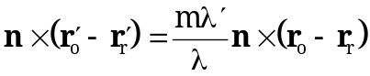

where:
m is the order number for diffraction
n is the surface normal unit vector
ro is the unit vector along construction beam 1 (sometimes referred to as the construction object point ray or just the object ray)
rr is the unit vector along construction beam 2 ( sometimes referred to as the construction reference point ray or just the reference ray)
r'o is the unit vector along the diffracted ray (sometimes called the image ray)
r'r is the unit vector along the incident ray (sometimes called the readout ray or reconstruction ray)
λ' is the end-use or play back wavelength (wavelength at which ray is traced)
λ is the construction wavelength

Coefficient C1 = order number
Coefficient C2 = construction wavelength in microns
Coefficient C3 = X-coordinate of the source point
Coefficient C4 = Y-coordinate of the source point
Coefficient C5 = Z-coordinate of the source point
Coefficient C6 = +1 if the source is real and -1 if the source is virtual
Coefficient C7 = X-coordinate of the reference point
Coefficient C8 = Y-coordinate of the reference point
Coefficient C9 = Z-coordinate of the reference point
Coefficient C10 = +1 if the reference is real and -1 if the reference is virtual

Coefficient C11 = 0 for no added phase
= 1 (R) for a rotationally symmetric phase polynomial in R starting at R² and extending to R²⁰ (even powers of R)
= 2 (XY) for a rectangular phase polynomial
= 3 (AXY) same as 2 but uses absolute value of x
= 4 (XAY) same as 2 but uses absolute value of y
= 5 (AXAY) same as 2 but uses absolute value of x and y
= 6 (AR) for a polynomial in absolute value of R starting at ABS(R)⁰ and extending to ABS(R)²⁰
= 7 (U) user-defined phase and phase derivative (macro function FUN09)*
* Phase is returned in the IZ register, the x and y partial derivatives are returned in the IX and IY registers.

During lens scaling, the coefficients C3 , C4 , C5 , C7 , C8 and C9 are scaled by the scale factor. If the source or reference object is defined as real, light will diverge away from it. If the source or reference object is defined as virtual, light will converge toward it. The coordinates of the source and reference objects are always represented in the local coordinate system of the HOE surface. Reflection HOEs should always have the source and reference points on opposite sides of the HOE surface. Unexpected and non-physically real results will occur if:
1. If the source and reference points are on the same side of the HOE and the glass type is REFL;
2. If the source and reference points are on opposite sides of the HOE and the glass type is not REFL;
3. If the source and reference points are located at the HOE surface.
If C11 = 1, the optional rotationally symmetric polynomial phase terms (coefficients 12 through 21) (R-type) which modify the HOE equation are defined by the following equation:
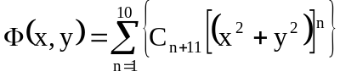

The coefficients used for the rotationally symmetric phase terms are coefficients C12 through C31. If C11 = 6, the optional rotationally symmetric polynomial phase terms (AR-type) which modify the HOE equation are defined by the following equation:

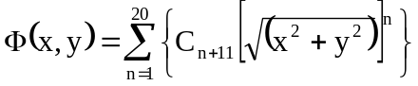

The coefficients used for the rotationally symmetric phase terms are coefficients C12 through C31. If C11 = 2, 3, 4 or 5 the optional rectangular polynomial phase terms which modify the HOE equation are defined by the following equation:

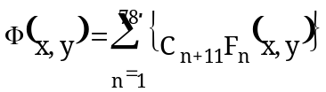
and:

F₁ (X,Y) = 1

F_{2,3} (x,y) = x,y
F_{4,5,6} (x,y) = x²,xy,y²
F_{7,8,9,10} (x,y) = x³,x²y,xy²,y³
F_{11,12,13,14,15} (x,y) = x⁴,x³y,x²y²,xy³,y⁴
F_{16,17,18,19,20,21} (x,y) = x⁵,x⁴y,x³y²,x²y³,xy⁴,y⁵
F_{22,23,24,25,26,27,28} (x,y) = x⁶,x⁵y,x⁴y²,x³y³,x²y⁴,x¹y⁵,y⁶
F_{29,30,31,32,33,34,35,36} (x,y) = x⁷,x⁶y,x⁵y²,x⁴y³,x³y⁴,x²y⁵,xy⁶,y⁷
F_{37,38,39,40,41,42,43,44,45} (x,y) = x⁸,x⁷y,x⁶y²,x⁵y³,x⁴y⁴,x³y⁵,x²y⁶,xy⁷,y⁸
F_{46,47,48,49,50,51,52,53,54,55} (x,y) = x⁹,x⁸y,x⁷y²,x⁶y³,x⁵y⁴,x⁴y⁵,x³y⁶,x²y⁷,xy⁸,y⁹
F56,57,58,59,60,61,62,63,64,65,66 (x,y) = x¹⁰,x⁹y,x⁸y²,x⁷y³,x⁶y⁴,x⁵y⁵,x⁴y⁶,x³y⁷,x²y⁸,xy⁹,y¹⁰
F67,68,69,70,71,72,73,74,75,76,77,78 (x,y) = x¹¹,x¹⁰y,x⁹y²,x⁸y³,x⁷y⁴,x⁶y⁵,x⁵y⁶,x⁴y⁷,x³y⁸,x²y⁹,xy¹⁰,y¹¹

The coefficients used for the rectangular polynomial phase terms are coefficients C12 through C89. The "x" and "y" terms in the equations are the "x" and "y" ray coordinates at the lens database surface. The phase, in terms of OPD in lens units with respect to the construction wavelength is added to the phase of the ray being traced. The final ray direction cosines are then modified appropriately. For example, if the current lens units are millimeters, then the phase Φ(x,y) will be in millimeters. Before this phase is added to the phase of the diffracted ray, it is further modified by the following equation:

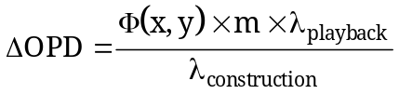

"m" is the diffraction order number. λplayback is the wavelength of the ray being traced. When a ray is traced through a diffractive phase surface, the delta optical path length is added to the optical path length of the ray according to the following equation:

When C11 is set to 7 and user-defined added phase is in effect, the values of the coefficients #1 through #96 are passed via general purpose storage registers 201 through 296. Coefficients C12 through C96 may be used to pass additional information to the macro function. The current X-ray coordinate is passed via the X-register and the current Y-ray value is passed via the Y-register. The surface number is passed via the T-register. The LASTX-register remembers the previous value of the X-register as usual. All data passing is performed automatically by the program. When using a user-defined phase to model a diffraction grating, the magnitude of the gradient of the phase divded into the HOE construction wavelength (represented in lens units) is equal to the grating spacing in lens units. It is not the intent here to teach HOE theory. Please refer to the paper by W. T. Welford, Opt. Comm., Vol. 14, No.3, pp. 322-323 (1975) for HOE theory and modeling details.

THE TYPE 13 SPECIAL SURFACE (HOE-R) - The TYPE 13 special surface is a Holographic Optical Element-Real Rays (HOE-R). This type of HOE is valid only at the main (config#1) lens configuration. This is superior to the technique in other codes because real ray aiming is used throughout the ray trace process. The HOE diffraction equation used for ray tracing is just:

where:
m is the order number for diffraction
n is the surface normal unit vector
ro is the unit vector along construction beam 1 (sometimes referred to as the construction object point ray or just the object ray)
rr is the unit vector along construction beam 2 ( sometimes referred to as the construction reference point ray or just the reference ray)
r'o is the unit vector along the diffracted ray (sometimes called the image ray)
r'r is the unit vector along the incident ray (sometimes called the readout ray or reconstruction ray)
λ' is the end-use or play back wavelength (wavelength at which ray is traced through HOE)
λ is the construction wavelength

Coefficient C1 = order number
Coefficient C2 = construction wavelength in microns
Coefficient C3 = X-coordinate of the source point (default 0.0)
Coefficient C4 = Y-coordinate of the source point (default 0.0)
Coefficient C5 = Z-coordinate of the source point (default 0.0)
Coefficient C6 = +1 if the source point ray trace is to be interpreted as initially tracing into the +Z direction and is equal to –1 if the source point ray trace is to be interpreted as initially tracing into the –Z direction.
Coefficient C7 = +1 if the source beam is to be considered to be "real" and -1 if it is to be considered "virtual"
Coefficient C8 = X-coordinate of the reference point (default 0.0)
Coefficient C9 = Y-coordinate of the reference point (default 0.0)
Coefficient C10 = Z-coordinate of the reference point (default 0.0)
Coefficient C11 = +1 if the reference point ray trace is to be interpreted as initially tracing into the +Z direction and is equal to –1 if the reference point ray trace is to be interpreted as initially tracing into the –Z direction
Coefficient C12 = +1 if the reference beam is to be considered to be "real" and -1 if it is to be considered "virtual".
Coefficient C13 = alternate lens configuration for the source point definition (source point configuration)
Coefficient C14 = alternate lens configuration for the reference point definition (reference point configuration)
During lens scaling, none of the coefficients are scaled. The coordinates of the source and reference rays are always understood to be represented in the local coordinate system of the HOE-R surface.
Unexpected and non-physically real results will occur if:

- If the effective source and reference points are on the same side of the HOE-R and the glass type is REFL;
2. If the effective source and reference points are on opposite sides of the HOE-R and the glass type is not REFL;
3. If the effective source and reference points are located at the HOE-R surface.
During ray tracing, when the ray in the main lens configuration (configuration #1) reaches a HOE-R type of surface, an internal program flag is set at which time the following things happen automatically:

1. The ray trace data of the ray at the HOE-R surface are remembered. The x, y and z-coordinates of the ray are called X₀, Y₀ and Z₀.
2. A ray is traced from the object point specified by C3, C4 and C5 in the alternate lens configuration specified by C13 to final surface. This ray is aimed such that it strikes the final surface of this alternate configuration at X₀,Y₀ and Z₀. This is the construction ray. Its direction vector is remembered as: ro. No differential ray data is generated for this ray. Real ray aiming is used. The object distance in this configuration must be greater than zero.
3. A ray is traced from the object point specified by C8, C9 and C10 in the alternate lens configuration specified by C14 to final surface. This ray is aimed such that it strikes the final surface of this alternate configuration at X₀,Y₀ and Z₀. This is the construction ray. Its direction vector is remembered as: rr. No differential ray data is generated for this ray. Real ray aiming is used. The object distance in this configuration must be greater than zero.
4. The lens is then returned to the main configuration and the original ray is traced through the HOE using the vector data stored in ro and rr. This is done for all rays including differential rays.

The process of generating a HOE "on the fly" must be done with the knowledge that the rays trace more slowly than in a type 12 special surface. The constructional parameters in the CFGs specified in C13 and C13 can be used as optimization variables while the merit function is made up of operand values only calculated in the main CFG. Direction of the traced rays in the two alternate configurations. If coefficient C6 or C11 is positive, the construction or reference rays are assumed to be initially trace in the positive Z direction, "left to right". If the coefficients are negative, the rays are assumed to be initially traced in the negative Z direction, "right to left". This convention keeps the user from needing to set an alternate configuration up "backward". Since the HOE-R surface is represented by the final surfaces in configurations C13 and C14, if there is a curvature or other non-flat definition on the HOE-R surface, it should also be represented in the alternate configurations. It is not the intent here to teach HOE theory. Please refer to the paper by W. T. Welford, Opt. Comm., Vol. 14, No.3, pp. 322-323 (1975) for HOE theory and modeling details.

THE TYPE 14 SPECIAL SURFACE (Aberration Polynomial) - -The TYPE 14 special surface is a 48-term aberration polynomial defined by the following equation:

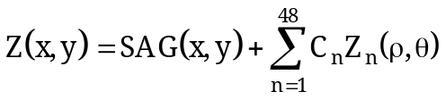
where:
SAG(x,y) is the original surface sag due to radius, conic, aspheric terms, etc.
(All ambiguities in θ are resolved in the program internals)

and:

Z₁ (ρ,θ) = 1 {constant}
Z₂ (ρ,θ) = ρ cos(θ ) {x-tilt}
Z₃ (ρ,θ) = ρ sin(θ ) {y-tilt}
Z₄ (ρ,θ) = ρ² {focus}
Z₅ (ρ,θ) = ρ²cos(2 θ) {0 degree astigmatism (3rd)}
Z₆ (ρ,θ) = ρ²sin(2 θ) {45 degree astigmatism (3rd)}
Z₇ (ρ,θ) = ρ³cos(θ) {x-coma (3rd)}
Z₈ (ρ,θ) = ρ³sin(θ) {y-coma (3rd)}
Z₉(ρ,θ) = ρ³cos(3θ) {x-clover (3rd)}
Z₁₀(ρ,θ) = ρ³sin(3θ) {y-clover (3rd)}
Z₁₁(ρ,θ) = ρ⁴ {spherical (3rd)}
Z₁₂(ρ,θ) = ρ⁴cos(2θ) {0 degree astigmatism (5th)}
Z₁₃ (ρ,θ) = ρ⁴sin(2θ) {45 degree astigmatism (5th)}
Z₁₄ (ρ,θ) = ρ⁴cos(4θ)
Z₁₅(ρ,θ) = ρ⁴sin(4θ)
Z₁₆ (ρ,θ) = ρ⁵cos(θ) {x-coma (5th)}
Z₁₇ (ρ,θ) = ρ⁵sin(θ) {y-coma (5th)}
Z₁₈(ρ,θ) = ρ⁵cos(3θ) {x-clover (5th)}
Z₁₉ (ρ,θ) = ρ⁵sin(3θ) {y-clover (5th)}
Z₂₀ (ρ,θ) = ρ⁵cos(5θ)
Z₂₁(ρ,θ) = ρ⁵sin(5θ)

Z₂₂(ρ,θ) = ρ⁶ {spherical (5th)}
Z₂₃(ρ,θ) = ρ⁸ {spherical (7th)}
Z₂₄(ρ,θ) = ρ¹⁰ {spherical (9th)}
Z₂₅(ρ,θ) = ρ⁶cos(2θ) {0 degree astigmatism (7th)}
Z₂₆(ρ,θ) = ρ⁶sin(2θ) {45 degree astigmatism (7th)}
Z₂₇ (ρ,θ) = ρ⁶cos(4θ)
Z₂₈(ρ,θ).= ρ⁶sin(4θ)
Z₂₉ (ρ,θ) = ρ⁶cos(6θ)
Z₃₀(ρ,θ).= ρ⁶sin(6θ)
Z₃₁ (ρ,θ) = ρ⁷cos(θ) {x-coma (7th)}
Z₃₂ (ρ,θ) = ρ⁷sin(θ) {y-coma (7th)}
Z₃₃ (ρ,θ) = ρ⁷cos(3θ) {x-clover (7th)}
Z₃₄ (ρ,θ) = ρ⁷sin(3θ) {y-clover (7th)}
Z₃₅(ρ,θ).= ρ⁷cos(5θ)
Z₃₆(ρ,θ).= ρ⁷sin(5θ)
Z₃₇(ρ,θ).= ρ⁷cos(7θ)
Z₃₈(ρ,θ).= ρ⁷sin(7θ)

Z₃₉(ρ,θ) = ρ⁸cos(2θ) {0 degree astigmatism (9th)}
Z₄₀(ρ,θ) = ρ⁸sin(2θ) {45 degree astigmatism (9th)}
Z₄₁(ρ,θ).= ρ⁸cos(4θ)
Z₄₂(ρ,θ).= ρ⁸sin(4θ)
Z₄₃(ρ,θ).= ρ⁸cos(6θ)
Z₄₄(ρ,θ).= ρ⁸sin(6θ)
Z₄₅(ρ,θ).= ρ⁸cos(8θ)
Z₄₆(ρ,θ).= ρ⁸sin(8θ)
Z₄₇(ρ,θ) = ρ¹² {spherical (11th)}
Z₄₈(ρ,θ) = ρ¹⁴ {spherical (13th)}

THE TYPE 15 SPECIAL SURFACE (Aberration Polynomial Phase) - The TYPE 15 special surface is a 48-term aberration polynomial similar to a TYPE 14 surface, except that the polynomial represents a variation in phase rather than surface profile. It may only be applied to a flat dummy surface. It is defined by the following equation:

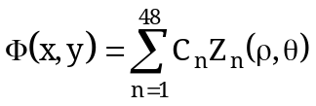
where:

All ambiguities in θ are resolved in the program internals. The phase, in terms of OPD with respect to the control wavelength, is added to the phase of the ray being traced. The ray direction cosines are modified appropriately. The terms Z1 to Z48 are the same as those listed in the TYPE 14 surface description.

THE TYPE 16 SPECIAL SURFACE (FRESNEL) - The TYPE 16 special surface is either a rotationally symmetric or a cylindrical FRESNEL surface. In FRESNEL surfaces, fresnel zones are considered to be small. This is not a good approximation to surfaces with large, deep zones as are found in some illumination systems. It is a good approximation for surfaces which have many small, shallow zones.

ROTATIONALLY SYMMETRIC CASE - If the surface upon which a TYPE 16 special surface definition is placed is not defined as a toric surface in the lens database, then base surface profile is considered to be rotationally symmetric about the surface local Z-axis. The profile is determined by the curvature and optionally the conic constant values set in the lens database. The surface profile, therefore, may be a flat, a sphere or a conic. The fresnel zones will be circular with their center at the surface vertex.

CYLINDRICAL CASE - If the surface upon which a TYPE 16 special surface definition is placed is defined as an X or Y-toric surface in the lens database, then base surface profile is considered to be cylindrical. The cylinder orientation and profile are determined by the toric type definition (X or Y-toric), the toric curvature and optionally the toric conic constant set in the lens database. The surface curvature, conic constant and surface aspheric terms will be considered to be equal to zero for all ray tracing. The surface profile, therefore, may be a flat, a cylinder or a conic profile cylinder. The fresnel zone boundaries will be linear rather than circular and they will be parallel to the axis of the cylinder. For a Y-toric, the zone boundaries will be considered to be parallel to the local Y-axis of the surface. For an X-toric, the zone boundaries will be considered to be parallel to the local X-axis of the surface. During the ray trace, the surface curvature and conic constant (rotationally symmetric case) or toric type, toric curvature and toric conic constant (cylinder case) only determine the intersection coordinates of the ray with the surface. After these intersection coordinates are computed, the direction cosines of the surface normal are calculated by assuming that the shape is described by the equation below:

where:

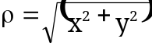 Rotationally Symmetric Case (Non-Toric)

Y-Toric Surface Profile Cylinder

X-Toric Surface Profile Cylinder

Coefficient C2 has no effect if coefficient C1 is 0.0. The CMD level "SAG" commands, output only the base surface profile and ignore the special surface coefficients which define the surface slope.

THE TYPE 17 SPECIAL SURFACE (User-Defined #2) -The TYPE 17 special surface is a user-defined surface defined by the following equation:

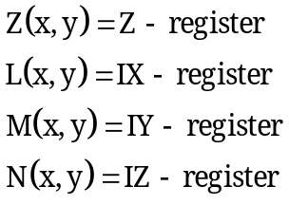

The TYPE 17 special surface is a second user-defined surface type. Unlike the TYPE 5 user-defined surface, the TYPE 17 user-defined surface ignores all non-special surface characteristics such as curvature, conic constant, aspheric deformation coefficients, toric definitions or anamorphic coefficients. The TYPE 17 special surface may use none, any or all of the special surface coefficients C1 to C96. The surface sag, Z, is defined by the user in macro function FUN10. If FUN10 does not exist, the sag is 0.0. If FUN10 exists, the surface sag will be whatever is left in the Z-storage register after FUN10 finishes its execution. FUN10 may not call any other macros or macro functions when used in special surface definitions. Unlike other surface types, the user must explicitly define the surface normal direction cosines in the macro function FUN10. The L, M and N direction cosines must be placed in registers IX, IY and IZ. If FUN10 does not exist, these values will be assumed to be 0.0, 0.0 and 1.0 respectively. The values of the 96 coefficients are passed via general purpose storage registers 301 through 396. The current X-ray coordinate is passed via the X-register and the current Y-ray value is passed via the Y-register. The surface number is passed via the T-register. The LASTX-register remembers the previous value of the X-register as usual.

THE TYPE 18 SPECIAL SURFACE (Grazing Incidence Surface) - The TYPE 18 special surface is a grazing incidence optical surface. The TYPE 18 surface assignment causes the ray trace algorithm to be modified so as to minimize any numerical problems which could occur when rays intersect and reflect from a surface at near grazing incidence. The TYPE 18 special surface also provides a capability to represent surface deformations in terms of 15 Fourier-Legendre polynomials. The type 18 special surface can only be assigned to a surface which is spherical or conic in profile and which is a mirror (material defined by the "REFL" command). The TYPE 18 coefficients have the following meaning:

COEFFICIENT | MEANING
C1 | Forward, most negative Z-coordinate which corresponds to the location of the entrance edge of the surface clear aperture which is closest to the object surface. This is called Z₁. Negative values lie to the left of the surface vertex and positive values lie to the right. (This value is also used during surface profile and clear aperture plotting).
C2 | Rear, most positive Z-coordinate which corresponds to the location of the exit edge of the surface clear aperture which is closest to the image surface. This is called Z₂. Negative values lie to the left of the surface vertex and positive values lie to the right. (This value is also used during surface profile and clear aperture plotting).
C3 | Central Z-coordinate which is measured from the surface vertex and acts as the z-offset for ray tracing. This is called Z₀. Negative values lie to the left of the surface vertex and positive values lie to the right.
C4 | Fourier-Legendre coefficient #1 (n=0, m=0) COS
C5 | Fourier-Legendre coefficient #2 (n=1, m=0) COS
C6 | Fourier-Legendre coefficient #3 (n=2, m=0) COS
C7 | Fourier-Legendre coefficient #4 (n=0, m=1) COS
C8 | Fourier-Legendre coefficient #5 (n=0, m=1) SIN
C9 | Fourier-Legendre coefficient #6 (n=1, m=1) SIN
C10 | Fourier-Legendre coefficient #7 (n=1, m=1) COS
C11 | Fourier-Legendre coefficient #8 (n=2, m=1) SIN
C12 | Fourier-Legendre coefficient #9 (n=2, ,m=1) COS
C13 | Fourier-Legendre coefficient #10 (n=0, m=2) COS
C14 | Fourier-Legendre coefficient #11 (n=0, m=2) SIN
C15 | Fourier-Legendre coefficient #12 (n=1, m=2) COS
C16 | Fourier-Legendre coefficient #13 (n=1, m=2) SIN
C17 | Fourier-Legendre coefficient #14 (n=2, m=2) COS
C18 | Fourier-Legendre coefficient #15 (n=2, m=2) SIN

The Fourier-Legendre polynomials are given by:

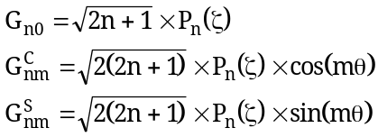
where:

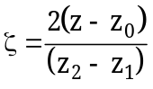

and:

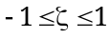
and when z lies to the left of z₀ then ζ is negative.
The first three Legendre polynomials, P_{n}(ζ), are:

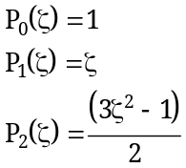

The terms used are:

TERM # | n | m | COS or SIN
1 | 0 | 0 | COS
2 | 1 | 0 | COS
3 | 2 | 0 | COS
4 | 0 | 1 | COS
5 | 0 | 1 | SIN
6 | 1 | 1 | COS
7 | 1 | 1 | SIN
8 | 2 | 1 | COS
9 | 2 | 1 | SIN
10 | 0 | 2 | COS
11 | 0 | 2 | SIN
12 | 1 | 2 | COS
13 | 1 | 2 | SIN
14 | 2 | 2 | COS
15 | 2 | 2 | SIN

The technique of using these particular coefficients to model near cylindrical mirror deformations is described in detail by Paul Glenn, "Set of orthonormal surface error descriptors for near cylindrical optics", Optical Engineering ,July/August 1984, Vol. 23, No.4. The following figure illustrates the use of the first three TYPE 18 coefficients and the section of the surface to be used in the ray trace. If rays fall outside the area designated by the coefficients C1 and C2, the ray is considered to have failed for the purposes of spot diagram analysis.

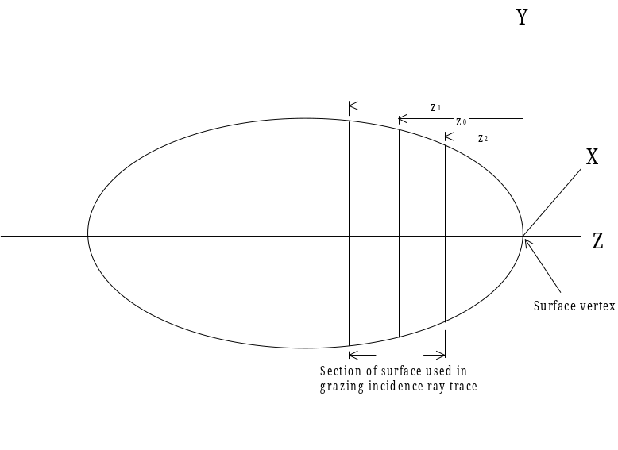

Surface Section in Grazing Ray Trace

The base radius of curvature or the curvature, the conic constant and the vertex position for the grazing incidence surface are set using the lens database commands described in the LENS section of this manual. There are several grazing incidence There are also dedicated grazing incidence CMD level commands in the CMD section of the manual.

THE TYPE 19 SPECIAL SURFACE (Apodization Surface) - The TYPE 19 special surface is an grid aperture apodization type of surface which is defined over nxn data points using data stored in a specified ASCII disk file. The special surface coefficients have the following meaning.

COEFFICIENT | MEANING
C1 | Integer value, 1 to 10. Designates that the file named APGRIDxx.DAT will be used as the source file for the apodization grid. The xx is replaced by the value of C1. If C1 = 23, then file APGRID23.DAT is used as the source file for the current apodization grid. If the file does not exist, then a single grid value for the entire surface will be assumed and will represent uniform, 100% transmission.
C2 | Integer value greater than 0. C2 specifies the dimension "n" of the apodization grid. C2 = 10 would specify a 10 x 10 grid. Default value is 5. Minimum allowed value is 5.
C3 | Clear aperture dimension, in current lens units, of the grid semi-extent at the assigned surface. This is equal to ½ of C2 times the x or y-grid point separation. If this input is left out, the default will be to apply the grid over a square area on the surface equal to twice the "inr" value at that surface. The "inr" value and the "INR" command are fully described in the LENS section of this manual.
C4 | Scale factor for apodization data. Default value = 1.0

Apodization values are transmittance or reflectance values. There range is always 0.0 (no transmission or reflection) to 1.0 (100% transmission or reflection). The first point on the grid is at the grid point index n_{x}=1 and n_{y} = 1. This grid point will lie at the most negative location in x and y in the local coordinate system of the assigned surface. The final point in the grid, index n_{x}=n, n_{y}=n will lie at the most positive location in x and y in the local coordinate system of the assigned surface. See the figure on the next page. If rays which have an apodization value assigned to them are blocked by any normal ray blocking (clear apertures, obscurations etc.) then the effective apodization factor for that ray becomes 0.0.

DATA FILE ENTRIES - There must be exactly C2xC2 lines in the file designated by the value C1. If there are not exactly that many lines, an error message will be issued, file input will be ignored and no apodization grid data will be assigned to the surface. Each file entry can be free form and each line consists of two integers and one floating point value. The integers can range from 1 to n and the floating point apodization values can range from 0.0 to 1.0. Any missing grid points in this file will be set to a transmission value of 1.0.

Example: File APGRID01.DAT with a 3x3 grid of apodization data:

1,1,0.1D0
1,2,0.5D0
1,3,0.1D0
2,1,0.5D0
2,2,1.0D0
2,3,0.5D0
3,1,0.1D0
3,2,0.5D0
3,3,0.1D0

The input values in each line of the file may be separated by spaces or commas. The file will be "list directed" read when the program reads it. Input is always x-index, y-index, apodization factor (integer, integer, double precision).

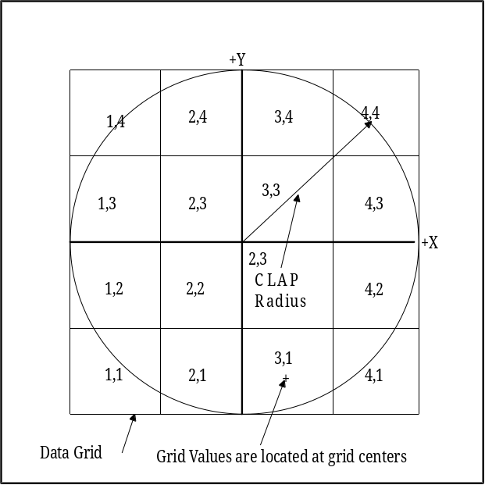

APOD Data Grid/Surface Relationship

The grid datum is always considered to be located at the center of a grid square. The above figure shows the grid counting system and relationship to the surface clear aperture for a 4x4 grid assigned to a surface. Grid square (1,1) is at the lower left. The value anywhere inside a grid square is interpolated from the value at the grid center using slope values which are automatically calculated based on apodization values at surrounding grid squares centers. If a ray falls inside a grid square, an apodization value is assigned to that ray unless the ray is blocked by a clear aperture or obscuration or unless the ray fails for some other reason. Rays which fall on grid square boundaries are assigned to a bordering grid square based upon a random "coin flip".

THE TYPE 20 SPECIAL SURFACE (Grid Phase Surface) - The TYPE 20 special surface is an grid OPD (Optical Path Difference) phase type of surface which is defined over nxn data points using data stored in a specified ASCII disk file. The special surface coefficients have the following meaning. It may only be applied to a flat dummy surface.

COEFFICIENT | MEANING
C1 | Integer value, 1 to 10. Designates that the file named PHGRIDxx.DAT will be used as the source file for the phase grid. The xx is replaced by the value of C1. If C1 = 23, then file PHGRID23.DAT is used as the source file for the current phase grid. If the file does not exist, then a single grid value for the entire surface will be assumed and will represent zero phase.
C2 | Integer value greater than 0. C2 specifies the dimension "n" of the SAG grid. C2 = 10 would specify a 10 x 10 grid. Default value is 5. Minimum allowed value is 5.
C3 | Clear aperture dimension, in current lens units, of the grid semi-extent at the assigned surface. This is equal to ½ of C2 times the x or y-grid point separation. If this input is left out, the default will be to apply the grid over a square area on the surface equal to twice the "inr" value at that surface. The "inr" value and the "INR" command are fully described in the LENS section of this manual.
C4 | Phase unit indicator:  0 = OPD phase in fractions of waves of the current reference wavelength.  1 = OPD in current lens units.  2 = OPD in microns.
C5 | Scale factor for phase data. Default value = 1.0

The first point on the grid is at the grid point index n_{x}=1 and n_{y} = 1. This grid point will lie at the most negative location in x and y in the local coordinate system of the assigned surface. The final point in the grid, index n_{x}=n, n_{y}=n will lie at the most positive location in x and y in the local coordinate system of the assigned surface. See the figure on the next page. Rays which are blocked or fail, have no phase term added to them. The phase in adjacent grid squares is used to calculate the "wavefront slope" which is used during the ray trace to "adjust" the direction cosines of the deviated ray.

DATA FILE ENTRIES - There must be exactly C2xC2 lines in the file designated by the value C1. If there are not exactly that many lines, an error message will be issued, file input will be ignored and no phase grid data will be assigned to the surface. Each file entry can be free form and each line consists of two integers and one floating point value. The integers can range from 1 to n and the floating point phase values which can take on any value. Any missing grid points in this file will be set to a phase = 0.0

Example: File PHGRID01.DAT with a 3x3 grid of phase data:

1,1,0.9D0
1,2,1.5D0
1,3,0.1D0
2,1,0.5D0
2,2,-.01D0
2,3,0.5D0
3,1,0.1D0
3,2,0.5D0
3,3,0.1D0

The input values in each line of the file may be separated by spaces or commas. The file will be "list directed" read when the program reads it. Input is always x-index, y-index, phase (integer, integer, double precision). The phase is added to the phase of the ray being traced. The ray direction cosines are modified appropriately in exactly the same manner as is done in other phase surfaces.

OPD Data Grid/Surface Relationship

The grid datum is always considered to be located at the center of a grid square. The above figure shows the grid counting system and relationship to the surface clear aperture for an 4x4 grid assigned to a surface. Grid square 1,1 is at the lower left. If a ray falls inside a grid square, a phase value is added to that ray unless the ray is blocked by a clear aperture or obscuration or unless the ray fails for some other reason. Rays which fall on grid square boundaries are assigned to a bordering grid square based upon a random "coin flip".

THE TYPE 21 SPECIAL SURFACE (User-defined Subroutine Surface) - The User-defined Subroutine Surface type of special surface, is a special surface definition which may be added to any other regular surface definition. It simulates the effects of complex, generalized surface shapes which are user-defined in the USERSURF.FOR subroutine. By default, the USERSURF.FOR subroutine is just an empty subroutine which does nothing until it is modified to do something, by the user. The USERSURF.FOR special surface subroutine may use any and all of the 96 special surface coefficients plus any of the general purpose storage registers.

THE TYPE 22 SPECIAL SURFACE (Grid SAG Surface) - The TYPE 22 special surface is a grid SAG type of surface which is defined over nxn data points using data stored in a specified ASCII disk file. The SAG value for the grid square in which the current ray lies is added to the SAG of the surface at that x,y due to curvatures, conics or aspheric non-special surface definitions. The added SAG must be represented in the local coordinate system of the surface to which the sag grid file it is being assigned. The SAG values in SAG grid file are assumed to be represented in the same units as the current lens file data.

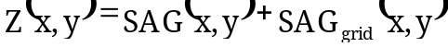

The special surface coefficients have the following meaning.

COEFFICIENT | MEANING
C1 | Integer value, 1 to 10. Designates that the file named SGGRIDxx.DAT will be used as the source file for the SAG grid. The xx is replaced by the value of C1. If C1 = 23, then file SGRID23.DAT is used as the source file for the current SAG grid. If the file does not exist, then a single SAG grid value for the entire surface will be assumed and will represent zero SAG.
C2 | Integer value greater than 0. C2 specifies the dimension "n" of the SAG grid. C2 = 10 would specify a 10 x 10 grid. Default value is 5. Minimum allowed value is 5.
C3 | Clear aperture dimension, in current lens units, of the grid semi-extent at the assigned surface. This is equal to ½ of C2 times the x or y-grid point separation. If this input is left out, the default will be to apply the grid over a square area on the surface equal to twice the "inr" value at that surface. The "inr" value and the "INR" command are fully described in the LENS section of this manual.
C4 | Scale factor for sag data. Default value = 1.0

The first point on the grid is at the grid point index n_{x}=1 and n_{y} = 1. This grid point will lie at the most negative location in x and y in the local coordinate system of the assigned surface. The final point in the grid, index n_{x}=n, n_{y}=n will lie at the most positive location in x and y in the local coordinate system of the assigned surface. See the figure on the next page. The SAG in adjacent grid squares is used to calculate the surface direction cosine contributions from the grid SAG data.

DATA FILE ENTRIES - There must be exactly C2xC2 lines in the file designated by the value C1. If there are not exactly that many lines, an error message will be issued, file input will be ignored and no SAG grid data will be assigned to the surface. Each file entry can be free form and each line consists of two integers and one floating point value. The integers can range from 1 to n and the floating point SAG values can take on any value. Any missing grid points in this file will be set to a SAG = 0.0

Example: File SGGRID01.DAT with a 3x3 grid of SAG data:

1,1,0.9D0
1,2,1.5D0
1,3,0.1D0
2,1,0.5D0
2,2,-.01D0
2,3,0.5D0
3,1,0.1D0
3,2,0.5D0
3,3,0.1D0

The input values in each line of the file may be separated by spaces or commas. The file will be "list directed" read when the program reads it. Input is always x-index, y-index, sag (integer,integer,double precision). The SAG is added to the SAG of the base surface.

SAG Data Grid/Surface Relationship

The grid datum is always considered to be located at the center of a grid square. The above figure shows the grid counting system and relationship to the surface clear aperture for an 4x4 grid assigned to a surface. Grid square 1,1 is at the lower left. If a ray falls inside a grid square, a SAG value is added to that ray unless the ray is blocked by a clear aperture or obscuration or unless the ray fails for some other reason. Rays which fall on grid square boundaries are assigned to a bordering grid square based upon a random "coin flip".

THE TYPE 23 SPECIAL SURFACE (Cubic Spline) - The TYPE 23 special surface is a rotationally symmetric, normal, cubic spline surface. A normal cubic spline is one which has zero valued second derivatives at its end points. The surface is characterized by from 3 to 94 equally spaced spline input SAG data entries. The resultant surface sag is defined as:

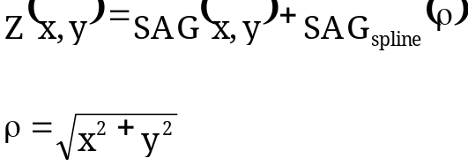

SAG(x,y) is the original surface SAG due to radius, conic, aspheric terms, etc. Coefficients C1 and C2 are not used for specifiying surface sag data points. Coefficient C1 is used to specify the number of equally spaced spline SAG data points including the 0,0,0 point at the surface vertex. Coefficient C2 is used to specify the reference radius value over which these data points are to be located. C1 has a default value of 0. If C1 has a value less than 3 at the time that rays are traced, then the cubic spline surface will have no effect during ray tracing. C2, if not input by the user, will be taken as the current "INR" value at that surface. The spline SAG data points are assumed to be arranged in assending radial order with C3 located at the local surface origin and the highest numbered coefficient being the most distant from the local surface origin. The sag value assigned to coefficient C3 Must always be zero or strange things will happen during ray tracing.

FOR EXAMPLE: If C1 is equal to 10, then the program will use coefficients C3 through C12 as the basis of the spline surface definition. The first data point will be located at the surface vertex. The 10th data point will be located at a radial distance equal to the value of C2 from the surface vertex.

