OPTICAL DESIGN AND ANALYSIS

by

James.E. Klein

Introduction

Optical design and analysis is really quit simple. All of optical design and optical analysis is based upon very simple descriptions of physical relationships which describe the way in which electromagnetic radiation (light) interacts with matter. After you have finished reading this text and finished working through the examples contained herein, you will be able to call yourself an optical designer and an optical analyst. The degree to which you become an experienced optical designer and analyst will, of course, depend on how much optical design and analysis you perform during your career.

You can learn ABOUT Optical Design and Analysis by reading about it. To LEARN optical design, you have to DO IT! There is no shortcut. This book is going to make learning how to do optical design and analysis both fun and interesting.

In order to do optical design and analysis, you will need to be able to mathematically model optical systems, trace rays through these systems, perform other calculations and interpret the results of these calculations. You will need a good, full featured optical design and analysis computer program in order to build these models and to perform these calculations. This text is built around the program which I have written and which you can get for free via the internet by going to: http://www.engcalc.com. KDP (Klein's Design Program) runs on most computer systems which run the MS Windows family of operating systems.

This free program contains everything you need in order to learn to become an experienced optical designer and analyst.

Chapter 1

Introduction

Light Rays or Light Waves

There has been a rumor going around that electromagnetic radiation (light) has a split personality. Some say light is a ray, others say its a wave. In the craft of optical design and analysis, light can be described both as a ray and as a wave. What the true nature of light really is, is of course, not of the slightest importance to us here. What is important is that we have a way of describing light which will allow us to accurately predict the behavior of that light as it interacts with our to-be-built or to-be-analyzed optical systems. We will mainly speak of light rays. We will always want to remember that these light rays are meant to represent the local perpendiculars or normals to these light wave fronts (physicists call that the Pointing Vector) as these wave fronts pass through our optical systems.

Simple Physical Laws

At the microscopic level, the interaction of electromagnetic radiation with matter is wondrous and complex. Fortunately for us, we can ignore most of that complexity. Remember back in high school when we learned about a man named Snell and his simple and useful laws of refraction and reflection. Snell's Law of Refraction is a simple algebraic relationship between the direction of light inside a material and the speed of light in that material. Snell's Law of Reflection comes from Snell's Law of Refraction when light is reflected back into the same material from whence it came. What causes the reflection is generally of no importance except when polarization effects or partial reflection come into play, but that is a topic to be covered later.

Snell's laws describe the behavior of light rays when they are refracted and reflected. If we know the direction of the incoming light relative to a perpendicular (surface normal) vector at the ray intersection point with the refracting or reflecting surface and if we know what the refractive indices are in all the surrounding spaces, then Snell's laws are all we need to predict the direction of the light ray after refraction or reflection. It's just that simple. The particular geometry may be complex but KDP takes care of all that for you. Snell's law is built into KDP. Now for diffraction.

In the paragraph above, we said that at the microscopic level, light and matter interact in complex ways. From the study of this complex microscopic behavior comes two more simple, exact macroscopic relationships. They are the grating equation and the more general diffraction equation. We will need these in order to describe diffraction gratings and generally diffractive things like Holographic Optical Elements (H.O.E.s). These too are built into KDP.

O.K., so now we have Snell's laws which we will use to describe refraction and reflection and we have the grating equation and the general diffraction equation for describing diffractive optical elements. All we need to do now is apply these four simple relationships to the geometry we find in lenses and mirrors and we can calculate, to any practical numerical degree of accuracy, the location and direction or rays of light passing through our optical system. Knowing ray locations and directions allows us to go ahead an calculate optical path lengths along these rays and compare these optical path lengths to the optical path lengths of perfectly ideal wave fronts. With this we have a way to perform about 99% of the all possible optical analysis on about 99% of all possible optical systems. If we add the ability to automatically vary the geometry of the optical elements which make up our optical system, so that the optical path differences between our existing optical system and the "perfect" optical system are minimized, we will have a way to optimize our designs.

At this point you may have noticed that no equations have been given. You don't need any right now. If you want to see the equations for Snell's law, consult a basic optics text book. The equations used when tracing rays through diffraction gratings and H.O.E.s can be found in the reference manual for the KDP program. This can be accessed from the KDP Help menu.

Enough for the introduction. Let's get to work and do some practical lens design. Fortunately, I have done all the really nasty work by writing the KDP optical design and analysis program which you can use to do the really interesting stuff, i.e. the design and analysis of new and hopefully innovative optical systems.

Chapter 2

Starting Simple

I am not going to keep the following discussions generic to all optical design programs. Too many texts already do that. It keeps the author on friendly terms with all of the optical design program vendors at the expense of the learning designer. Therefore, I assume you have downloaded and installed the FREE KDP optical design program. If you have not, go to my web site referenced in Chapter 1 and download and install it. For convenience, make a shortcut to the KDP.EXE program and place the shortcut's icon on the desktop. I find this to be very convenient. As an aside, KDP runs from inside a directory on your computer named WINKDP which was set up when you installed KDP. Everything that is KDP, involves files which either lie in this directory or in a directory beneath this directory.

Some versions of KDP may have some form of menu system for use by the casual user. Since this menu system is a sub-set of the KDP command structure (except for the Help menus) and since real designers use a command interface and since you are reading book this because you want to be a real designer, I will teach you optical design via KDP commands. The menu system is simple and self-explanatory.

A Single Airspace

The simplest optical system you can model is one in which light travels through a simple airspace. Start KDP by double clicking on the KDP icon. All future commands assume that you press the ENTER key to execute the command.

Now just type the following bolded commands:

COMMAND | What it does.
LENS | Initializes lens database input
TH 1.0D20 | Puts the object at infinity
AIR | Terminates input for the object surface, surface #0
TH 10.0 | Gives surface #1 a thickness of 10.0 lens units
AIR | Terminates input for surface #1
AIR | Adds and then terminates input for surface #2
AIR | Adds and then terminates input for surface #3
EOS | Terminates lens input and returns you to the CMD program level

Depending upon where you are in KDP, you will see different three-letter groups which preceed the command prompt The command prompt is located at the left end of the command input box at the bottom of the KDP window. The CMD level is the level of KDP where you do most analysis and design work. That is the program level when the program begins.

When you typed "LENS" many default values were established for this lens database. Some of the important things are wavelengths, object heights or angles and default aperture sizes. In this example, the wavelengths are set to: 0.58756, 0.48613, 0.65627, 0.43584 and 0.70652 (all in micron units), the reference object half-angle is set to 1.0 degree and the reference semi-diameter of the aperture (this is one-half the entrance pupil diameter) is set to 1.0 lens unit. By default, lens units are inches. In order to verify that you have the lens typed in correctly, issue the RTG ALL command which lists "radius, thickness, glass" for the entire lens. You will see:

BASIC LENS DATA (RADIUS MODE)

SURF RADIUS THICKNESS MATERIAL INDEX V-NUM
0 0.00000 0.100000E+21 AIR
1* 0.00000 10.0000 AIR
1* : REFS
2 0.00000 0.00000 AIR
3 0.00000 0.00000 LAST SURFACE

Granted it is not much of a lens, but it's a start. If you want to see the rays traced in this system, the VIE command will generate the following picture:
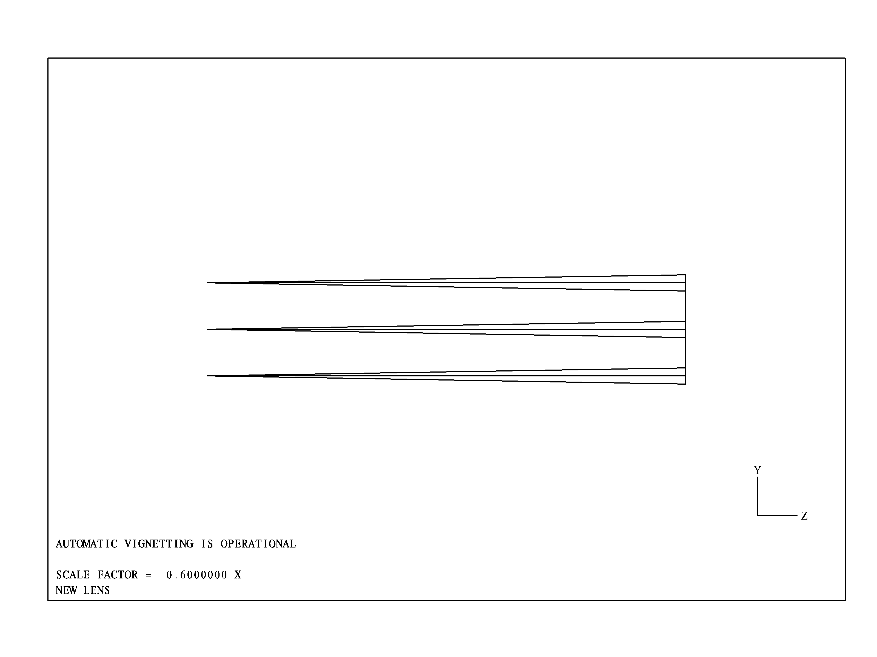
This isn't too exciting yet but it does show upper, lower and on-axis rays from three field of view positions (+1.0 degree, on-axis and –1.0 degree) traced from surface #1 to the final or image surface (#3). We have now modeled the simplest optical system imaginable.

Chapter 3

Adding the Simplest Optical Element

A Plane Parallel Plate

Let's add a plane parallel plate with a diameter of 2.5 inches after surface #1 and make the distance from the back surface of this plate to the image surface, 5.0 inches.
Now just type the following commands:

COMMAND | What it does.
U L | Starts lens database update
INS 2 | Inserts a new surface after surface #1 and leaves the lens pointer there
TH .25 | Make the plate thickness 0.25 inch
CLAP 1.25 | Make the surface semi-diameter 1.25 inches
GLASS BK7 | Make the plate material Schott BK7 glass
CHG 3 | Set the lens pointer to surface #3
TH 5.0 | Make the distance from surface #3 to the image surface 5.0 inches
CLAP 1.25 | Make the surface semi-diameter 1.25 inches
EOS | Terminates lens update and returns you to the CMD program level

Typing RTG ALL again lists the new prescription.

BASIC LENS DATA (RADIUS MODE)

SURF RADIUS THICKNESS MATERIAL INDEX V-NUM
0 0.00000 0.100000E+21 AIR
1* 0.00000 10.0000 AIR
1* : REFS
2 0.00000 0.250000 SCHOTT BK7 1.51680 64.2
3 0.00000 5.00000 AIR
4 0.00000 0.00000 LAST SURFACE

Typing CAOB ALL, lists the newly assigned clear aperture values.

CLEAR APERTURES AND OBSCURATIONS

SURF TYPE Y-SEMI. X-SEMI. Y-DEC X-DEC CORNER-RADIUS TILT(DEG)
(RADIUS) (N-POLY)
(RAD-FLT) (DELTA-Z)
2 CIRC 1.25 1.25
3 CIRC 1.25 1.25

VIE now shows the following layout:
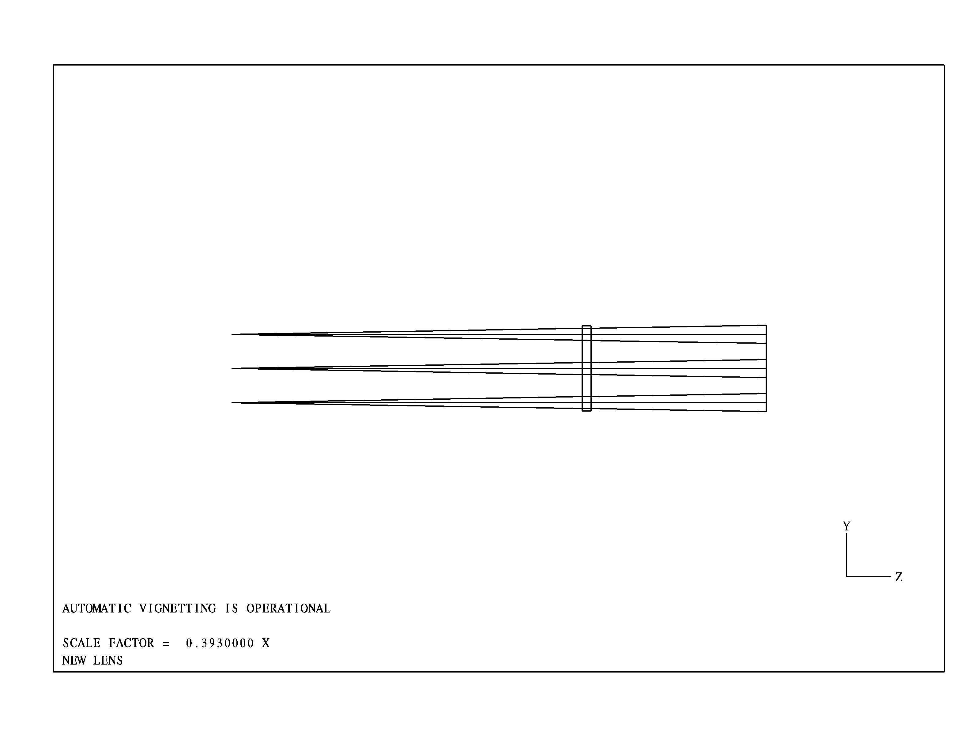
The plane parallel plate is now seen to be 10 inches behind surface #1 and 5 inches in front of the image surface. Now lets tilt the plane by 45 degrees about the X-axis. This is an ALPHA tilt.. It should be obvious that the dimension of the plate should be increased in the YZ-plane by the square root of 2 in order for it to be large enough to pass the current beam. We will redefine the clear apertures on the plate to be elliptical and tilt the plate by 45 degrees with the next short set of commands.

Now just type the following commands:

COMMAND | What it does.
U L | Initializes lens database update
CHG 2 | Sets the lens pointer at surface #2
CLAP ELIP 1.768 1.25 | Assigns the elliptical clear aperture to surface 2.
TILT 45 | Tilts surface #2 and all following surfaces by 45 degrees about the X-axis
CHG 3 | Sets the lens pointer at surface #2
CLAP ELIP 1.768 1.25 | Assigns the elliptical clear aperture to surface 2.
TH 0.0 | Set thickness of surface #3 to 0.0 inch
INS 4 | Insert surface #4
TH 5.0 | Set thickness of surface #4 to 5.0 inches
TILT AUTO | Set a TILT AUTO on this dummy surface which realigns the optical axis to the central ray after the ray passes through the plate. This "tilt plus decenter" is automatically established when the on-axis chief ray is traced.
EOS | Terminates lens update and returns you to the CMD program level
FOB | Causes the TILT AUTO assignment to be activated.

The term "dummy surface" refers to any surface which has identical optical material on both of its sides. The term central ray refers to the chief ray which is traced from the center of the object surface to the center of the reference surface and aperture stop which by default is located at surface #1.

RTG ALL now shows the new prescription,

BASIC LENS DATA (RADIUS MODE)

SURF RADIUS THICKNESS MATERIAL INDEX V-NUM
0 0.00000 0.100000E+21 AIR
1* 0.00000 10.0000 AIR
1* : REFS
2* 0.00000 0.250000 SCHOTT BK7 1.51680 64.2
2* : Tilt
3 0.00000 0.00000 AIR
4* 0.00000 5.00000 AIR
4* : Tilt,Decenter
5 0.00000 0.00000 LAST SURFACE

CAOB ALL now shows the new elliptical clear apertures,

CLEAR APERTURES AND OBSCURATIONS

SURF TYPE Y-SEMI. X-SEMI. Y-DEC X-DEC CORNER-RADIUS TILT(DEG)
(RADIUS) (N-POLY)
(RAD-FLT) (DELTA-Z)
2 ELIP 1.77 1.25
3 ELIP 1.77 1.25

and TAD ALL shows the tilts and decentered after the FOB command causes TAD ALL to realign surface #4 and beyond.

TILT AND DECENTER DATA (ANGLES MODE = "MIXED")

SURF TYPE ALPHA BETA GAMMA RETURN SURF
2 TILT 45.000000 0.0000000 0.0000000
4 TILT A 315.00000 0.0000000 0.0000000

SURF TYPE YD XD ZD
4 DEC -0.13173659 0.0000000 0.0000000

VIE now shows the following layout:
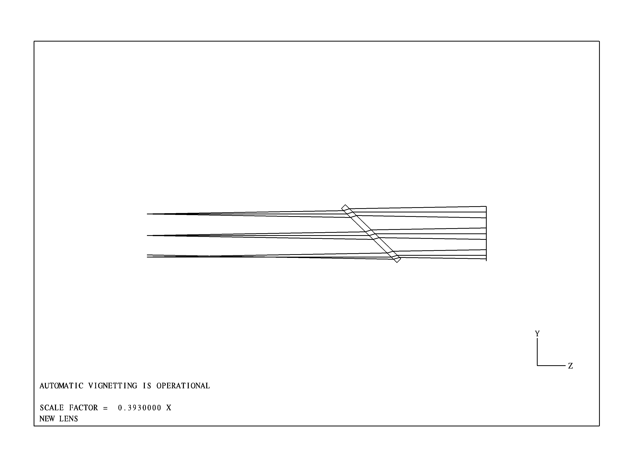
If it is desired to remove the automatic nature of TILT AUTO then the user simply issued the following few commands:

COMMAND | What it does.
U L | Initializes lens database update
CHG 4 | Sets the lens pointer at surface #4
TILT AUTOD | Converts the TILT AUTO into a simple TILT with a de-center
EOS | Terminates lens update and returns you to the CMD program level

Exercises for the user before moving to chapter 4:

- Try displaying the optical system in the XZ-plane using VIE XZ or in an orthographic projection using VIE ORTHO. All of the drawings have been done so far with automatic scaling. Try instead VIE .3 to re-display the system with a scale factor of 0.3.
Try assigning a BETA tilt instead of an ALPHA tilt by using TILT 0 45 instead of the TILT 45. Make sure to have TILT AUTO set on surface #4 or things could get strange in a big hurry! Try adding a GAMMA tilt as well. Remember, U L gets you into update lens mode, CHG sets the surface you're changing, INS adds a surface, DEL deletes a surface and EOS gets you out of the update lens mode and puts you back at the CMD level where you can trace rays and do other analysis.

Chapter 4

House Keeping

Save Your Work

Let's add a plane parallel plate with a diameter of 2.5 inches after surface #1 and make the distance from the back surface of this plate to the image surface, 5.0 inches.
Now just type the following commands:

COMMAND | What it does.
U L | Starts lens database update
INS 2 | Inserts a new surface after surface #1 and leaves the lens pointer there
TH .25 | Make the plate thickness 0.25 inch
CLAP 1.25 | Make the surface semi-diameter 1.25 inches
GLASS BK7 | Make the plate material Schott BK7 glass
CHG 3 | Set the lens pointer to surface #3
TH 5.0 | Make the distance from surface #3 to the image surface 5.0 inches
CLAP 1.25 | Make the surface semi-diameter 1.25 inches
EOS | Terminates lens update and returns you to the CMD program level

Typing RTG ALL again lists the new prescription.

BASIC LENS DATA (RADIUS MODE)

SURF RADIUS THICKNESS MATERIAL INDEX V-NUM
0 0.00000 0.100000E+21 AIR
1* 0.00000 10.0000 AIR
1* : REFS
2 0.00000 0.250000 SCHOTT BK7 1.51680 64.2
3 0.00000 5.00000 AIR
4 0.00000 0.00000 LAST SURFACE

Typing CAOB ALL, lists the newly assigned clear aperture values.

CLEAR APERTURES AND OBSCURATIONS

SURF TYPE Y-SEMI. X-SEMI. Y-DEC X-DEC CORNER-RADIUS TILT(DEG)
(RADIUS) (N-POLY)
(RAD-FLT) (DELTA-Z)
2 CIRC 1.25 1.25
3 CIRC 1.25 1.25

