Introduction To Python – Homework 1

Q1) What is a computer program?

|  |
| --- |
|  |

Q2) What are some good reasons to learn how to program?

|  |
| --- |
|  |

Q3) What is wrong with this code?

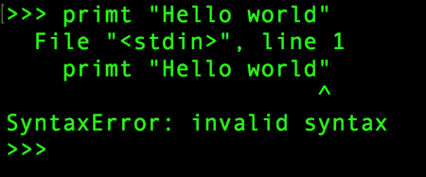

|  |
| --- |
|  |

Q4) What will print out after this code is run?

>>> x = 43

>>> x=x+1

>>> print(x)

1. 43
2. 44
3. x + 1
4. This is an error, x = x + 1 is not possible in math