Introduction to Python – Extra Credit

Use what you’ve learned about Python’s **Turtle** library to make some cool drawings! Here’s an example:

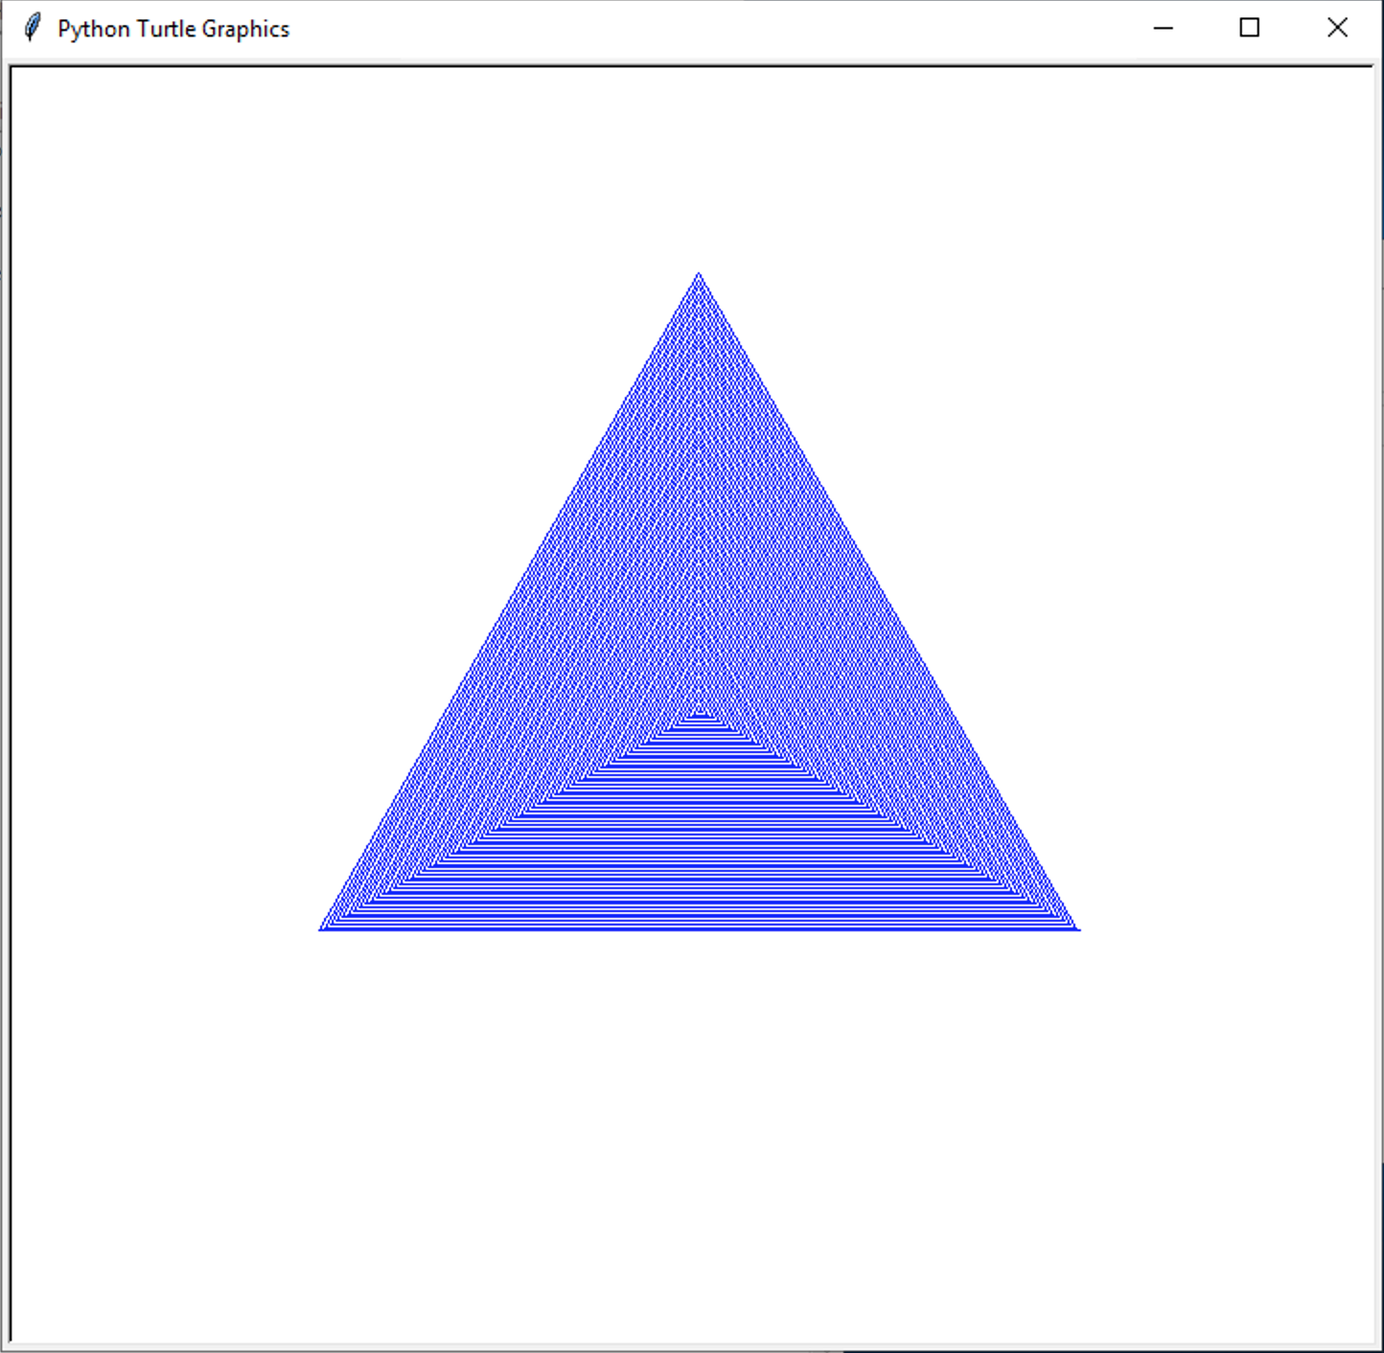

What can *you* do? Look at the example code in turtle.zip!