Introduction to Python: Class 6 Homework

Q1) Use PyGame to draw a face:

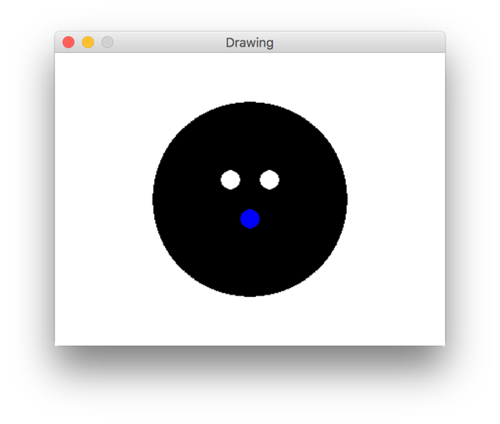

Q2) Change your code so that the face is drawn by a **function**. The function should take **arguments** for skin color, eye color, and mouth color, like this:

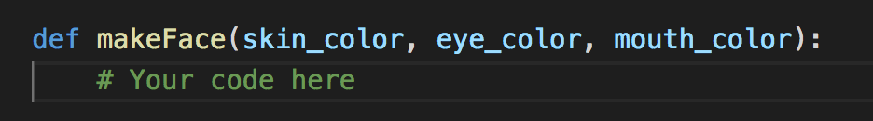

The output should be something like this (if my inputs are BLUE, GREEN, and RED):

