Introduction To Python – Quiz 5

Q1) You use the keyword "func" to make new functions in Python, like this:
func hello(name):
print("Hello there", name)

- True
- False

Q2) What will print out when this program runs?
def squaresAndCubes(number):
square = number * number
cube = number * number * number
return (square, cube)
square, cube = squaresAndCubes(5)
print("Square:", square)
print("Cube:", cube)
- Square: 25
Cube: 125

- Square: 25
Cube: 25
- Square: 125
Cube: 25
- This is an error, functions can only return one thing

Q3) Why do we use functions? (multiple choice)
- To make our code easier to read
- To make our programs run faster
- To avoid writing the same code over and over
- To make our programs easier to update and change

Q4) We have a drawing program that opens a 400x300 pixel window on our computer. Connect each line of code to the shape it will draw.

pygame.draw.line(DISPLAYSURF, BLUE, (120, 60), (60, 120)) |  | 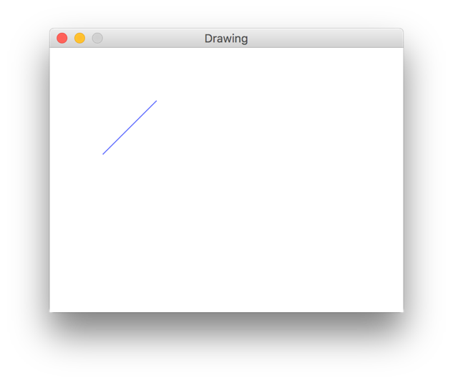
pygame.draw.ellipse(DISPLAYSURF, RED, (300, 200, 40, 80), 1) |  | 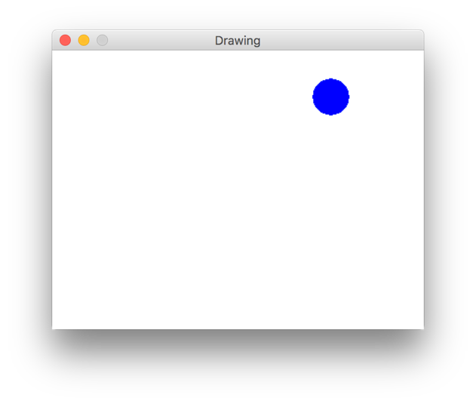
pygame.draw.circle(DISPLAYSURF, BLUE, (300, 50), 20, 0) |  | 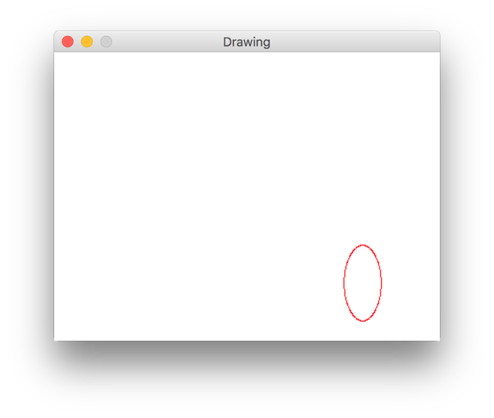

Q5) Match each color to the PyGame code for that color.

Red |  | (0, 0, 255)
Green |  | (255, 0, 0)
Blue |  | (0, 255, 0)

Q6) The code to make BLACK and WHITE is:
BLACK = (0, 0, 0)
WHITE = (255, 255, 255)
- True
- False

