Introduction to Python: Class 7 Homework
Q1) I have given you the code for “bubbles.py”. Change this code so that some bubbles actually move away from you, and touching them makes you get bigger. Your program should then look something like this:
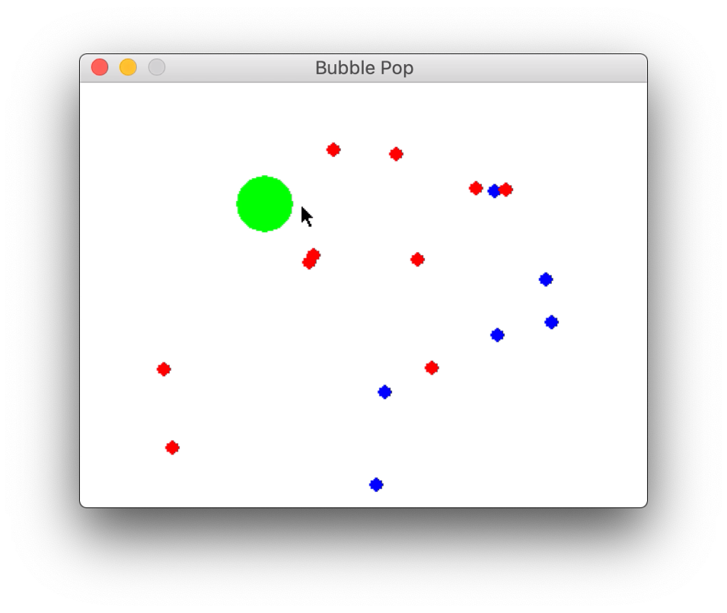
Eating the blue bubbles should make the green circle get bigger. Touching the red circles still makes you get smaller. See the video in the slides for an example.

Q2) Add a “score” to your game. Each time you eat a blue bubble, you get 1 point. Show this score on the screen. When the score gets to 100, print “YOU WIN” on the screen and stop the game.

