Introduction To Python – Quiz 1

Q1) What does the computer’s secondary memory (hard drive, or “disk”) do?

- Run programs
- Get websites from the Internet
- Take input from users
- Store programs and data, even when the computer is off

Q2) What makes computers different from other kinds of machines, like bicycles and cars?

Q3) What makes a computer different from a calculator? What can the computer do that the calculator cannot?

Q4) What is wrong with this code?

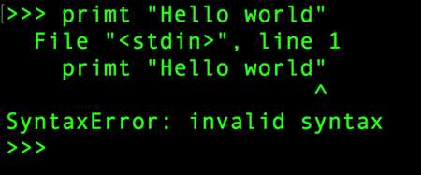

Q5) After we run the code below, where is “x” stored?
>>> x = 123
- CPU
- Main memory
- Secondary memory
- Input devices
- Output devices

Q6) What will print out after this code is run?
>>> x = 43
>>> x=x+1
>>> print(x)

- 43
- 44
- x + 1
- This is an error, x = x + 1 is not possible in math

