Introduction to Python: Class 5 Homework
Q1) Change the code in “blankgame.py” so that it draws a face, like this:

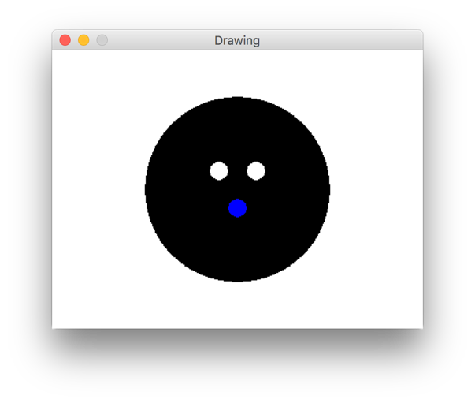

Q2) Change your code so that the face is made by a function. The function should take arguments for skin color, eye color, and mouth color, like this:
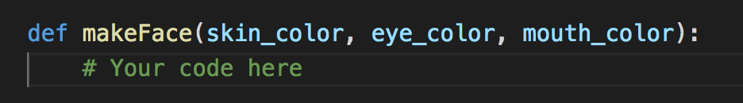
The output should be something like this (if my inputs are BLUE, GREEN, and RED):

