This is your practice final exam

Step 1 - Create the database and insert the data. This is a music inventory database..(This is not my collection!) You will have to keep create each table
- Decide on primary keys and what they should be. (Create a separate unique identifier)
- Decide if a field is required or options
- Decide if information should be foreign key or redundant data (Do you really want redundant data?)
- Decide on what restrictions or checks you should have on data

What you should keep in mind:
- You are working with a relational database, create foreign keys and relationships where needed.
- Remember that one of the great facts of relation data is that data is not repeated from table to tale!

Data Set 1: Music Categories

Music Category
Classical
Rock
Jazz
Country
New Age

Data Set 2: Recording Artists

Recording Artist | Notes
The Popular Mechanics | Classic rock sound
Crawdad Stare | Grunge Rock style.
Dog House Rules | Smooth Jazz from Chicago area.
Mary Saveley | Soft soul jase

Data Set 3: Recordings

Recording Title | Recording Artist ID | Music Category ID | Recording Label | Format | Number of Tracks | Notes
Noise in the Garage | Crawdad Stare | Rock | Goes to 11, Inc. | CD | 10 | 1st recording to break top 10 by this artist
Look Both Ways | Crawdad Stare | Rock | Hippo Records | Cassette | 12 | Artists original release. Underground until Noise in garage was popular.
Outback | Crawdad Stare | Rock |  | CD | 10
Short Circuit | Dog House Rules | Jazz |  | Cassette | 7
Meditations | Mary Saveley | New Age |  | CD | 6
Opus 65 | The Popular Mechanics | Classical |  | CD | 5
Sounds Better Louder | Crawdad Stare | Rock | Goes to 11, Inc. | CD | 10

After creating your tables and inserting your data, you may proceed to step 2.

Step 2 - Create the following SQL statements against your new database. This is a music inventory database..

CREATE DATABASE MUSIC_INVENTORY;

CREATE TABLE MUSIC_GENRES
(GENRE VARCHAR(30),
PRIMARY KEY (GENRE));

INSERT INTO MUSIC_GENRES
VALUES ('Classical'),
('Rock'),
('Jazz'),
('Country'),
('New Age')

CREATE TABLE RECORDING_ARTISTS
(ARTISTS VARCHAR(30) NOT NULL,
NOTES VARCHAR(100),
PRIMARY KEY (ARTISTS));

INSERT INTO RECORDING_ARTISTS
VALUES('The Popular Mechanics', 'Classic Rock Sound'),
('Crowded Stare', 'Grunge Rock Style'),
('Dog House Rules', 'Smooth Jazz from Chicago area'),
('Mary Saveley', 'Soft Soul Jazz')

CREATE TABLE ALBUMS
(ALBUM_NAME VARCHAR(50) NOT NULL,
ARTIST VARCHAR(30) NOT NULL,
GENRE VARCHAR(30) NOT NULL,
RECORD_LABEL VARCHAR(30),
FORMAT_CD CHAR(3) NOT NULL,
FORMAT_CASSETTE CHAR(3) NOT NULL,
NUMBER_OF_TRACKS SMALLINT NOT NULL,
NOTES VARCHAR(160),
PRIMARY KEY (ALBUM_NAME),
FOREIGN KEY (ARTIST)
REFERENCES RECORDING_ARTISTS(ARTISTS),
FOREIGN KEY (GENRE)
REFERENCES MUSIC_GENRES(GENRE));

INSERT INTO ALBUMS
VALUES ('Noise in the Garage', 'Crawdad Stare', 'Rock', 'Goes to 11, Inc.', 'yes', 'no', '1st recording to break Top 10 by this artist'),
('Look Both Ways', 'Crawdad State', 'Rock', 'Hippo Records', 'no', 'yes', ''Look Both Ways', 'Crawdad State', 'Rock', 'Hippo Records', 'no', 'yes', '12', '1st release by artist. Was underground before Noice in the Garage becaome popular'),

('Outback', 'Crawdad Stare', 'Rock', null, 'yes', 'no', 10, NULL),
('Short Circuit', 'Doghouse Rules', 'Jazz', null, 'no', 'yes', 7, NULL),
('Meditations', 'Mary Saveley', 'New Age', null, 'yes', 'no', 6, NULL),
('Opus 65', 'The Popular Mechanics', 'Classical', null, 'yes', 'no', 5, NULL),
('Sounds Better Louder', 'Crawdad Stare', 'Rock', 'Goes to 11, Inc.', 'yes', 'no', 10, NULL)

You should include both your SQL statements and the results of your query.

- Show all information available on Music Categories 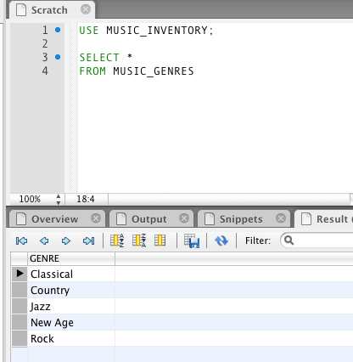

- Show all the information available on Recordings.

SELECT *
FROM ALBUM

- Show all the information available on Recording Artists.

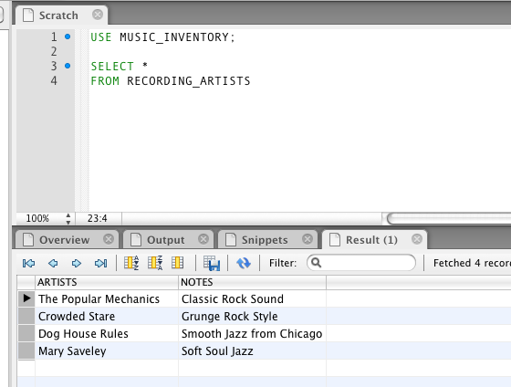

- For all Recording Artists, show the artist's name, recording title, recording format and the number of tracks available on the recording.

SELECT ARTIST, ALBUM_NAME, FORMAT_CD, FORMAT_CASSETTE, NUMBER_OF_TRACKS
FROM ALBUMS

ARTIST | ALBUM_NAME | FORMAT_CD | FORMAT_CASSETTE | NUMBER_OF_TRACKS
Crawdad Stare | Noise in the Garage | yes | no | 10
Crawdad State | Look Both Ways | no | yes | 12
Crawdad Stare | Outback | yes | no | 10
Doghouse Rules | Short Circuit | no | yes | 7
Mary Saveley | Meditations | yes | no | 6
The Popular Mechanics | Opus 65 | yes | no | 5
Crawdad Stare | Sounds Better Louder | yes | no | 10

- For all Music Categories, show the category and recording title.

SELECT M.GENRE, A.ALBUM_NAME
FROM MUSIC_GENRES AS M LEFT OUTER JOIN ALBUMS AS A
ON M.GENRE = A.GENRE

GENRE | ALBUM_NAME
Classical | Opus 65
Country | NULL
Jazz | Short Circuit
New Age | Meditations
Rock | Noise in the Garage
Rock | Look Both Ways
Rock | Outback
Rock | Sounds Better Louder

- For all Recordings, show the recording title, artist name, and music category.

SELECT ALBUM_NAME, ARTIST, GENRE
FROM ALBUMS

ALBUM_NAME | ARTIST | GENRE
Noise in the Garage | Crawdad Stare | Rock
Look Both Ways | Crawdad State | Rock
Outback | Crawdad Stare | Rock
Short Circuit | Doghouse Rules | Jazz
Meditations | Mary Saveley | New Age
Opus 65 | The Popular Mechanics | Classical
Sounds Better Louder | Crawdad Stare | Rock

- You have found that you are asking for the information in question 6 often as your collection grows. Create a view entitled: "my_collection" AND show all information available from the view.

CREATE VIEW MY_COLLECTION
SELECT ALBUM_NAME, ARTIST, GENRE
FROM ALBUMS

SELECT *
FROM MY_COLLECTION

ALBUM_NAME | ARTIST | GENRE
Noise in the Garage | Crawdad Stare | Rock
Look Both Ways | Crawdad State | Rock
Outback | Crawdad Stare | Rock
Short Circuit | Doghouse Rules | Jazz
Meditations | Mary Saveley | New Age
Opus 65 | The Popular Mechanics | Classical
Sounds Better Louder | Crawdad Stare | Rock

- Using your newly created view, show all the information from "my_collection" and the comments about the recordings.;

SELECT M.ALBUM_NAME, M.ARTIST, M.GENRE, A.NOTES
FROM MY_COLLECTION AS M LEFT OUTER JOIN ALBUMS AS A
ON M.ALBUM_NAME = A.ALBUM_NAME

ALBUM_NAME | ARTIST | GENRE | NOTES
Noise in the Garage | Crawdad Stare | Rock | 1st recording to break Top 10 by this artist
Look Both Ways | Crawdad State | Rock | 1st release by artist. Was underground before Noice in the Garage becaome popular
Outback | Crawdad Stare | Rock | NULL
Short Circuit | Doghouse Rules | Jazz | NULL
Meditations | Mary Saveley | New Age | NULL
Opus 65 | The Popular Mechanics | Classical | NULL
Sounds Better Louder | Crawdad Stare | Rock | NULL

- Using your newly created view, show all the information from "my_collection" and the comments about the recording artists.

SELECT M.ALBUM_NAME, M.ARTIST, M.GENRE, R.NOTES
FROM MY_COLLECTION AS M LEFT OUTER JOIN RECORDING_ARTISTS AS R
ON M.ARTIST = R.ARTISTS

ALBUM_NAME | ARTIST | GENRE | NOTES
Noise in the Garage | Crawdad Stare | Rock | Grunge Rock Style
Look Both Ways | Crawdad State | Rock | NULL
Outback | Crawdad Stare | Rock | Grunge Rock Style
Short Circuit | Doghouse Rules | Jazz | NULL
Meditations | Mary Saveley | New Age | Soft Soul Jazz
Opus 65 | The Popular Mechanics | Classical | Classic Rock Sound
Sounds Better Louder | Crawdad Stare | Rock | Grunge Rock Style

- Delete your database and all information

DELETE DATABASE MUSIC_INVENTORY

