**CIS 233: Grading Criteria – System Requirements Document**

**Team Name/Members: Amazing Analysts: Priya Niralay, Raphael Durias, Laurie Corniel and Jeremy Perry**

The following are the sections required for the System Requirements Document. Please attach a copy of this grading sheet to front of your deliverables.

|  |  |  |  |
| --- | --- | --- | --- |
| **Points Earned** | **Points**  **Possible** | **Criteria** | **Grading Notes** |
|  | 5 | **Organization**  Document is organized as specified in the assignment. It is well structured and has appropriate spacing. |  |
|  | 5 | **Spelling, Grammar, Etc.**  Document is free of spelling and grammatical errors. |  |
|  | 10 | **Cover Pages, Table of Contents, and Introduction**  Follows the guidelines specified in CIS Writing Criteria. |  |
|  | 10 | **Section 1 Management Summary**  Covers content specified in assignment. |  |
|  | 20 | **Section 2 Current Situation Analysis (AS-IS)**  Covers all content specified in assignment. |  |
|  | 20 | **Section 3: Overview of the proposed system (TO-BE)**  Covers all content specified in assignment. |  |
|  | 20 | **Section 4: Functional Requirements**  Covers all content specified in assignment. |  |
|  | 5 | **Section 5: Summary of Systems Analysis Phase**  Covers all content specified in assignment. |  |
|  | 15 | **Section 6: Alternatives**  Covers all content specified in assignment. |  |
|  | 15 | **Section 7: Recommendations**  Covers all content specified in assignment. |  |
|  | 10 | **Section 8: Time estimates**  Covers all content specified in assignment. |  |
|  | 5 | **Section 9: Conclusion**  Covers all content specified in assignment. |  |
|  | 10 | **Section 10: Appendices**  Covers all content specified in assignment. All appendices referenced. |  |
|  | **150** | **TOTAL**  **Comments:** | |

Edmonds Community College

Computer Information Systems Department

CIS 233

Fall 2010

**Research Project 2**

Bank of Xanadu - Bellevue Banking Center

Systems Requirement Document

Preliminary Draft

Prepared by the Amazing Analysts

Team members: Priya Niralay, Raphael Durias, Laurie Corniel and Jeremy Perry

December 3, 2010

DATE: 3 December 2010

TO: Patrick Jay, Vice President and Manager

FROM: The Amazing Analysts Team

SUBJECT: Systems Requirement Document

\_\_\_\_\_\_\_\_\_\_\_\_\_\_\_\_\_\_\_\_\_\_\_\_\_\_\_\_\_\_\_\_\_\_\_\_\_\_\_\_\_\_\_\_\_\_\_\_\_\_\_\_\_\_\_\_\_\_\_\_\_\_\_\_\_\_\_\_\_\_\_\_\_\_\_\_\_\_\_\_\_\_\_\_\_\_\_\_\_\_\_\_\_\_\_\_\_\_\_\_\_\_\_\_\_

We are pleased to inform you that we have completed our systems requirement document, which marks the culmination of the analysis phase of the Systems Development Life Cycle (SDLC). We trust that the report will serve as a valuable insight into the overall implementation effort. In order to facilitate any questions you and anybody else at the banking center may have, we would like to schedule a follow-on appointment with you. Please let us know what dates and times will work for you, and our staff will do our utmost to accommodate you.

**Systems Requirement Document**

Bank of Xanadu – Bellevue Banking Center

Prepared by the Amazing Analysts

Team members: Priya Niralay, Raphael Durias, Laurie Corniel and Jeremy Perry

December 3, 2010

Table of Contents

[Management Summary 9](#_Toc279152498)

[As-Is Model 11](#_Toc279152499)

[Current Information System 11](#_Toc279152500)

[Introduction 11](#_Toc279152501)

[Analysis Approach 11](#_Toc279152502)

[Problem 12](#_Toc279152503)

[People 12](#_Toc279152504)

[Current Processes 13](#_Toc279152505)

[Data/Information 14](#_Toc279152506)

[Technology 15](#_Toc279152507)

[Strengths of the Current System 15](#_Toc279152508)

[Problems with the Current System 15](#_Toc279152509)

[To-Be Model 16](#_Toc279152510)

[Overview of the Proposed System 16](#_Toc279152511)

[Proposed System 16](#_Toc279152512)

[Purpose and intention of the new system 16](#_Toc279152513)

[Scope of the proposed system 16](#_Toc279152514)

[Project Assumptions 18](#_Toc279152515)

[Objectives and Benefits 18](#_Toc279152516)

[Objectives 18](#_Toc279152517)

[Benefits 19](#_Toc279152518)

[Summary of Systems Analysis Phase 20](#_Toc279152519)

[Functional Requirements 21](#_Toc279152520)

[Introduction 21](#_Toc279152521)

[Analysis Approach 21](#_Toc279152522)

[Requirements Catalog 21](#_Toc279152523)

[Alternatives Analysis 22](#_Toc279152524)

[Software Alternatives 22](#_Toc279152525)

[Software Packages Researched 22](#_Toc279152526)

[Microsoft Dynamics GP for Project Accounting 22](#_Toc279152527)

[Primavera P6 Professional Project Management (Oracle) 23](#_Toc279152528)

[Peachtree Premium Accounting 23](#_Toc279152529)

[QuickBooks Premier Professional Services 24](#_Toc279152530)

[Tenrox Project Workforce Management 25](#_Toc279152531)

[Microsoft Access 26](#_Toc279152532)

[Customized Package 26](#_Toc279152533)

[MBA Software 26](#_Toc279152534)

[Build In-House Package 27](#_Toc279152535)

[Outsourcing 27](#_Toc279152536)

[AccountsNext 27](#_Toc279152537)

[Manual Alternatives 28](#_Toc279152538)

[Microsoft Excel has Expanded Capabilities 28](#_Toc279152539)

[Recommendations 29](#_Toc279152540)

[Time Estimates 32](#_Toc279152541)

[Conclusion 33](#_Toc279152542)

[APPENDIX 34](#_Toc279152543)

[Appendix A 35](#_Toc279152544)

[Systems Request 37](#_Toc279152545)

[Memo 38](#_Toc279152546)

[Appendix B 39](#_Toc279152547)

[Preliminary Investigation Report 40](#_Toc279152548)

[Introduction 41](#_Toc279152549)

[Systems Request Summary 41](#_Toc279152550)

[Background 43](#_Toc279152551)

[Preliminary Investigation Findings 44](#_Toc279152552)

[Problem Description 44](#_Toc279152553)

[Project Stakeholders 44](#_Toc279152554)

[Project Scope 45](#_Toc279152555)

[Current Procedures 45](#_Toc279152556)

[Current System Weaknesses/Strengths 45](#_Toc279152557)

[New System Requested Features 46](#_Toc279152558)

[Project Constraints 47](#_Toc279152559)

[Technological Resources 47](#_Toc279152560)

[Financial 47](#_Toc279152561)

[Geographical 47](#_Toc279152562)

[User Training 47](#_Toc279152563)

[Technical Feasibility 48](#_Toc279152564)

[Economic Feasibility 48](#_Toc279152565)

[Organizational Feasibility 49](#_Toc279152566)

[Expected Benefits 49](#_Toc279152567)

[Tangible Benefits 49](#_Toc279152568)

[Intangible Benefits 49](#_Toc279152569)

[Time and Cost Estimates 50](#_Toc279152570)

[Recommendation for Action 51](#_Toc279152571)

[Microsoft Dynamics GP for Project Accounting 51](#_Toc279152572)

[Primavera P6 Professional Project Management (Oracle) 52](#_Toc279152573)

[QuickBooks Premier Professional Services 53](#_Toc279152574)

[Tenrox Project Workforce Management 53](#_Toc279152575)

[Microsoft Access 54](#_Toc279152576)

[MS Excel 55](#_Toc279152577)

[Summary 55](#_Toc279152578)

[PIR APPENDIX 56](#_Toc279152579)

[Meeting Notes, Correspondence, and Source Documents 57](#_Toc279152580)

[Correspondences 62](#_Toc279152581)

[Information Systems Work Request 62](#_Toc279152582)

[Source Documents 64](#_Toc279152583)

[Assumptions 77](#_Toc279152584)

[Issues 77](#_Toc279152585)

[Appendix C 78](#_Toc279152586)

[Developer Documentation 78](#_Toc279152587)

[Data Flow Diagram (DFD): 79](#_Toc279152588)

[Functional Decomposition Diagram (FDD): 80](#_Toc279152589)

[Use Case Diagram: 81](#_Toc279152590)

[Use Cases 82](#_Toc279152591)

[Receive Contract 82](#_Toc279152592)

[Contract Exception 84](#_Toc279152593)

[Update Contract 86](#_Toc279152594)

[Receive Invoice 88](#_Toc279152595)

[Invoice Exception 90](#_Toc279152596)

[Update Invoice 91](#_Toc279152597)

[Pay Invoice 93](#_Toc279152598)

[Generate Accruals 94](#_Toc279152599)

[Requirements Catalog 95](#_Toc279152600)

[Information Requirements 98](#_Toc279152601)

# Management Summary

The Amazing Analysts is pleased to present to you the Systems Requirement Document (SRD). It is the culmination of the analysis phase of the System Development Life Cycle and it contains the findings of our research and investigation into your work request. Each step, from analyzing the current Excel workbook to our final recommended solution has been included.

We started off by analyzing the Excel workbook. Each worksheet was analyzed and comprehensive interviews on each user were performed. We also categorized how the current and replacement system with a Data Functional Diagram (DFD), which can be found in Appendix C on page 78. Our conclusion is that while Excel sufficed as a temporary and cost effective measure until a permanent system can be implemented, it will be inadequate for long-term needs. As such, we highly recommend its replacement.

Knowing that a new system is the way to go, our team proceeded to research the best possible system available to replace the Excel workbook. From the interviews conducted with the primary users, we determined that the new system should be as automated as possible. Other requirements, physical and otherwise, were determined as well. The result would be less labor hours being used to handle the contractual payments, allowing such labor to be redirected to more critical banking operations. A use case diagram and use case scenarios, which demonstrate the interactions between the system and the primary users, were created and can be found in Appendix C on page 81.

A comprehensive list of alternative programs to Excel has been created. It includes but isn’t limited to Microsoft Dynamics GP, Oracle, Peachtree, QuickBooks, Tenrox, QuickBooks, Microsoft Access and SQL. After carefully analyzing each alternative, we determined that the use of Microsoft Access would best suit the Bellevue Banking Center’s needs. It is a robust database system that meets or exceeds all of the Bellevue Banking Center’s needs, and is already pre-installed on the banking center’s computers as part of the Microsoft Office software suite. All of this combined with our team’s expert knowledge of implementing an Access database makes it the most cost effective solution available to the banking center. In addition, it will make meeting the implementation deadlines very realistic and can be later scaled to enterprise level when combined with SQL server.

The body of the SRD contains all of our research and findings, along with a detailed appendix section with supplemental information. The implementation of a new system is in the best interest of the Bellevue Banking Center as it will result in reduced labor time spent on managing IT expenses, thus increasing profitability. Based on the findings of this report, we are ready to proceed to the System Design Phase and await your authorization to do so.

# As-Is Model

## Current Information System

### Introduction

This section will offer an in-depth explanation of the current information system that Bank of Xanadu’s Bellevue Banking Center currently uses to track their IT contractual expenses. It will provide valuable insight into how the banking center currently tracks these expenses and its associated processes. The strengths and weaknesses will be discussed, as well as a way of using some of the approaches undertaken by the current system that can be incorporated into the new one.

### Analysis Approach

As a method of figuring out the processes of how the contractual information works, our team took the time to ask thorough questions to the system’s current users and carefully examine the system itself. The method we used was to organize the system into a Data Flow Diagram (DFD). A DFD is a relatively simple chart that demonstrates how the processes and activities that are associated with the system. A DFD can be used to document the date flow of just about any system, be it automated or not or not.

A DFD model was developed for the process of assisting us how data flowed between the system and the external entities (users, processes, etc. associated with the system) along with all of the conceivable processes that each user would require of the system. Because the concept of the payment system does not vary in basic function from the current to the conceptualized system, a DFD was developed that will properly suit both. Page 29 in the appendix lists the model used.

### Problem

As mentioned in the Preliminary Investigation Report (available in the appendix), the problem with the current system, which is a Microsoft Excel workbook, originally stemmed from the bank’s decision to outsource their IT functions as a method of reducing costs. The banking center set up the Excel workbook as a temporary means of keeping track of the contractor expenses. While Excel is an extremely useful program that has an untold number of uses, it was never designed to have the database capabilities that more modern programs, such as Oracle and Microsoft Access, have. Excel is inefficient in handling large amounts of data and is more time consuming, which results in labor being unnecessarily wasted.

### People

There are a number of people who would be considered a stakeholder in the use of the current system:

1. **Accounting Group Assistant Manager:** The primary user of the Excel workbook. Lack of a more efficient system significantly increases his/her overall workload.
2. **Accounting Group Manager and Vice President**: Initiated the work systems request because of the inefficiencies of Excel.
3. **The Contract Group**: Deals with the system indirectly when they award a new contract, as well as when a contract and invoice are given to them for exception handling. It should be noted that error rate of the spreadsheet increases how much exception handling has to be done.
4. **The Senior Vice President and other senior management:** The banking center’s senior management all receive reports on the IT monthly expenditures, which is based on the information stored in the workbook.
5. **Vendors:** The vendors themselves and their companies are indirectly affected by the current system each time they submit an invoice. An exception that occurs because of errors in the workbook can delay payment for services rendered.
6. **Accounts Payable:** Deals with the system indirectly when the accounting group instructs them to issue payment to the vendors.

### Current Processes

The banking center uses the following processes to keep track of the contracts and invoices.

**For recording new contracts:**

1. The contract group submits the new contract to accounting group’s assistant manager for approval.
2. The assistant manager approves the contract.
3. Either Mr. Spencer or another accounting representative inputs the new contract information into the Excel workbook.

**For recording and paying invoices:**

1. The vendor submits their invoice to the accounting department.
2. A member of the accounting group compares the invoice to the data in the workbook to verify if the invoice is payable.
3. If the invoice is payable against the contract, the spreadsheet is updated to reflect the invoice. For invoices that require exception handling, see section on handling invoice/contract exceptions.
4. The accounts payable department is notified to issue the check to the contractor.

**For handling invoice/contract exceptions:**

1. The workbook is first checked for possible errors. If an exception is the result of just a workbook error, the regular invoice processing resumes.
2. If any invoice is not payable against a contract because of an actual irregularity, the invoice and the related contract are sent to the contract department for exception handling.
3. The contract department fixes the irregularity, working with the accounting group and/or vendor as necessary to resolve the problem.
4. If only the invoice has to be fixed, the invoice and contract are returned to the accounting department for the rest of the regular invoice processing.
5. If the contract had to be amended or a new contract had to be drawn up to make the invoice payable, the contract and invoice would be forwarded to the accounting group’s assistant manager for approval.
6. The contract resumes the rest of the regular invoice processing.

**For Reports:**

The workbook has the information necessary for the accounting department to prepare regular and requested reports to the accounting group’s manager and other senior management concerning the contract expenses. Much of the process is manual and requires a considerable amount of manpower to accomplish.

### Data/Information

The workbook is divided into 11 different worksheets. The first 8 sheets are for vendor information, project manager contact information, charge information, contract and programmer information, problem invoices, maximum fees per contract, invoices, and accruals. The remaining sheets serve as templates for the following kind of reports: expense recaps, contract programmer fee maximum vs. accruals, and monthly contract recap.

The inputs required by each sheet in the workbook vary, but each require a degree of attention to detail in order to ensure they store the correct information. The workbook does have the capability of generating reports, but they require manual input by the user. For a more detailed explanation, please refer to the requirements catalog on page 16.

### Technology

**Computer hardware** – The spreadsheet is stored on the bank’s Windows-based server, which is accessible by the members of the accounting department on their work desktops. The work desktops are IBM compatible computers and run the Business Edition of Windows XP.

**Computer software** – The current software is Microsoft Excel 2007, part of the Microsoft Office suite.

## Strengths of the Current System

The main strength of using Excel is that it is low-cost and easy program to set up for database use until a permanent database system can be implemented. Excel does have the ability to store large amounts of data, as well as be able to perform complex calculations on such.

## Problems with the Current System

The weaknesses are severe; it is cumbersome to manage all the worksheets, not to mention there is no way to effectively and efficiently input and verify the accuracy of the data. As a result, a significant amount of time is wasted on this process and there is a relatively high chance of human error in the data. There are no significant strengths in this current system, other than the fact that it serves as a temporary measure to allow the accounting department to get the job done.

# To-Be Model

# Overview of the Proposed System

## Proposed System

The proposed solution is an automated system, which must be able to accurately provide key information about the various terms and conditions of a contract and make it available to the accountant. The accountant as a result will be able to arrange payment for the invoice without any errors while being time efficient. The system will also provide accurate automated reporting of the contracts and payment reports that need to be sent to the accounting and management teams.

### Purpose and intention of the new system

The system is intended to minimize the manual effort required to process invoices and reduce the current high error rate in invoice, monthly reporting and money allocation for payables. The automation will reduce the amount of data entry done by the accountant and create fixed fields, which will reduce duplication of information on various spreadsheets. The system would also automatically calculate various metrics for the reports that have to be submitted to the accounting and management teams at the end of the month.

### Scope of the proposed system

The scope of this project will include data and information about the Business Unit, Contract, Project, Invoice, Vendor, Programmer and Project Manager.

**Product Scope Description** – The product will be a stand-alone system that will be deployed on a database server that is scalable and currently able to handle the growing transactional records of contract employees for the next 4 years. Any authorized user who’s using the banking system’s computer network can access the front end.

**Product Acceptance Criteria** – All the requirements as described in the Appendix must be met in order for the system to be accepted and deployed live for use. User training and documentation will be also be provided for.

**Project Exclusions** – The contract and invoice processing system will be only designed to cater to the IT personnel, whom are either direct contract or via a vendor and does not include any permanent or direct employees of the bank. The system will not be currently integrated with the existing ERP/human resource payroll systems of the bank. The system is only being tested and will go in production at the banking center.

**Project Constraints** – The total cost of the project over the next 4 years is estimated to be $38, 500. This cost includes the breakdown of equipment, software, manpower, consultancy and maintenance services as detailed out in the Preliminary Investigation report (Appendix)

* Design and Implementation phase of the project is expected to begin from January 2011 and be complete by April 2011.
* The design team from Amazing analysts will continue to interview the primary users of the system as needed to get the User Acceptance tests during the testing phase.
* The system design and architecture will be developed offsite at the development studio of The Amazing Analysts.
* The final implementation of the system is expected to be complete by March 14 2011 and it will be onsite.
* Post implementation and maintenance services will be provided after this period (March 14, 2011) for one month.
* The system will get deployed and go live into production from April 2010.

### **Project Assumptions**

* The programmers/contractors will continue to send the invoices in hard copy to the accounting department.
* Each programmer has only one contract at any given point of time.
* Each contract has only one programmer as the listed provider.
* Accounts Payable will continue to get a payment request sheet from the accountant.
* Accounts Payable will notify the Accountant when a check for an invoice has been mailed with check and mailing date details.

## Objectives and Benefits

### Objectives

* The system objectively will reduce the errors that result from manual entry of all contract and invoice records.
* The system will automatically check for dates and figures of invoices and ensure they comply with the contract terms.
* The system will automate the monthly reporting activities.
* The system will notify the accountant of exceptions or missing information in a record and prevent incorrect entry.
* The system will automatically generate the data entry sheet to be sent to accounts payables.

### Benefits

**Tangible Benefits**

* Reduction in Accounting costs.
* Reduction in reporting costs
* Rework accountant costs
* Reduced errors in data entry
* Reduced errors in budgetary accounting calculations
* Faster processing of invoices
* Reduced manual reports
* Accuracy of data and reports.
* Increased departmental efficiency and time management
* Increased contractor satisfaction due to speedier invoice turnaround time.
* Increased employee/accountant satisfaction.

**Intangible Benefits**

* Goodwill within the organization and customers.

# Summary of Systems Analysis Phase

Based on the analysis, the current system is *manual and slow*. Though it is *low cost*, the disadvantages far outweigh the advantages. If Xanadu implements a new contract payment system, they can lighten the load on their accountants and increase productivity by a large amount. The requirements of the as-is and to-be system are essentially the same; however, most, if not all, of the processes are automated in the to-be system.

# Functional Requirements

## Introduction

A functional requirement is one that states what the system must do or what characteristics it needs to have. This is different from a nonfunctional requirement, which is a type of requirement that refer to behavioral properties – the way a system must specifically do something, or the way it should look like. The following section covers the functional requirements of the contractual payment system.

## Analysis Approach

A use case scenario is a detailed form that shows what happens after certain things are done in sequence. A use case diagram shows the “big picture;” a depiction of the entire system and all the use case scenarios are shown. These things allow of the discovery of the logical system requirements from the users’ point of view by giving us a huge external visualization of the entire system’s flow of events, which also makes it easier to see possible errors and flaws that, otherwise, would not be encountered until the design and implementation. The proposed system use cases can be found in Appendix C on page 81.

## Requirements Catalog

The information requirements, found in Appendix C on page 95, goes in-depth with the major processes of each use case, detailing what each must be able to do. The requirements catalog can be found in Appendix C on page 98.

# Alternatives Analysis

## Software Alternatives

### Software Packages Researched

The following six brands of automated software packages meet or exceed the minimum requirements of the Windows XP Operating System at the Bellevue Banking Center. The selections were based on the requirements pulled from the Excel Spreadsheet example (a sample contract programmer invoice, and data entry sheet). The six potential software packages are Dynamics GP for Project Accounting, Primavera P6 Professional Project Management (Oracle), Peachtree, QuickBooks Premier Professional Services, Microsoft Tenrox Project Workforce Management, and Microsoft Access.

### Microsoft Dynamics GP for Project Accounting

  Helps maintain an efficient system for Project Accounting; it ultimately connects the project activities within financials, provides extensive reporting capabilities, helps ensure accurate accounting and billing processes throughout project life cycles, and streamlines your time and expense management.

Microsoft Dynamics GP will maintain tight control over strategic direction, support resources effectively, and ensure that projects are complete on time and within budget.

There are two key features: Project Time & Expense for Business Portal, and Personal Data Keeper (PDK). The Project Time & Expense for Business Portal helps create customer invoices and reimburse employees faster and more accurately by managing project details via a central Web-based location. Personal Data Keeper (PDK) makes it possible to submit time and expenses when it is convenient for you, whether online or offline. **Strong integration with Microsoft Office, SharePoint, and SQL and is great for economical for mid-size companies.**

The total cost of an ERP system includes the [software, hardware, and services](http://www.computeration.com/pricing-and-promotions/) that meet your needs and expectations. Microsoft Dynamics GP License Cost Per User: $2,250.  
Each additional user from 1-10 is $2,250 per user.

System requirements**:** Windows 7; Windows Server 2003; Windows Server 2008; Windows Small Business Server 2003; Windows Small Business Server 2008 Premium; Windows Small Business Server 2008 Standard; Windows Vista: and Windows XP.

### Primavera P6 Professional Project Management (Oracle)

Primavera P6 Professional Project Management is a powerful, yet easy-to-use solution for planning, managing, and executing projects and programs. Primavera P6 gives control. It is designed to handle large-scale, highly sophisticated, and multifaceted projects. It can be used to organize up to 100,000 activities.

There are multitudes of ways to organize, filter, and sort activities, projects, and resources. Some of the benefits are planning, scheduling, and controlling projects, assigning tasks and tracking progress, evaluating risks, identifying issues, and determining their impact on projects. It costs $2,500.00 per application user and the cost of first year support is $550.00.

System requirements**:** Microsoft Windows (32-bit): Windows XP Professional sp3, Windows Vista sp2, Windows 7 and Microsoft Windows x64 (64-bit): Windows XP Professional sp3, Windows Vista sp2, Windows 7

### Peachtree Premium Accounting

Peachtree has a daily/weekly time tracking system for contract employees with job costing summaries and can generate pre-formatted reports. Some adaptation of report formats is possible. There is a job management module for monitoring project status. The program also has cash and accrual capabilities. Peachtree also offers real-time error alerts for more accurate data entry.

It can compare budgets and financial results across multiple years over its general ledger reports and financial statements. Time is saved with simplified navigation and dashboards, multi-tasking screens, integration with Microsoft Excel, and comparative budgeting. The Internal Accounting Review helps you track errors and deter fraud. Cost of QuickBooks Premier Professional Services is $ $424.99 per User or $1,019.99 for **5 Users.**

System requirements**:** 1 GHz Intel Pentium III (or equivalent) for single user and 1.8 GHz Intel Pentium 4 (or equivalent) for multiple users, 512 MB of RAM for single user and 1 GB for multiple users

### QuickBooks Premier Professional Services

QuickBooks Premier Professional Services is business financial management software, tailored for the specific industry to help make businesses more profitable. Get all the features of QuickBooks Pro and know exactly where your business stands, plus efficiently track and manage your unique business, grow with easy-to-use business planning tools, and automatically forecast future sales and expenses.

Some of the benefits of QuickBooks Premier are that it tracks balance sheets by class, track time and expenses by employee, project, client, etc., as well as transfer unbilled time and expenses to customized invoices. It can set different billing rates by employee, client, and service, analyze profitability by project with project costing reports, (like billed vs. proposal by project), cost-to-complete by job, and job costs by job.

QuickBooks Premier also imports data from Excel, Quicken, Microsoft Office Accounting, & prior QuickBooks versions. It also intergrades with Word and synchronizes with Outlook. Cost of QuickBooks Premier Professional Services is $399.95 per User and Intuit QuickBooks Care Protection Plan with Intuit Data Protect Service is 24.99 a month.

System requirements**:** QuickBooks Pro uses 1 GB of disk space plus data storage. Windows Vista, Window 7, and Windows XP either (32 or 64bit).

### Tenrox Project Workforce Management

With Tenrox online project management software, companies can replace the spreadsheets and band-aid applications that leave project-driven workforces and processes disconnected. Everything you need to empower your project workforce is connected for the first time, in real time, including: project management, [project planning](http://www.tenrox.com/en/solutions/project_planning.htm), [resource management & scheduling](http://www.tenrox.com/en/solutions/workforce_planning.htm), [time and expense tracking](http://www.tenrox.com/en/solutions/time_expense.htm), [cost accounting and/or billing solutions](http://www.tenrox.com/en/solutions/cost_revenue.htm), [process management tools](http://www.tenrox.com/en/solutions/project_process_management.htm), [analytic tools](http://www.tenrox.com/en/solutions/analytics.htm).

Tenrox works with all major financial applications and tools such as Sage ACCPAC, ADP, Ceridian, Paychex, QuickBooks, Microsoft Dynamics (including Great Plains, Navision, & Solomon), PeopleSoft, Oracle, SAP, and more, as well as to CRM applications such as salesforce.com and Microsoft CRM.

Features include an intuitive project-planning tool that is easy to use; project plans are interchangeable with Microsoft Project files, including Excel and outstanding time tracking, cost accounting and billing capabilities.

Tenrox Global is an on-demand project management software provides timesheet management, budget management, and estimate to complete, cost and schedule variance, global project management, project controls, cost accounting, charge back, software capitalization (sop 98) and billing, accounting and payroll integration, and project health and dashboards.

The pricing starts at $120 per user, per module, per year.

System requirements**:** Windows Installer 3.0 version+; MDAC 2.8 +; Microsoft Visual C++ 2005, 2008; Microsoft .NET Framework Version 3.5 +; Microsoft SQL 2008 System CLR Types x86, Native Client x86 or Management Objects x86.

The Tenrox application supports SQL Server 2005 with at least SP1 and SQL Server 2008. It is compatible with these operating systems: Microsoft Windows Server 2003 32-bit version for the Application Server; Microsoft Windows Server 2003 32 bit and 64-bit versions for the Database Server; Microsoft Windows Server 2008. Also compatible with these web browsers: Internet Explorer 6.0 SP2, 7.0; Mozilla Firefox 2.0 + Safari V3.2.1

### Microsoft Access

In reviewing the compatibility issues, it was noted that Access is available in the MS Office Suite that the banking center presently uses. By using MS Access, it would help in consolidating scattered functionality and utilizing the full flexibility of an existing product and by placing an Access database on a network multiple users could share and update data. With the SQL Server, the amount of data and users can expand to enterprise-level solutions. MS Access is simple enough for end users and will save time and money.

## Customized Package

### MBA Software

MBA has been providing accounting, distribution, and payroll solutions to growing and mid-sized companies. MBA has a complete line of accounting products designed for use in all types of businesses. Examples include but are not limited to printing, banking, retail, government, schools, and accounting and consulting firms.

The modules include system manager, general ledger, accounts receivable, accounts payable, payroll, and check reconciliation. These modules can stand-alone or operate as a completely integrated system. The software can be run on a single computer or in a networked environment. It is designed entirely from customer input, meaning it completely conforms to the needs of users.

MBA custom accounting software for small business, known as Series 3, helps make the financial process simple by tracking all facets of your business and automating complex tasks. Series 3 handles business essentials like accounting, distribution, and payroll. It also handles a variety of other advanced accounting tasks.

Series 3 is powerful business management software that provides growing and midsize companies with a completely scalable solution that adds financial and operational functionality. MBA customers enjoy features like robust business intelligence, extensive reporting, advanced consolidation, forecasting, budgeting, etc. at a price point that has competitors scratching their heads. MBA has unrivaled commitment to customer service, affordability, and scalability.

## Build In-House Package

A custom tailored, vertical package for tracking contractor expenses offers the most fully automated and directly applicable solution. Our analysts can design and install software that meets automation goals and is compatible with existing hardware. Completion targets would move out to early December for this option.

## Outsourcing

### AccountsNext

AccountsNext can take care of your expense needs, providing with immediate cost reductions of up to 40-50% and minimizing risk of penalties and saves a lot of time, which will allow the Bellevue Banking Center to focus on its core business more efficiently.

AccountsNext will take on the tedious work such as keeping track of invoices, deadlines, reports, and prepare 1099 forms as necessary.

AccountsNext helps with repetitive activities, will deliver cost savings from hiring, training, and managing the in house staff. Cost of service: no sign up fee. Cost is per hour or per transaction. Monthly minimum is $190.

## Manual Alternatives

### Microsoft Excel has Expanded Capabilities

The existing software, Excel, can be utilized more fully. An option is to train or educate the user in Excel’s capabilities for contractor expense tracking.

Data can be entered once by linking worksheets and placing cell references to the summary pages for reports. Advanced filters can limit the data entry to a specified format minimizing errors. Multiple worksheets or even dependent workbooks can be automatically updated whenever the source workbook is edited. Pivot tables can alter information layout and grouping for management in multiple formats. There are also multiple pre-formatted graphs and reports.

# Recommendations

No pre-designed system exactly meets the needs of contractor invoice tracking. They all offer more bells and whistles than the banking center presently needs for the case at hand. There will be need for adaptation and training. Some of the software packages may take up more hard drive space than others. Oracle, Tenrox, and MBA Software willcustomize software for the banking center. They all allow multiple, concurrent users and can scale up to a considerably higher volume of contractors than Bellevue office presently needs.

QuickBooks and Peachtree cost under $500, represent brand new software for the users, and a steep learning curve. Some adaptation will be required to meet present needs and some excess in capabilities exists in each package.

Microsoft Dynamics GP is a package software system that is featured financial accounting and business management solution. It is similar to Primavera P6 Professional Project Management. It is powerful software to operate and grow your business. It does take a use of massive hard drive and is comparatively expensive.

Primavera P6 Professional Project Management will customize software for us. However, it is a complete set of business applications that exceed present requirements. It is designed for large-scale, highly sophisticated, and multifaceted projects. That aspect along with a high learning curve and considerable use of hard drive space would make this option comparatively expensive.

Peachtree Premium Accounting offers a complete financial system; the software would take up more hard drive space than it is worth to us. This alternative comes with a learning curve for users. This is a potential package that can be considered for future use if expanding is needed.

QuickBooks Premier Professional Services is similar to Peachtree; it offers a broad financial solution but none of its components exactly fit the contractor payment tracking needs.

Tenrox is highly compatible with Excel for data migration and with SQL server in case of future expansion to additional databases. If an externally customized application were chosen, Tenrox would be the most cost effective choice. However, there is the ever-present learning curve and chronically under-utilized capabilities of the system. This package too would have a high learning curve and use considerable drive space, and would be comparatively expensive.

Outsourcing the job to AccountsNext for expense tracking and keeping track of invoices is an option. Unfortunately, the banking center’s accounting department would still be doing most of the documentation and invoice processing to prepare data for this service. AccountsNext would mainly take care of the accounts payable group’s job, as well as report production. This would not take care of the time-consuming manual system of invoice documentation

Building an in-house package would give the most customized solution to present needs. It would be scalable, automated, and designed specifically to meet the banking center’s expense tracking needs.

Microsoft Excel would be the simplest solution, in which there would be minimal training and the least expensive from all the software packages that was already mention.

However, this is not as automated as the bank center wants and the security is limited on Excel; data can be easily erased or mis-entered, as was mentioned during the interview. If the system would be scaled to a bank-wide operation, sharing would be challenging and data would be loss or the format would be changed if not careful

The simplest fully automated solution would be to utilize the existing Access program. It would also consolidate some scattered functionality and utilize the full flexibility of an existing product. Simple tasks can be automated through macros. Access is designed to scale up for support of more data and users by linking to multiple Access databases or using a back-end database like Microsoft SQL Server. With the SQL Server, the amount of data and users can expand to enterprise-level solutions.

Access Database software is already installed on the banking center’s computers. If future expansion were needed, the cost to add additional licenses would be minimal in comparison to buying new software. Migration from the historical Excel data would be easy and automated. Privileges could be limited as needed while concurrent accessibility is maintained. Microsoft Access is simple enough for end users to create their own queries, forms, and reports, eliminating the need for professional developers. There would be no wasted hard drive space and User education would be simple and straightforward.

# Time Estimates

The following shows the estimated time it will take to finish the remaining two phases: the design phase and the implementation phase. This is a Gantt chart; the left side gives a text outline of the tasks to be done, when they start and finish, and what the prerequisites for each task are; the right side shows a visual depiction of the length of time each task will take. The lines that connect tasks shows their relationship to each other, as some tasks need to be finished before a certain one can be started.

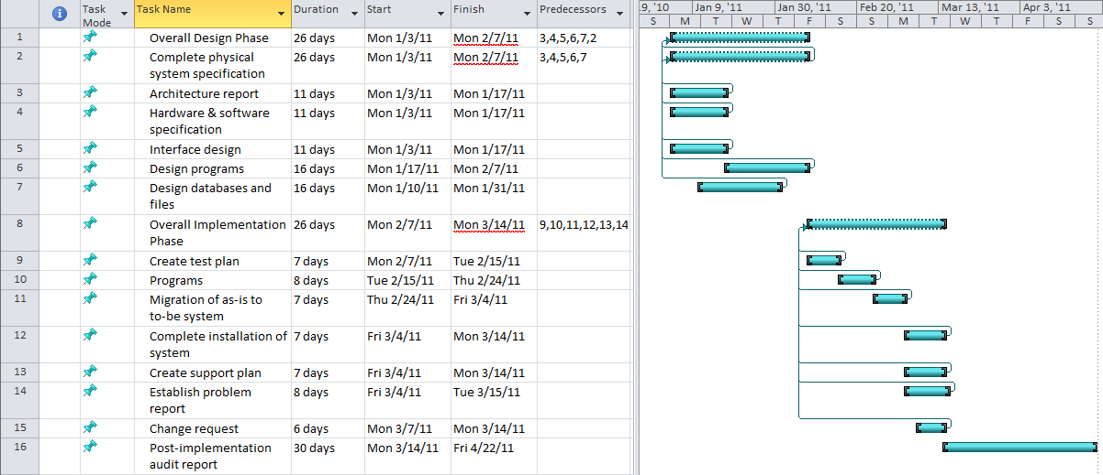Conclusion

We would like to take this time to reemphasize the need for the Excel workbook to be replaced. All of our research points to this. A new system will be of instant value to the company as it will greatly reduce the labor time spent on managing IT expenses. From the findings in research in our report, we came to the conclusion that Microsoft Access will fit the needs of the Bellevue Banking Center best, as it will provide the most cost effective solution. Access does have the capability to be coupled with SQL server to support enterprise-level operations.

Unless a new system is implemented, the banking center’s account group will continue to be constrained by the time consuming process of managing the IT expenses via the Excel workbook. The negative effects of doing so will be felt throughout the entire banking center’s operations. Therefore, we will be looking forward to your approval of this Systems Requirement Document and the authorization to proceed with further development of your new system. We find it very realistic that the new Access-based system will be fully operational within the proposed deadlines.

# APPENDIX

# Appendix A

Contents

[APPENDIX 34](#_Toc279152647)

[Appendix A 35](#_Toc279152648)

[Systems Request 38](#_Toc279152649)

[Memo 39](#_Toc279152650)

[Appendix B 40](#_Toc279152651)

[Preliminary Investigation Report 41](#_Toc279152652)

[Introduction 42](#_Toc279152653)

[Systems Request Summary 42](#_Toc279152654)

[Background 44](#_Toc279152655)

[Preliminary Investigation Findings 45](#_Toc279152656)

[Problem Description 45](#_Toc279152657)

[Project Stakeholders 45](#_Toc279152658)

[Project Scope 46](#_Toc279152659)

[Current Procedures 46](#_Toc279152660)

[Current System Weaknesses/Strengths 46](#_Toc279152661)

[New System Requested Features 47](#_Toc279152662)

[Project Constraints 48](#_Toc279152663)

[Technological Resources 48](#_Toc279152664)

[Financial 48](#_Toc279152665)

[Geographical 48](#_Toc279152666)

[User Training 48](#_Toc279152667)

[Technical Feasibility 49](#_Toc279152668)

[Economic Feasibility 49](#_Toc279152669)

[Organizational Feasibility 50](#_Toc279152670)

[Expected Benefits 50](#_Toc279152671)

[Tangible Benefits 50](#_Toc279152672)

[Intangible Benefits 50](#_Toc279152673)

[Time and Cost Estimates 51](#_Toc279152674)

[Recommendation for Action 52](#_Toc279152675)

[Microsoft Dynamics GP for Project Accounting 52](#_Toc279152676)

[Primavera P6 Professional Project Management (Oracle) 53](#_Toc279152677)

[QuickBooks Premier Professional Services 54](#_Toc279152678)

[Tenrox Project Workforce Management 54](#_Toc279152679)

[Microsoft Access 55](#_Toc279152680)

[MS Excel 56](#_Toc279152681)

[Summary 56](#_Toc279152682)

[PIR APPENDIX 57](#_Toc279152683)

[Meeting Notes, Correspondence, and Source Documents 58](#_Toc279152684)

[Correspondences 63](#_Toc279152685)

[Information Systems Work Request 63](#_Toc279152686)

[Source Documents 65](#_Toc279152687)

[Assumptions 78](#_Toc279152688)

[Issues 78](#_Toc279152689)

[Appendix C 79](#_Toc279152690)

[Developer Documentation 79](#_Toc279152691)

[Data Flow Diagram (DFD): 80](#_Toc279152692)

[Functional Decomposition Diagram (FDD): 81](#_Toc279152693)

[Use Case Diagram: 82](#_Toc279152694)

[Use Cases 83](#_Toc279152695)

[Receive Contract 83](#_Toc279152696)

[Contract Exception 85](#_Toc279152697)

[Update Contract 87](#_Toc279152698)

[Receive Invoice 89](#_Toc279152699)

[Invoice Exception 91](#_Toc279152700)

[Update Invoice 92](#_Toc279152701)

[Pay Invoice 94](#_Toc279152702)

[Generate Accruals 95](#_Toc279152703)

[Requirements Catalog 96](#_Toc279152704)

[Information Requirements 99](#_Toc279152705)

## Systems Request

bd19819_

**Bank of Xanadu**

*Corporate Headquarters***: George Town, Cayman Islands**

*Major Banking Centers:* **Amsterdam • Aspen • Beijing •Bellevue • Berlin • Beverly Hills • Canberra • Cape Town • Dallas • Denver • Hong Kong • Kuala Lumpur • Las Vegas • London • Mumbai • Newport • New York • Nice • Ottawa • Palm Beach • Pine Valley • Santiago • Savannah • Sao Paulo • Scottsdale • Singapore • Tokyo • Wellington**

**Information Systems Work Request**

**Date 1/25/08 Department Accounting**

**Contact Patrick Jay Location Bellevue, WA**

**Title Vice President, & Manager Email pjammer@box.bank**

**Project Description (in brief):**

**The strategic direction and growth of the bank has put new emphasis on streamlining our internal procedures. Xanadu Bank is in the business of banking, and to remain profitable and competitive, we have shifted our focus to concentrate on our core competencies, outsourcing any functions and processes that are not part of these core business operations. Since we began this process late last year, we have redeployed all in-house programming positions, resulting in the need to use outside contractors to provide the necessary programming services. This move will save our company over one 1 million dollars annually in employee administrative and benefit costs.**

**The major problem we face now is finding a suitable way to track these new programming expenses to the scope of service stipulated in their official contracts. While the accounting department has hastily thrown together a stop-gap solution using an Excel workbook, it is taking an incredibly large amount of time to manually enter all the contractual information, receive and process the incoming programming invoices, prepare accurate accruals, determine whether the invoice falls within the time limitations, and calculating whether enough funding is left on the contract to pay the invoice. In recent strategic planning sessions, the senior management has determined that a new, more automated process for managing contractual payables is needed. The objective of this project is to investigate and recommend a solution to control payments in accordance to contractual time and fee limitations throughout the company.**

**Submitted by: \_\_\_\_\_\_\_\_\_\_\_\_\_\_\_\_\_\_\_\_\_\_\_\_\_\_\_\_ Date \_\_\_\_\_\_\_\_\_\_\_\_\_\_\_\_\_\_\_\_\_**

**Approved by: \_\_\_\_\_\_\_\_\_\_\_\_\_\_\_\_\_\_\_\_\_\_\_\_\_\_\_\_\_ Date \_\_\_\_\_\_\_\_\_\_\_\_\_\_\_\_\_\_\_\_\_**

## Memo

Date: October 14, 2010

To: Patrick Jay, Vice President & Manager

From: Raphael Durias

Subject: First Project Meeting for New Contractual Payment System

I’d like to express my thanks to you for taking the time to meet with my team last week and discuss the details regarding the information systems work request you initiated almost three years ago. Just as a quick refresher, we interviewed you about the information systems work request that involves creating a new, more automated process for managing contractual payables due to the company’s current system (Excel can only do so much!). Thanks to your input, we now have a grasp of the three most important things this new system must meet: First, invoices must fall within the time limitations; second, the system must be able to calculate if there’s enough funding left on the contract to pay the invoice; and finally, it must be able to verify that the rate of the invoice matches the rate on the contract.

Obviously, this interview is only the tip of the iceberg. Our team will approach this project using a system prototyping-based SDLC. This will allow us to create prototypes based on input from the system’s target users, and then refine it until it suits the company’s needs. Expandability and scalability will be kept in mind while planning this system. You can expect the first prototype to be completed and ready to use by December 3rd, 2010.

Finally, I’d like to have a follow-up meeting with you this coming October 22nd concerning the implementation of the system later on. Thank you for all your help, your input’s incredibly helpful to us.

Best regards,

Raphael Durias

*The Amazing Analysts*

# Appendix B

# Preliminary Investigation Report

Bank of Xanadu – Bellevue Banking Center

Prepared by the Amazing Analysts

Team members: Priya Niralay, Raphael Durias, Laurie Corniel and Jeremy Perry

October 22, 2010

Edmonds Community College

Computer Information Systems Department

CIS 233

Fall 2010

## Introduction

The Amazing Analysts received an Information Systems Work Request on or about Friday, October 8, 2010 from Patrick Jay, Vice President and Accounting Manager at Bank of Xanadu’s Bellevue Banking Center. The request was for the design and implementation of a software and database program that will allow Mr. Jay’s accounting group to automatically track invoices and payments for services rendered by the banking center’s IT contractors. The new system will supersede the banking center’s current method of tracking their IT expenses via a Microsoft Excel spreadsheet.

This preliminary investigation report comprises the findings and recommendations of the Amazing Analysts. It represents a combined effort by team members Priya Niralay, Raphael Durias, Laurie Corniel and Jeremy Perry. The completion date of this report is Friday, October 22, 2010.

## Systems Request Summary

The IS system Proposal submitted by Mr. Jay is an indirect result of the Bank of Xanadu’s decision to contract out their IT services. When the Bellevue Banking Center had its in-house IT staff, these employees were considered full time members of the banking center and their wages were paid by the center’s employee payroll system. In response to the bank’s decision to contract out these services, the accounting department implemented an Excel spreadsheet as a temporary means of tracking the center’s IT expenses.

Excel had its advantages as it was easy and cost effective to set up while a permanent solution would be implemented later. However, the spreadsheet was only meant to be a temporary solution as it has many disadvantages for expense tracking. The most notable disadvantage is the process is time consuming. Mr. Jay estimates that the accounting department spends up to a half hour processing each IT invoice. With numerous invoices to process each month, the system consumes a lot of working hours that can be redirected elsewhere. Dave Spencer, who is Mr. Jay’s principal assistant and oversees the day to day operations of tracking the IT expenses, further elaborated on the shortcomings of the Excel spreadsheet, an example being the spreadsheet lacking formatting standards and the high potential of the contract not being paid because of irregularities.

Mr. Jay has requested that the new system be automated as a way of reducing the labor time spent processing and tracking the IT expenses. Both Mr. Jay and Mr. Spencer have identified further features that they would like to see implemented into the system, which include but aren’t limited to the need to calculate fields, keep track of contractors who would require a 1099 tax form, keeping track of programmers, balancing the contractor rates against the balance on the contract, etc.

While we must ensure the systems meets or exceeds the accounting group’s requirements, Mr. Jay has afforded our group a considerable amount of leeway in designing and implementing this system. An example of which is giving us the ability to determine whether a commercial or custom software system will be suitable and if this system should be stored on individual computers of the banking center’s server.

## Background

Xanadu Bank, originally based out of Bellevue, WA, began operations in 1978 by three banking entrepreneurs. The bank was founded on the concepts of putting the customer first no matter what, a system of solid banking practices, and a company slogan of “No Boundaries”. Over the next 32 years, the bank grew from having a small presence in the Seattle metropolitan area to becoming a worldwide banking conglomerate. The bank’s current corporate headquarters is in Georgetown, Cayman Islands.

Because of the economic downturn, the bank’s senior management determined that the bank can save money by outsourcing all business functions that were non-essential to core bank operations. Among the functions outsourced was every banking center’s IT department. Each center previously employed approximately 15 to 20 full-time IT personnel. Because the IT personnel were direct employees, their wages were handled by the banking center’s payroll and accounting system.

After the realignment, each banking center’s accounting group was left to its own devices in regards to tracking and maintaining their IT contractual expenses as there was no bank-wide method of doing such. Bellevue Banking Center put together an Excel workbook as a temporary method of tracking these expenses. Realizing that a permanent solution was needed, senior management choose the Bellevue Banking Center to implement a pilot system that would automatically track the IT contractual expenses.

The system is to be designed based on the recommendations and requirements of the banking center’s accounting group. If the system proves to be successful and cost-effective, there is the potential for the system to be scaled out to other banking centers and possibly see bank-wide implementation.

# Preliminary Investigation Findings

## Problem Description

The Bank of Xanadu’s Bellevue Banking Center needs a new system to help process and manage contractual payables for IT expenses. Unfortunately, the bank has no efficient system in place to handle these payments so the account department has been using Excel workbooks. This leads to all sorts of problems, ranging from data errors in the spreadsheets, to errors with invoice processing altogether, and simply to wasted time that can be better utilized by the accounting department.

## Project Stakeholders

The main stakeholders in this project are:

1. **Dave Spencer**: He will be the one using the system the most, along with a couple other select users. Because of this, he will be one of the main sources of information while developing the new system. He will also be the primary beneficiary of the system implementation because he will be able to work on other business matters.
2. **Patrick Jay**: The person who initiated the information systems work request. He’s also the Vice President and manager of the accounting department, so he will be keeping a close eye on the development of this new system and will be giving input as well.
3. **The accounting department at Bellevue:** Like Dave Spencer and Patrick Jay, there will be other accounting department members who will be using the new system. Because the type of SDLC used will be prototyping, there will be many test runs with the whole accounting department.
4. **The other branches of Bank of Xanadu in general**: This new system will be tested in the Bellevue Banking Center. If this system is successful and cost-effective, there exists the possibility that it will be implemented at other banking centers or throughout the entire company.

## Project Scope

Things within the scope of this project includes information about the contract itself; who the vendor is, the beginning and end dates, the charge number, division, pay per hour, the fee max (which is recorded in-depth in a separate worksheet), the contact person, unit, phone number, and the project description. Project managers’ contact information is also recorded, as well as charge information (charge unit, division). Invoices are recorded in full -- complete with ID number, the programmer, vendor, charge number, invoice number, the date paid, beginning and end date, the rate, total hours, the total invoice, date accrued (detailed accrual information is recorded on another worksheet), a memo, and the monthly expenses. Expense recap reports, and monthly recap reports are included in the project scope as well.

Things outside of the scope of this project are things like the employee payroll; basically anything that doesn’t have to do with contractors.

## Current Procedures

After the bank has a valid contract, Dave inputs it into the workbook. Eventually after that, the services are performed and the company the programmer works for sends an invoice. Dave checks this invoice against the contract to see if he can pay it. He approves it and sends it over to the accounts payable group, and then the group inputs it into the system.

## Current System Weaknesses/Strengths

The current system employed by the banking center to manage contractual payments is an Excel workbook. This workbook holds information ranging from contract and contractor details to invoices and accruals and everything else in between. The weaknesses are severe; it is cumbersome to manage all the worksheets, not to mention there is no way to effectively and efficiently input and verify the accuracy of the data. As a result, a significant amount of time is wasted on this process and there is a relatively high chance of human error in the data. There are no significant strengths in this current system, other than the fact that it serves as a temporary measure to allow the accounting department to get the job done.

## New System Requested Features

The new system is relatively simple. There are only a couple things that this new system should do:

* Data entry - similar to the input method in the spreadsheets, except that more calculations will done by the system, not the user.
* Automation - the current system is completely manual, which means it takes a lot longer to input data. Automation would exponentially increase the time it takes to process all the data
* Verification - to see if the invoice is payable or not; the spreadsheet makes this process time consuming.

## Project Constraints

### Technological Resources

The current scope of the project would have to be contracted to an external agency due to unavailability of internal resources to perform this exercise and implement a solution to meet the requirements.

### Financial

Due to the changing economic landscape, the funding available for this project is limited and subject to analysis of potential benefits and overall cost savings that can be obtained by its deployment.

### Geographical

The system proposed will be set up for use by the Bellevue Banking Center. If successful, this system could potentially be implemented in all the other locations to realize the potential benefits. Thus, the system should be scalable to include a larger deployment in the future.

### User Training

The users of the systems will have to be trained and familiarized on database system to input information, query reports and also to create standardized reports that are similar to the ones that are currently prepared manually in spreadsheets.

Project Feasibility

### Technical Feasibility

The accounting team’s risk regarding familiarity with technology is moderately low. They are likely not familiar with Microsoft Access or the SQL commands needed to operate and create customized reports. However, since Access is user friendly and the team already is familiar with the use of spreadsheets, it does not present a significant challenge for them to transition to using Access.

Customized report templates, along with SQL commands, can be pre-entered in the system in order to generate the required reports in an instant. Basic user training to input data, create new forms and print reports will be provided to the users in order to realize success.

The Bellevue Banking Center’s risk regarding infrastructure compatibility is low. The new system can be installed on the current server, or be integrated into the IT suite as a standalone system if there are compatibility issues. The cost between the two options is negligible and both involve minimal if any downtime of the network.

The bank’s risk regarding project size and scope is low. The system is also going to be implemented in one location as a pilot project and number of users using the system are also few.

### Economic Feasibility

- ROI over 3.9 years is 117%

- NPV over 3.9 years is $4316

- Breakeven of all costs occur in the beginning of year 4**.**

Although, the financial breakeven and figures are moderately risky, the intangible benefits of deploying the new system in terms of customer satisfaction and employee efficiency cannot be overlooked.

### Organizational Feasibility

From an organizational perspective, the project has low risk. The executives from the headquarters of the company are supportive of this project and have approved the deployment at an initial location.

Mr. Jay and Mr. Spencer have been working with Bank of Xanadu for 10 plus years and are well respected in this industry and company. They would rather improve organizational efficiency than spend numerous hours manually calculating payables and the accruals and risking high error rates in the reports or in the actual disbursements of company accounts.

## Expected Benefits

### Tangible Benefits

* Reduction in Accounting costs.
* Reduction in reporting costs
* Rework accountant costs

### Intangible Benefits

* Reduced errors in data entry
* Reduced errors in budgetary accounting calculations
* Reduced manual reports
* Increased departmental efficiency and time management
* Faster processing of invoices
* Increased contractor satisfaction due to speedier invoice turnaround time.

## Time and Cost Estimates

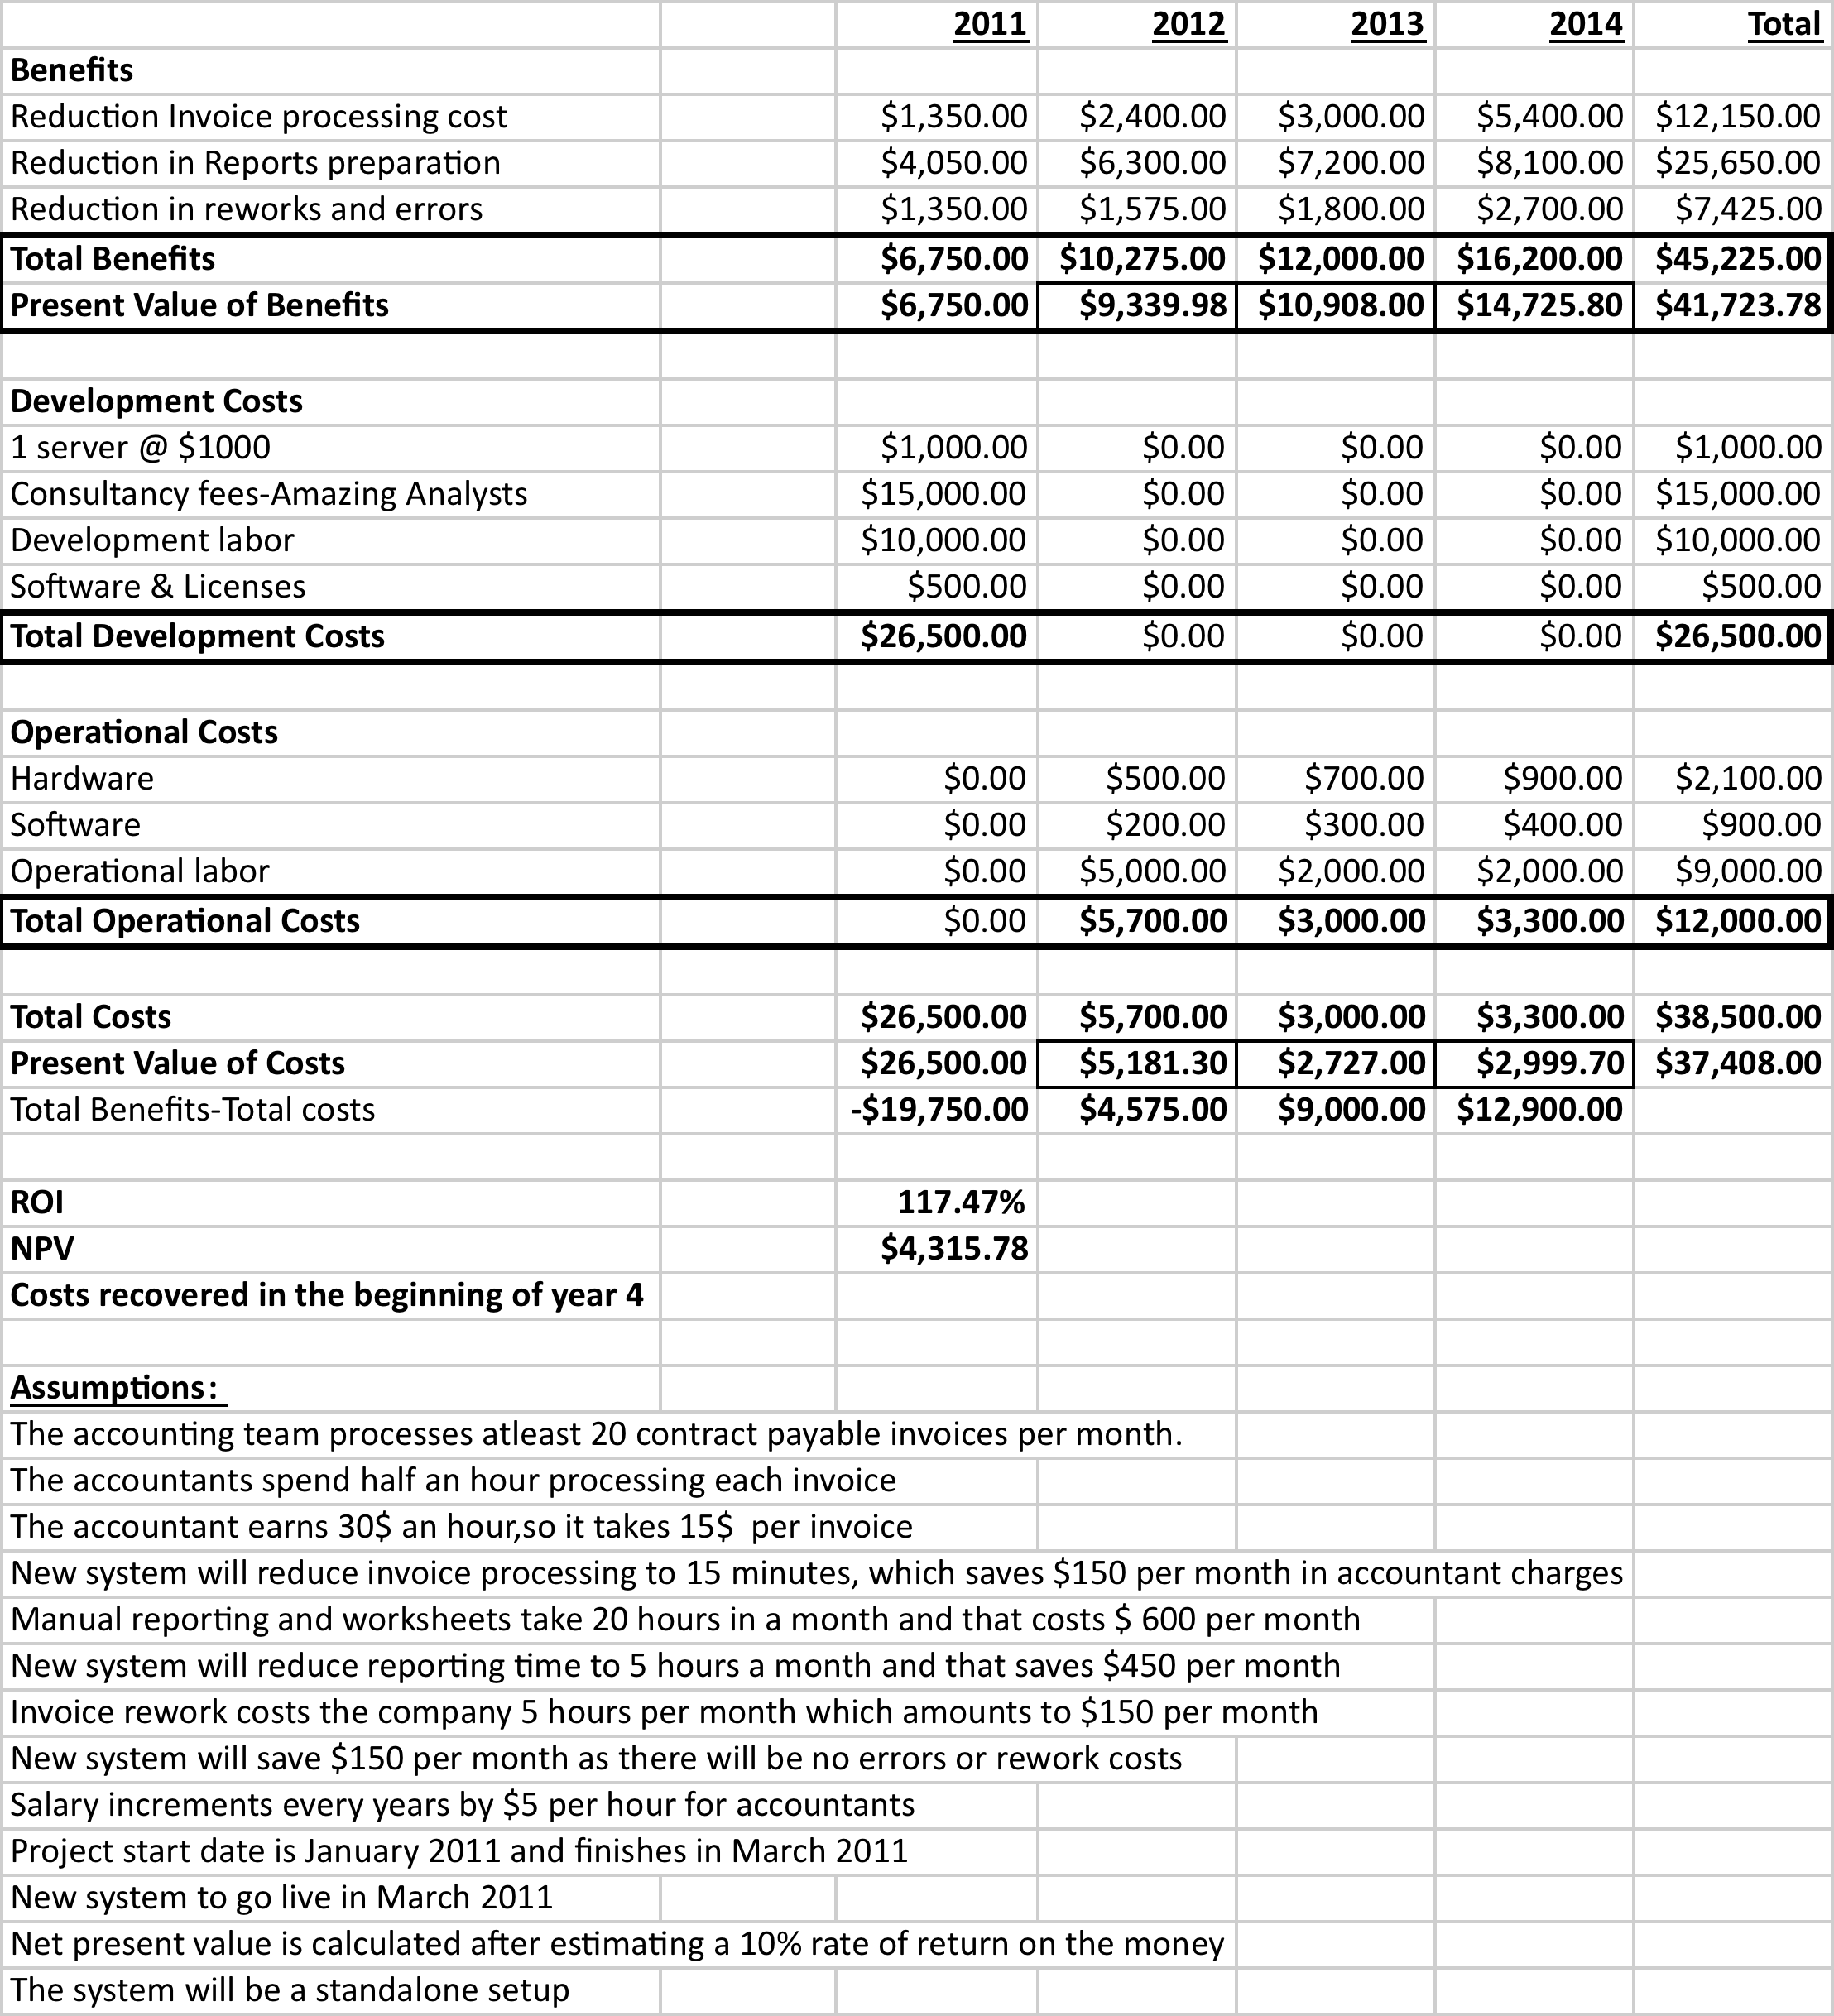

*Actual costs may vary.*

# Recommendation for Action

Below are a few recommendations of automated software packages. The learning curve may be higher for some and other will be simple to use. There will be need for adaptation and training. All should be able to run on the Operating System at the Bank of Xanadu, which is Windows XP.

Base on the example that was given of an Excel Spreadsheet (asample contract, programmer invoice, and data entry sheet) the automated software packages that were chosen are qualified to meet the Bank of Xanadu needs. Some of the software packages may take up more hard drive space than others. Oracle and Tenrox will customize software for the banking center.

Below are the potential software packages for the Bank of Xanadu’s Bellevue Banking Center.

### Microsoft Dynamics GP for Project Accounting

  Helps maintain an efficient system for project accounting. It ultimately connects project activities within financials, provides extensive reporting capabilities, helps ensure accurate accounting and billing processes throughout project life cycles, and streamlines time and expense management.

Microsoft Dynamics GP will maintain tight control over strategic direction, support resources effectively, and ensure that projects are completed on time and within budget. There are two key features: Project Time & Expense for Business Portal and Personal Data Keeper (PDK). The Project Time & Expense for Business Portal helps create customer invoices and reimburse employees faster and more accurately by managing project details via a central Web-based location. Personal Data Keeper (PDK) makes it possible to submit time and expenses when it is convenient for you, whether online or offline. **It offers strong integration with Microsoft Office, SharePoint, and SQL; ideal and economical for mid-size companies.**

***The total cost of an ERP system includes the***[***software, hardware, and services***](http://www.computeration.com/pricing-and-promotions/)***that meet your needs and expectations. Microsoft Dynamics GP License Cost Per User: $2,250.  
Each additional user from 1-10 is $2,250 per user.***

System requirements**:** Windows 7; Windows Server 2003; Windows Server 2008; Windows Small Business Server 2003; Windows Small Business Server 2008 Premium; Windows Small Business Server 2008 Standard; Windows Vista: and Windows XP.

### Primavera P6 Professional Project Management (Oracle)

Primavera P6 Professional Project Management is a powerful, yet easy-to-use solution for planning, managing, and executing projects and programs. Primavera P6 Professional Project Management gives control. It is designed to handle large-scale, highly sophisticated, and multifaceted projects. It can be used to organize projects up to 100,000 activities.

There exists a multitude of ways to organize, filter, and sort activities, projects, and resources. Some of the benefits include planning, scheduling, and controlling projects, assigning tasks and tracking progress, and evaluating risks, identifying issues, and determining their impact on projects. It cost $2,500.00 per application user and the cost of first year support is $550.00

System requirements**:** Microsoft Windows (32-bit): Windows XP Professional sp3, Windows Vista sp2, Windows 7 and Microsoft Windows x64 (64-bit): Windows XP Professional sp3, Windows Vista sp2, Windows 7

### QuickBooks Premier Professional Services

QuickBooks Premier Professional Services is business financial management software, tailored for your industry to help make your business more profitable. Get all the features of QuickBooks Pro and know exactly where your business stands, plus efficiently track and manage your unique business, grow with easy-to-use business planning tools, automatically forecast future sales and expenses.

Some of the benefits of QuickBooks Premier is the ability to track balance sheet by class, time & expenses by employee, project, client, etc., transfer unbilled time & expenses to customized invoices and set different billing rates by employee, client, & service, analyze profitability by project with project costing reports, like billed vs. proposal by project, cost-to-complete by job, and job costs by job.QuickBooks Premier also imports data from Excel, Quicken, Microsoft Office Accounting, & prior QuickBooks versions. It also intergrades with Word and synchronizes with Outlook.

The cost of QuickBooks Premier Professional Services is $399.95 per User and Intuit QuickBooks Care Protection Plan with Intuit Data Protect Service is 24.99 a month.

System requirements**:** Windows Vista, Window 7, and Windows XP either (32 or 64bit).

### Tenrox Project Workforce Management

With Tenrox online project management software, companies can replace the spreadsheets and band-aid applications that leave project-driven workforces and processes disconnected. Everything you need to empower your project workforce is connected for the first time, in real time, including: project management, [project planning](http://www.tenrox.com/en/solutions/project_planning.htm), [resource management & scheduling](http://www.tenrox.com/en/solutions/workforce_planning.htm), [time and expense tracking](http://www.tenrox.com/en/solutions/time_expense.htm), [cost accounting and/or billing solutions](http://www.tenrox.com/en/solutions/cost_revenue.htm), [process management tools](http://www.tenrox.com/en/solutions/project_process_management.htm), [analytic tools](http://www.tenrox.com/en/solutions/analytics.htm).

Tenrox works with all major financial applications and tools such as Sage ACCPAC, ADP, Ceridian, Paychex, QuickBooks, Microsoft Dynamics (including Great Plains, Navision, & Solomon), PeopleSoft, Oracle, SAP, and more, as well as to CRM applications such as salesforce.com and Microsoft CRM.

Features include an intuitive project-planning tool that is easy to use; project plans are interchangeable with Microsoft Project files, including Excel and outstanding time tracking, cost accounting and billing capabilities

Tenrox Global is an on-demand project management software provides timesheet management, budget management, and estimate to complete, cost and schedule variance, global project management, project controls, cost accounting, charge back, software capitalization (sop 98) and billing, accounting and payroll integration, and project health and dashboards.

The pricing starts at $120 per user, per module, per year.

System requirements**:** Windows Installer 3.0 version+; MDAC 2.8 +; Microsoft Visual C++ 2005, 2008; Microsoft .NET Framework Version 3.5 +; Microsoft SQL 2008 System CLR Types x86, Native Client x86 or Management Objects x86.

The Tenrox application supports SQL Server 2005 with at least SP1 and SQL Server 2008. It is compatible with these operating systems: Microsoft Windows Server 2003 32-bit version for the Application Server; Microsoft Windows Server 2003 32 bit and 64-bit versions for the Database Server; Microsoft Windows Server 2008. Also compatible with these web browsers: Internet Explorer 6.0 SP2, 7.0; Mozilla Firefox 2.0 + Safari V3.2.1

### Microsoft Access

In reviewing the compatibility issues, it was noted that Access is available in the MS Office Suite that the Bank of Xanadu presently uses. By using MS Access, it would help in consolidating scattered functionality and utilizing the full flexibility of an existing product and by placing MS Access database on a network multiple users could share and update data. With the SQL Server, the amount of data and users can expand to enterprise-level solutions. MS Access is simple enough for end users and will save time and money.

### MS Excel

This would be the simplest solution, in which there would be minimal training and the least expensive from all the software packages that was already mentioned. It would be ideal to utilize all Excel’s functions, but it is not as automated as Bank of Xanadu wants and the security is limited on Excel because data can be easily erased or mis-entered as was mentioned during the interview, whereas the software’s mentioned above would be more secure and less likely to be lost. If MS Excel would continue to be use worldwide, sharing would be challenging and data would be loss or the format would be changed.

### Summary

Since each bank will be dealing with their own IT contractors, QuickBooks would be the best for small to midsize banking center or satellite branches. For the larger Bank of Xanadu branches, Tenrox is recommend since it is global and integrates with QuickBooks. Either Tenrox or QuickBooks will be sufficent for the Bellevue Banking Center.

# PIR APPENDIX

## Meeting Notes, Correspondence, and Source Documents

October 15, 2010

Patrick Jay

Q: Would you elaborate on the scope of this project?

A: We’re going to try it out at the Bellevue accounting department. We don’t even know if this is going to work so we want to do a local test first. This is a “pilot project”.

…After we have a valid contract, Dave records it and – some point after that, services are performed and the programmer/company he works for will submit an invoice. We have to make sure we can pay this invoice according to the terms of contract. Dave looks at invoice and checks it against the contract to see if he can pay it. He approves it and sends it over to accounts payable group, then the group inputs it into the system(?).

Q: What improvements would you like to see in the new system?

A: We would like to see this system to be automated. Current system takes a loooong, looooong time.

Q: What kind of usability features would you like to see included with this system in addition to the ones you already described?

A: Data entry, of course. Verification to see if the invoice is payable or not (current system makes this take forever)

Q: Could you tell us the names of the employees who would be users of this system?

A: The only users will be the accounting department (no contractors will use this) (DAVE)

Q: What is our budget?

A: The bank has enough resources to do what you need to do for this project.

Q: Can you give us a timeline that we would have for system development and completion?

A: The analysis phase – December 4; Will continue on until… final system should be prepared by March 14(?)

Q: Do you wish for the system to be able to pay companies and/or individual contractors (i.e. those who would need a 1099)?

A: Yes

!!! – The bank’s (Bellevue) network is very secure (firewalls, etc.)

Q: Do you require that your contractors require some sort of security clearance, and we need to know what to do if you get more contractors(?...)

A: Sign a non-disclosure agreement to maintain security

!!! – Parallel or phase transition?

!!! – This is ONLY for contract programs

!!! - Paper checks; no wire transfers (Q15)

!!! – we track information about bank units… crap forgot to write everything else

!!! – contractors work at an hourly rate; every contract has a max amount of $$$, not hours

!!! – Invoices are sent monthly – bi weekly <<< (when contractors are billed)

Q: frequency of contractual payments

A: They should be processed as soon as they come in (invoices). Invoice processing goes on throughout the month (The minute you get it, it should be processed ASAP)

!!! – It could take Dave up to 30 minutes to process an invoice using the Excel stuff

Q: How many pages are the invoices?

A: It’s not so much there’s a ton of pages, it’s because he has to go back and find all the… (all the what?)

Q: Would the records for these contractual payments need to be accessible by either the main corporate office or any other branch? 18:39:01

A: Certainly not the main corporate office, and at this point not by any other branch. EVENTUALLY, if this thing works out then we need to scale this out to every other branch.

!!! – We track every invoice the minute it enters the department

!!! – Dave makes a copy of every invoice (apparently they get lost often?)

!!! – We use an Excel workbook right now, and ONLY an Excel workbook

Q: Would you like this system to be integrated with the current IT suite that you have set up? 18:39:01 @5:00

A: Eventually, but not right now. It could either be installed on Dave’s PC and possibly 1 or 2 other related employee’s PCs, or server and have it so that only Dave and his cronies can have access to it.

Q: How do you pay your employees?

A: HP-3000 system (it’s a mainframe), HR handles that…

Q: Is there some sort of default contract you use?

A: Yes, there is a standard contract that contract people use. Every contract used is essentially the same.

Q: Are there any elements of the contract you’d like to track?

A: NO. Be glad I said that!

Q: What types of information and data(?) will be needed to be inputted?

A: The contracts, the programmers themselves, the companies they work ffor, the invoices they provide, the different bank units/departments, the project managers/people responsible for handling the contractors.

Q: Does it have to be custom software or off-the-shelf? (Same as Q16)

A: It’s up to you. Research and recommend us.

Q: Are there existing vendor contracts that we need to honor?

A: Yes, there are.

Q: Do we get to see an example of this contract?

A: Yes… Appendix A (the last pages of the contract)

!!! – Yes, you can have a copy of the Excel workbooks (?)

Q: What is the operating system of the server you use right now?

A: Windows. Version inspecific…

Q: Can we see an example of an invoice? 18:50:16 @ 3:20

A: YES! YES!

Q: Will there be a need for calculated fields?

A: Almost certainly.

Dave Spencer (4:18)

Q: What are the key things you look for in the contract?

A: 1. Programmer/contractor listed 2. Start/end date 3. Fee maximum amount 4. Hourly rate for each programmer on contract 5. Bank contact unit, bank charge unit, project manager, and their signatures (PM)

!!! – It’s one programmer per contract!

Q: What are the problems with the invoices (Using Excel workbook???)

A: Sometimes the invoices can’t be processed… if the invoice’s outside of the start/end date; if the programmer isn’t on the contract; if the money’s exceeded; if the hourly rate doesn’t match; these are problems that can cause the invoice not to be paid. This slows Dave down when I have to handle these exceptions

Q: Do you have any processes for contract change orders?

A: Yes, there is a contract exception memo; attach it to the contract and send it back to the contract people and have them fix it. One of the most common things left off is the charge unit… if it’s a mission critical project, the programmers made the fix long before the contract is ever made… then when the invoice comes it, there’s a contract occurrence on it. Can’t pay the invoice without having the charge unit… If the invoice comes in and I can’t pay it, it goes back to the contract people; it does not get returned to the vendor/programmer; it goes to the contract people for a resolution then it goes back to me (Dave).

!!! – The contract has to have the unit that gets the dollar charge and the contractor unit(?) it’s mailed to

Q: Would there be a need to merge the current Excel data into the new system? If so, would you want us to do it?

A: Perhaps… eh… I don’t know how perfectly accurate it all is.

Q: What would you estimate is the current margin of error in the Excel workbooks?

A: There are probably some small mistakes I haven’t caught… I need something that will allow me to make as few errors as possible.

!!! - It could take up to half an hour to process these invoices… (for me anyway) It would cost me $15 to process ‘em; I get paid $30 an hour.

Q: Are you open to having an assistant?

A: Sure, I’m in need of some.

Q: Is there a standardized way of inputting data into the workbooks?

A: [Will explain later]

!!! – Contract ID is the main identifier (in workbook?)

Scott/Rob(?)

Q: How many contracts do you expect to receive on a monthly basis?

A: Hundreds, and growing.

Q: Is there any kind of back charge provision in case someone doesn’t fulfill their contract?

A: Yes (we don’t need to know about that though)

Lyle Newhart

!!! – I get the original invoices, not the copies

!!! – A copy of a contract extension, I can give it to you! I can also give you an exception memo copy.

# Correspondences

bd19819_

**Bank of Xanadu**

*Corporate Headquarters***: George Town, Cayman Islands**

*Major Banking Centers:* **Amsterdam • Aspen • Beijing •Bellevue • Berlin • Beverly Hills • Canberra • Cape Town • Dallas • Denver • Hong Kong • Kuala Lumpur • Las Vegas • London • Mumbai • Newport • New York • Nice • Ottawa • Palm Beach • Pine Valley • Santiago • Savannah • Sao Paulo • Scottsdale • Singapore • Tokyo • Wellington**

## Information Systems Work Request

**Date 1/25/08 Department Accounting**

**Contact Patrick Jay Location Bellevue, WA**

**Title Vice President, & Manager Email pjammer@box.bank**

**Project Description (in brief):**

**The strategic direction and growth of the bank has put new emphasis on streamlining our internal procedures. Xanadu Bank is in the business of banking, and to remain profitable and competitive, we have shifted our focus to concentrate on our core competencies, outsourcing any functions and processes that are not part of these core business operations. Since we began this process late last year, we have redeployed all in-house programming positions, resulting in the need to use outside contractors to provide the necessary programming services. This move will save our company over one 1 million dollars annually in employee administrative and benefit costs.**

**The major problem we face now is finding a suitable way to track these new programming expenses to the scope of service stipulated in their official contracts. While the accounting department has hastily thrown together a stop-gap solution using an Excel workbook, it is taking an incredibly large amount of time to manually enter all the contractual information, receive and process the incoming programming invoices, prepare accurate accruals, determine whether the invoice falls within the time limitations, and calculating whether enough funding is left on the contract to pay the invoice. In recent strategic planning sessions, the senior management has determined that a new, more automated process for managing contractual payables is needed. The objective of this project is to investigate and recommend a solution to control payments in accordance to contractual time and fee limitations throughout the company.**

**Submitted by: \_\_\_\_\_\_\_\_\_\_\_\_\_\_\_\_\_\_\_\_\_\_\_\_\_\_\_\_**

**Date: \_\_\_\_\_\_\_\_\_\_\_\_\_\_\_\_\_\_\_\_\_**

**Approved by: \_\_\_\_\_\_\_\_\_\_\_\_\_\_\_\_\_\_\_\_\_\_\_\_\_\_\_\_\_**

**Date: \_\_\_\_\_\_\_\_\_\_\_\_\_\_\_\_\_\_\_\_\_**

# Source Documents

# 

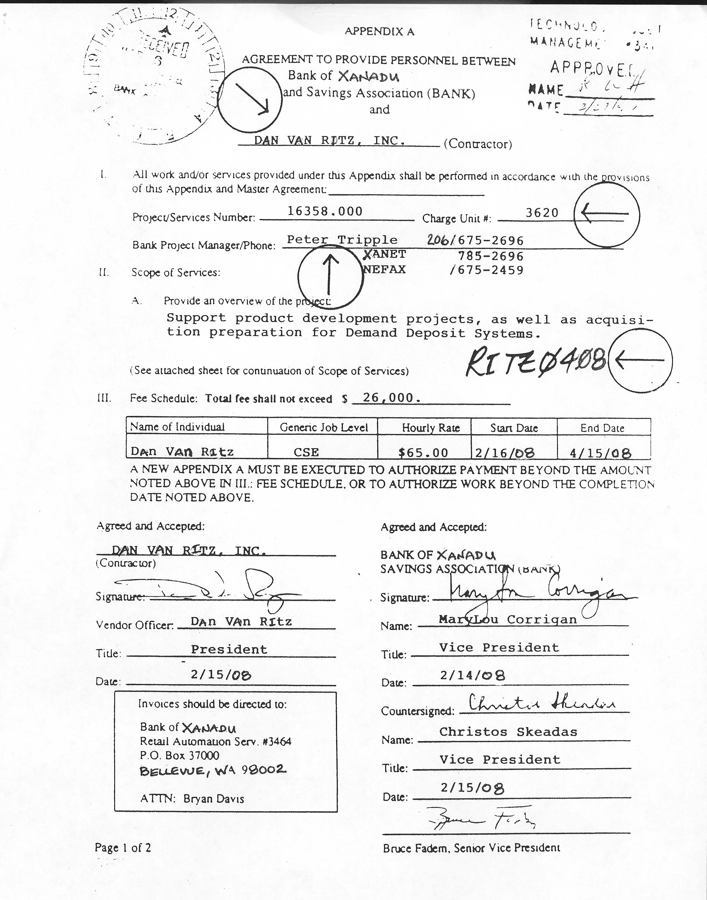

**DATA ENTRY SHEET**

|  |  |  |
| --- | --- | --- |
| **Vendor Name:** |  | Donny Wicks Associates |
| **Vendor Number:** |  | ZZ0002 |
| **Invoice Number:** |  | 329 |
| **Description:** |  | A. Peckham 12/16/07 to 12/31/07 |
| **Invoice Date:** |  | 01/02/08 |
| **Due Date:** |  | 01/17/08 |
| **Invoice Total:** |  | 3,600.00 |
| **G/L Account:** |  | 507613 |
| **P.O. Number:** |  | A. Peckham |
| **Charge Unit:** |  | 9408 |

Processed by Dave Spencer 1/11/08

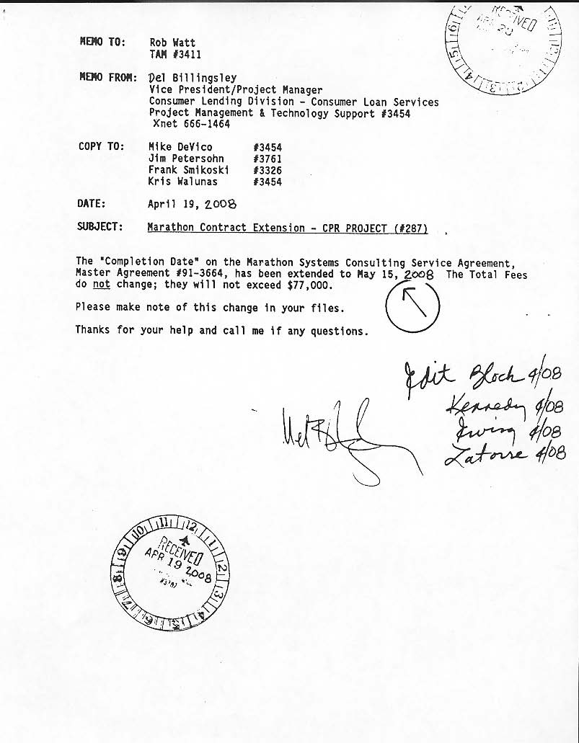

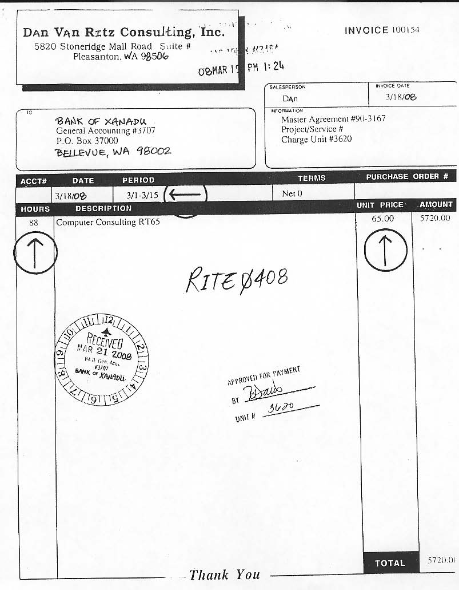

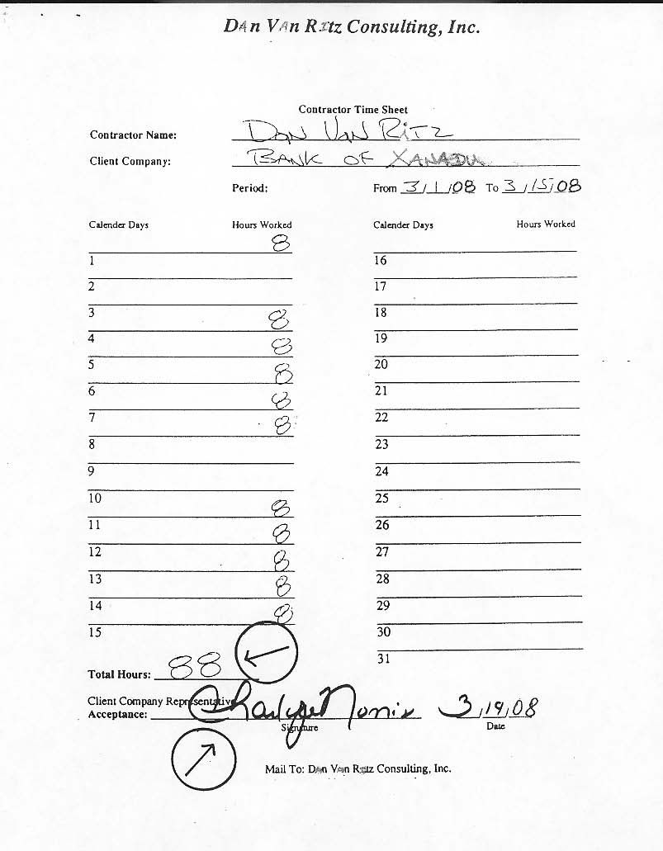

  

 











# Assumptions

We are planning to get internal support from the Bank of Xanadu in the next phase of this analysis. From there, based on The Bank of Xanadu suggestion and input of which automated software system meets their needs, if any.

We will then decide how the automatic software system will operate, in terms of what is needed including hardware, software, and/ or network infrastructure that needs to be in place. From there we will develop a strategy and how to approach the next phase, with is designing the automated system software system.

# Issues

* Would you consider using two automated software programs?
* Is each major banking center and satellite branch, will be doing their own invoicing and payments, or is the banking center near the satellite branch, is doing both theirs and the satellite branch.
* Bank of Xanadu corporate headquarters and the major banking centers would use the automated software that is global and the smaller satellite branches would use automated software that is for small to midsize companies that will integrate with the corporate automated software. This would save time and money.
* How many IT contractors’ programmers are employed at each satellite branch, major banking centers and at the corporate headquarters?
* Do you plan to upgrade to the Windows 7 OS or continue to use Windows XP?
* What version of windows XP are you using? Are they 32-bit, 64-bit or both?
* What email service do you use for the company? Is it MS Outlook or Outlook Express or/and different email service?
* Do you see in the near future any more IT projects taken place?

# Appendix C

# Developer Documentation

## Data Flow Diagram (DFD):



## Functional Decomposition Diagram (FDD):



## Use Case Diagram:



## Use Cases

### Receive Contract

|  |  |  |
| --- | --- | --- |
| **USE CASE NAME:** | **RECEIVE CONTRACT** | **ID: UC001** |
| **Primary Actor:** | Accountant | |
| **Brief Description:** | This use case describes the steps for **processing a new contract**, from the time that it is delivered by **the vendor/programmer**, until a new **contract is verified and entered** into the system. | |
| **Trigger:** | A new contract is delivered to the accounting department. | |
| **Related Use Cases:** | Contract Exception (extended by); Update Contract (used by); Create New Contract (extended by) | |
| **Normal Flow of Events:** | This use case begins when the **vendor delivers the new contract** to the Accountant.   1. The accountant manually reviews the contract to see if all information is correct and required for the accounting department. 2. The accountant log onto the system and navigate to the screen for contracts. 3. Then the accountant searches for the Vendor/ Programmer ID number and select it. 4. The accountant enters all the required information that is required. (see Information Requirements below) 5. When the accountant is done entering all required information, it is set to “active” and then “saved”. 6. The accountant approves and files the contract.   This use case ends when **the contract is entered** into the system. | |
| **Exceptions:** | 1. If the information is wrong or done incorrectly, an exception memo is written, and sent to the vendor/programmer to have correction made. 2. If the vendor/programmer is not in the system, a new create vendor is made and recorded. 3. If information is missing in any of the fields in the system , new information is created and recorded | |
| **Pre-condition(s):** | The new contract delivered from the vendor/programmer. | |
| **Post-condition(s):** | The valid contract is in the system and is ready for the invoices come in to apply against it. | |
| **Information Requirements:**  **(from Appendix A)** | Contract ID  Programmer  Vendor  Start Date  End Date  Hourly Rate  Fee Maximum  Contact (Project Manager)  Contact Unit  Contact Phone  Charge Unit  Bank Division  Project Description  Status | |
| **Assumptions:** | The accountant needs to refer to the main bank directory, look up the correct contact unit, and phone number for the project manager of each contract. | |
| **Business Rules:** | 1. The contract is not an active contract until a valid, signed contract is received. 2. The contract is not valid if information is missing. 3. If the contract is not valid, both a written exception memo and the original contract are sent back to the vendor/programmer. 4. There should be one vendor/programmer per contract. 5. There needs to be an ID number on the contract for the accounting department that the accounts payable provide. 6. There needs to be a project manager on file in the main bank directory, if none is provided, the accountant or person in charge need to obtain that information. 7. The accounting department needs to keep all contracts on file. | |

### Contract Exception

|  |  |  |
| --- | --- | --- |
| **USE CASE NAME:** | **CONTRACT EXCEPTION** | **ID: UC002** |
| **Primary Actor:** | **Accounting** | |
| **Brief Description:** | This use case describes the step for processing a Contract Exception. | |
| **Trigger:** | New contract is delivered to the accounting department. | |
| **Related Use Cases:** | Contract exception (extended by); Update Contract(used by); Create new contract information (extended by) | |
| **Normal Flow of Events:** | This use case begins when the buyer delivers a new contract to the Accountant.   1. Manually review contract to ensure all the information needed by the accounting department is on the contract 2. If any require information is not one the contract, and exception memo is generated and sent to the buyer with the contract for resolution 3. If the vendor is not listed, navigate to the “Create Vendor” screen and create a new vendor record.   If the contract (project manager) change unit or bank division is not listed in the appropriate lookup fields, a new record for that information will need to be created. | |
| **Exceptions:** | N/A | |
| **Pre-condition(s):** | The existence of a new contract delivered from the buyer | |
| **Post-condition(s):** | Contract Exception report sent to the buyer for review | |
| **Information Requirements:** | Contract ID, Programmer,  Vendor  Start Date  End Date  Hourly rate  Fee Maximum  Contact (Project)  Charge Unit  Contact Unit  Contact Phone  Project Description  Bank Division  Status | |
| **Assumptions:** | The accountant must refer to the corporate directory to verify the correct contact unit and phone number for the project manager. | |
| **Business Rules:** | 1. The contract start date must come before the end date 2. The contract is not considered valid by the accounting department if any of the required information is missing 3. If the contract is deemed invalid, an exception memo must be generated and returned to the buyer with the original contact 4. The Accounts payable group provides vendor numbers for use in accounting. 5. A programmer can work on more than one contract at the same time 6. A contract may have more than one programmer and mast have at least one | |

### Update Contract

|  |  |  |
| --- | --- | --- |
| **USE CASE NAME:** | **UPDATE CONTRACT** | **ID: UC003** |
| **Primary Actor:** | **Accounting** | |
| **Brief Description:** | This use case describe the step for update a contract from the time that is delivered by the buyer, until a new contract is verified and entered into the system | |
| **Trigger:** | Buyer sent an update contract to the accounting department. | |
| **Related Use Cases:** | Contract exception (extended by); Update Contract(used by); Create new contract information (extended by) | |
| **Normal Flow of Events:** | This use case begins when the buyer delivers an update contract to the Accountant.   1. Manually review contract to ensure all the information needed by the accounting department is on the contract 2. If the contract is acceptable and accurate the accountant Log onto the system (if necessary) and navigate to the “Enter Contract” screen 3. Search for the correct Vendor (Contractor) and select it 4. Enter all required in formation (see information requirement below) into the system. Use appropriate “lookups” when applicable 5. When finished entering all required information, set contract status to “Active” SAVE the new contract record into the system 6. After saving the record, file the contract away.   This use case ends when the new contract is entered into the system. | |
| **Exceptions:** | N/A | |
| **Pre-condition(s):** | The existence of a new update contract delivered from the buyer | |
| **Post-condition(s):** | The verified contract has been entered into the system and is ready to have valid invoices processed against it. | |
| **Information Requirements:** | Contract ID, Programmer,  Vendor  Start Date  End Date  Hourly rate  Fee Maximum  Contact (Project)  Charge Unit  Contact Unit  Contact Phone  Project Description  Bank Division  Status | |
| **Assumptions:** | The accountant must refer to the corporate directory to verify the correct contact unit and phone number for the project manager. | |
| **Business Rules:** | 1. The contract start date must come before the end date 2. The contract is not considered valid by the accounting department if any of the required information is missing 3. If the contract is deemed invalid, an exception memo must be generated and returned to the buyer with the original contact 4. Vendor numbers for use in accounting are provided by the Accounts payable group. 5. A programmer can work on more than one contract at the same time 6. A contract may have more than one programmer and mast have at least one 7. If the project manager is not listed in the corporate directory, the signing authority needs to be contacted to obtain that information 8. The accounting must keep a hard copy file of the contract | |

### Receive Invoice

|  |  |  |
| --- | --- | --- |
| **USE CASE NAME:** | **RECEIVE INVOICE** | **ID: UC004** |
| **Primary Actor:** | Accountant | |
| **Brief Description:** | This use case describes the steps for **receiving an invoice**, from the time that it is delivered by **the vendor/programmer** submits it to when the authorization is given to accounts payable to issue the check. | |
| **Trigger:** | An invoice is submitted to the accounting department. | |
| **Related Use Cases:** | Invoice Exception (extended by); Update Invoice (used by); Create New Invoice (extended by) | |
| **Normal Flow of Events:** | This use case begins when the **vendor/ programmer submits the invoice** for IT services performed at the companyto the Accountant.   1. The accountant manually reviews the invoice to see if all information is correct and required for the accounting department. 2. The accountant log onto the system and inputs the invoice information into the system that matches the contract. 3. The system searches and automatically verifies if the invoice is payable under the terms specified in the related contract 4. The system automatically sends an authorization to the accounts payable department to issue a check to the contractor and notifies the accountant of the approval.   This use case ends when **the Accounts Payable issues the check** and into the system, it is paid. | |
| **Exceptions:** | 1. If the information is wrong or done incorrectly on an invoice, hours do not match, or pay does not match to the contractual terms, an exception memo is written, and sent to the vendor/programmer to have corrections made. 2. If changes have occurred on the invoice and a new invoice is sent, it will be sent to the authorized person for approval, before it is entered into the system. | |
| **Pre-condition(s):** | A valid contract must be in system, for the invoice to be entered into system electronically. | |
| **Post-condition(s):** | The submitted invoice will be pending until the accounts payable issues a payment. | |
| **Information Requirements:**  **(from Appendix A)** | Programmer name  or  Vendor name  Address  Contract charges  Contractors Time Sheet  Invoice Date  Period of service  Hours  Description  Unit Price  Hourly rate  Total Amount | |
| **Assumptions:** | If the invoice is not approved the contract group will notify the accountant and the vendor/programmer | |
| **Business Rules:** | 1. The invoice is not accepted until an active contract is valid, signed approved and entered into the system. 2. The invoice is not valid if information is missing or there are errors... 3. If the invoice is not valid, both a written exception memo and the original invoice are sent back to the vendor/programmer for corrections 4. The valid invoice is not complete until the accounts payable department has issue payment, and entered the payment into the system. 5. The accounting department needs to keep all invoices on file. | |

### Invoice Exception

|  |  |  |
| --- | --- | --- |
| **USE CASE NAME:** | **INVOICE EXCEPTION** | **ID: UC005** |
| **Primary Actor:** | Accountant | |
| **Brief Description:** | This use case describes the steps for **handling an invoice exception**, from the time that it is **determined by the accountant** to when it is **sent to the vendor/programmer.** | |
| **Trigger:** | An invoice is received and the information is incorrect. | |
| **Related Use Cases:** | Received invoice (uses); Update Invoice (used by) | |
| **Normal Flow of Events:** | This use case begins when incorrect information is encountered by the accountant.   1. The exception is determined. 2. A memo exception is created by the accountant. 3. The invoice exception is sent to the vendor/programmer   This use case ends when the invoice exception is sent to the vendor/programmer. | |
| **Exceptions:** | N/A | |
| **Pre-condition(s):** | An invoice must have already been received. | |
| **Post-condition(s):** | The invoice will be pending update from vendor/programmer. | |
| **Information Requirements:**  **(from Appendix A)** | Programmer name  or  Vendor name  Address  Exception type  Invoice Exception Date  Course of Action | |
| **Assumptions:** | N/A | |
| **Business Rules:** | 1. The invoice is considered pending when the exception is sent to the vendor/programmer | |

### Update Invoice

|  |  |  |
| --- | --- | --- |
| **USE CASE NAME:** | **UPDATE INVOICE** | **ID: UC006** |
| **Primary Actor:** | Accountant | |
| **Brief Description:** | This use case describes the steps for **updating an invoice**, from the time that it is **reviewed by the accountant** to when it is **sent back to the vendor/programmer.** | |
| **Trigger:** | The vendor/programmer sends a revised invoice into the system. | |
| **Related Use Cases:** | Received invoice (used by Update Invoice (used by) | |
| **Normal Flow of Events:** | This use case begins when the vendor/programmer sends an updated invoice into the system.   1. The accountant reviews the revised invoice. 2. The revised invoice is entered into the system. 3. The accountant files the invoice for payment.   This use case ends when the accountant files the invoice for payment. | |
| **Exceptions:** | 1. If the information is wrong or done incorrectly on an invoice, hours do not match, or pay does not match to the contractual terms, an exception memo is written, and sent to the vendor/programmer to have corrections made. 2. If changes have occurred on the invoice and a new invoice is sent, it will be sent to the authorized person for approval, before it is entered into the system. | |
| **Pre-condition(s):** | A valid contract must be in the system for the invoice to be entered into the system electronically. | |
| **Post-condition(s):** | The submitted invoice will be pending until the accounts payable issues a payment. | |
| **Information Requirements:**  **(from Appendix A)** | Programmer name  or  Vendor name  Address  Contract charges  Contractors Time Sheet  Invoice Date  Period of service  Hours  Description | |
| **Assumptions:** | If the invoice is not approved the contract group will notify the accountant and the vendor/programmer. | |
| **Business Rules:** | 1. The invoice is not accepted until an active contract is valid, signed, approved and entered into the system. 2. The invoice is not valid if information is missing or there are errors. 3. If the invoice is not valid, both a written exception memo and the original invoice are snet back to the vendor/programmer for corrections. 4. The valid invoice is not complete until the accounts payable department has issue payment, and entered the payment into the system. 5. The accounting department needs to keep all invoices on file. | |

### Pay Invoice

|  |  |  |
| --- | --- | --- |
| **USE CASE NAME:** | **PAY INVOICE** | **ID: UC007** |
| **Primary Actor:** | Accountant, Accounts Payable | |
| **Brief Description:** | This use case describes the steps for paying the invoice, from the time the invoice is matched with the contract for payment to when the check is sent to the vendor/programmer. | |
| **Trigger:** | Invoices are paid every two weeks, if invoice has been filed for payment | |
| **Related Use Cases:** | N/A | |
| **Normal Flow of Events:** | This use case begins when the system determines when to match the invoice with the contract.   1. The system automatically matches the invoice with the contract for payment. 2. The system automatically approves the invoice for payment. 3. The system automatically generates the data entry sheet. 4. It is then delivered to accounts payable. 5. The invoice is paid by the Accounts Payable department. 6. Accounts payable cuts the check for the vendor/programmer. 7. The check is sent to the vendor/programmer.   This use case ends when the check is sent to the vendor/programmer. | |
| **Exceptions:** | N/A | |
| **Pre-condition(s):** | 1) The invoice and contract must have valid information.  2) The invoice must be filed for payment | |
| **Post-condition(s):** | 1) Invoice will be marked as paid | |
| **Information Requirements:**  **(from Appendix A)** | Programmer name/Vendor name  Date  Amount  Invoice number  Invoice date | |
| **Assumptions:** | 1) The contract terms have already been fulfilled. | |
| **Business Rules:** | 1) The accounting department needs to keep records of the checks on file. | |

### Generate Accruals

|  |  |  |
| --- | --- | --- |
| **USE CASE NAME:** | **GENERATE ACCRUALS** | **ID: UC008** |
| **Primary Actor:** | Accountant | |
| **Brief Description:** | This use case describes the steps for generating accruals, from when it is determined it is needed to when the reports are made. | |
| **Trigger:** |  | |
| **Related Use Cases:** | Generate Accounting Dept Reports (Used By) | |
| **Normal Flow of Events:** | This use case begins when it is determined accruals are needed.  1) Determine if accruals are needed.  2) The accrual is processed through the automated system.  3) The accruals are reversed as needed.  4) The report is automatically generated.  This use case ends when the accrual reports are generated. | |
| **Exceptions:** | N/A | |
| **Pre-condition(s):** | The corresponding invoice must be unpaid. | |
| **Post-condition(s):** | 1) The accrual report is kept on file for the accounting department, when they get their month-end reports. | |
| **Information Requirements:**  **(from Appendix A)** | Programmer/Vendor  Invoice Number  Charge Unit  Total Invoice  Date Accrued  Date Reversed | |
| **Assumptions:** | The invoice has not yet been paid. | |
| **Business Rules:** | The corresponding invoice must be marked paid in the database. | |

## Requirements Catalog

**UC1.0 The system must allow the entry and creation of contract information.**

UC1.1 The system must allow a vendor/programmer to be selected.

UC1.2 The system must allow a project manager to be selected

UC1.3 The system must allow a charge unit to be selected.

UC1.4 The system must allow the accountant to enter a unique contract ID which is made of the alphanumeric character i.e. last name of the programmer and ending month and year of a contract.

UC1.5 The system must be able to accept the name of the programmer

UC1.6 The system must be able to accept the fee max amount of a contract.

UC1.7 The system must be able to accept the hourly rate charged by the programmer.

UC1.8 The system must accept a valid start date of the contract.

UC1.9 The system must accept a valid end date of the contract.

UC 1.10 The system must allow a brief description of the project the contract was awarded for.

UC1.11 The system must allow for creating any of the above new record if not found in the system.

UC 1.12 The system must save the information as a new contract record.

**UC2.0 The system must be able to send a memo for exceptions or data missing in the contract.**

UC 2.1 The memo must have a checkbox for flagging the record as having an exception if any of the information is missing or incorrect.

UC2.2 The memo must allow for briefly describing the exception.

**UC3.0The system must allow editing/updating of a contract record.**

UC3.1 The system must allow updating a record after receiving clarifications from the contracts team, extensions or change in contracts terms and conditions

**UC 4.0 The system must allow entry and creation of an invoice.**

UC4.1 The system must allow for entering the date of invoice entry.

UC4.2 The system must allow selection of a contractor name which results in the display of contract details for that contractor.

UC4.3 The system must allow selection of the contract ID valid for the invoice.

UC 4.4 The system must accept a valid date for the invoice in accordance with contract dates.

UC4.5 The system must accept a valid period for the invoice in accordance with the contract dates.

UC4.6 The system must accept a valid hourly rate charged in accordance with contract rates.

UC4.7 The system must accept a valid total invoice value and it should not exceed the max fee amount of the contract.

UC4.8 The system must accept the total hours worked and calculate to check of total invoice amount matches the hours worked multiplied by the hourly rate.

UC4.9 The system must have a check box for confirming Project Managers approval of the timesheet attached to the invoice.

UC4.10 The system must automatically prepare a Data entry sheet.

UC4.11 The system must be able print the data entry sheet.

**UC5.0 The system must be able to send a memo if there are exceptions or data is missing in the invoice.**

UC 5.1 The memo must have a checkbox for flagging the record as having an exception if any of the information is missing or incorrect.

UC5.2 The memo must allow for briefly describing the exception.

**UC6.0The system must allow editing/updating of an invoice record.**

UC6.1 The system must allow updating an invoice record after receiving clarifications from the contracts team.

**UC7.0The system must be able to calculate accruals for a specified period.**

UC7.1 The system must be able to calculate all payments made for a period.

UC7.2 The system must be able to calculate all payments authorized for a period.

UC7.3 The system must be able to calculate the difference between the payments authorized and payments made.

**UC8.0The system must generate accounting reports at the end of the month or when required by the accounting team.**

UC8.1The system must be able to generate an Invoice report for a period.

UC8.2The system must be able to generate an Accrual report for a period.

**UC910.0 The system must automatically generate Bank/Management reports.**

UC910.1 The system must automatically be able to generate a Query Expense Recap report for a period.

UC910.2 The system must automatically be able to generate a Fees vs. Actuals Recap report for a period..

UC 910.3 The system must automatically must be able to generate a Con-Recap report for a period..

## Information Requirements

* PROJECT
* Project Services Number
* Project description
* CONTRACT
* Contract ID
* Scope of services
* Begin Date
* End Date
* $/hour
* Fee Max
* BUSINESS UNIT
* Contact unit/charge unit
* Division
* INVOICE
* Invoice number
* Invoice date
* Amount
* Period
* Hours worked
* Invoice description
* VENDOR
* Vendor Name
* Vendor Address
* Vendor Number
* PROGRAMMER
* Programmer Name
* Programmer Contact number
* Address
* Designation
* Technical expertise
* PROJECT MANAGER
* Name
* Contact number
* Phone number