SIEBWALDE APPLICATION

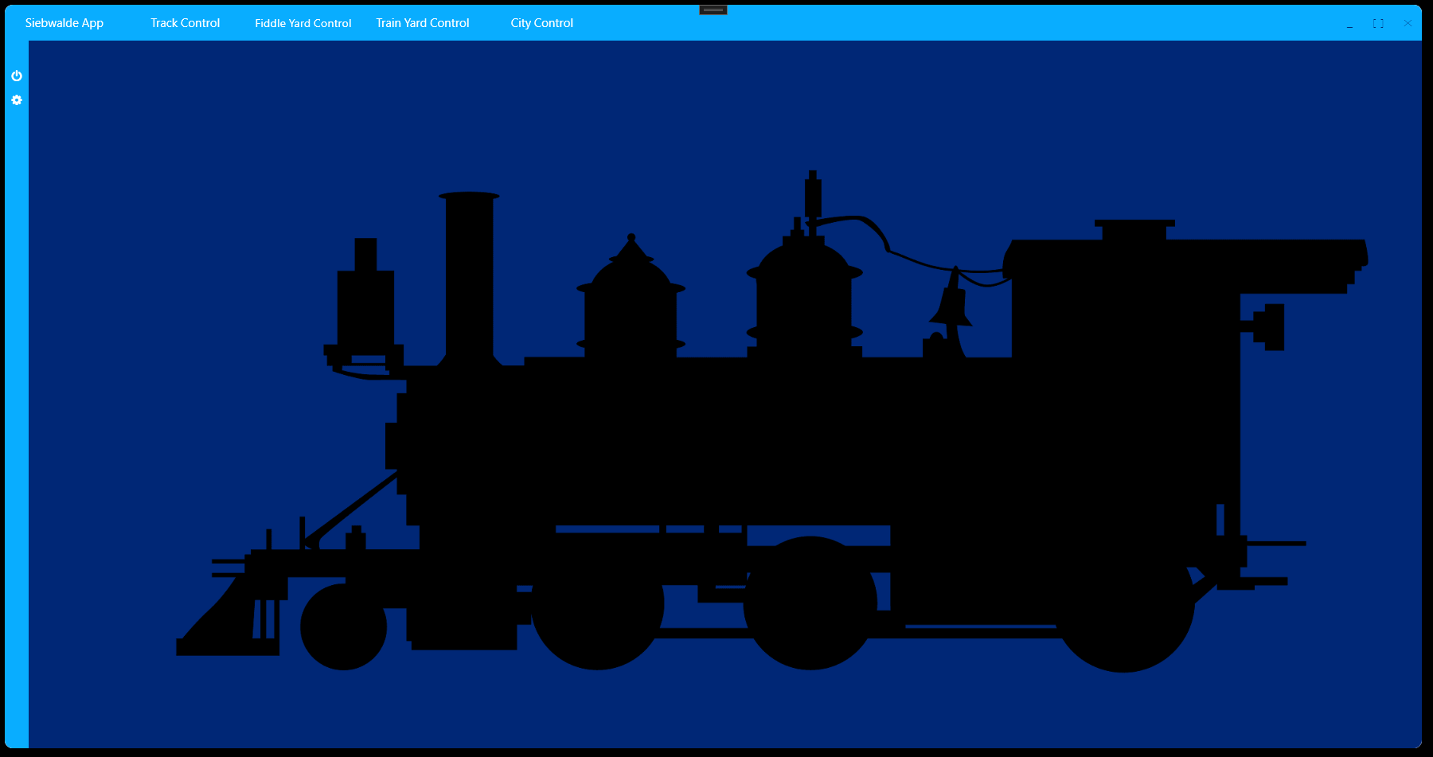Figure 1: Preliminary Siebwalde Application

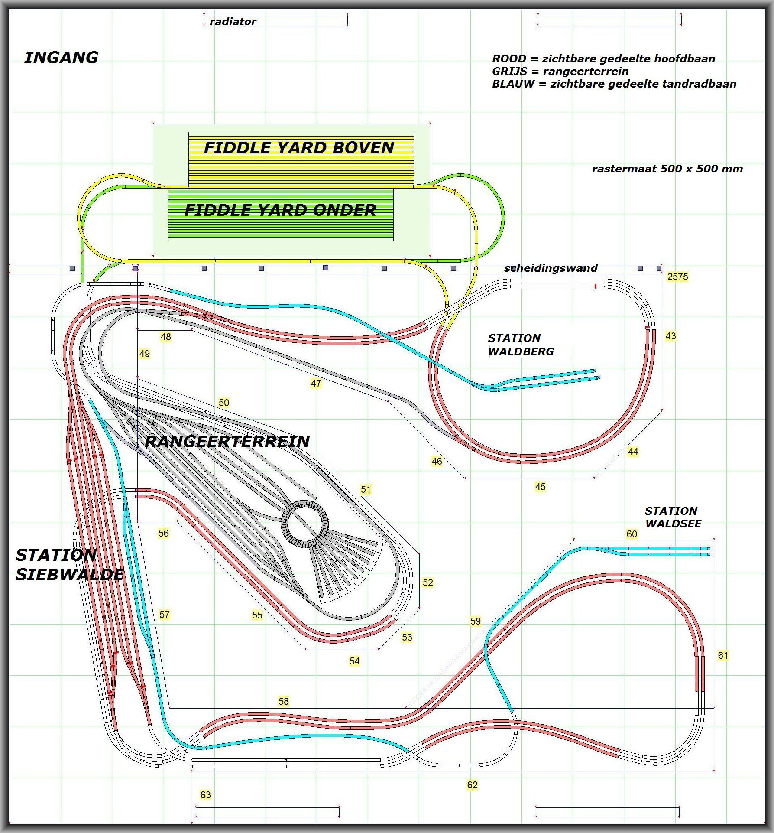Figure 2: Main track layout [www.siebers.org]
Table of Contents
Introduction 3
Siebwalde Application 4
The Main Track 5
Problem analysis and rationale 5
Block System 5
Fiddle Yard 6
The Yard 6
Train stations 6
The Mountain climbing track 6
Current Design and Starting Point 7
Main Track Feature List 8
Top Use Case Diagram 9
MT-Controller: Operates Block System features 9
MT-Controller: Runs trains on Main and Mountain track features 10
MT-Controller: Exchange trains with Fiddle Yard features 10
MT-Controller: Exchange trains with the yard features 11
Operator: Init, start and stop Main Track Controller 11
Operator: Influences behavior of Main Track Controller 11
Operator: Operates Yard manually 11

Introduction
The Siebwalde application is a man-machine-interface that shall act as the interface between an operator and the whole Siebwalde track assembly. This application shall make it possible to operate the following sections of this assembly:
- The Main track layout
- The Fiddle Yard
- The Yard
- The Car Track
- The Siebwalde City lights/actions/sounds
All these sections will be connected to either the local Ethernet network (TCP/IP based) or to a dedicated modbus I/O system.
The features of the Siebwalde app are as following:
- Provide initializers for remote connected hosts (HW: Ethernet, serial(modbus)).
- Provide FW download/upgrade to these remote connected hosts.
- Provide a user friendly interface of the main parts of the whole layout, e.g. Track layout, Fiddle Yard, Yard, Mountain track, Car tracks and City lighting.
- Provide integration between connected parts, the Main track, Fiddle Yard, Mountain track, Car track and City lighting shall all run automatically with the possibility of user intervention and selectable behaviours.
- Provide manual control for the Yard in order to manually drive the trains, split them up and combine them again, request and re-insert trains automatically from/into the main track.
- Provide manual safety and rescue control in order to recover decoupled/derailed trains.

This document shall document and record requirements, designs decisions, HW, FW and SW specifications and design information.
This document describes all the mentioned sections above in the following chapters.

Siebwalde Application

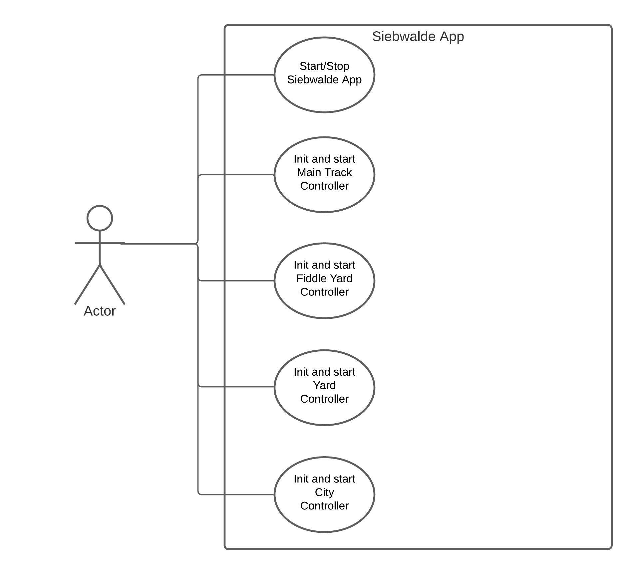

The Main Track

Problem analysis and rationale
The main track layout is a from a technical perspective a simple circle. All trains and locomotives will drive only into 1 direction. As can be seen on the front cover of this document, is the “circle” layout squeezed together to form a highway for trains where trains on the right side of the track drive forwards. This squeezed form, when straighten, will look like a bone:
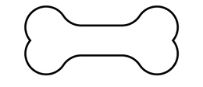
On both ends of the bone a turn around corner is present in order to adhere to the circle principle.
These ends are physically located at the back side of the Siebwalde diorama and are integrated into the Fiddle Yard.
[note]The Fiddle Yard is described into its own chapter but since it has a close relation to the main track it will mentioned in explanations and in requirements.

In order to let multiple trains drive on one single track a sophisticated system is required that can manage this complete track and all trains driving on it at the same time.
Nowadays various digital solutions are available in order to communicate with each locomotive and give it commands on what to do. Since the collection of locomotives currently ranges from very old to relative young models, a digital (build in digital decoder) solution would be to costly.
Therefore a choice is made not to make the locomotives digital but the track itself. This will allow to still drive old locomotives combined with newer models all together.
The system that is required to dissect the whole track into smaller parts and to manage the traffic on top is called a block system.

Block System
The main track layout will be divided into sections of which each section will be controlled by a dedicated amplifier. This amplifier is able to control a locomotive, detect electrical current consumption and to flag that the section is occupied, communicate with a master controller and apply basic safety functions.
The dynamics in train stations of stopping and starting trains and for that matter everywhere else, require a dedicated amplifier for each section. This means that amplifiers have to work together when a locomotive crosses one section to another. Especially when the locomotive has to accelerate out of standstill and is going to cross multiple sections.
The block system will have amplifiers connected to each of the track pieces of the Fiddle Yard with the exception of the centre piece railroad that is switched automatically to one of the 11 tracks automatically, depending on the alignment of a Fiddle Yard with the fixed world. This means that the Siebwalde app hosting the Main track controller and the Fiddle Yard controller have to communicate together to manage the incoming and outgoing traffic (on 2 Fiddle Yard levels, top and bottom Fiddle Yard).

Fiddle Yard
The Fiddle Yard shall control the storage of the trains on the 22 tracks which are divided in a Top layer and a Bottom layer. When the Siebwalde app is started and everything is good to go a FILA (First In Last Out) program is started in the Fiddle Yard controller. This program will store any train that comes in to the Fiddle Yard and when possible will select another train to leave the Fiddle Yard.
This arrangement of train storage will run fully automatic but will provide options and configurations to the operator to select various programs. Next to the FILA program a Collect program can be selected which will take care to store all trains that are coming into the Fiddle Yard. Once a layer is full, it will let first a train leave in order to store another coming into the Fiddle Yard. It is of course important that when there are more than 22 trains on the complete track an involvement of the main track controller is required to store any additional train elsewhere.

The Yard
The Yard will be a separate section that is connected on 2 points with the main track. A request to receive a freight train can be made by means of using a specialized remote that will create a demand to the main track controller. The main track controller will take special actions to manage traffic and to deliver a freight train onto the entry railroad track of the Yard. From this point forward the Yard remote control can be used to operate the freight train.
When the operator is done constructing a new freight train, a request can be made to the main track controller to takeover control over the freight train and to add it back into the main track.

Train stations
In the main track train stations are present that will simulate the people boarding process and will involve track switches that can guide a people carrier close to the platform for boarding while freight carriers will be guided into the middle more straight railroad section so they can pass a station without stopping.
These stations will be part of the track controller and will run therefore automatic. By means of configuration an operator can influence this behaviour for instance to hold a train, keep a track empty, specify waiting times etc.

The Mountain climbing track
A special track in Siebwalde is the Mountain track. This track is coloured blue in Figure 1 and runs up from station Waldberg all the way down to station Waldsee passing a lower segment of the main Siebwalde train station in the middle.
This track will also be controlled by the same type of amplifiers as from the main track. This also means that they are connected to the same communication system and that they operate in the exact same way. The difference here is that it is not a circular track but a commute track where trains will go up and down from station to station and back. Since there is only a single track trains will have to pass each other in one of the 3 stations. This also means that there can be only 1 or 2 trains driving at the same moment on this track.

Current Design and Starting Point
Some great effort is already made on the design of the Fiddle Yard controller and a first setup of the Siebwalde Application. The application and all other parts are and will be written by the use of the C# language by making use of the .Net framework and WPF for visualization.
The Fiddle Yard part was constructed first by using WinForms to visualize the Fiddle Yard control centre. The intention is to accommodate the Fiddle Yard part as-is until there is enough coding capacity to alter and upgrade it to a higher form of programming and migrating it to WPF.
The Siebwalde application shall be programmed making use of the MVVM pattern that matches perfectly with WPF and the required separation between view and model.

The block system has been largely pre-developed on HW with the existence of 50 PWM amplifiers that are connected to a Modbus bidirectional bus that is communicating with a dedicated embedded controller. This controller acts as a gateway between Ethernet and Modbus. The job of the master controller for the main track is to accommodate data transfer from and to the slaves but also to provide means of initialization, FW downloading and safety behaviours.
Pre-baked C# code is already available but shall be re-engineered to meet the more high level event based way of operation.

As a starting point for the Main track part of the Siebwalde application will be the technical details within this document following the OO&AD methods in order to come to a basic software design where this main track problem is dissected into smaller problems etc.

The Siebwalde Application will act as an example of how the revised version will look like but with the necessary changes/updates on:
- Dependency injection
- Notification property changed framework
- Dividing the core application from the View and View-Models
- Restructuring of the whole application

Main Track Feature List
- Trains will drive onto 1 direction, except in a recovery situation. In the recovery situation an operator shall be able to drive a decoupled locomotive backwards to the decoupled wagons.
- The main track shall dissected into various sections that will be operated by using a block system without digital decoders. The sections themselves shall be operated digitally.
- The block system will be build with a number of digital amplifiers that support starting, stopping of locomotives but also can indicate that a current consumer is still present at a piece of track; the track is occupied.
- When crossing sections the amplifiers shall be able to work together in order to let a locomotive pass from one section of the block system into another while accelerating or decelerating.
- The block system shall control the whole layout using the digital amplifiers including the Fiddle Yard. There shall be data communication between Fiddle Yard control and Main Track control.
- The Main track shall support a “storage/collect” function that allows the Main track controller to store trains in the Fiddle Yard until it is full. In that case it shall park other trains at various pre determined locations like the main station or hidden in tunnels.
- The Main track controller shall support a train exchange command with the Yard controller.
This means that the Yard can request a freight train from the Main track controller or give a freight train back to the Main track controller.
- The Main track controller shall manage all traffic in order to support train exchange events with the Yard.
- The Main track controller shall support a user interface for controlling trains on the Yard.
- The Main track controller shall support 3 real train stations; 1 main track train station “Siebwalde (upper and lower)”, “Waldsee” and “Waldberg”.
- The Main track controller shall operate the mountain track with stations Waldsee and Waldberg independently from the Main track but with using the same digital amplifiers.
- The Main track controller shall drive 1 or 2 trains simultaneously on the Mountain track.
- The Main track controller shall let trains pass each other at the lower station of Siebwalde.
- The Main track controller shall toggle between stationary trains at stations Waldsee and Waldberg if any available.
- The Main track controller shall have means of detecting how many trains are present at the Mountain track and the Main track upon initialization.
- The operator shall be able to select mode of operation and to start or stop automatic running of the Main track and Mountain track.
- The Main track controller shall support manual modes for manual train drive on the Mountain track and Main track.
- The Main track controller shall support running the Main track independently from the Mountain track.
- The Main track controller shall support simulation events on:
  - On all train stations stop-waiting-start times for passenger trains.
  - Slow down and pass by speeds for freight trains on selectable tracks at the station while maintaining the block system rules.
  - Event generation to external modules like city light controller or sound processor boards.
  - Freight train detection for Yard purposes
- The Main track controller shall support the possibility for the operator to set behaviors all around the track related to train behaviors as well as how many trains can drive at once on the whole track.
- The Main track controller shall support the initialization, FW download, data communication and damage control rules.
- The Main track controller shall be programmed in an event driven way.
- The Main track controller shall be displayed in the Siebwalde application having it’s own interface, options and settings menu’s and initialization button.
- The Main track controller shall depend on the Fiddle Yard controller to be initialized first. Until the Fiddle Yard controller will be slimmed down or integrated (partly) into the Main track controller.
- The Main track controller shall communicate with the Fiddle Yard to manage traffic from and to the Fiddle Yard.

Top Use Case Diagram
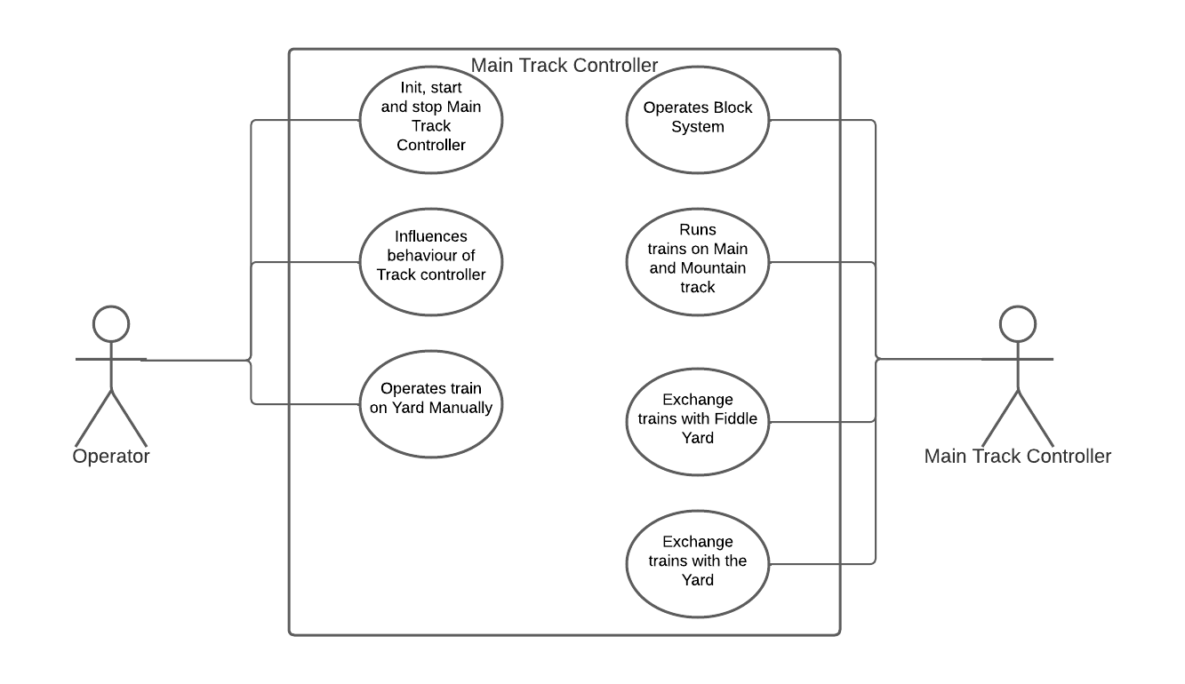

MT-Controller: Operates Block System features
- Trains will drive onto 1 direction, except in a recovery situation. In the recovery situation an operator shall be able to drive a decoupled locomotive backwards to the decoupled wagons.
- The main track shall dissected into various sections that will be operated by using a block system without digital decoders. The sections themselves shall be operated digitally.
- The block system will be build with a number of digital amplifiers that support starting, stopping of locomotives but also can indicate that a current consumer is still present at a piece of track; the track is occupied.
- When crossing sections the amplifiers shall be able to work together in order to let a locomotive pass from one section of the block system into another while accelerating or decelerating.
- The block system shall control the whole layout using the digital amplifiers including the Fiddle Yard. There shall be data communication between Fiddle Yard control and Main Track control.
- The Main track controller shall have means of detecting how many trains are present at the Mountain track and the Main track upon initialization.
- The Main track controller shall support the initialization, FW download, data communication and damage control rules.

MT-Controller: Runs trains on Main and Mountain track features
- Trains will drive onto 1 direction, except in a recovery situation. In the recovery situation an operator shall be able to drive a decoupled locomotive backwards to the decoupled wagons.
- The Main track shall support a “storage/collect” function that allows the Main track controller to store trains in the Fiddle Yard until it is full. In that case it shall park other trains at various pre determined locations like the main station or hidden in tunnels.
- The Main track controller shall support a train exchange command with the Yard controller.
This means that the Yard can request a freight train from the Main track controller or give a freight train back to the Main track controller.
- The Main track controller shall manage all traffic in order to support train exchange events with the Yard.
- The Main track controller shall support 3 real train stations; 1 main track train station “Siebwalde (upper and lower)”, “Waldsee” and “Waldberg”.
- The Main track controller shall operate the mountain track with stations Waldsee and Waldberg independently from the Main track but with using the same digital amplifiers.
- The Main track controller shall drive 1 or 2 trains simultaneously on the Mountain track.
- The Main track controller shall let trains pass each other at the lower station of Siebwalde.
- The Main track controller shall toggle between stationary trains at stations Waldsee and Waldberg if any available.
- The Main track controller shall support running the Main track independently from the Mountain track.
- The Main track controller shall support simulation events on:
  - On all train stations stop-waiting-start times for passenger trains.
  - Slow down and pass by speeds for freight trains on selectable tracks at the station while maintaining the block system rules.
  - Event generation to external modules like city light controller or sound processor boards.
  - Freight train detection for Yard purposes
- The Main track controller shall be programmed in an event driven way.
- The Main track controller shall depend on the Fiddle Yard controller to be initialized first. Until the Fiddle Yard controller will be slimmed down or integrated (partly) into the Main track controller.

MT-Controller: Exchange trains with Fiddle Yard features
- The Main track shall support a “storage/collect” function that allows the Main track controller to store trains in the Fiddle Yard until it is full. In that case it shall park other trains at various predetermined locations like the main station or hidden in tunnels.
- The Main track controller shall depend on the Fiddle Yard controller to be initialized first. Until the Fiddle Yard controller will be slimmed down or integrated (partly) into the Main track controller.
- The Main track controller shall communicate with the Fiddle Yard to manage traffic from and to the Fiddle Yard.

MT-Controller: Exchange trains with the yard features
- The Main track controller shall support a train exchange command with the Yard controller.
This means that the Yard can request a freight train from the Main track controller or give a freight train back to the Main track controller.
- The Main track controller shall manage all traffic in order to support train exchange events with the Yard.

Operator: Init, start and stop Main Track Controller features
- The operator shall be able to select mode of operation and to start or stop automatic running of the Main track and Mountain track.
- The Main track controller shall support the initialization, FW download, data communication and damage control rules.

Operator: Influences behavior of Main Track Controller features
- The Main track shall support a “storage/collect” function that allows the Main track controller to store trains in the Fiddle Yard until it is full. In that case it shall park other trains at various pre determined locations like the main station or hidden in tunnels.
- The Main track controller shall support the possibility for the operator to set behaviors all around the track related to train behaviors as well as how many trains can drive at once on the whole track.

Operator: Operates Yard manually features
- The Main track controller shall support a train exchange command with the Yard controller.
This means that the Yard(Operator) can request a freight train from the Main track controller or give a freight train back to the Main track controller.
- The Main track controller shall support a user interface for controlling trains on the Yard.
- The operator shall be able to select mode of operation and to start or stop automatic running of the Main track and Mountain track.
- The Main track controller shall support manual modes for manual train drive on the Mountain track and Main track.
- The Main track controller shall support running the Main track independently from the Mountain track.

