Application: WinderStairs
Revit Platform: Architecture
Revit Version: 2013.0
First Released For: 2013.0
Programming Language: C#
Skill Level: Advanced
Category: Elements
Type: ExternalCommand
Subject: API Sketched Winder Stairs
Summary:
This sample demos the Winder Stairs creation via sketched stairs API. It implemented the single point L-Winder and U-Winder layout algorithms. And also it utilizes the DMU (dynamic model update) framework to regenerate the winder stairs.

Classes:
Autodesk.Revit.DB.XYZ
Autodesk.Revit.DB.Arc
Autodesk.Revit.DB.Line
Autodesk.Revit.DB.Curve
Autodesk.Revit.DB.Transform
Autodesk.Revit.DB.Transaction
Autodesk.Revit.DB.StairsEditScope
Autodesk.Revit.DB.Architecture.Stairs
Autodesk.Revit.DB.Architecture.StairsRun
Autodesk.Revit.DB.IUpdater
Autodesk.Revit.DB.UpdaterRegistry
Autodesk.Revit.UI.IExternalEventHandler
Autodesk.Revit.UI.ExternalEvent
Autodesk.Revit.UI.IExternalCommand

Project Files:
Command.cs
It contains the class Command which inherits from interface IExternalCommand and implements the Execute method.

WinderUpdater.cs
This class implements IUpdater and IExternalEventHandler interfaces. It’s mainly for winder stairs creation and regeneration when its dependencies are being changed.

WinderCorner.cs
It represents a winder region and used to connect straight runs. For L-shape stairs, there is one WinderCorner, For U-shape stairs, there are two such components.

WinderSinglePoint.cs
This class inherits from WinderCorner. It represents a single point winder corner. It implements the Australia single point algorithm.

WinderStraight.cs
It represents a straight run connecting to winder-corner.

Winder.cs
It represents a winder stairs, and might include multiple straight runs and winder corners.

LWinder.cs
It inherits from Winder and represents an L-Shape winder. An L-Winder consists of two straight runs and a winder corner.

UWinder.cs
It inherits from Winder and represents a U-Shape winder. A U-Winder consists of three straight runs and two winder corners.

WinderUtil.cs
Utility verifies the input parameters, like curves from Revit document. It also adapts the input data for winder stairs creation.

LWinderOptions.cs
This form is used to collect parameters for LWinder creation. It also validates the input parameters.

UWinderOptions.cs
This form is used to collect parameters for UWinder creation. It also validates the input parameters.

Description:
This sample provides following functionalities.
- Let user create single point L-Winder as below:
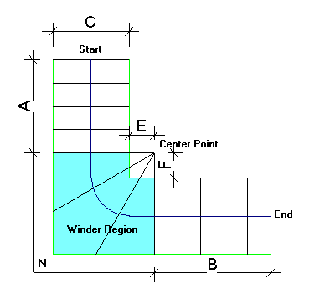

Parameters Description:
N: number of steps in winder region
A: number of parallel steps at start
B: number of parallel steps at end
C: stairs run width
E: distance from center point to interior boundary (=0 by default in Australia)
F: distance from center point to interior boundary (=0 by default in Australia)

- Let user create single point U-Winder Stairs as below:
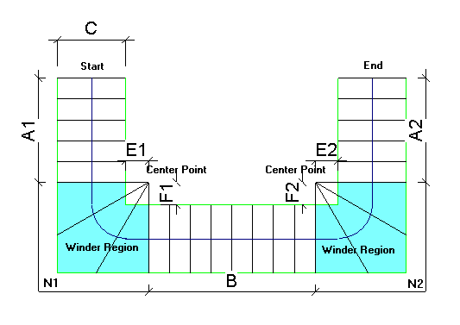

Parameters Description:
C: stairs run width
N1: number of steps in 1st winder region
N2: number of steps in 2nd winder region
A1: number of parallel steps at start
A2: number of parallel steps at end
B: number of parallel steps in the middle
E1: distance from center point to interior boundary (=0 by default in Australia)
F1: distance from center point to interior boundary (=0 by default in Australia)
E2: distance from center point to interior boundary (=0 by default in Australia)
F2: distance from center point to interior boundary (=0 by default in Australia)

Instructions:
Launch Revit and open WinderStairs.rvt file.
- Create L-Winder Stairs.
- Select two connected straight Walls or Model Lines.
- Execute the command and a Form will be shown up.
- Adjust the parameters on the Form for L-Winder creation.
- There are two checkboxes “DMU” and “Sketch”. DMU is to control whether to regenerate the L-Winder stairs when the selected Walls or Model Lines changes. Sketch option indicates whether to draw the winder sketch (including boundary, walk path and risers) as model curves.
- Click OK button to create the L-Winder stairs.
- Expected result: The L-Winder stairs will be created.

- Create U-Winder Stairs.
- Select three connected straight Walls or Model Lines.
- Execute the command and a Form will be shown up.
- Adjust the parameters on the Form for U-Winder creation.
- There are two checkboxes “DMU” and “Sketch”. DMU is to control whether to regenerate the U-Winder stairs when the selected Walls or Model Lines changes. Sketch option indicates whether to draw the winder sketch (including boundary, walk path and risers) as model curves.
- Click OK button to create the U-Winder stairs.
- Expected result: The U-Winder stairs will be created.

