Application: StairsAutomation
Revit Platform: Architecture
Revit Version: 2013.0
First Released For: 2013.0
Programming Language: C#
Skill Level: Medium
Category: Elements
Type: ExternalCommand
Subject: Stairs creation
Summary:
A utility sample that creates a series of stairs, stairs runs and stairs landings configurations based upon predefined rules and parameters.

Classes:
Autodesk.Revit.UI.IExternalCommand
Autodesk.Revit.DB.Architecture.Stairs
Autodesk.Revit.DB.Architecture.StairsRun
Autodesk.Revit.DB.Architecture.StairsLanding
Autodesk.Revit.DB.Architecture.StairsEditScope

Project Files:
- Command.cs - contains the class Command which inherits from interface IExternalCommand and implements the Execute method.
- StairsAutomationUtility.cs - The main class governing the automatic stairs element creation.
- IStairsConfiguration.cs - This interface represents a configuration of stairs runs and landings to be created.
- StairsConfiguration.cs - A specific implementation of IStairsConfiguration with some default storage included.
- StairsSingleStraightRun.cs - A stairs configuration representing a single straight run.
- StairsSingleCurvedRun.cs - A stairs component consisting of a single curved run.
- StairsSingleSketchedStraightRun.cs - A stairs run consisting of a single sketched straight run.
- StairsSingleSketchedCurvedRun.cs - A stairs configuration that represents a single curved run (which will be made in Revit as a sketched run).
- StairsStandardConfiguration.cs - Represents a stairs configuration consisting of straight runs and rectangular landings. The runs will switch based upon the input parameters. The landings width can be adjusted independently.
- GeometryUtils.cs - Geometric utilities used by this sample.
- RunComponents/IStairsRunComponent.cs - The base interface for a single stairs run.
- RunComponents /TransformedStairsComponent.cs - An abstract base class for stairs components which can be moved via a translation and rotation.
- RunComponents /StraightStairsRunComponent.cs - A stairs run consisting of a linear straight run.
- RunComponents /CurvedStairsRunComponent.cs - A stairs component consisting of a single curved run.
- RunComponents /SketchedStraightStairsRunComponent.cs - A stairs run consisting of a single sketched straight run.
- RunComponents /SketchedCurvedStairsRunComponent.cs - A stairs run consisting of a single sketched curved run.
- LandingComponents /IStairsLandingComponent.cs - An interface that represents a landing.
- LandingComponents/StairsRectangleLandingConfiguration.cs - A configuration for creation of a landing with a fixed cross section.
- LandingComponents/LandingComponentUtils.cs - Utilities used in processing of landings.

Description:
This sample provides following:
- An example for how to create and populate stairs elements.
  - Use of StairsEditMode
  - Creation of standard stairs runs
  - Creation of sketched stairs runs
  - Creation of sketched landings
- An extensible structure demonstrating how runs and landings creation can be combined into different stairs configurations

Instructions:
Open Revit and open the sample document. Execute the command. Each time the command is run a different predefined stairs configuration is created.

- Single straight stairs run | 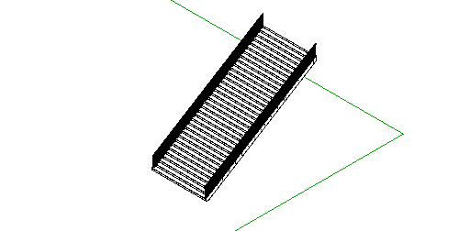
- Stairs/landing combination up to level 2 | 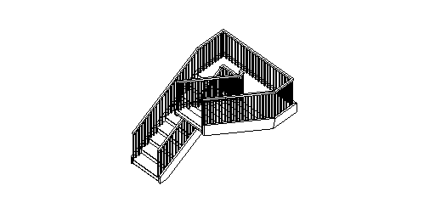
- Multi-span stairs/landing combination up to level 3 | 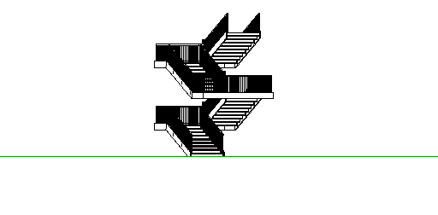
- Single curved stairs run | 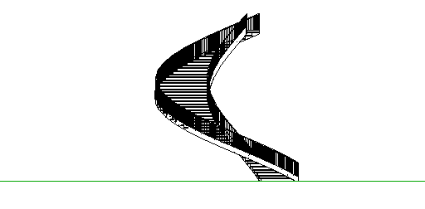
- Curve stairs run > 360 degrees | 