Application: FreeFormElement
Revit Platform: All
Revit Version: 2014.0
First Released For: 2014.0
Programming Language: C#
Skill Level: Medium
Category: Geometry
Type: ExternalApplication
Subject: FreeFormElement creation
Summary:
Use geometry tools to create a new family which has a cutout from an existing element.

Classes:
Autodesk.Revit.UI.IExternalCommand
Autodesk.Revit.DB.FreeFormElement
Autodesk.Revit.DB.BooleanOperationsUtils
Autodesk.Revit.DB.CurveLoop
Autodesk.Revit.DB.Curve

Project Files:
- Application.cs - Implements the Revit add-in IExternalApplication.
- CreateNegativeBlockCommand.cs - A command to create a new family block representing a negative of a selected element.
- FreeFormElementUtils.cs - Utilities supporting the creation of a family containing a FreeFormElement which is cut out from existing geometry.

Description:
This sample:
- Prompts the user to select a solid element in the project to use as a template.
- Prompts the user to select a closed loop of curves parallel to the XY plane.
- Creates a generic model family.
- Creates a FreeFormElement in the family. The geometry will consist of:
  - The closed loop of curves extruded upward to above the height of the target
  - The geometry of the target subtracted from the extruded block
- Loads the family into the project, and places an instance aligned with the original curves.

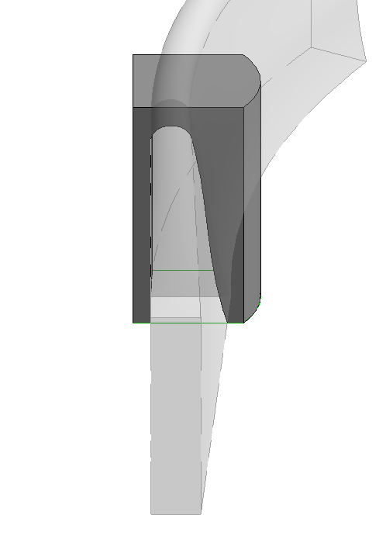
Instructions:
- Open the included Revit project or another project with proper elements set up.
- Select the Add-ins -> FreeForm -> Create negative block button
- Select the target solid element.
- Select the loop of curves (all curves must be selected one-by-one or via box-select).
- Choose Finish.

The new family should be created, loaded and placed in the model.

