Submitting your app to the Autodesk Exchange store

Introduction
Please read through this document before and while submitting your first app to the new Exchange store. It explains the basic workflow and highlights some known issues you need to be aware of in order to make publishing your app as easy as possible.
When using the store, please bear in mind that publisher work flow is still under development. There is more functionality yet to be added, and you may encounter some problems. If you do experience any problems, then please report them to AppSubmissions@autodesk.com.
The publisher workflow is hidden now. We’re doing this because there are some small issues with the publisher workflow that we need to fix and so we don’t want to expose that part of the website to our mutual customers. You will still be able to access the exchange store with the following ‘backend’ URLs:
- To submit a new app,
  - Go to apps.exchange.autodesk.com
  - Select the appropriate product by clicking on the button “Select a store to begin”
  - Login using the login link (that is, by clicking on “Sign In” )
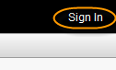
  - Then use http://apps.exchange.autodesk.com/Publisher/Description
- To edit your existing apps,
  - Go to apps.exchange.autodesk.com
  - Select the appropriate product by clicking on the button “Select a store to begin”
  - Login using the login link (that is, by clicking on “Sign In”)
  - Then use http://apps.exchange.autodesk.com/MyUploads
The URL for the new store is apps.exchange.autodesk.com.
Note
- The images shown in below document may be bit different than the actual images in the publisher workflow as we are still enhancing the publisher workflow.
- Please do not forward this document. If someone you know is interested in the Exchange store, please ask them to email AppSubmissions@autodesk.com for more information
- Again, if you face any issues in adding or editing of your application, then report them to AppSubmissions@autodesk.com.
- You must email AppSubmissions@autodesk.com when you have submitted your app.

Submitting a new app

Go to http://apps.exchange.autodesk.com/Publisher/Description.
You will then be taken to a page showing some publishing information. Click the Continue button to move to the publish workflow. (You will be asked to login using your Autodesk Single-Sign-On account if you’re not already logged in):
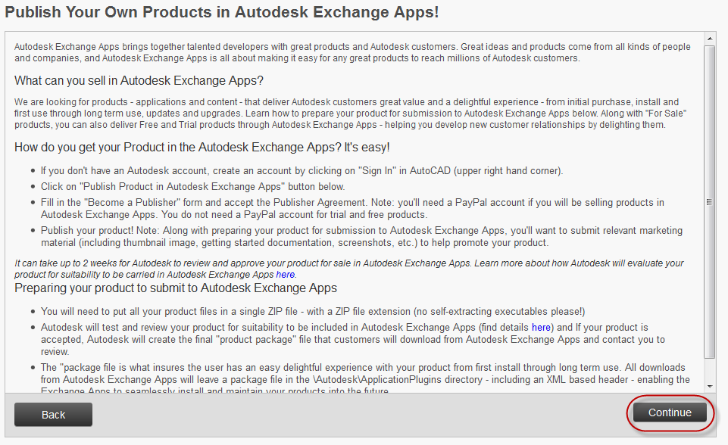

Language selection Screen
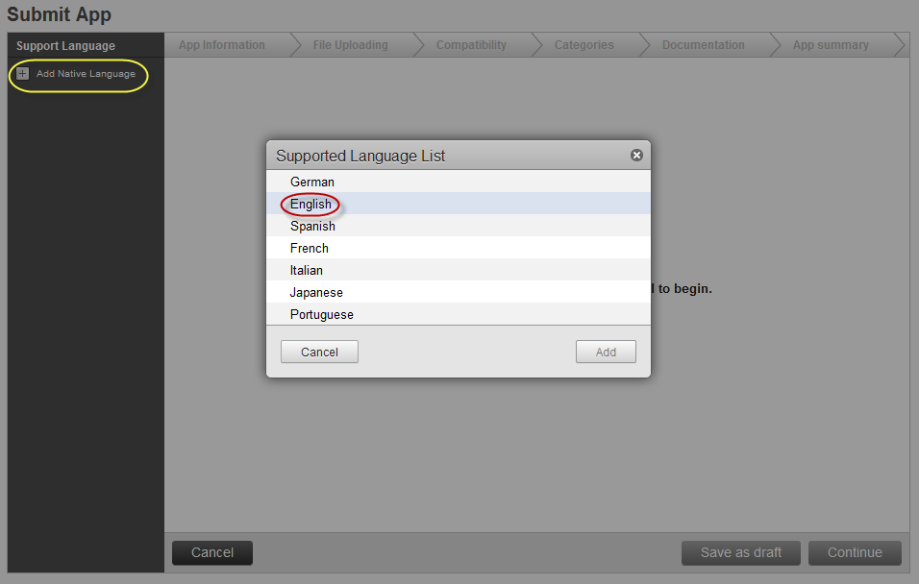
- Click on the Add Native Language link select English from the list, and click the Add button.
  - Only English is supported at this time. We expect the submissions forms for the other languages to become available soon. Every app you submit must include an English version – adding other languages is optional.
- Click the Continue button

App Information Screen
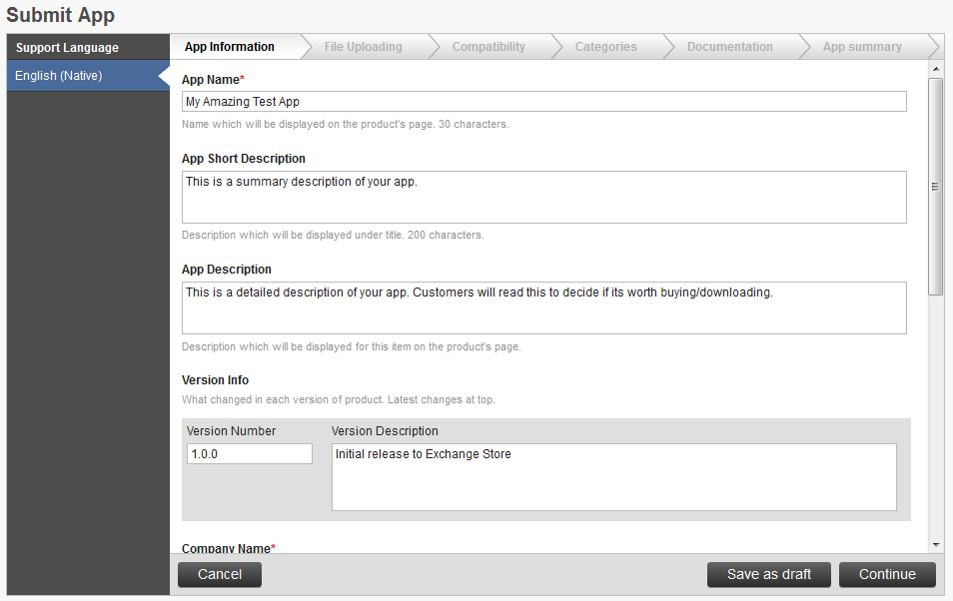
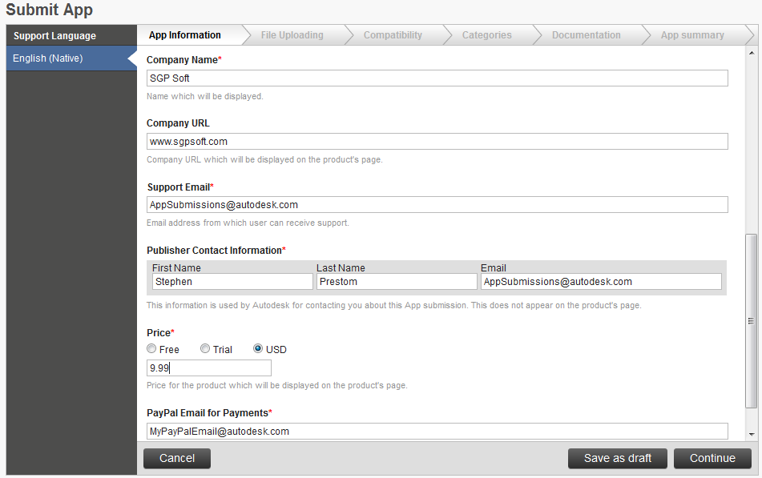
- Enter information in your app in the textboxes on the form.
  - The App Description textbox allows long descriptions (i.e. 1000 characters). This is where you should include a detailed description of your app. Customers will read this section to see if your App is worth buying/downloading.
  - Although the textboxes accept multiline text, the App Description displayed on the store does not currently display carriage returns. This will be fixed soon.
  - If you set a Price, the value you enter must be numeric only (i.e. don’t use $, £, ¥, €, etc.).
  - If you indicate your App is a paid App you will then be asked to add a PayPal email address (but not if you’ll just be providing Free and Trial Products). You should have either a PayPal Business Account or a Premier Account.
- Click Continue to proceed.

File Uploading Screen
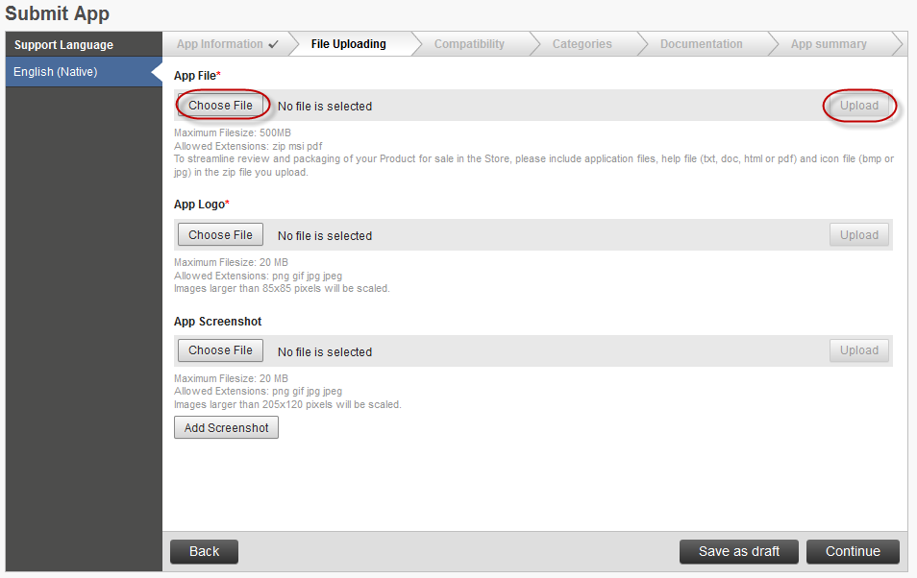
- To upload your app files, click the Choose File button and select your file in the dialog that appears. Then click the Upload button.
- Your App File is your installer, your zipped plug-in files, or your PDF document.
  - If we have already provided you with an MSI installer file for your app, please upload the MSI directly – do not zip it first.
  - Please also upload PDF files unzipped.
- Your App Logo is the icon displayed on the store to represent your app.
  - We recommend 80x80 pixels for your Logo.
  - If you’re looking for a good, free icon editing tool, then you might consider GIMP or Paint.NET.
- Add as many App Screenshots as you wish. Once you’ve uploaded each image, a text box will appear in which you should enter the text that will accompany the screenshot.
- Click Continue to proceed.

Compatibility Screen
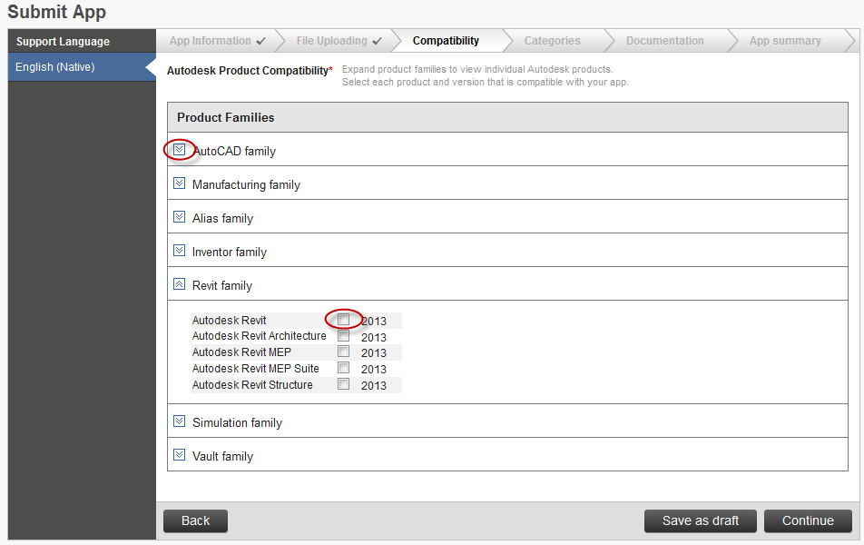
- Click on the ‘down arrow’ symbols to extend a product family list.
- Select all the Autodesk products your app is compatible with.
  - If a product isn’t listed here, then it means that it is not supported by the store at this time. Please contact us for information on unlisted products you’re interested in.
- Marking your app as compatible with a product means that:
  - You have tested your app with that product
  - You are able to support customers using your app with that product.
- Click Continue to proceed.

Categories Screen
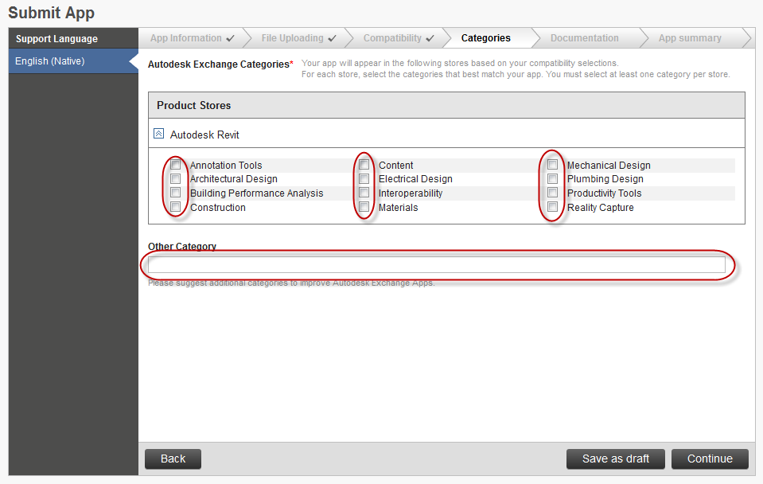
- A list of Categories will be displayed for each Product you selected on the Compatibility Screen.
- Select up to 4 the categories that apply to your application for each product it is compatible with, and add a custom category if needed.
  - Don’t spam customers by selecting Categories that are not relevant to your app.
  - Browsing by Category is not yet implemented on the storefront. It is expected to be available at launch.
- Click Continue to proceed.

Documentation Screen
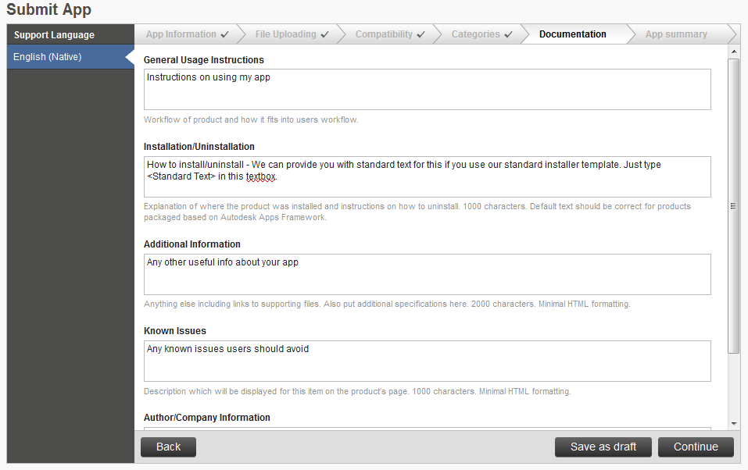
- Enter the information for your app that we can use to create a standard format quick start helpfile. This will be shipped with your app and displayed on the store (not yet implemented).
  - If you’re using our standard installer template (i.e. we are creating the installer for you) then just write ‘standard text’ in the Installation/Uninstallation textbox.
  - In the Author/Company Information textbox, please include details of how a customer can contact you for support (e.g. email this email address, or visit this webpage).
- Click Continue to proceed.

App Summary screen
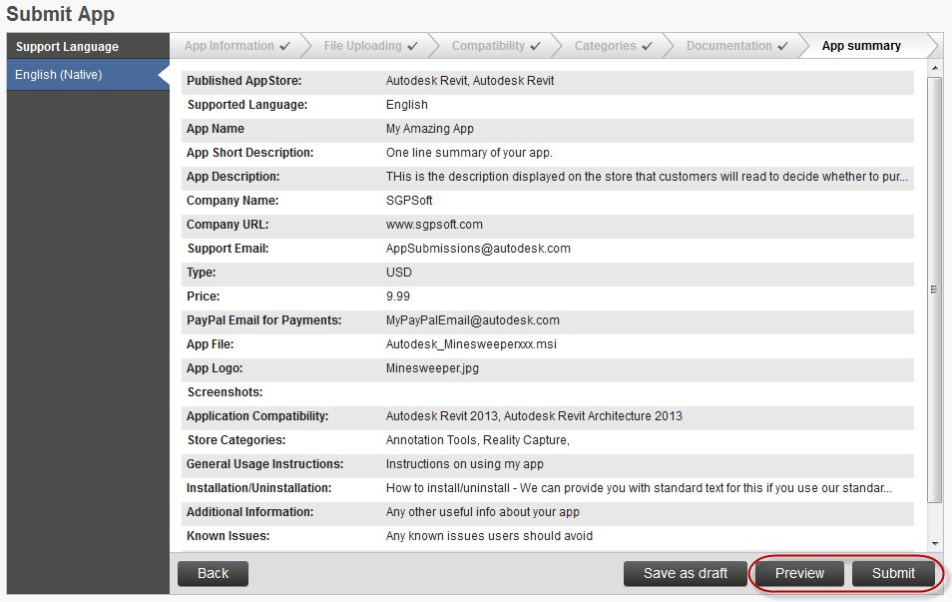
- This is a summary of the information you entered about your app.
- Click the Preview Button to open a new browser tab showing how your app will look in the store.
  - Use the Back button to go back through the workflow to change any information that you don’t like in the Preview.
- Click the Submit button if you’re happy with the Preview.
  - Please also email AppSubmissions@autodesk.com after submitting an app to ensure we process it quickly.

Editing an existing app
- Go to http://apps.exchange.autodesk.com/MyUploads.
- You will then be prompted to log in using your Autodesk Single Sign On account.
- To edit, use edit button corresponding to your application as shown below.
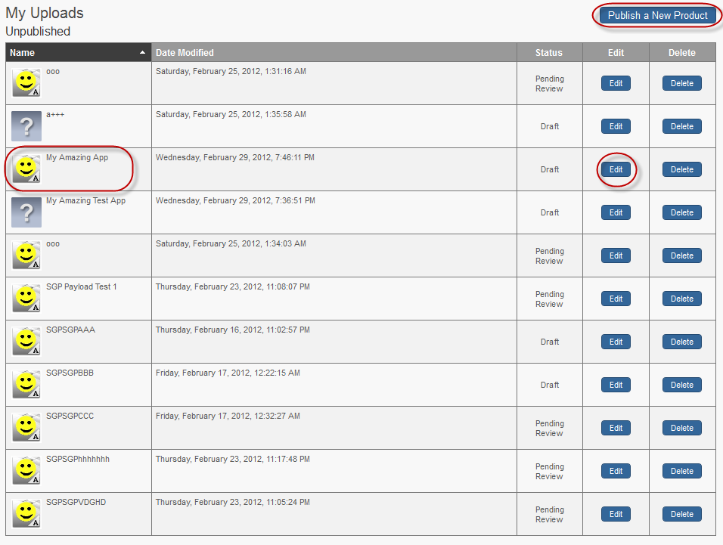
- When you start editing the app, you follow the same workflow as creating a new app, except the information you previously entered is now displayed.

Good luck
- Thank you for your interest in the Exchange store, and good luck with your application sales. Please email AppSubmissions@autodesk.com if you have any questions or experience any problems with the store.

Written by: Stephen Preston

