Steel and Wood Shapes

Type Catalogue

- Steel shapes are generated from type catalogues.

- Type catalogues are text files with ANSI encoding.

- The text file is a comma delimitated, with no spaces. Commas are used to separate fields.

- A return is needed at the end of each row.

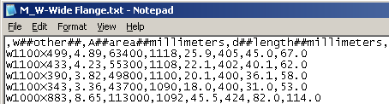

Description

The first row of the text file maps to parameters in Revit families. For example, the below parameter “d” maps to the depth of the I-Shape beam.

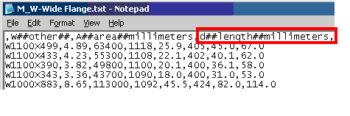

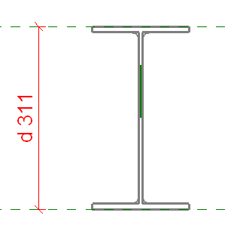

Syntax:

- Header field syntax:

Where

d | Revit Parameter
## | Character Separator
length | Dimension
millimeters | Unit
, | Field Separator

- The first column must contain a comma. This comma indicates that the type name (steel member size) is located in that column.

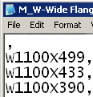

- Successive rows of data must be sequential with the header row.

I-Shape (W Shape)
Use M_W-Wide Flange.txt as template
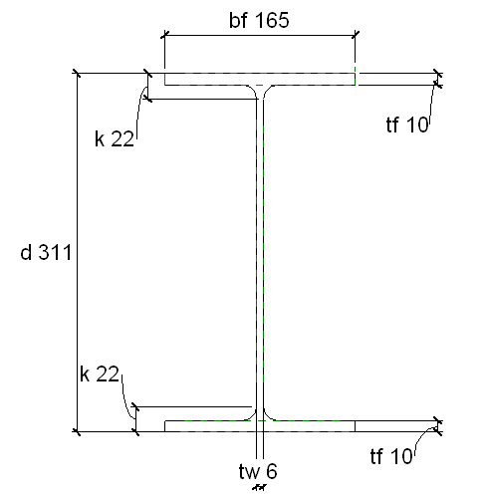

,W##other##,A##area##millimeters,d##length##millimeters,tw##length##millimeters,bf##length##millimeters,tf##length##millimeters,k##length##millimeters

Syntax Header | Description | Units
, | Type Name (or Section Name) | Text
W##other##, | Weight per length of member | Kn/m
A##area##millimeters, | Cross-Sectional Area | millimeters
tw##length##millimeters, | Thickness of Web | millimeters
bf##length##millimeters, | Width of Flange | millimeters
tf##length##millimeters, | Thickness of Flange | millimeters
k##length##millimeters, | Distance from outer flange edge to end or radius | millimeters

M-Shape (Miscellaneous Wide Flange)
Use M_M-Miscellaneous Wide Flange.txt as template
,W##other##,A##area##millimeters,d##length##millimeters,tw##length##millimeters,bf##length##millimeters,k##length##millimeters

Syntax Header | Description | Units
, | Type Name (or Section Name) | Text
W##other##, | Weight per length of member | Kn/m
A##area##millimeters, | Cross-Sectional Area | millimeters
tw##length##millimeters, | Thickness of Web | millimeters
bf##length##millimeters, | Width of Flange | millimeters
tf##length##millimeters, | Thickness of Flange | millimeters
k##length##millimeters | Distance from outer flange edge to end or radius | millimeters

HP-Shape (HP-Bearing Pile)
Use M_HP-Bearing Pile.txt as template

Header

,W##other##,A##area##millimeters,d##length##millimeters,tw##length##millimeters,bf##length##millimeters,tf##length##millimeters, k##length##millimeters

Fields | Descriptions | Units
, | Type Name (or Section Name) | Text
W##other##, | Weight per length of member | Kn/m
A##area##millimeters, | Cross-Sectional Area | millimeters
tw##length##millimeters, | Thickness of Web | millimeters
bf##length##millimeters, | Width of Flange | millimeters
tf##length##millimeters | Thickness of Flange | millimeters
k##length##millimeters | Distance from outer flange edge to end or radius | millimeters

C-Shape (Channel)
Use M_HP-Bearing Pile.txt as template

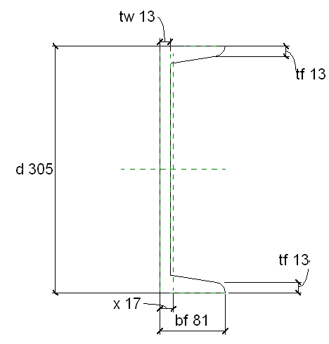

,W##other##,A##area##millimeters,d##length##millimeters,tw##length##millimeters,bf##length##millimeters,tf##length##millimeters,x##length##millimeters

Fields | Descriptions | Units
, | Type Name (or Section Name) | Text
W##other##, | Weight per length of member | Kn/m
A##area##millimeters, | Cross-Sectional Area | millimeters
tw##length##millimeters, | Thickness of Web | millimeters
bf##length##millimeters, | Width of Flange | millimeters
tf##length##millimeters, | Thickness of Flange | millimeters
x##length##millimeters | Distance from edge of web to centroid | millimeters

MC-Shape (Miscellaneous Channel)
Use M_MC-Miscellaneous Channel.txt as template

,W##other##,A##area##millimeters,d##length##millimeters,tw##length##millimeters,bf##length##millimeters,tf##length##millimeters,x##length##millimeters

Fields | Descriptions | Units
, | Type Name (or Section Name) | Text
W##other##, | Weight per length of member | Kn/m
A##area##millimeters, | Cross-Sectional Area | millimeters
tw##length##millimeters, | Thickness of Web | millimeters
bf##length##millimeters, | Width of Flange | millimeters
tf##length##millimeters, | Thickness of Flange | millimeters
x##length##millimeters | Distance from edge of web to centroid | millimeters

ST- Structural Tee
Use M_ST-Structural Tee.txt as template
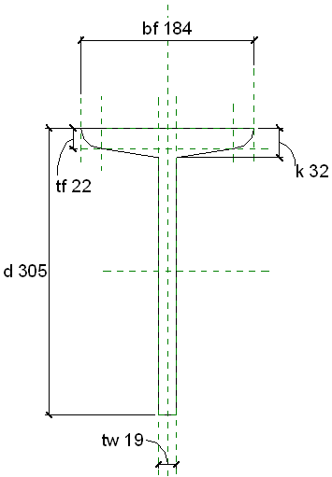

,W##other##,A##area##millimeters,d##length##millimeters,bf##length##millimeters,tw##length##millimeters,tf##length##millimeters,k##length##millimeters

Fields | Descriptions | Units
, | Type Name (or Section Name) | Text
W##other##, | Weight per length of member | Kn/m
A##area##millimeters, | Cross-Sectional Area | millimeters
tw##length##millimeters, | Thickness of Web | millimeters
bf##length##millimeters, | Width of Flange | millimeters
tf##length##millimeters, | Thickness of Flange | millimeters
k##length##millimeters | Distance from outer flange edge to end or radius | millimeters

MT- Structural Tee
Use M_MT-Structural Tee.txt as template

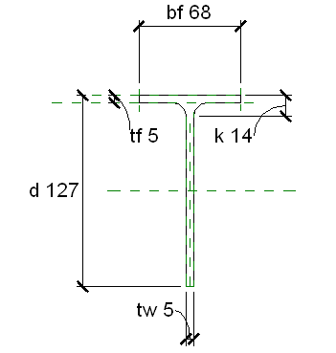

,W##other##,A##area##millimeters,d##length##millimeters,bf##length##millimeters,tw##length##millimeters,tf##length##millimeters,k##length##millimeters

Fields | Descriptions | Units
, | Type Name (or Section Name) | Text
W##other##, | Weight per length of member | Kn/m
A##area##millimeters, | Cross-Sectional Area | millimeters
tw##length##millimeters, | Thickness of Web | millimeters
bf##length##millimeters, | Width of Flange | millimeters
tf##length##millimeters, | Thickness of Flange | millimeters
k##length##millimeters | Distance from outer flange edge to end or radius | millimeters

WT- Structural Tee
Use M_WT-Structural Tee.txt as template

,W##other##,A##area##millimeters,d##length##millimeters,bf##length##millimeters,tw##length##millimeters,tf##length##millimeters,k##length##millimeters

Fields | Descriptions | Units
, | Type Name (or Section Name) | Text
W##other##, | Weight per length of member | Kn/m
A##area##millimeters, | Cross-Sectional Area | millimeters
tw##length##millimeters, | Thickness of Web | millimeters
bf##length##millimeters, | Width of Flange | millimeters
tf##length##millimeters, | Thickness of Flange | millimeters
k##length##millimeters | Distance from outer flange edge to end or radius | millimeters

L-Angle
Use M_L-Angle.txt as template
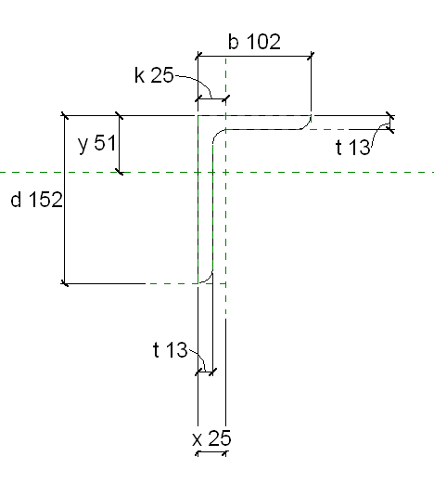

,W##other##,A##area##millimeters,d##length##millimeters,b##length##millimeters,t##length##millimeters,k##length##millimeters,x##length##millimeters,y##length##millimeters

Fields | Descriptions | Units
, | Type Name (or Section Name) | Text
W##other##, | Weight per length of member | Kn/m
A##area##millimeters, | Cross-Sectional Area | millimeters
d##length##millimeters | Member depth | millimeters
b##length##millimeters, | Width of Flange | millimeters
t##length##millimeters, | Member thickness | millimeters
k##length##millimeters, | Distance from outer edge to end of radius | millimeters
x##length##millimeters, | Distance from edge to centroid in X-direction | millimeters
y##length##millimeters | Distance from edge to centroid in Y-direction | millimeters

LL-Double Angle
Use M_L-Angle.txt as template

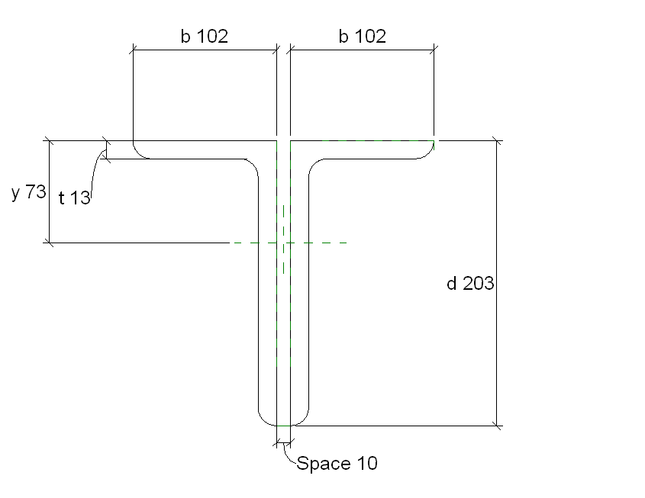

,Legs##other##,Space##length##millimeters,W##other##,A##area##millimeters,d##length##millimeters,b##length##millimeters,t##length##millimeters,y##length##millimeters

Fields | Descriptions | Units
, | Type Name (or Section Name) | Text
Legs##other##, | A text identifier describing the orientation of the two angles. For example “LLBB” signifies Long Leg Back to Back | Text
Space##length##millimeters, | Distance (or gap) between the two angles | millimeters
W##other##, | Weight per length of member | Kn/m
A##area##millimeters, | Cross-Sectional Area | millimeters
d##length##millimeters | Member depth | millimeters
b##length##millimeters, | Width of Flange | millimeters
t##length##millimeters, | Member thickness | millimeters
y##length##millimeters | Distance from edge to centroid in Y-direction | millimeters

Hollow Tube
Use M_HSS-Hollow Structural Section.txt as template

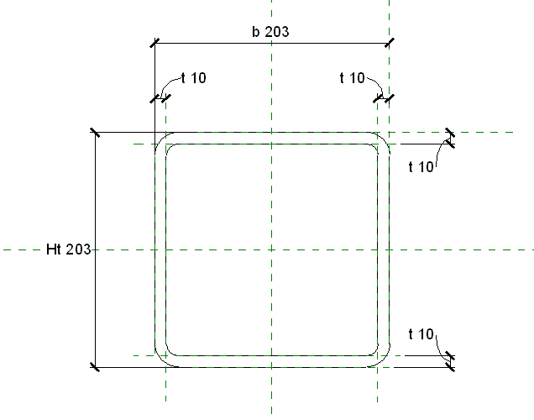

,Shape##other##,W##other##,A##area##millimeters,Ht##length##millimeters,b##length##millimeters,t##length##millimeters

Fields | Descriptions | Units
, | Type Name (or Section Name) | Text
Shape##other##, | Text identifier indicating either “Rectangular” or “Square” | Text
W##other##, | Weight per length of member | Kn/m
A##area##millimeters, | Cross-Sectional Area | millimeters
Ht##length##millimeters, | Height of member | millimeters
b##length##millimeters, | Width of Member | millimeters
t##length##millimeters | Thickness | millimeters

Circular Hollow Tube
Use M_HSS-Round Structural Tubing.txt as template

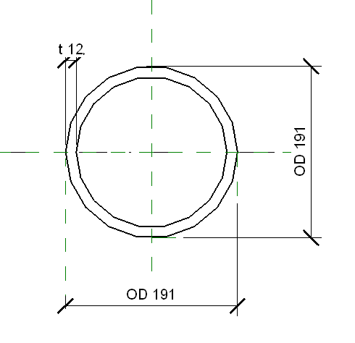

,W##other##,A##area##millimeters,OD##length##millimeters,t##length##millimeters

Fields | Descriptions | Units
, | Type Name (or Section Name) | Text
W##other##, | Weight per length of member | Kn/m
A##area##millimeters, | Cross-Sectional Area | millimeters
OD##length##millimeters, | Outside Diameter | millimeters
t##length##millimeters | Thickness | millimeters

Pipe Column
M_Pipe-Column.rfa

Required Information
Type | Depth (d) | Width (b)
 | mm | mm

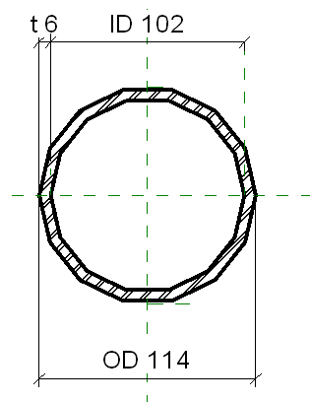

Open Web Steel Joist
M_K-Series Bar Joist-Angle Web.rfa, M_K-Series Bar Joist-Rod Web.rfa, M_DLH-Series Bar Joist.rfa, M_LH-Series Bar Joist.rfa

NOTE: The Open Web Steel Joist is depicted in elevation and section below.

Required Information
Type | Extended End | Seat Length | End Panel | Depth | Panel | Web Thickness | Cord Depth
text | mm | mm | mm | mm | mm | mm | mm
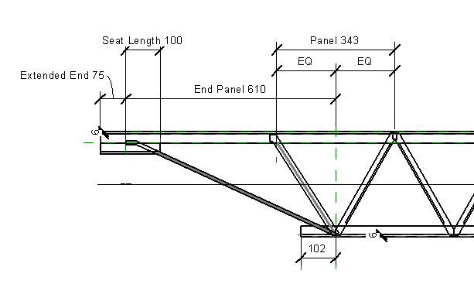

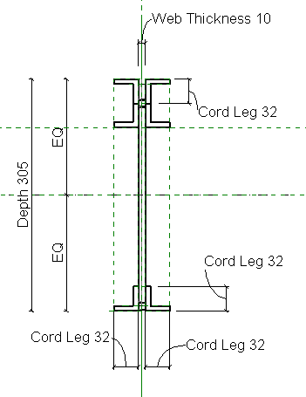

Wood Shapes

Columns- Lumber

M_Dimension Lumber-Column.rfa

Required Information
Type | Depth (d) | Width (b)
text | mm | mm

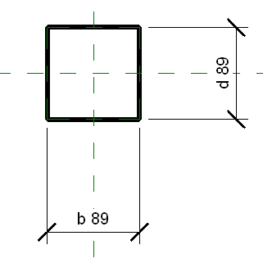

Columns- Timber

M_Timber-Column.rfa

Required Information
Type | Depth (d) | Width (b)
text | mm | mm

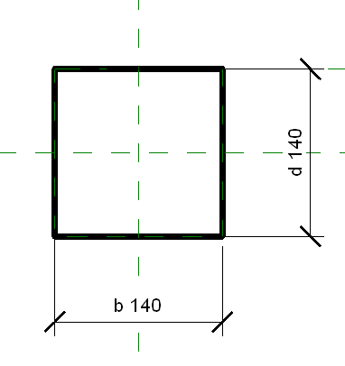

Beam- Lumber

M_Dimension Lumber.rfa

Required Information
Type | Depth (d) | Width (b)
text | mm | mm

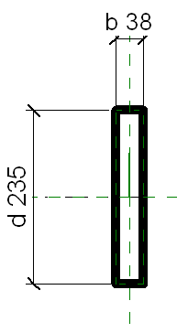

Plywood Web Joist

M_Plywood Web Joist.rfa

Required Information
Type | Depth (d) | Width (b)
text | mm | mm

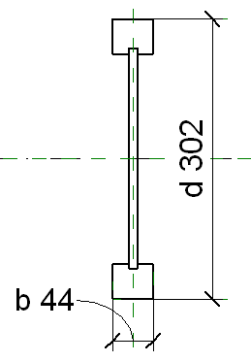

Beam- Timber

M_Timber.rfa

Required Information
Type | Depth (d) | Width (b)
text | mm | mm

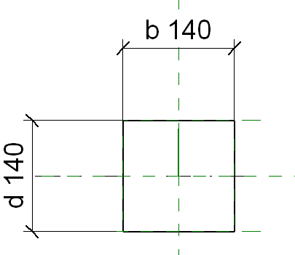

Open Web Wood Joist

M_Wood Open Web Joist.rfa

NOTE: The Wood Open Web Joist is given in elevation and section below.
Required Information
Type | Depth | Chord Depth | Chord Width
text | mm | mm | mm

