**Achievements of CIIE**

Last year's CIIE was the first one. It was the first time any nation of this size actually said we want imports.

Last year's results were good：

* Over 57 billion dollars' worth of deals were signed
* A million people came
* And over 3,500 different companies participated.

The 2nd China International Import Expo (CIIE)

* made 71 billion U.S. dollars of intended deals, a 23-percent increase from the last expo.
* the six-day event attracted 3,900 companies from more than 150 countries and regions to participate, with major achievements following from 13 enterprises that have greatly benefited from the first CIIE.

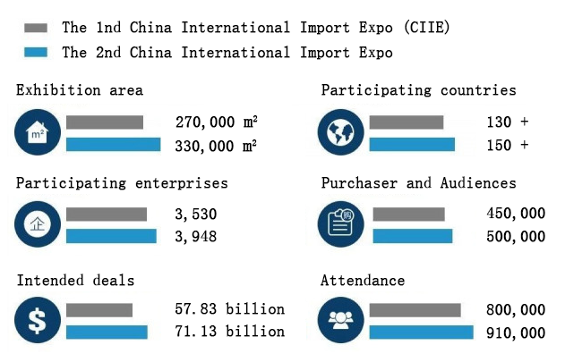

**Popular themes**

* smart and industry equipment products
* medical equipment and medical care products
* automobiles
* electronic products and home appliances
* food and agricultural products
* clothes and consumer goods
* service trade

**The third CIIE next year will feature**

* Technology and equipment
* consumer and smart life
* food and agricultural
* service and health

As of now, more than 230 companies have signed up for the next CIIE, with an exhibition area of ​​over 84,000 square meters. Eighty of them are among the world's top 500 and leading enterprises.

**What does CIIE mean to China?**

* In terms of consumption, it means lower-cost goods for the average consumers in China.
* In terms of the other things, China is trying to make sure that companies who are coming in here to do business be part of this market, are creating new jobs in high technology, design – the areas that will continue to be a growth factor for them.
* Bringing technology, knowhow – these are the important things.

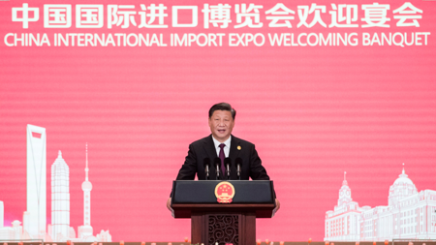

It is a major step for China in opening its market to the world. Like President Xi Jinping said, the CIIE is designed to trade goods and services, exchange culture and ideas, welcome visitors from across the globe

President Xi Jinping：“*benefit the whole world and respond to the aspirations of people from various countries to live a better life.*”

**In Future**

China has rolled out a slew of measures to ease restrictions on foreign investment.

The government also plans on removing the investment cap of 25 percent in Chinese commercial banks by multiple overseas financial institutions.

Moreover, the government promises to offer land and logistical support to certain foreign investment projects to help cut costs.