2026 Employee Benefits Guide
This guide summarises your medical, dental, vision, retirement, and flexible spending account (FSA) options for the 2026 plan year. Review each section carefully before Open Enrollment closes November 15. For help choosing a plan, click here to reach the Benefits Portal.

Medical Plan Comparison
UT Southwestern offers three medical plans through BlueCross BlueShield. All plans include preventive care at 100% in-network.
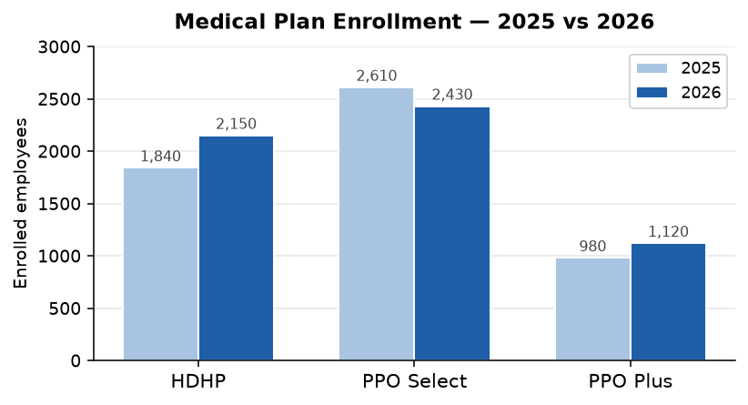
Figure 1: Medical plan enrollment by tier — 2025 vs 2026
Plan | Monthly Premium | Deductible | Out-of-Pocket Max
HDHP | $180 / $510 | $1,500 / $3,000 | $4,000 / $8,000
PPO Select | $310 / $820 | $500 / $1,000 | $3,000 / $6,000
PPO Plus | $420 / $1,100 | $250 / $500 | $2,000 / $4,000

Dental Coverage
Delta Dental PPO covers two cleanings per year at 100% in-network. Major restorative work is covered at 50% after the $75 deductible. click here for the full Dental Schedule of Benefits.
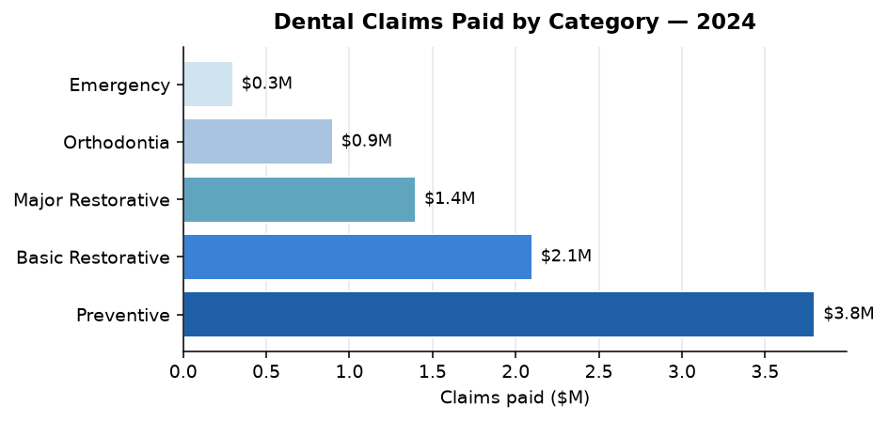
Figure 2: Dental claims paid by category, 2024

Retirement — 403(b) Plan
UT Southwestern matches 100% of your first 3% of salary deferred and 50% of the next 2%, for a maximum institutional match of 4% of pay. Contributions vest immediately.
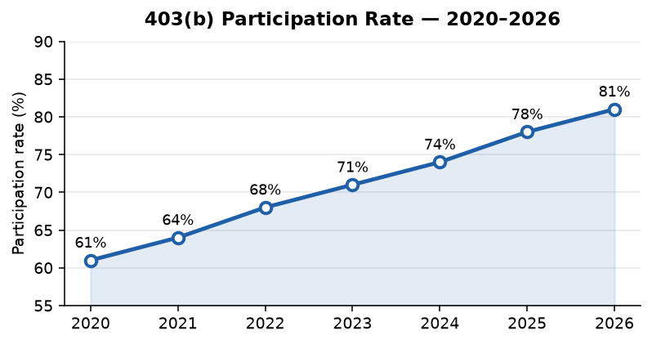
Figure 3: 403(b) participation rate trend 2020–2026

403(b) Contribution Tiers
Your Contribution | UT SW Match | Total
1–3% | 3% | 4–6%
4–5% | 3.5% | 7.5–8.5%
> 5% | 4% | > 9%

Flexible Spending Accounts (FSA)
You may elect up to $3,200/year to a Healthcare FSA and $5,000 to a Dependent Care FSA. FSA funds are available on day one of the plan year.
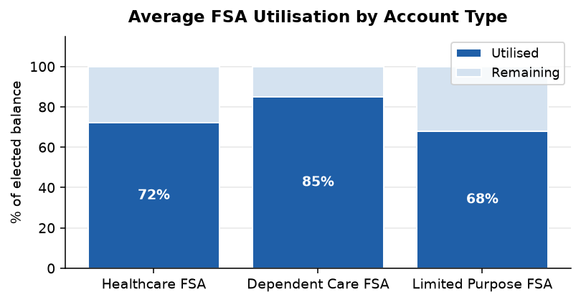
Figure 4: FSA utilisation by account type — all employees
Questions? Contact HR Benefits at benefits@utsw.edu or 214-648-3996. Open Enrollment closes November 15, 2025.

