Linux Servers
Classroom Assignment 1 – Initial configuration
Document your commands or take screenshots. Answer questions in english or finnish. Remember that the lab work is graded and you should always show both how you configured the service and that it works in order to get points.

Network settings and hostname (1p)
Using the material as help, configure your server to have a static IP address. First check what subnet the current class uses (usually 192.168.x.0/24) Then check the ip address of your physical workstation (usually numbered so x.11 is WS-01, x.12 is WS-02 etc.[WS-33] )[192.168.48.43]. and add 50.[192.168.48.93] This is your new IP address for the server.
Configure .1 address from the classroom subnet as your gateway and 192.168.40.21 and 192.168.40.22 as your DNS servers.
Restart networking and test that you can both resolve and ping www.google.com or any other internet service.
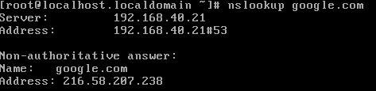
If you are doing the work at home, use any IP you want in your own network, but it must be set statically. You can also use any nameservers you like, for example your ISPs or Google public ones.
Set the hostname of your server as lab1.<your student-id>.local
Set it also at hosts file to point to your ip address. Test that you can ping your own hostname. Reboot or logout may be necessary for the server to show the new hostname correctly in the command line.
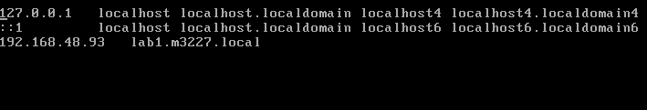
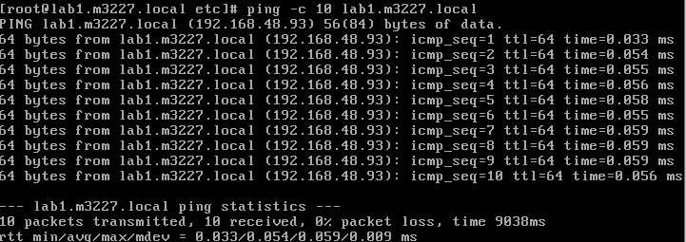
Bonus: At home, if you have access to internal DNS settings in your firewall or edge router, create a static host entry and point it to the servers IP.

Time and date (1p)
With timedatectl, set the correct date and time. Time needs to be set in format "year-month-day hh:mm". Set timezone as Europe/Helsinki.
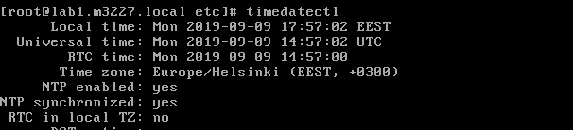
Edit /etc/chrony.conf and disable the current NTP servers. (comment the lines). Add your own line so the only NTP server to be used is ntp.labranet.jamk.fi.dir
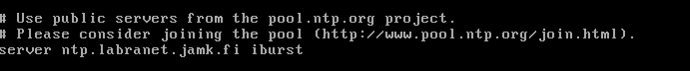
Turn NTP on and confirm that time is synchronized with chronyc tracking.
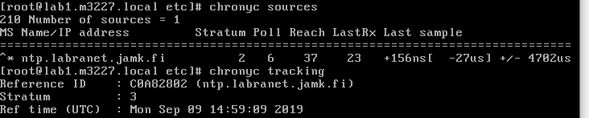
If you are doing the work at home, find a public NTP server, for example from FUNET and use that instead.

User accounts and groups (1p)
Create a new user account with the name as your student-id. (For example, useradd … e6210). Make sure a home folder is created for the user.
Add this account to SECONDARY group wheel and set a password for it. You should use this account for the next few labs.
Create users teppo and sulo and set a password for them. Create group legacy and add both users to the group as SECONDARY group.
ss
Create a folder /legacy. Change the owner of the folder to yourself and group to legacy. Set the permissions so that owner and group have full permissions and others have none. Use setgid permission to make sure all new files created in the folder are owned by the group legacy.
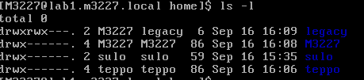
Login as teppo or sulo and verify they can create files in /legacy and the owner and group are correct.

Multi-user permissions (1p)
Log on to the student-servers (ssh student.labranet.jamk.fi) using your LabraNet account. You can use PuTTY or ssh from the Linux server. What group do you belong to? What is your numerical system ID.
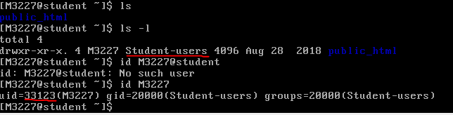
Create a new folder in your home directory with the name lx
Inside the folder, create a text document called extra.txt containing some text.
Now the tricky part: Give access to the lx folder for all users in the same group as you are. Set the permissions as following:
- Your home folder: You have all permissions, group and others have traverse (execute)
cd

- lx-folder: You have all permissions, group has all permissions and others have none
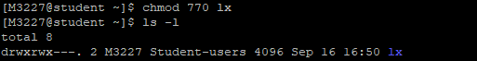
- extra.txt document: You have read and write, group has only read and others have none
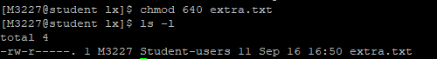
When you are done, ask someone else or the teacher to verify:
- They should be able to list the contents of your lx-folder, but not other folders or files in your home directory. (NOTE: You will need to use the full path to access someone others lx-folder, such as /home/e6210/lx/. You should not see inside /home/e6210/)
- They should also be able to read your text document but not modify it.
- They should also be able to create new files in your lx folder
If you have access to other users lx-folder, create a new document there called <your student-id>-says-hello.txt and leave a polite message there that everything seems to work.
Why does your home directory need the execute permission? Why is there execute permission for everyone by default?

Keypair -based login (1p)
Using the software Puttygen, create a RSA keypair and copy the public key to the server, allowing you to log in without remembering password every time.
On CentOS7, the correct folder/file for the public key is .ssh/authorized_keys in users home folder. For root this is /root/.ssh/authorized_keys. This folder and file MUST have the correct permissions, or key-based logins will not work:

- .ssh: User(owner) has all permissions, group and others have none
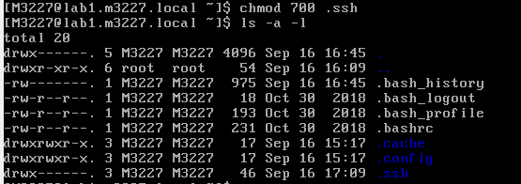
- .ssh/authorized_keys: User has read/write, group and others have none
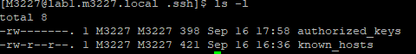
Set these permissions NUMERICALLY for practice.

BONUS ENGINEERING TASK
When you create a new file, you can see how that the permissions for this file are set as rw-r--r-- (644)
Also when you create a new folder, the default permissions are rwxr-xr-x (755)
This is sub-optimal on a multi-user environment as users can read others data by default.
Find out how this can be modified and demonstrate so new files are created with permissions 640 and folders with 750.
