Linux Servers
Classroom Assignment 2 – Service management
Document your commands or take screenshots. Answer questions in english or finnish.
You can use the same VM as before or clone a new one.

Systemctl (1p)
What is the Active status of the following services (systemctl status servicename): sshd, network and kdump
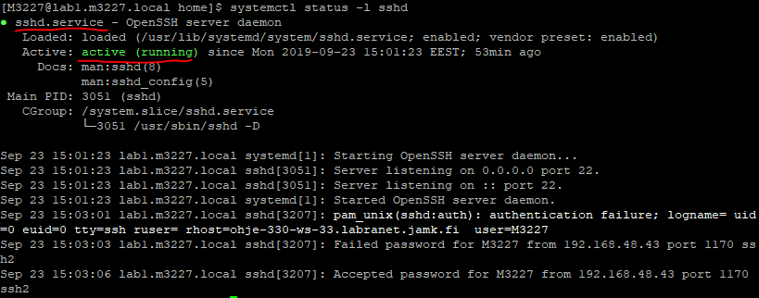

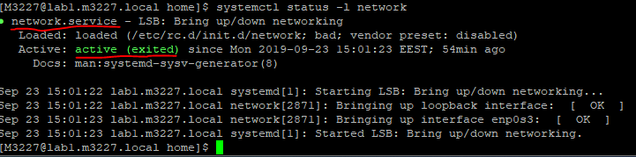
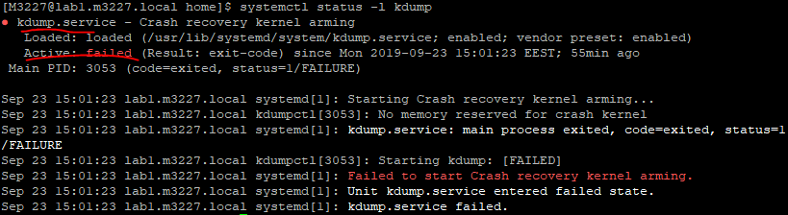
Search the internet and explain the differences between the status messages.
Stop the firewalld service and verify with systemctl status. Reboot. Why is the service now running? Where do you see this in the status output? What process number(s) is the service using?
- firewalld stars automatically with start up because Vendor preset is enabled
- firewalld:s process number is 2561
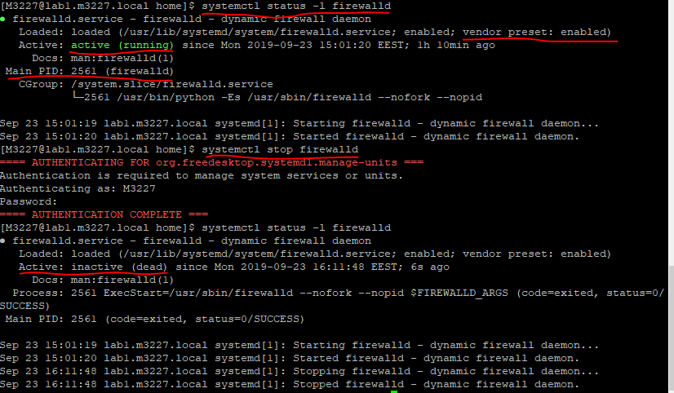

YUM (1p)
Clear yum cache and update the server with yum update.
- yum clean all
NEVER cancel the update when it is installing packages (Canceling when it is downloading is ok as no packages are yet installed)
Reboot and check that there are no new updates pending.
- yum check-update
Install epel-release package. This will automatically enable the EPEL repo. What is the architecture of the package?
- yum install epel-release
- No architecture

Install Grafana (1p)
Grafana is a graphing tool that is used to collect metrics. We will be using it to demonstrate how installing software from custom repos work. Create /etc/yum.repos.d/grafana.repo and include the following config:
[grafana]
name=grafana
baseurl=https://packages.grafana.com/oss/rpm
repo_gpgcheck=1
enabled=1
gpgcheck=1
gpgkey=https://packages.grafana.com/gpg.key
sslverify=1
sslcacert=/etc/pki/tls/certs/ca-bundle.crt

Pro tip: If you are not using PuTTY already, please do. That way you can just copy&paste the above config into the file.
Clean yum cache and test that the repository works using yum repolist. Install the package grafana.
Start the grafana-server -package and make sure it start every time on boot.
- systemctl enable Grafana-server
Check the status of the service. Find out what port this service is using (from the internet or using tools such as netstat -lnut). Confirm with lsof -i:portnumber, this should show you the ntopng process.
- Grafana uses port 3000

Firewall rule (1p)
Create a new firewalld service definition for the service (you will need at least the port and protocol). Use firewall-cmd --new-service=grafana as a starting point.
Then allow the service permanently in firewalld. Remember to reload the firewall when making changes. Make sure the XML file has no typos or you cannot add the service!
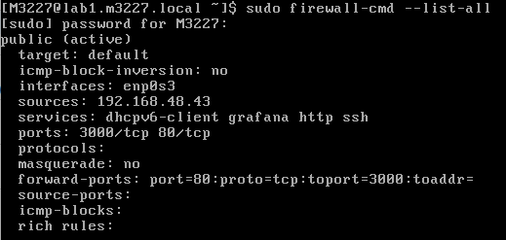

Now you should be able to open the service management page by browsing to the server ip with Firefox/Chrome. Remember that the service uses nonstandard port (use serverip:port in browser). Default username and password are admin/admin. 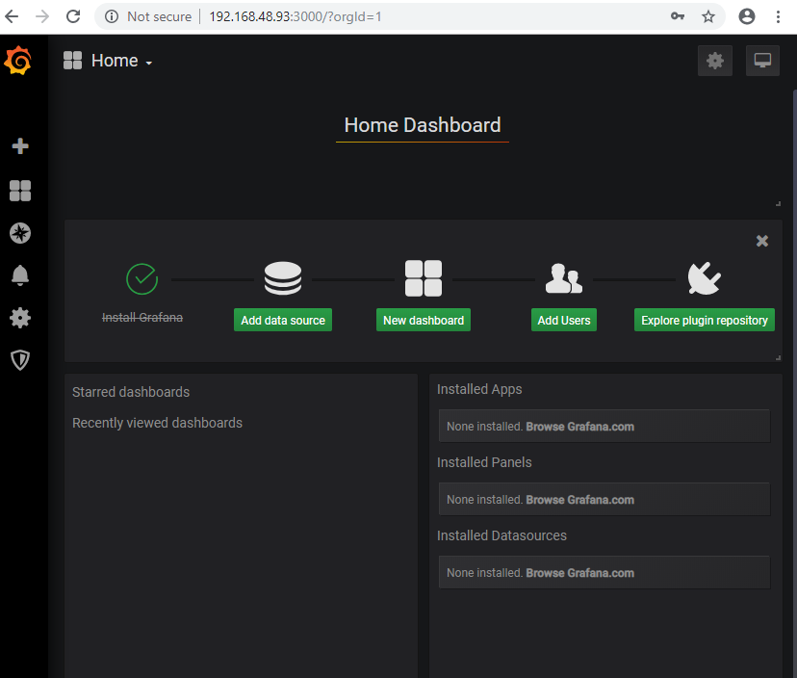
Create a port forward rule in the FirewallD so you can use the service from the normal HTTP port 80.

Manual package installation (1p)
OpenTFTPD is a service for creating a TFTP server, but it has no known repositories. A tar.gz-package can be found in http://student.labranet.jamk.fi/~jojuh/lx/opentftpd.tar.gz
The package does include a README. You can also check http://student.labranet.jamk.fi/~jojuh/lx/INSTALL.opentftpd for help.
OpenTFTPD needs to be compiled and installed by hand! The steps needed are:
- Fetch the package using wget
- "Untar" the package (tar -xvf)
- Find out what you need for compiling (hint: yum provides), install compiler package, compile
  - yum groupinstall 'Development Tools'
- (Note: No special libraries are needed for compiling, just the compiler package and dependencies)
- Copy the files to their correct paths (see INSTALL.opentftpd)
- Create a systemd service definition and start the service
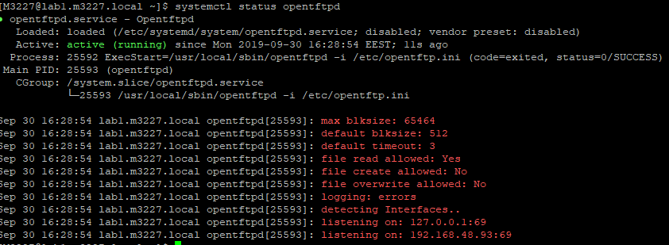

BONUS ENGINEERING TASK
Clone a new virtual machine. Assume you have forgotten the root password.
Find out how to do a password recovery. You will need to enter GRUB during boot and interrupt the normal boot sequence somehow.
- Enter the Boot service pressing ´e´ during boot.
- Modify boot options by removing ´rhgb´ and ´quiet´, and adding ´rd.break´ and ´enforcing=0´
There are many guides on how to do this but only few of them will work correctly. Find one that takes SELinux into account and you should be okay.
