Lab1 – Certificates
You can use this lab manual for your personal documentation. Use screenshots for your own documentation, there will be questions later on that may point to this lab manual. Take care to check if you need to collect some information from the lab for the answers.
\ at the end of the line is used to mark that the command needs to be on one line. Replace student-id with your own student-id and x or y as your VMs correct IP in the labs.
The labs use the following topology:

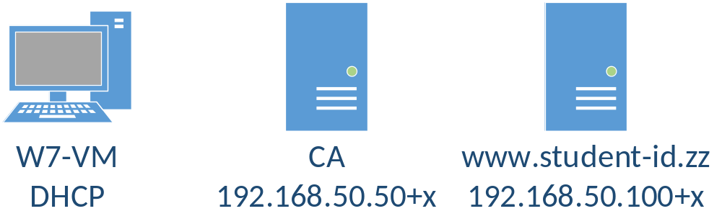
All VMs in this lab are in VirtualBox Bridged network. The machines that have static IP need to have an offset, check the topology image for reference. USE YOUR WIN7 WORKSTATION IP ADDRESS AS x.
All templates for VMs can be found in \\ghost.labranet.jamk.fi\virtuaalikoneet\TTKS\

Install subCA
Using the Centos7_k2019 template from \\ghost.labranet.jamk.fi\virtuaalikoneet\TTKS\, clone another VM with the name CA. Remember to set “Reinitialize the MAC address…” tickbox in the import wizard. Set VM interface as Bridged.
Boot up the VMs shown in the topology and login to the new subCA VM (root/root66). Check that it has got an IP. First, lets create the CA certificate and other required files:
mkdir /root/ca
cd /root/ca
wget https://student.labranet.jamk.fi/~jojuh/ttks/ca.cnf
wget https://student.labranet.jamk.fi/~jojuh/ttks/usr.cnf
echo 01 > serial
touch index.txt
touch index.txt.attr
openssl req -new -newkey rsa:4096 -keyout ca.key -config ca.cnf -days 365 -extensions v3_ca -x509 -out ca.pem
When asked for a passphrase for the key, use root66. Fill in the information, set both CN (Common Name) as your-student-id-CA and O (Organisation) as your-student-id. (Example: CN=e6210-ca and O=e6210).
Check the content of the new CA certificate:
openssl x509 -text -noout -in ca.pem
You should see the info you typed, public key is 4096bits and the most important part: CA:TRUE in Basic constraints. Without this, your CA cert will not be trusted by the clients.
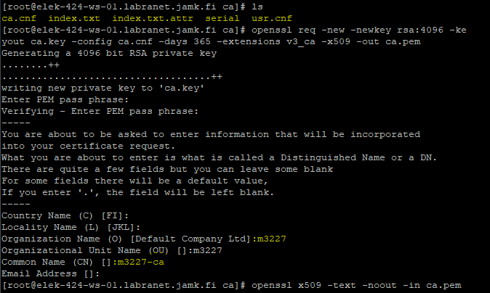
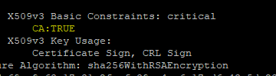

Creating a CSR for the web server
Clone and boot up the Webserver VM. Create a new RSA key and CSR for the webserver. To use subjectAltNames correctly, we need a local copy of the openssl.conf:
cp /etc/pki/tls/openssl.cnf /root/openssl_san.cnf
Now modify this new file and add the following lines to the bottom of the config:
[alt_names]
DNS.1 = www.your-student-id.zz
DNS.2 = your-student-id.zz
IP.1 = your-webserver-ip-here
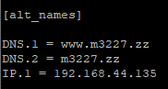
Then find the [v3_req] section and add:
subjectAltName = @alt_names
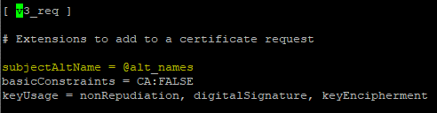
Also uncomment the following under [req] –section:
req_extensions = v3_req
BONUS: As there is no way to give these subjectAltNames as parameters to openssl command-line, several different ways of doing this have been engineered. If you want a challenge, find a way to add SANs in a oneliner command.
Now we can use the new config file and correct SANs should appear in the certificate request:
openssl req -new -newkey rsa:2048 -nodes -keyout www.key -out www.csr -config /root/openssl_san.cnf
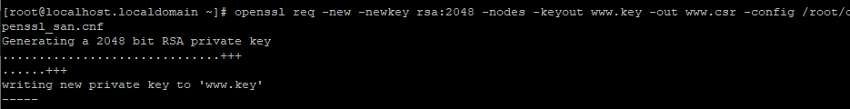
Set CN as www.your-student-id.zz, other fields like you did with the CA. Be very precise with the command-line above to avoid errors! It is only a single line! Double-check the contents of the CSR, it absolutely should show the Subject Alternative Name fields too:
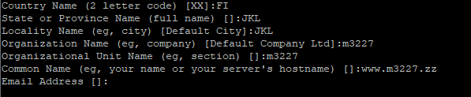
openssl req -noout -text -in www.csr
On the CA VM, copy the csr from the webserver to the CA machine (Change the IP to point to Web server):
cd /root/ca
scp root@webserver-ip-here:www.csr ./
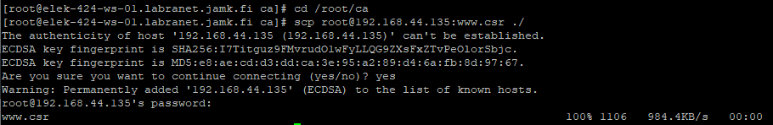
If everything seems to be right, sign the CSR with the CA key:
openssl ca -config usr.cnf -extensions usr_cert -days 180 -keyfile ca.key -cert ca.pem -in www.csr -out www.pem
Before answering yes, take time to check that the certificate info is correct. Especially check that Basic Constraints has CA:FALSE as we do not want our webserver to be a CA. Examine the contents of the new CRT file: 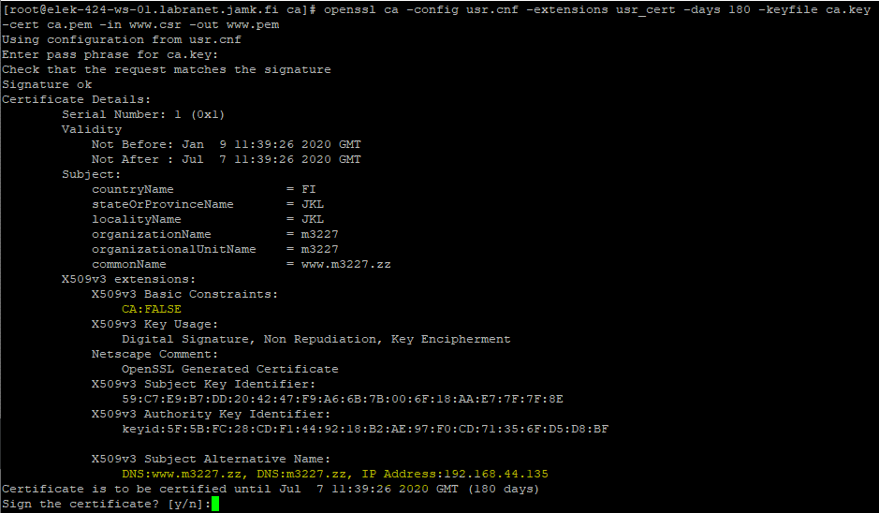

QUESTIONNAIRE: What are the correct key usage values for a generic Web server?
- Digital Signature, Non Repudiation, Key Encipherment
openssl x509 -noout -text -in www.pem
And finally, copy it back to the Webserver VM.
scp www.pem root@webserver-ip-here:www.pem

Configure SSL
In the Webserver, you have to do two things. First, install Apache and mod_ssl and add firewall rule:
yum install httpd mod_ssl
firewall-cmd --permanent --add-service=http --add-service=https
firewall-cmd --reload
Then copy the key and certificate to the correct paths:
cp www.key /etc/pki/tls/private/
cp www.pem /etc/pki/tls/certs/
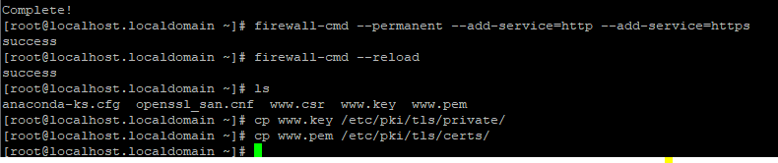
In those folders should exist also a default self-signed certificate (localhost.key and localhost.crt). Check their permissions and set the same permissions to the www.key and www.pem.
Last thing you need to do is edit /etc/httpd/conf.d/ssl.conf and change Apache to use your certificates. Find the following lines:
SSLCertificateFile …
SSLCertificateKeyFile …
SSLCertificateChainFile …
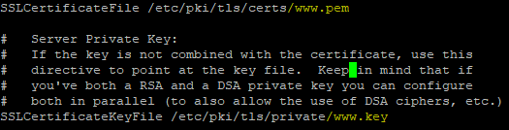
And set them to point to your files. Reload apache (systemctl restart httpd).
QUESTIONNAIRE: When and how is the SSLCertificateChainFile option used?
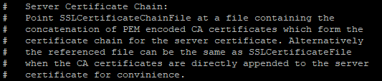 Trusted root
Your Workstation VM needs to trust the CA certificate. Copy the ca.pem to the Windows VM. You can use WinSCP or copy/paste via PuTTY. There are several places where the ca.pem needs to be put
In a Windows-based PC, you can add the certificate to trusted roots in MMC console using the Local Computer Certificate tool. Open mmc.exe from Start->Run, and add Certificates Snap-in for the Computer Account. Import the certificate to Trusted Root Certification Authorities.
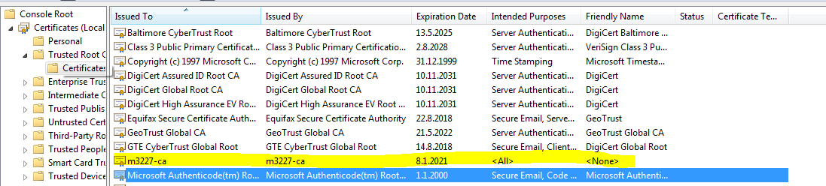
However, Firefox does not use the system certificates so we must add it to your Firefox profile Certificates. Open Firefox, select Options -> Advanced -> Certificates -> View Certificates. Select the Authorities tab, Click Import and select the certificate file. Add trusts for all purposes.
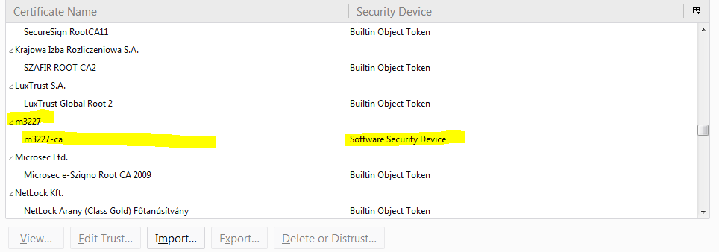
BONUS: Copy the ca.pem to the webserver also and add it to the trusted root certificates of the Centos. Test with wget https://localhost/. Check the man page for update-ca-trust command for help/more information.

DNS name and testing
Final step is to add a DNS name for the webserver. If you added the correct IP address to the SubjectAltNames, this is not strictly necessary as browsing with IP works also.
Browse to https://zz.labranet.jamk.fi/ and login with your LabraNet account. You need to add an DNS A record for www.student-id.zz like in the picture. After this, you should be able to access the webserver using the DNS name also.
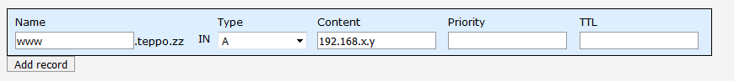
If you are working at home, find out how to add a hosts-entry to the Workstation VM. The correct path for Windows 7 VM is C:\Windows\System32\drivers\etc\hosts. Point www.student-id.zz in the Windows hosts-file to the correct IP address. This way you can test the server even without a DNS entry.
When you are finished, take a screenshot of the Certificate Hierarchy path (shown in View Certificate - Details)
