Lab3 – TLS Hardening
You can use this lab manual for your personal documentation. Use screenshots for your own documentation, there will be questions later on that may point to this lab manual. Take care to check if you need to collect some information from the lab for the answers.
\ at the end of the line is used to mark that the command needs to be on one line. Replace student-id with your own student-id and x or y as your VMs correct IP in the labs.
The labs use the following topology:

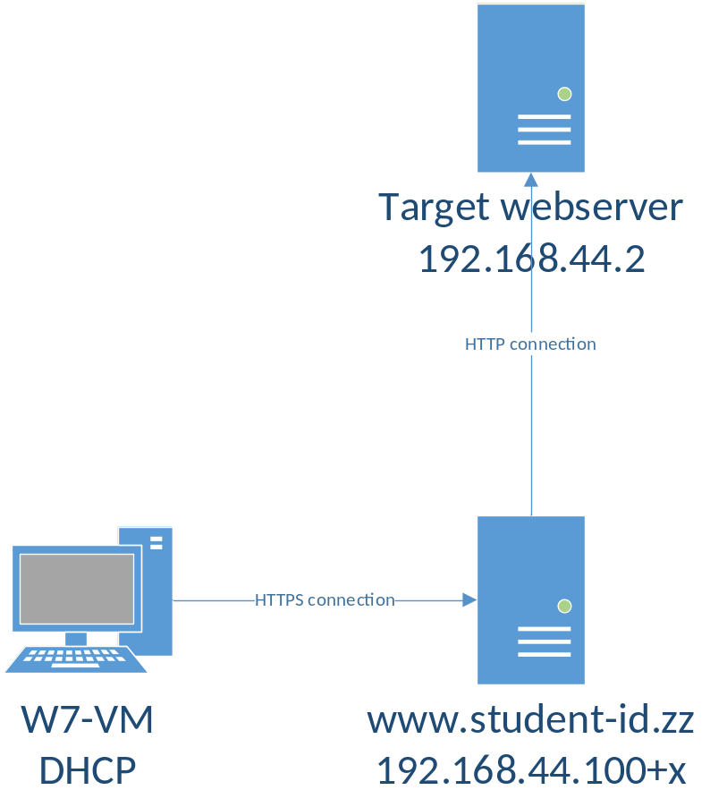
All VMs in this lab are in VirtualBox Bridged network. The machines that have static IP need to have an offset, check the topology image for reference. USE YOUR WIN7 WORKSTATION IP ADDRESS AS x.
All templates for VMs can be found in \\ghost.labranet.jamk.fi\virtuaalikoneet\TTKS\

TestSSL.sh
Before and after hardening, check results with testssl.sh (https://testssl.sh/). Download it to the proxy server and run against localhost:
yum install git
git clone --depth 1 https://github.com/drwetter/testssl.sh.git
cd testssl.sh
./testssl.sh https://www.student-id.zz/

Take note of at least the lines printed in RED and ORANGE, as they are critical. These should be mitigated.
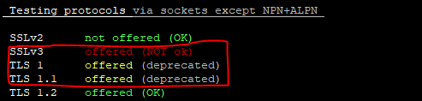
- SSl ja TLS1-1.1 ovat vanhentuneet, ja poistuneet käytöstä

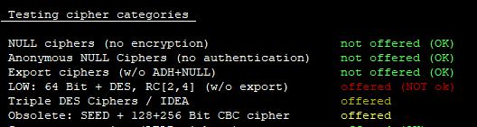

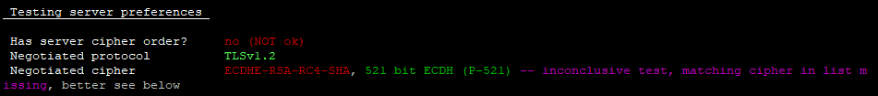
- jos cipher order on päällä, käytetään parasta cipher salausta ensisijaisesti

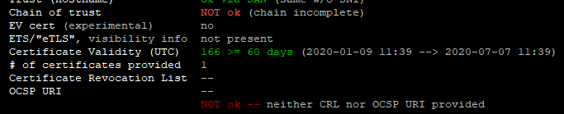
- CA ei ole luotettujen certifikaattien joukossa

- poodle haavoittuvuus mahdollinen, jos joku ssl protokolla vielä käytössä.

- RC4 haavoittuvuus saattaa olla mahdollinen viel TLS1.1 prokollan ollessa käytössä.

Mozilla TLS
Mozilla has a nice TLS configuration generator in https://mozilla.github.io/server-side-tls/ssl-config-generator/
Find out from your server:
- Your Apache version
  - Apache 2.4.6
- Your OpenSSL library version
  - OpenSSL 1.0.2k-fips
Using the Mozilla Generator, generate configuration for the server. Add this to your proxy.conf. Do not add OCSP configurations as we don’t have a valid OCSP Responder for the CA Certificate.
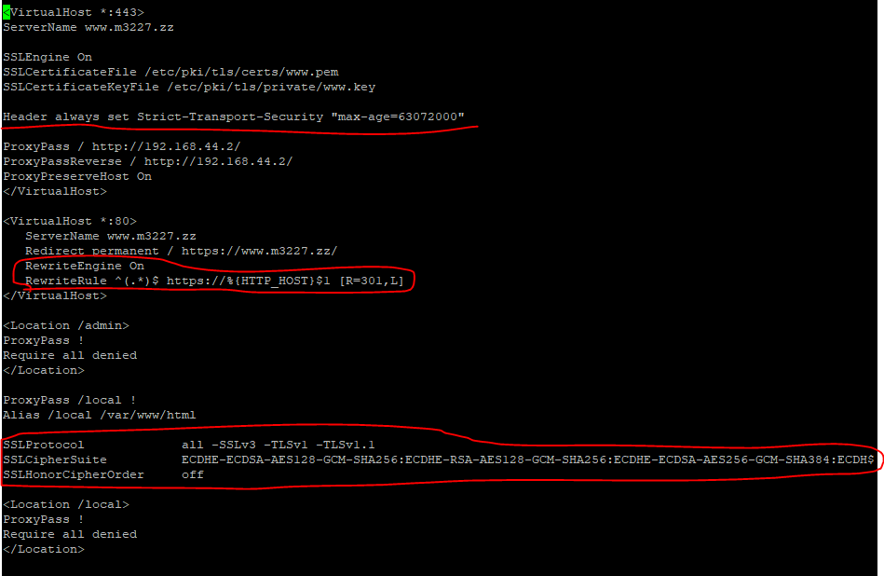
After configuring these, check again with testssl.sh
- Kaikki muut korjaantuivat, paitsi kolme kohtaa, näistä yksi oli ocsp.

Extra hardening
If critical errors still occur when testing with testssl.sh, try to find out the causes for them and mitigate. These may vary depending on the current changes in updates, new vulnerabilities, etc. If unsure, ask the teacher.
- Lisätään conffeihin SSLHonorCipherOrder on
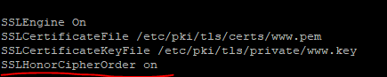
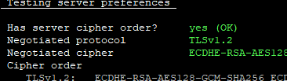
- Tuodaan CA hakemistoon /root/testssl.sh/etc/

