Lab11 – Traffic Monitoring
You can use this lab manual for your personal documentation. Use screenshots for your own documentation, there will be questions later on that may point to this lab manual. Take care to check if you need to collect some information from the lab for the answers.
\ at the end of the line is used to mark that the command needs to be on one line. Replace student-id with your own student-id and x or y as your VMs correct IP in the labs.
This lab will use the following topology:

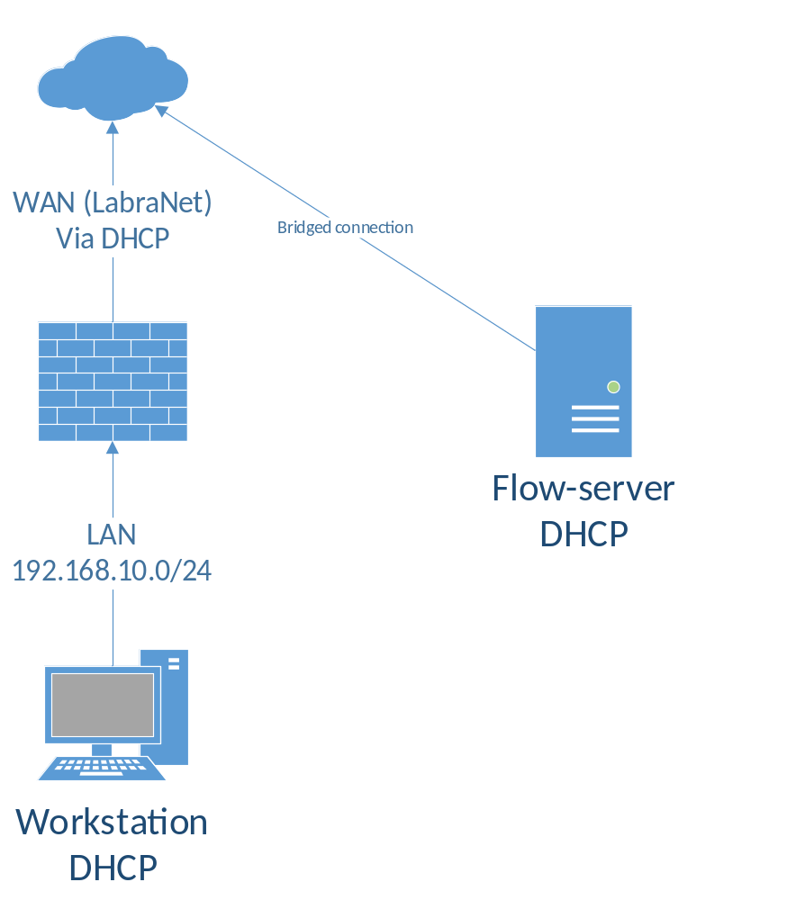

VM config
Fetch the ELK-Flow template from \\ghost.labranet.jamk.fi\virtuaalikoneet\TTKS\ and set the network settings to Bridged. NOTE: In real world situations the Netflow collector would be in a internal/management network segment, but to make the VM easier to use in the lab it is connected to LabraNet directly. Boot the VM and take note of the IP address.
- 192.168.1.188
The flow server is readily configured and listens to UDP/5000 for Netflow data. You can monitor the next steps with tcpdump:
tcpdump -i enp0s3 -nn port 5000

You should see incoming flow packets when the softflowd is correctly configured in the next step.

Sending flow-data
Configure the firewall to actually send netflow data to the collector. In Package Manager, find the package softflowd in Available Packages and install it. The configure softflowd under Services with the following settings:
- Interface: LAN
- Host: IP address of the Flow-server
- Port: 5000
- Hop Limit: 254
- Netflow version: 9
- Flow Tracking Level: Full
- General Timeout Value: 60
- Maximum Lifetime: 0
- Expire Interval: 0

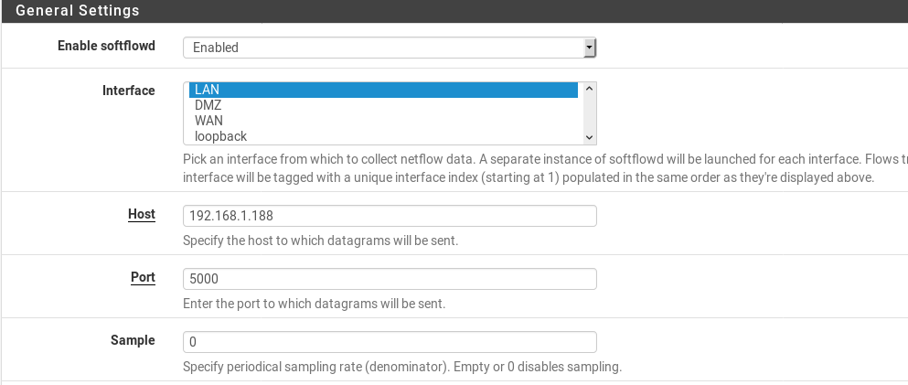
- softflowd asetukset

Save the changes.
Browse pages on the Workstation VM. The initial state cache of the softflowd seems to fill up very slowly, so it may take multiple different sites with images and such to get the actual data. Eventually you should start to get a constant stream of traffic in the Flow server tcpdump output.
For troubleshooting, you can try to run the following command on the firewall console (Press 8 for Shell in the menu):
softflowctl -c /var/run/softflowd.vtnet1.ctl statistics
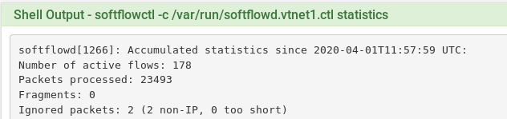
- pfsensen command promptissa ajettu komento
After a while, the output should contain flow statistics and sent packet amounts etc.

Flow indexing
Log in to the Flow-server using browser (Firefox is highly preferred). Set the Index pattern as flow-*, you should get a timestamp value and be able to click ok. You should also get a list of fields like in the image:
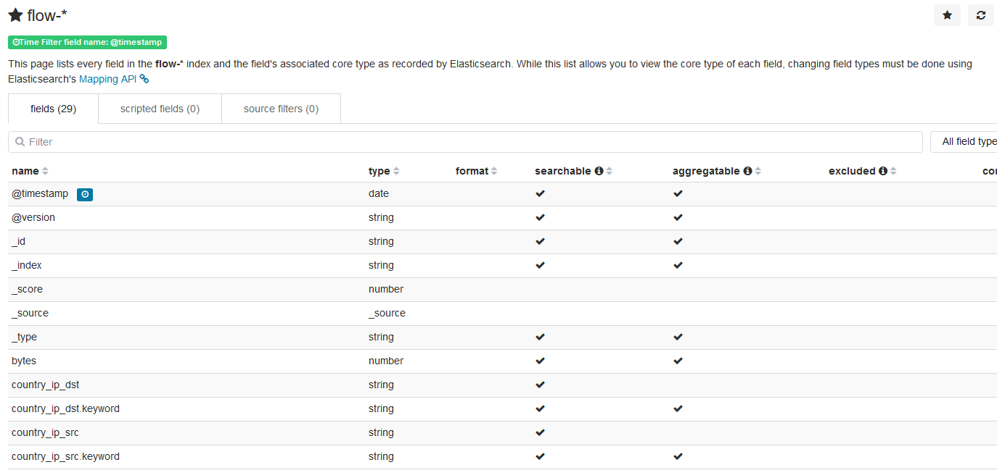
Verify that you can find the 5-tuple fields in the field list. Do NOT load the dashboards until you have the index pattern and fields correctly in the list.
Fetch the pre-made dashboards files (*.json in \\ghost.labranet.jamk.fi\virtuaalikoneet\TTKS\flow-json\ ) and import them in the Flow-server in Management -> Saved Objects. Import the json files in order:
- flow-search.json
- flow-viz.json
- flow-dashboard.json
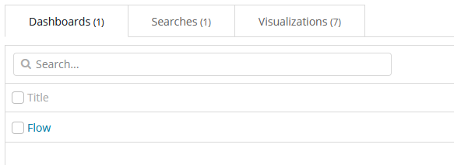

Flow analysis
Generate traffic from/to your VM. Use for example YouTube videos as they quickly generate a lot of traffic.
Find out the NetFlow 5-tuple values for the traffic going from your VM to the YouTube or other site using the Discover-tab. The upper right corner has option to select data start and end times, use the quick meny to select Last 15 minutes. To make sure you get an up-to-date view of the traffic.
5 tuple data
192.168.10.102 – 216.58.207.214
46,798 – 443
TCP
Visualize-tab can be used to quickly find top talkers and protocols/port numbers. Find out where your DNS queries go (top destination IP). You can add a filter with port_dst = 53 to show only DNS traffic.
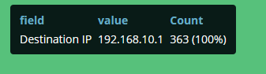
- saan dns kohde ip:ksi ainoastaan 192.168.10.1 eli pfsensen ip
By default the pie charts consist of packet count, which is useless for summarized flow-data. Go to Visualize -> Top 5 source IP and change the metric from Count to Sum of bytes. Save the chart from the top panel. Now the Pie chart shows the IPs that have sent the most traffic in bytes. Do the same for the Top 5 source ports -visualisation.

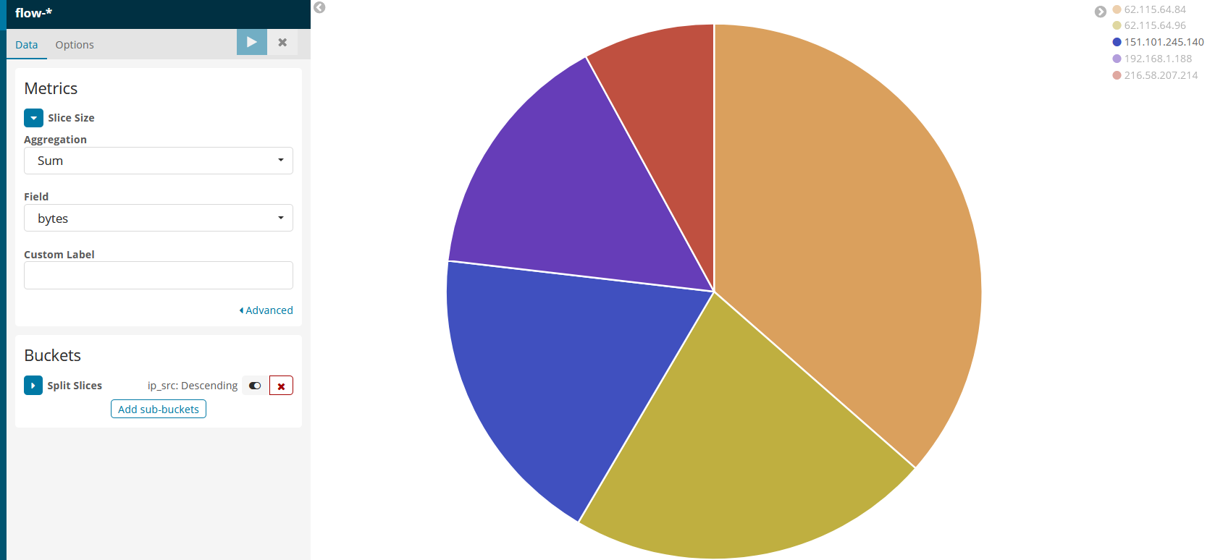
- top 5 source ip osoitteet

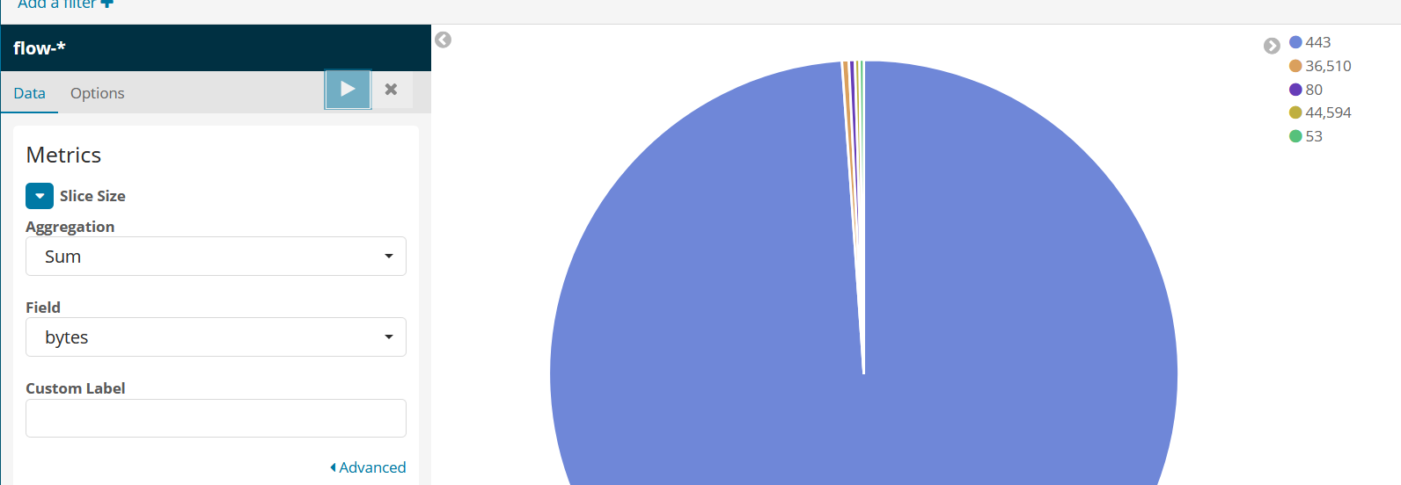
- Top 5 source portit

Finally find where the Youtube video traffic mostly comes from (Hint: Traffic sum by source). Take a screenshot of this. 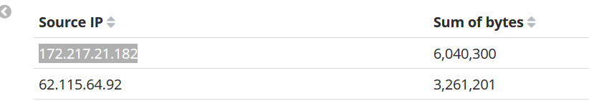

Extra work for the fastest
Find out how much of the traffic is HTTP vs HTTPS? Using this data, create a visualisation (pie) from the traffic using sum of bytes sorted by source port (80/443).

