cd et suLinux Servers
Classroom Assignment 3 – Web server
Document your commands or take screenshots. Answer questions in english or finnish.
In this assignment you will configure an Apache web server running a simple web application with file uploads. First,clone another machine with the name webservercs.

Basic VirtualHost configuration (1p)
Install Apache with SSL support (yum install httpd mod_ssl). Add a firewall-rule for http and https services. Test accessing the servers IP address from the classroom workstation. You should get the default page of the Apache installation.
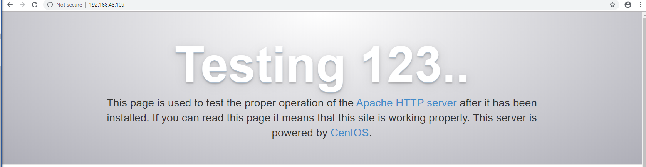
Turn off Apache default page (welcome page). You can do this by editing /etc/httpd/conf.d/welcome.conf (hints in the file itself).
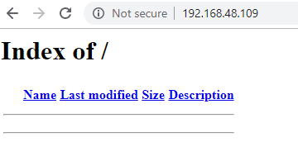

Create a new VirtualHost configuration /etc/httpd/conf.d/01_default.conf. You can use the following configuration as a starting point:
<VirtualHost *:80>
ServerName lx.your-student-id.zz
DocumentRoot /var/www/html/
</VirtualHost>
<VirtualHost *:443>
ServerName lx.your-student-id.zz
DocumentRoot /var/www/html/
SSLEngine On
SSLCertificateFile /etc/pki/tls/certs/localhost.crt
SSLCertificateKeyFile /etc/pki/tls/private/localhost.key
</VirtualHost>
Test the configuration before you start adding modifications.
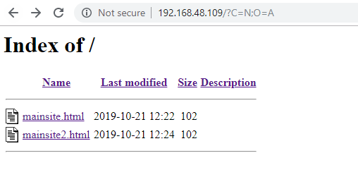
Create a redirect rule that forces SSL to be used if the server is accessed via HTTP. Restart httpd and test changes.

MySQL and PHP (1p)
Install the mariadb-server and mariadb packages. Start and enable the mariadb -service. Run mysql_secure_installation and set a root password as root66, remove unnecessary settings as default.
To create a database, log in with mysql -u root -p. Create a database and grant access with the following info (See slides for help):
Database: files
User: filesql
Password: KISSA123

reTest that you can access the database with mysql -u filesql -p files
Turn on the SELinux Boolean httpd_can_network_connect_db, otherwise HTTP-server cannot connect to the database

Install php and php-mysql packages. Configure the correct timezone in /etc/php.ini (Europe/Helsinki). Restart httpd -service.
To test your php installation create a index.php -file in /var/www/html/phpinfo with the following contents:
<?php
phpinfo();
?>
Try accessing your-webservers-ip/phpinfo. You should get an info page about your PHP installation.
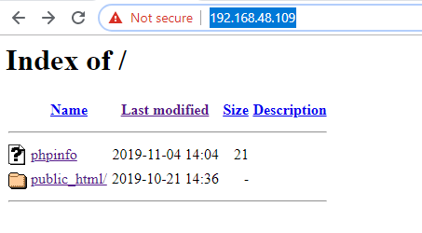

Application installation (1p)seman
You can find the filesql demo application package in https://student.labranet.jpwamk.fi/~jojuh/lx/filesql.tar.gz. Download it to the server using wget/curl and extract with tar.
You need to make sure at least the following are correct:
- SQL settings in sql_settings.php -file
- Owner and permission of the files in /var/www/html
- The SELinux -context of the file upload directory

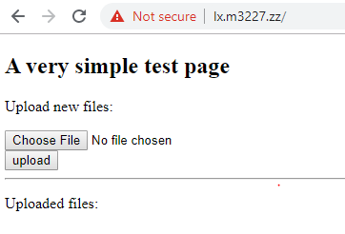cd

Access control (1p)
Create a require rule that allow access to the upload folder only from your workstation ip address or localhost (127.0.0.1).
If you did not manage to install the app correctly, create a test.php containing PHP hello world and limit access to that instead.
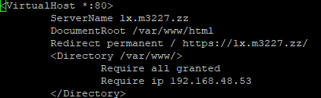

.htaccess (1p)
Using a .htaccess file in /phpinfo -directory, create a Basic Authentication to limit access.Use credentials sulo with password sulo1. Remember to set AllowOverride to All in httpd.conf.

BONUS ENGINEERING TASK
As you might have noticed, CentOS7 has a very old PHP version (5.4). Most modern web applications require at least PHP 5.6 and using PHP 7.x is recommended.
Evaluate and choose one of the additional repositories (IUS, Remi or some other) and install PHP 7.x. Make note how the package names are handled when installing.
You can clone a new VM for this or convert the existing one by removing all the previous php packages.

