Linux Servers
Classroom Assignment 4 – File server
Document your commands or take screenshots. Answer questions in english or finnish.
In this assignment you will configure a file server using Samba. You will also need to configure separate partition and LVM for the file storage. For this lab, clone another machine with the name fileserver.

LVM partitioning (1p)
Before booting the VM, add a new virtual hard disk to in VirtualBox VM settings. Set the hard disk size as 10GB dynamically allocated (This disk is kind of the storage disk for user files/data and would be bigger in reality, but for testing 10GB is enough).
Boot up the VM and check with fdisk -l that the new disk is detected. 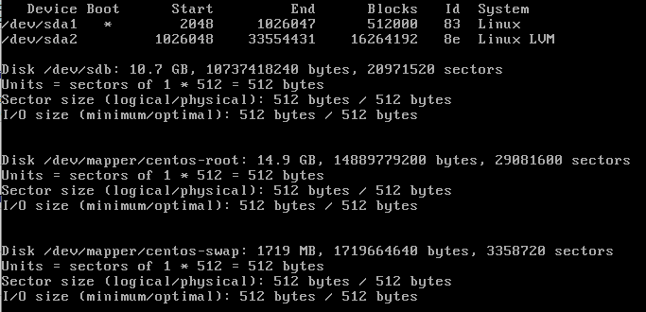
Create a primary partition on the hard disk with fdisk. Then create a LVM PV on the partition (pvcreate /dev/sdxy).
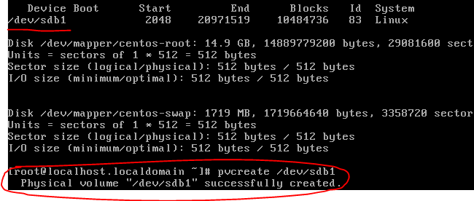
Create a new LVM volume group with the name vgstorage and attach the PV to it. Use vgcreate command.
Create a new LVM logical volume on the vgstorage volume group using lvcreate. Use the name data. Set the size as 100%FREE so the LV uses all the available space. Confirm with lvdisplay or lvs.
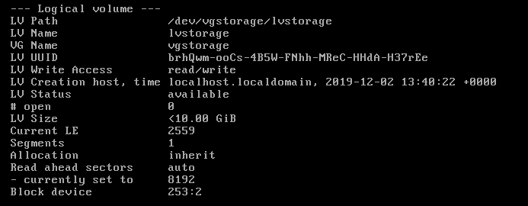

Filesystem and mountpoint (1p)
Create XFS file system on the new logical volume (it should be /dev/vgstorage/data).
Create a new directory /mnt/data and set the new filesystem to be mounted on it. Do this in /etc/fstab so the change is persistent. Use mount -a, mount and df -h to confirm the new filesystem is mounted. Confirm also that you have 10GB free on /mnt/data.

Samba (1p)
Install the package samba. Configure the following basic parameters (you can use the default config and modify it for your needs):
workgroup name: your-student-id.zz
(You can point smb.your-student-id.zz to your server IP address in https://zz.labranet.jamk.fi/ )
netbios name = SMBSERVER
map to guest = Bad User
Leave the homes-share as it is and turn on the samba_enable_home_dirs SELinux boolean. Create users sulo and teppo and add a samba password for them (smbpasswd).
With firewall-cmd, permit the correct service (samba). Start samba daemons. If something fails, check /var/log/samba for logs. Try to access the server from your workstation using \\IP-address or \\Netbios-name. You should be able to log in and see the users home directory.

Restricted folder (1p)
Create a group smbusers and add the previous users to the group as SECONDARY members. Create a folder /mnt/data/restricted, and change the owner group to smbusers -group. Set permissions so owner and group has all permissions and others have none. Use setgid special permission to make sure new files are created with correct group. Set the SELinux context for this folder as samba_share_t.
Add this folder to samba config as a restricted share. Set the create mask as 660 and directory mask as 770 in the share options (NOT as permissions to the folder).
Restart samba and try to access this folder. Confirm you need to login and you can create and read files after login. Confirm that the new files are created with correct groups and permissions.

Adding more space (1p)
Shutdown the server and add another 10GB disk. Boot the server and add partition to the disk. Create a LVM PV on the partition.
Add the new PV to the existing volume group and resize first the volume group, then the logical volume and lastly the file system. Confirm you now have +10GB more space available (with df -h)

NOTE: Confirm that samba still works, if not, check your systemctl commands, maybe you forgot a step… This will not lose you points on this lab but always check that your config persists after reboots.

BONUS ENGINEERING TASK
Take a peek at the next weeks Backup-material. Implement a poor man's Time Machine -type of backup with the following information:
Backup from: /mnt/data
Backup to: /backups (local directory)
Create a script that handles the copying via rsync, directory shuffling and removal of old backups. Configure the script so you keep 4 last backups.
Use crontab to run the script every 15 minutes
You can download some files from the internet to demonstrate the system works. Make note of the disk usage in /backups with du -sh.

