Lab5 – VulnScanning
You can use this lab manual for your personal documentation. Use screenshots for your own documentation, there will be questions later on that may point to this lab manual. Take care to check if you need to collect some information from the lab for the answers.
\ at the end of the line is used to mark that the command needs to be on one line. Replace student-id with your own student-id and x or y as your VMs correct IP in the labs.
For this lab you will need a local copy of the Target webserver. The target server template can be found in \\ghost.labranet.jamk.fi\virtuaalikoneet\TTKS\apukoneet. Credentials for the target are root / root66
This lab also uses tools from Kali for scanning. Grab the latest Kali image from \\ghost.labranet.jamk.fi\virtuaalikoneet\TTKS\. Credentials for the Kali are root / toor
You can use your own Kali if you have own already
NOTE! Set the VMs to use VirtualBox Host-Only network and check the IP addresses of the VMs. For this lab, DO NOT use Bridged or NAT network, so you don't accidentally scan other targets than the target-server. Double-check target IP addresses for correct results.
Using tools described in the lab, scan the target server for vulnerabilities. Using the results, write a short recommendation to your CTO (Teacher) on what are the most critical vulnerabilities and what mitigation steps should be taken.
Do NOT copy-paste the results or screenshots of the output of the tools. You have to do some digging on what the results actually mean, and what issues are actually relevant.
This lab is graded 4 points, 1 point for a correctly identified vulnerability.

Use the following tools:
- nmap, a generic port scan and OS detection tool
A good starting point for nmap parameters: nmap -A -T4 -p-
- NIKTO, web application scanner
- lynis (https://cisofy.com/lynis/), a host-based security auditing tool. NOTE! Install and run this tool directly ON the Target server
Installing lynis:
wget https://downloads.cisofy.com/lynis/lynis-2.7.0.tar.gz
tar -xvf lynis-2.7.0.tar.gz
cd lynis
./lynis audit system
You can also use any other tools for further analysis, but these three should point out at least 4 obvbious vulnerabilities/attack vectors.
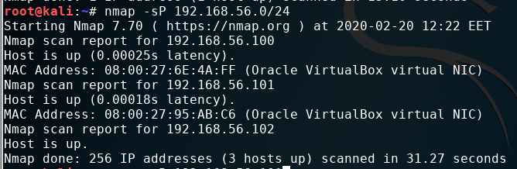
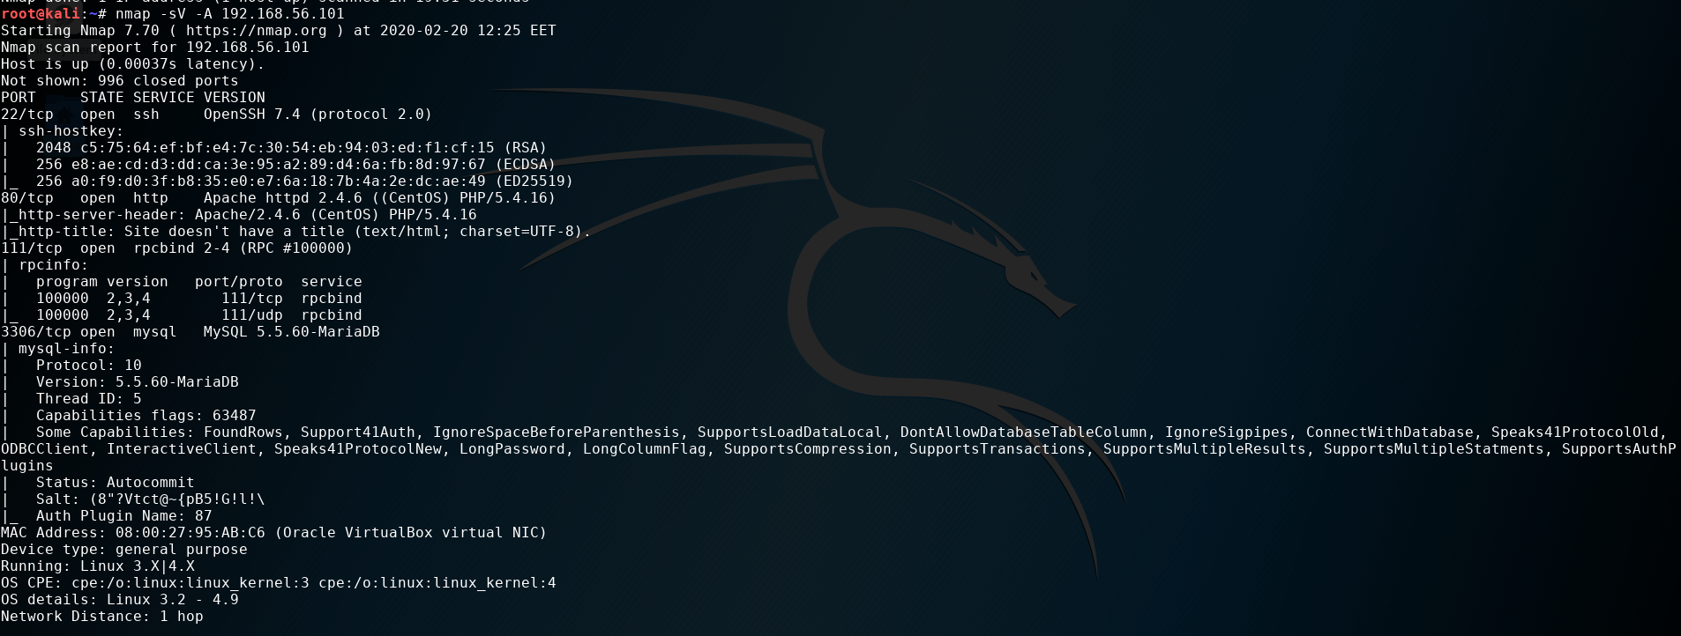
admin sivulle pääsy pitäisi olla evätty

/phpindo() sivusto on kaikkien nähtävillä, täältä löytyy kaikenlaista tietoa kohdekoneesta.

sudoers fileen kaikilla kaikki käyttöoikeudet, kuka tahansa joka pääsee koneelle voi lisäät sudo oikeudet kenelle tahansa kättäjälle

Centos Linux release 7.4.1708
http trace metodi on aktiivinen, hyökkääjä voi tarkkailla http pyyntöjä, mitä serverille tulee.

