

TCP Handshake when opening ssh connection

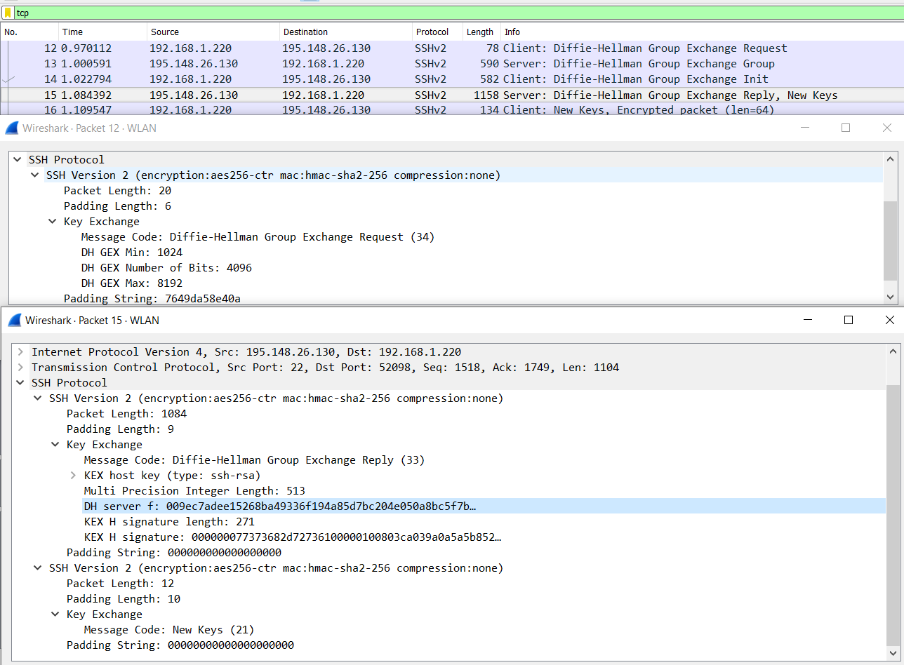

SSH Request and Reply

Diffie Helmann is Key exchange algorith commonly used by ssh

Packet includes encrypted message and MAC-address.



SSH Local port forwarding

Connecting to il.fi

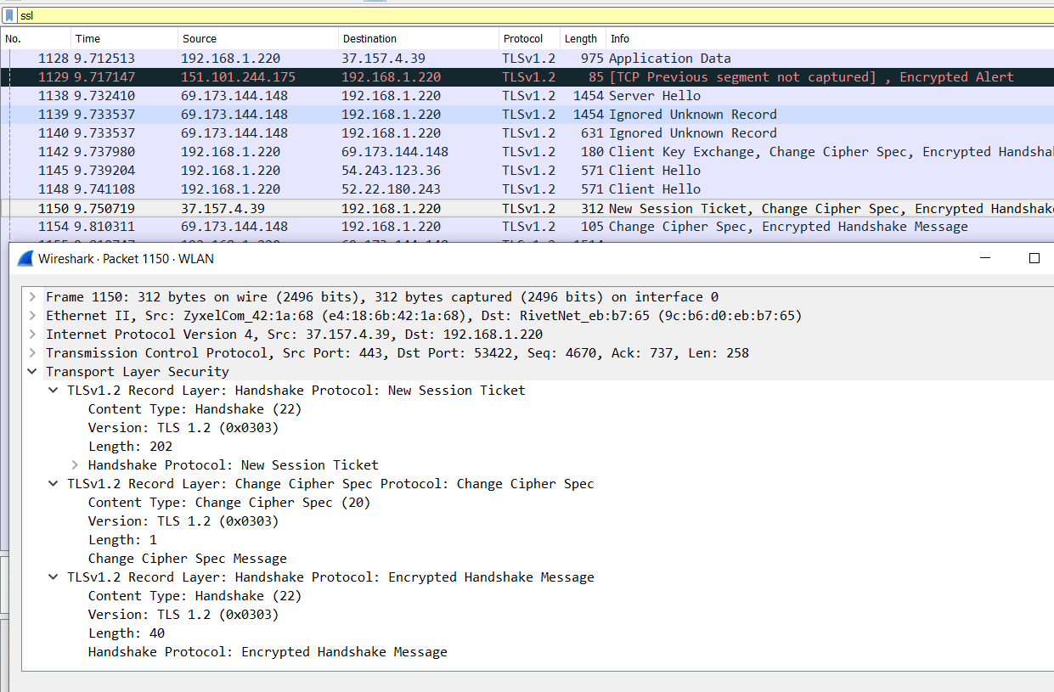

HTTPS is combination of HTTP and TLS.

TLS protocol includes Content type, TLS Version and packet lenght