* Find out with Wireshark the operation of
  + **DNS query**

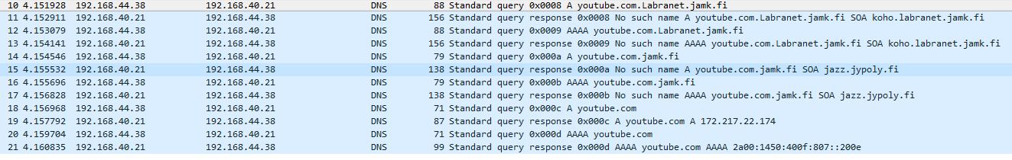

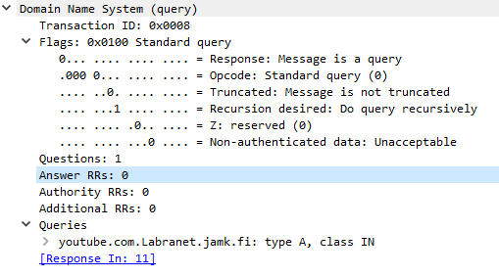

1. **Transaction ID =** Client uses this field to match responses to queries
2. **Flags =** Response code and operation requested.
3. **Questions =** Number of entries in questions
4. **Answer RRs =** Number of entries in answer section
5. **Authority RRs =** Number of entries in authority section
6. **Additional RRs =** Number of entries in additional section
7. **Queries =** Tells domain for which the query is sent, query type and class

Kuvissa näkyy DNS- queryn youtube.com osoitteesta Labranetin DNS-palvelimelle, ja saa response- vastauksella youtube.comin ip-osoitteen.

* + **DHCP query (ipconfig release, renew)**

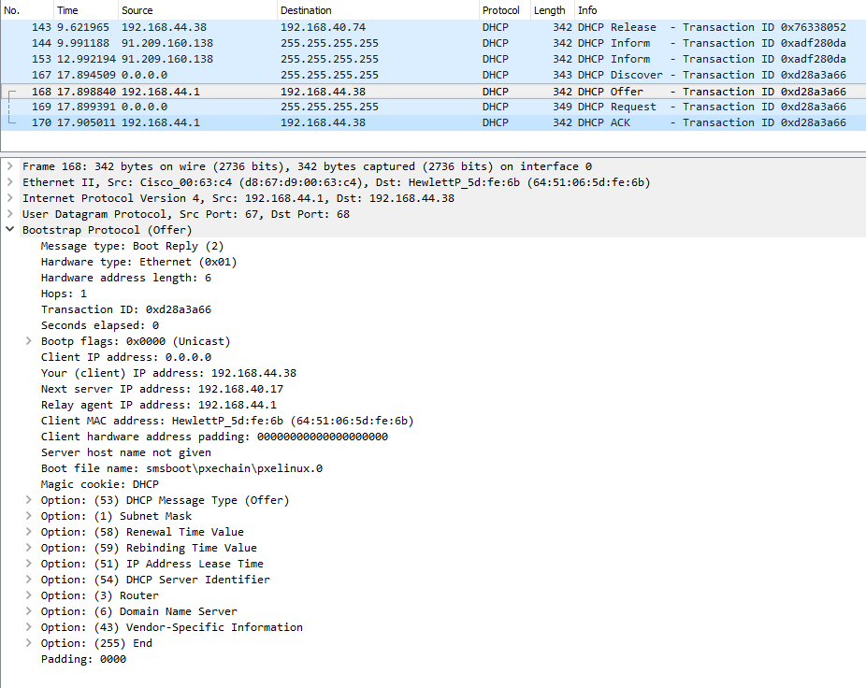

**Message type =** indicates if message is request r reply

**Hardware type =** Ethernet

**Hardware Address lenght =** MAC Addrees length = 6 bytes

**Hops =** the client starts this off with 0 and then this increment by each Bootp server if the packet is passed on

**Transaction id =** Diskless nodes use this number to match responses with the requests

**Second elapsed =** Displays elapsed time since client started booting

**bootp flags =** Defines packet flow = Unicast

**Client IP address =** Displays client ip address if known

**Your (Client) IP address =** Shows your IPv4 address

**Next Server IP address =** Configures the next server in the boot process of a DHCP client.

**Relay agent IT address =** Host server that allow single dhcp server to lease ip address information to DHCP clients on multiple networks.

**Client MAC address =** Address where servers send response back to

Clien hardware address padding = If address is lacking in some way padding can repair it

**Server Host name =** if the client puts a specific server name in here then it restricts itself to booting from that server alone. If no name is in here then the client can boot from any server that responds to a bootp request.

**boot file name =** the client can request a specific boot filename to copy the screenshots to a separate file