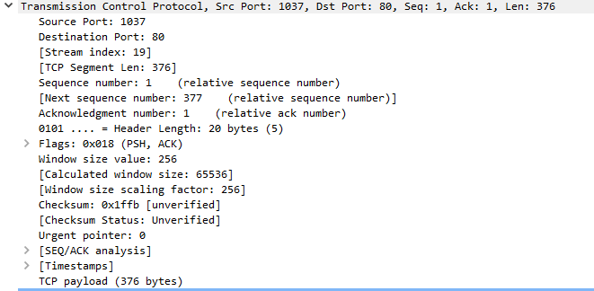

Source Port = Identifies source port

Destination Port = identifies destination port

Sequence number = tells first number assigned to first byte of data in message

Acknowledgement number = contains the value of next sequence number that segment sender is expecting to receive

Header Length = Tells how many words are contained in TCP header

Flags = contains 6 flags, each 1 bit long

URG - Indicates that some urgent data has been placed.

ACK - Indicates that acknowledgement number is valid.

PSH - Indicates that data should be passed to the application as soon as possible.

RST - Resets the connection.

SYN - Synchronizes sequence numbers to initiate a connection.

FIN - Means that the sender of the flag has finished sending data.

Window = Specifies sizr of senders receive window.

Checksum = tells if header was damaged in transit

Urgent pointer = point to the first urgent data byte

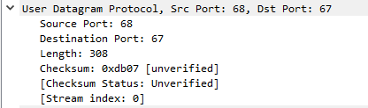

Difference between TCP and UDP is that TCP is more reliable, but it tracks all sent data, and requires acknowledgements. UDP is much less trustable. it is faster, but it might lost datagram.