Filtering FTP:

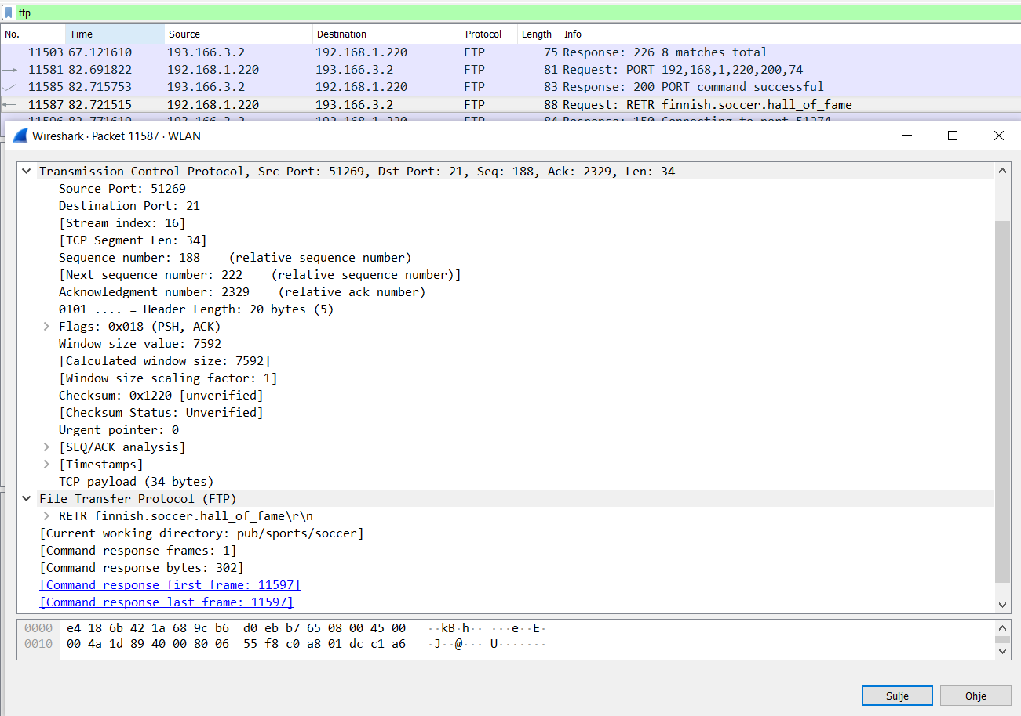

I connected to ftp.funet .fi and downloaded file finnish.soccer.hall_of_fame.

Under FTP field it doesnt contain a lot of information, only name of file, exception, current working directory and response frames and bytes count.

TCP contains more usefull information

Source port: = Port that connection is opened from

Destination port = Port which connection is opened to.

Sequence Number = Keeps track of how much data has been sent

Acknowledge Number = Keeps track of how much data has been acknowledged

Header size = Tells Header size. Min 20 bytes, Max 60 bytes

Flags = contain information about clients and servers communications. 1 bit each line.

Window size value = will display the most recent window value, which can grow or shrink as the connection progresses

Checksum = detect corruption of data during connection.

payload = tells amount of tansmitted data, that is actual intended message.

Filtering http:

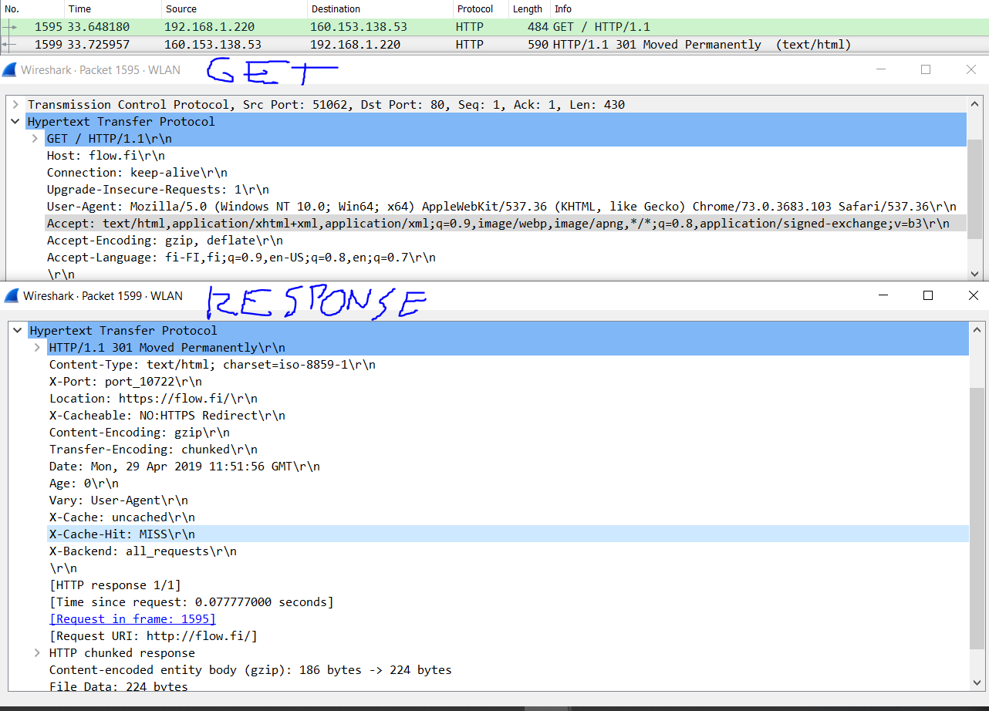

Get- method contains

Host name which trying to connect,

Connection status

Upgrade insecure requests tells the client’s preference for an encrypted and authenticated response

User-agent identifies the application type, operating system and software vendor

Accept fiels tells which content types the client is able to understand.

Response method contains

Content type informs media-type of content.

X-port tells port wcich client is connecting from.

Location shows hosts url address

X-Cacheable informs if cacheable or not

Content Encoding indicates the type of encodings applied to entire body

Transfer Encoding specifies the form of encoding used to safely transfer the entity to the user.

Date show date and time of when response is given.

Age show time in seconds that object has been in cache.

Vary determines how to match future request headers to decide whether a cached response can be used rather than requesting a fresh one from the origin server

X-cache informs if data is cacheable or not