Awesome Enterprise App[lication]
a group project by
….........................................................................................
….........................................................................................
for Enterprise Frameworks Module
on Postgraduate Diploma in Cloud Computing
at NATIONAL COLLEGE of IRELAND
Academic Year 2011/2012

4. Requirements analysis

  - The application needs to be accessible via a wide variety of devices from desktops to mobile phones and tablets.

  - The application has to be easily scalable (as in responsive to increasing or decreasing traffic, ready for cloud hosting) and extensible to cities other than New York.
New York is meant to be testing ground for the application’s attractiveness for tourists and catering vendors. It should be easily localized to other big cities in the US and Europe.

3. Application will initially use New York City Open API for film shot locations but it will not be dependent on it.
Application should at some stage be prepared for offline functioning.

4. Tourists will not require logging in to the application.
Tourists are the main consumers of the service provided by the application and they should have an easy access to it.

5. Restaurant or café owners/managers in New York willing to use the application for custom acquisition will need to register and fill out a short form describing their outlet.
It should an easy, 2-step process where after signing in business user is redirected to view/review/create/delete their profile. It will also be free.

6. The application should be able to keep track of where their user is if a device has geo-location feature enabled.
It should make use of Web maps such as Google, Yahoo or Bing.

7. The service that a tourist user receives presents a list of restaurants or cafes located nearby the chosen filming spot.
Restaurants or cafes shown in the listing will be the ones that owners or managers registered with the application.

5. Use cases

1. Tourist visiting the Web version of the application for the first time (see Fig.1):
- application is accessed via laptop or desktop interface
- 'Movie title' drop-down list is used for movie selection
- user (tourist) chooses a desired shot location from the second drop-down list
- user makes a final choice of radius he/she would like to find a restaurant in from the shot location (from 0 to 100 meters)
- user request is submitted and processed – the choice of restaurants/cafes is displayed beside/underneath the drop-down lists
- users chooses the cafe/restaurant and reviews its profile

Fig.1
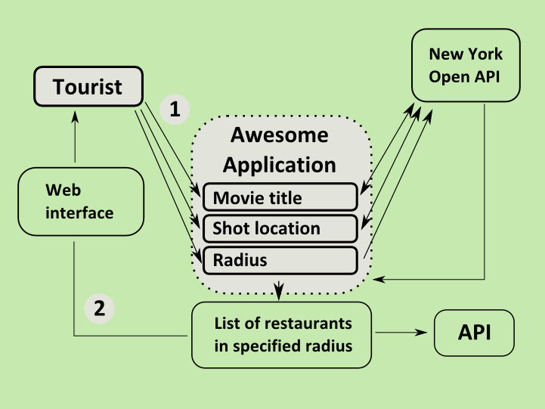

- Restaurant manager accessing the application for the first time (see Fig.2):
- clicks the 'Movie title' drop-down list (1)
- clicks the 'Shot location' drop-down (2)
- clicks radius or range (3)
- after a few thoughtless attempts he realizes what the application is about
- realizes that his/her restaurant is not there and browses the page in search of sign-up information
- manager goes to 'Register/Sign-up' section
- fills out a form and submits it
- he/she is immediately redirected to a profile page
- he/she fills out the profile and submits it
- confirmation email is sent to the given email address
- goes back to search area

Fig. 2

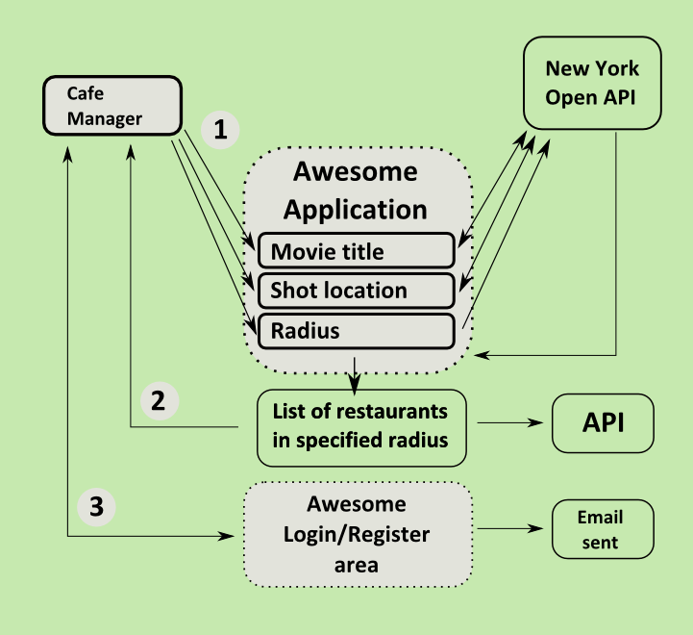
- Restaurant manager accessing the site/application the n-th time to update the restaurant's profile (see Fig.3):
- goes straight to login section
- updates opening hours, cuisine type and the menu
- saves changes
- goes to the search page and selects movie title,location and radius to bring up a selection of restaurants
- reviews the profile of his/her restaurant for submitted updates

Fig.3
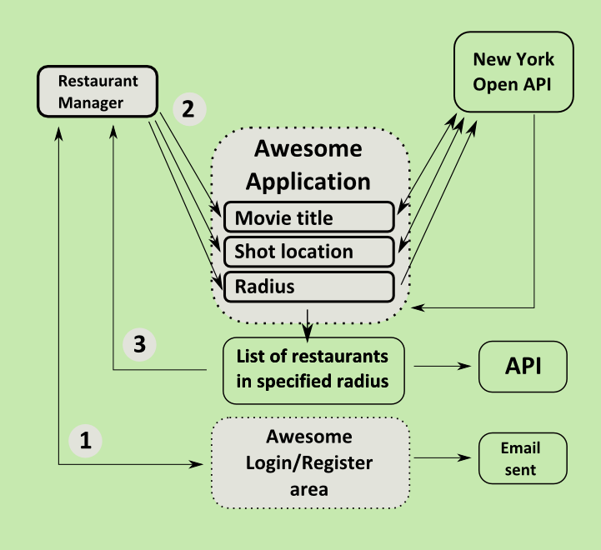

- Tourist playing with application (see Fig.4):
- goes to register/sign-up section
- fills out the details
- registration form is validated (although no validation against the list of already existing restaurants will be implemented unless many such random 'stub/dummy' registrations occur) against SQL and JavaScript injection, also the address and email input have to be impeccable
- form is submitted and notification sent to application administrator
Fig.4
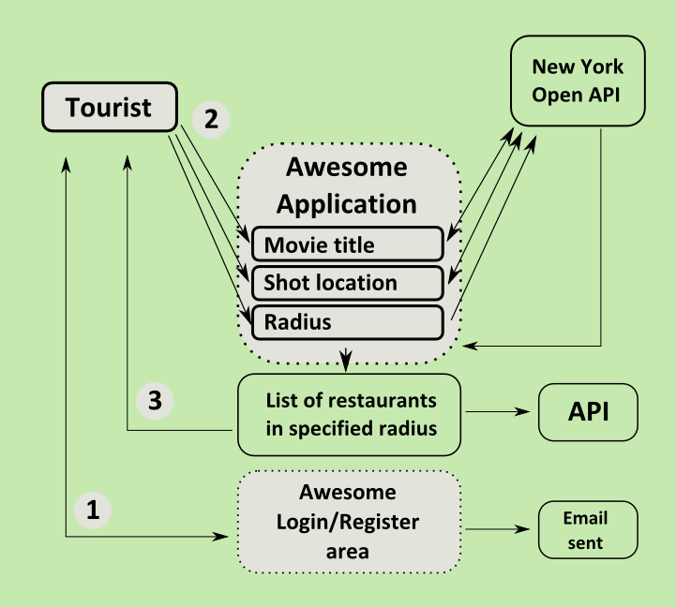

10. Use of client-side processing/AJAX

Awesome Enterprise Application is no different to a majority of currently created Web applications using JavaScript and AJAX technique to process data on the client side.
AJAX finds a lot of uses in A.E. Application – as it is created with rich end user interactions in mind. Data output either on the User Interface on a mobile device (main target group of users) or any other human-computer type of interface is best updated in runtime, easing end user of refreshing the page to see thir search results.
As the application uses ASP.NET MVC 2 framwork the default client side processing engine is the same as in classic Web Forms – it uses .aspx pages to present data for interaction with the user.
As MVC framework comes with jQuery library built into the list of default project featuresit is also handling creating XMLHttpRequest object and processing the request to the server.
AJAX calls are route to the a specified controller and its action (method) passing data that is an argument for that method.
Features powered by AJAX in Awesome Enterprise Application:
- Populating 2nd dropdown list on the homepage (list of movie shot locations) – this call is a response to end user action of choosing the movie title.
- Home page form submission – collection of data fromn the 3 dropdown lists is passed to another controller (RestaurantFinderController) that then communicates with a RestaurantFinder class in application's Business Logic layer.
- (Not implemented) Restaurant profile form and business user registration form will also use AJAX (no data will be output, just an ellegant message appended to the form on a successful save to a database).

12. Use of an ORM tool

Awesome Enterprise Application uses Entity Framework as its Object Relational Mapping tool. Entity Framework – in accordance with its use – is used to interactbetween the Data Access Layer of the application and the database.
Awesome Enterprise Application Data Access Layer comprises of 2 main entities – the User and the Restaurant.
There will also be separate sub-entities representing respectively restaurant address, point (used for proximity calculation), location of the restaurant, locations of the film shot and restaurant profile.
Enterprise Framework is mapping onto tables in SQL Server database running locally with the application.

