LABORATORY EXERCISE 8

REAL-TIME NOTIFICATIONS WITH JQUERY

Learning Objectives
By the end of this laboratory exercise, students should be able to:
- Implement AJAX functionality using jQuery to fetch data from the server without refreshing the page.
- Create a dynamic notification system that displays real-time updates to the user.
- Update the user interface (UI) based on server-side data, specifically by managing a notification badge.
- Utilize Bootstrap components for styling interactive alerts and badges.
- Manage application state by marking notifications as "read" via an AJAX call.

Prerequisite student experiences and knowledge
Before starting this exercise, students should have:
- Completed Laboratory Exercise 7 (File Uploads for Course Materials).
- A solid understanding of the CodeIgniter MVC structure and database operations.
- Proficiency in writing basic jQuery and JavaScript code.
- Experience with handling jQuery AJAX requests (GET, POST).
- Familiarity with manipulating the DOM with jQuery (e.g., showing/hiding elements, updating text).
- Knowledge of Bootstrap classes for badges and alerts.

Background
A key feature of modern, interactive web applications is the ability to provide real-time feedback and updates to users. Notifications inform users of important events, such as new course enrollments or available materials, without requiring a page reload. jQuery's AJAX methods allow the client-side browser to asynchronously communicate with the server, fetching new data in the background. This data can then be dynamically inserted into the webpage, creating a seamless user experience. This exercise will guide you in building a notification system that displays a badge count in the navigation bar and a dropdown list of alerts, all styled with Bootstrap.

Materials/Resources
- Personal Computer with Internet Access
- XAMPP/WAMP/LAMP server installed
- CodeIgniter Framework (latest version)
- Visual Studio Code or any code editor
- Git and GitHub Account
- Web Browser (Chrome, Firefox, etc.)

Laboratory Activity
Step 1: Database Setup for Notifications
- Create a new migration file for a notifications table.
Run: php spark make: migration CreateNotificationsTable
- Open the new migration file in app/Database/Migrations/.
  - In the up() method, define the table with the following fields:
    - id (primary key, auto-increment)
    - user_id (int, foreign key to users table)
    - message (varchar, e.g., "You have been enrolled in [Course Name]")
    - is_read (tinyint, default 0)
    - created_at (datetime)
- In the down() method, drop the notifications table.
- Run the migration: php spark migrate

Step 2: Create a Notification Model
- Navigate to app/Models/ and create a file named NotificationModel.php.
- Create methods for:
  - getUnreadCount($userId)
    - Fetches the count of unread notifications for a user.
  - getNotificationsForUser($userId)
    - Fetches the latest notifications (e.g., limit 5) for a user.
  - markAsRead($notificationId)
    - Updates a specific notification's is_read field to 1.

Step 3: Update the Base Controller/Layout
- To display the notification badge on all pages, we need to fetch the unread count for the logged-in user and make it available to the main layout.
- In your base controller (or a custom controller that others extend), add logic to load the unread notification count and pass it to the view. Alternatively, you can create a view fragment that uses an AJAX call to get the count (more complex but more efficient).
- For simplicity, modify your main layout file (e.g., app/Views/templates/header.php) to include a placeholder for the notification badge..

Step 4: Create a Notifications Controller and API Endpoints
- Create a controller named Notifications.php in app/Controllers/.
- Add the following methods:
  - get()
    - A method that returns a JSON response containing the current user's unread notification count and list of notifications. This will be called via AJAX.
  - mark_as_read($id)
    - A method that accepts a notification ID via POST and marks it as read. Returns a success/failure JSON response.
- Ensure these routes are added to app/Config/Routes.php:
  - \$routes-\>get('/notifications', 'Notifications::get');
  - \$routes-\>post('/notifications/mark_read/(:num)', 'Notifications::mark_as_read/$1');.

Step 5: Build the Notification UI with jQuery and Bootstrap
- In your main layout file (e.g., header.php), add the Bootstrap-styled notification dropdown to the navigation bar.
- Include a badge (`<span class="badge bg-danger">...</span>`) to show the unread count. Initially, it can be hidden or show 0.
- Create the dropdown menu structure to list notifications. It can initially be empty.
- Write a jQuery function (in a separate .js file or within a `<script>` tag) that uses `$.get()` to call your /notifications endpoint.
- In the AJAX success callback, update the badge count with the returned data. If the count is 0, hide the badge; otherwise, show it.
- Populate the dropdown menu with the list of notifications. Use Bootstrap's alert classes (e.g., `alert alert-info`) for each notification item to improve styling.
- For each notification, add a Mark as Read button/link that triggers another jQuery function.
  - This function should use $.post() to call the /notifications/mark_read/[id] endpoint and, upon success, remove the notification from the list and update the badge count.

Step 6: Trigger Notification Updates
- Call your jQuery notification-fetching function when the page loads (`$(document).ready()`).
- To simulate real-time updates, you can set an interval to fetch notifications every 60 seconds (optional advanced task).

Step 7: Generate Test Notifications
- Temporarily modify your course enrollment logic (from a previous lab) to create a new notification in the notifications table for the student when they enroll in a course.

Step 8: Test the Functionality
- Log in as a student and enroll in a new course (or create a notification manually in the database).
- Refresh the page and verify that the notification badge appears with the correct count.
- Click the notification dropdown and verify the list is populated correctly.
- Click the Mark as Read button on a notification and verify that it disappears from the list and the badge count decreases.

Step 9: Push to GitHub
- Commit and push your completed notification system code to your GitHub repository.

Output / Results
- Screenshot of the `notifications` table schema from your database (phpMyAdmin or equivalent).
- Screenshot of the browser's Developer Tools "Network" tab showing the successful AJAX call to the `/notifications` endpoint and its JSON response.
- Screenshots of the navigation bar:
- With the notification badge visible (showing a count > 0).
- With the dropdown open, showing the list of notifications styled with Bootstrap alerts.
- After marking a notification as read, showing the updated badge and list.

QUESTIONS:
- What are the benefits of using AJAX to load notifications compared to loading them directly with the initial page load in PHP?
Using AJAX to load notifications makes pages faster and feel more responsive because you don’t block the initial render with database queries and markup for items the user may not open. It reduces the first payload size, lets you poll or refresh in the background for near–real-time updates, and avoids full-page reloads when marking items as read. It also decouples the notifications UI from the page lifecycle, so you can reuse the same endpoint across pages, handle errors gracefully, and keep CSRF tokens and counts in sync without regenerating the whole page.

- Explain the role of the JSON format in the communication between your jQuery code and the CodeIgniter controller.
JSON is the lightweight, structured format your jQuery code and CodeIgniter controller use to exchange data consistently. The controller serializes server-side results into JSON, which jQuery can parse automatically and use to update the UI without a page reload. Because JSON maps naturally to JavaScript objects, it keeps the client logic simple, reduces payload size versus full HTML, allows clear error/status signaling, and enables incremental updates (polling, mark-as-read) while keeping the page responsive.

- In a production environment, what are more scalable alternatives to using a simple database query and page polling (intervals) for real-time notifications?
For real-time notifications at scale, replace page polling with push-based delivery. Common options are WebSockets (or Socket.IO) for full-duplex realtime, or Server‑Sent Events for one‑way streams. Back these with a message broker (Redis Pub/Sub, RabbitMQ, Kafka) so your controllers publish events and stateless WebSocket/SSE workers fan them out to connected users. Managed services like Pusher/Ably or Firebase can offload the realtime layer. For mobile/web push outside the app, use Web Push/APNs/FCM. Complement with background workers/queues for fan‑out, cache hot counts in Redis, and consider DB features like Postgres LISTEN/NOTIFY or CDC streams to trigger events without heavy queries. Long polling is a stopgap but less efficient than WebSockets/SSE.

Output / Results
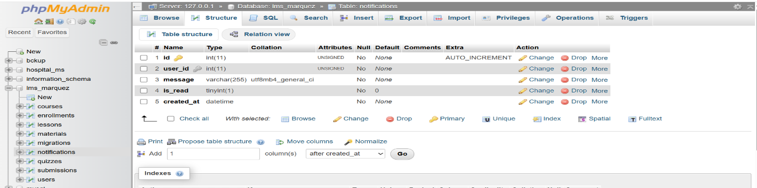
Notifications table schema

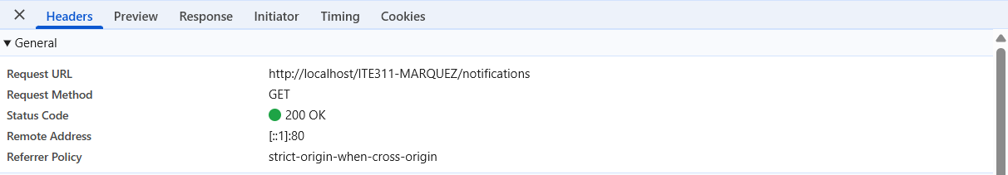
Successful AJAX call to the `/notifications` endpoint and its JSON response

Navigation bar
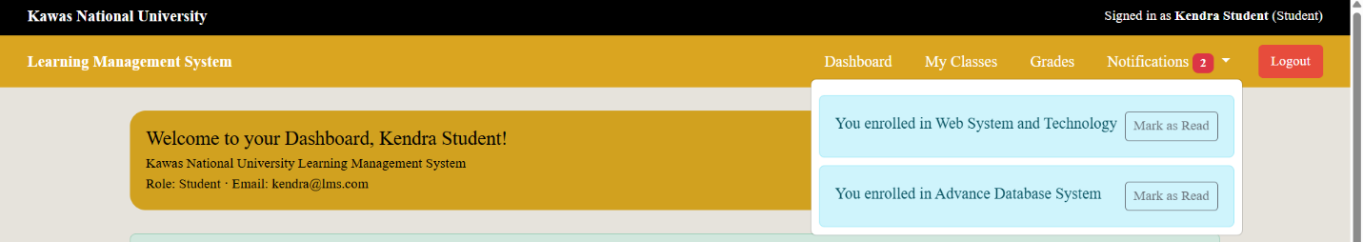

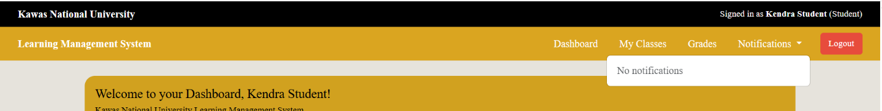

Conclusion
In conclusion, I implemented an AJAX-driven notification system that loads quickly and updates smoothly. On page load (and every 60 seconds), I fetch unread notifications and display a badge count and dropdown list. When I enroll in a course, I create a notification for myself, and when I click Mark as Read, I remove it immediately, decrement the badge, and re-fetch to keep everything perfectly in sync. I also handled CSRF token rotation and relaxed method checks to prevent false 405 errors. By returning only unread notifications from the model, read items no longer reappear. Overall, I delivered a secure, responsive UX and set a clear path for future real-time upgrades.

