LABORATORY EXERCISE 6

COURSE ENROLLMENT SYSTEM

Learning Objectives
By the end of this laboratory exercise, students should be able to:
- Design and create a new database table to manage relationships between users and courses.
- Implement server-side logic for handling course enrollments.
- Display user-specific data (enrolled courses) in a dashboard.
- Utilize jQuery and AJAX to create a dynamic, seamless user experience without page reloads.
- Understand and implement basic foreign key relationships in a web application.

Prerequisite student experiences and knowledge
Before starting this exercise, students should have:
- Completed Laboratory Exercise 5 (Admin and Student Dashboards).
- A solid understanding of the MVC architecture in CodeIgniter.
- Proficiency in writing database queries using CodeIgniter's Query Builder.
- Basic knowledge of SQL relationships (one-to-many).
- Familiarity with jQuery syntax and the concept of AJAX.
- Ability to create and style front-end components with Bootstrap.

Background
A core feature of any Learning Management System (LMS) is the ability for students to enroll in available courses. This involves creating a relationship between the users table (students) and the courses table. This relationship is typically stored in a pivot table. To enhance user experience, the enrollment process should be dynamic, allowing students to join courses without refreshing the page. This is achieved using jQuery AJAX to send a request to the server in the background, providing immediate feedback to the user.

Materials/Resources
- Personal Computer with Internet Access
- XAMPP/WAMP/LAMP server installed
- CodeIgniter Framework (latest version)
- Visual Studio Code or any code editor
- Git and GitHub Account
- Web Browser (Chrome, Firefox, etc.)
Laboratory Activity
Step 1: Create a Database Migration for the Enrollments Table
- Create a new migration file for the enrollments table.
Run: php spark make:migration CreateEnrollmentsTable
- Open the newly created file in app/Database/Migrations/.
- In the up() method, define the table with the following fields:
  - id (primary key, auto-increment)
  - user_id (int, foreign key to users table)
  - course_id (int, foreign key to courses table)
  - enrollment_date (datetime)

- In the down() method, define how to drop the table.
- Run the migration: php spark migrate.

Step 2: Create the Enrollment Model
- Navigate to app/Models/ and create a file named EnrollmentModel.php.
- Create a model class with methods to:
- enrollUser($data): Insert a new enrollment record.
- getUserEnrollments($user_id): Fetch all courses a user is enrolled in.
- isAlreadyEnrolled($user_id, $course_id): Check if a user is already enrolled in a specific course to prevent duplicates.

Step 3: Modify the Course Controller
- Open your Course.php controller (or create it if it doesn't exist).
- Add a new method, enroll(), to handle the AJAX request.
- This method should:
- Check if the user is logged in.
- Receive the course_id from the POST request.
- Check if the user is already enrolled.
- If not, insert the new enrollment record with the current timestamp.
- Return a JSON response indicating success or failure.

Step 4: Update Student Dashboard View
- Open/Check the student dashboard view file.
- Create a section to Display Enrolled Courses. Use a Bootstrap list group or cards to iterate over and display the courses returned by EnrollmentModel::getUserEnrollments().
- Create another section for Available Courses. Display a list of courses with an Enroll button next to each.

Step 5: Implement AJAX Enrollment
- In the Available Courses section of the dashboard, add a data_course_id attribute to each Enroll button containing the specific course ID.
- Include the jQuery library in your view if it's not already included.
- Write a jQuery script that:
- Listens for a click on the Enroll button.
- Prevents the default form submission behavior.
- Uses $.post() to send the course_id to the /course/enroll URL.
- On a successful response from the server:
- Displays a Bootstrap alert message.
- Hides or disables the Enroll button for that course.
- Updates the Enrolled Courses list dynamically without reloading the page.

Step 6: Configure Routes
- Update app/Config/Routes.php to include a route for the enrollment action.
$routes->post('/course/enroll', 'Course::enroll');

Step 7: Test the Application Thoroughly
- Log in as a student.
- Navigate to the student dashboard.
- Click the Enroll button on an available course and verify:
- The page does not reload.
- A success message appears.
- The button becomes disabled or disappears.
- The course appears in the Enrolled Courses list.

Step 8: Push to GitHub
- Commit your changes with a descriptive message.
- Push your changes to your GitHub repository.

Step 9: Vulnerable Checking
- Test for Authorization Bypass
  - Log out of the application and attempt to directly access the enrollment endpoint via Postman or browser console by sending a POST request to /course/enroll with a course_id parameter.
  - Verify that the server returns an unauthorized error instead of processing the enrollment.
- Test for SQL Injection
  - While logged in, use browser developer tools to modify the AJAX request and change the course_id value to 1 OR 1=1.
  - Check if the application properly validates the input and prevents SQL injection attacks.
- Test for CSRF (Cross-Site Request Forgery)
  - Check if your enrollment form includes CSRF protection tokens.
  - Verify that CodeIgniter's CSRF protection is enabled in app/Config/Security.php.
  - Attempt to make an enrollment request without a valid CSRF token and confirm it is rejected.
- Test for Data Tampering
  - As a student, try to enroll another user in a course by modifying the user ID in the request.
  - Verify that the server-side code uses the logged-in user's session ID rather than trusting client-supplied user IDs.
- Test for Input Validation
  - Attempt to enroll in non-existent courses by sending invalid course_id values.
  - Verify that the application properly validates that the course exists before creating an enrollment.

Output / Results
- Screenshot of your database's enrollments table structure (phpMyAdmin or equivalent).
- A screenshot of the student dashboard showing the Available and Enrolled Courses sections is attached.
- A screenshot of the browser's developer tools (Network tab) shows the successful AJAX POST request and response when enrolling in a course.
- A screenshot of the GitHub repository with the latest commit for this exercise.

QUESTIONS:
- What is the purpose of the enrollments table? Why is it necessary, instead of just adding a course_id column to the users table?
The enrollment table exists to correctly model many-to-many relationships, one student can join many courses, and one course can have many students. If we just added a single course_id column to the users table, each user could only be linked to one course, which doesn’t match real life. By having a separate enrollment table that stores user_id, course_id, and details like enrollment_date, we keep data organized, prevent duplicates with unique user_id and course_id.

- Explain the role of the isAlreadyEnrolled() method in the Model. What potential issue does it prevent?
It safeguards the system fro duplicate enrollments by checking if a row already exists in the enrollments table for the same user-course pair before a new insert happens. This prevents issues like double-clicks or repeated AJAX requests creating duplicates.

- Describe the client-side and server-side steps when students click the Enroll button until they receive confirmation.
When a student clicks the Enroll button on student/dashboard.php, the jQuery handler attached to .btn-enroll reads the data-course-id, disables the button, and sends a POST AJAX request to course/enroll, including the course_id and CSRF token. On the server-side, Course::enroll() checks that the user is logged in via session, ensures the request is POST, validates course_id as an integer, verifies the course exists in courses, and prevents duplicates using EnrollmentModel::isAlreadyEnrolled($userId, $courseId).

Output / Results
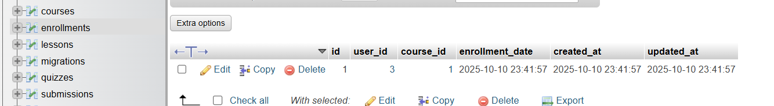
Enrollments table structure

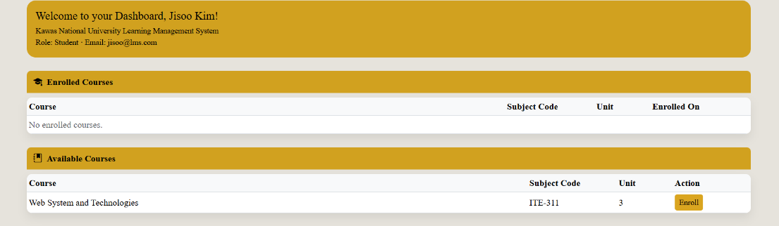
Student dashboard

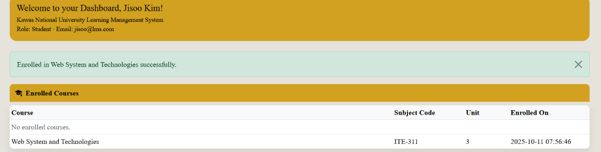

Network tab
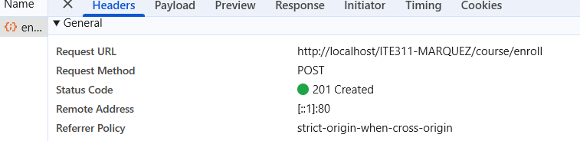

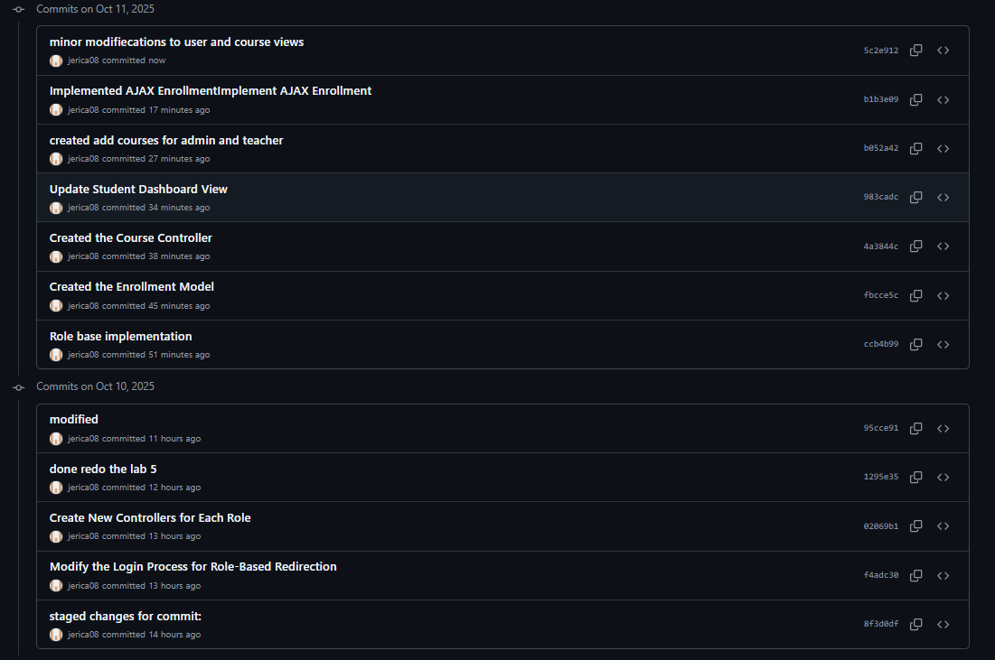
GitHub Repository

Conclusion
In conclusion, this activity successfully demonstrates the creation and integration of an enrollment system in CodeIgniter. By implementing a database migration, models, controller, and AJAX functionality, students learned how to manage user enrollments dynamically without page reloads. Security testing for authorization, CSRF, and SQL injection ensured the system’s reliability and protection against common vulnerabilities. Overall, the exercise enhanced understanding of backend integration, frontend interaction, and secure web application development.

