STEPS to run the Codevil Exam:

1. Download and install the Python 2.7 version here: <https://www.python.org/downloads/>

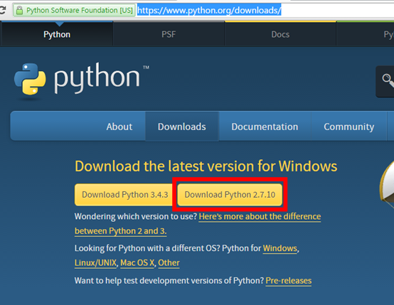

1. Extract sent zip file and open folder “Codevil Exam - JERIC BALANE”

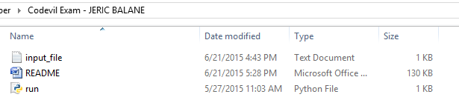

The only 3 files you’re going to touch:

* Input_file.txt – where your input text are.
* README.docx– you’re going to read it first before doing anything.
* run.py – I’ll discuss it later.

1. Open the README.docx

* You’re doing it right now.

1. Double-click on the file “run.py”



This should open afterward.

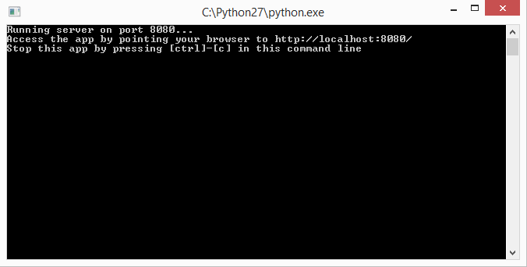

Leave it open, don’t close it.

1. In your browser, open the URL: <http://localhost:8080/>

The results of the exam should appear here:

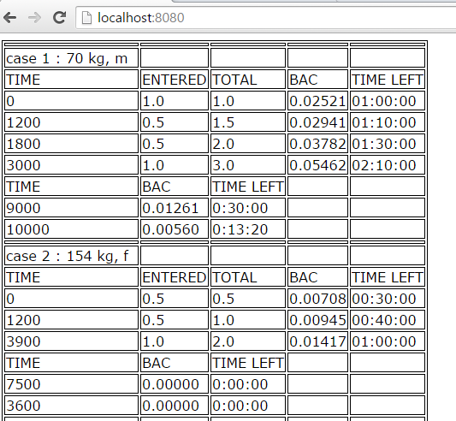

*The codes are in web.py but please don’t do anything on it.*