***SCS FORM NO. 005***

Arellano University School of Computer Science

Week No. 16

Date: September 27 – October 1

**No. Hours Rendered: 40 hours**

**Task Performed**

**Day 1**

Today, my main goal is to make certain that the websites on my supervisor's list are fully operational.

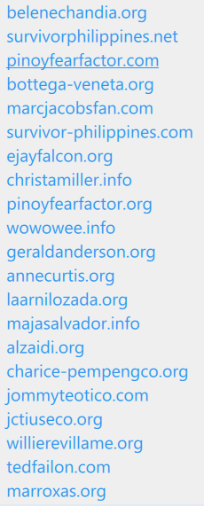

**Day 2**

The next site is willierevillame.org, Of course I just did what I usually do. First things first, I created 5 html files for home, about, photos, videos and forum page.

**Day 3**

The next one, I focus on the home page because that’s the main objective there to have a working home page. I create a RSS feed for the news and blogs.

**Day 4**

Then after that, I created a gmail account for that website, so I can easily create a shoutbox. I imported some messages to look real that there’s a really person or people go there and talking to each other.

**Day 5**

Then, I design the shoutbox to make compliment to the theme of webpage, then I insert it on webpage and use the iframe tag and assign to the left side.

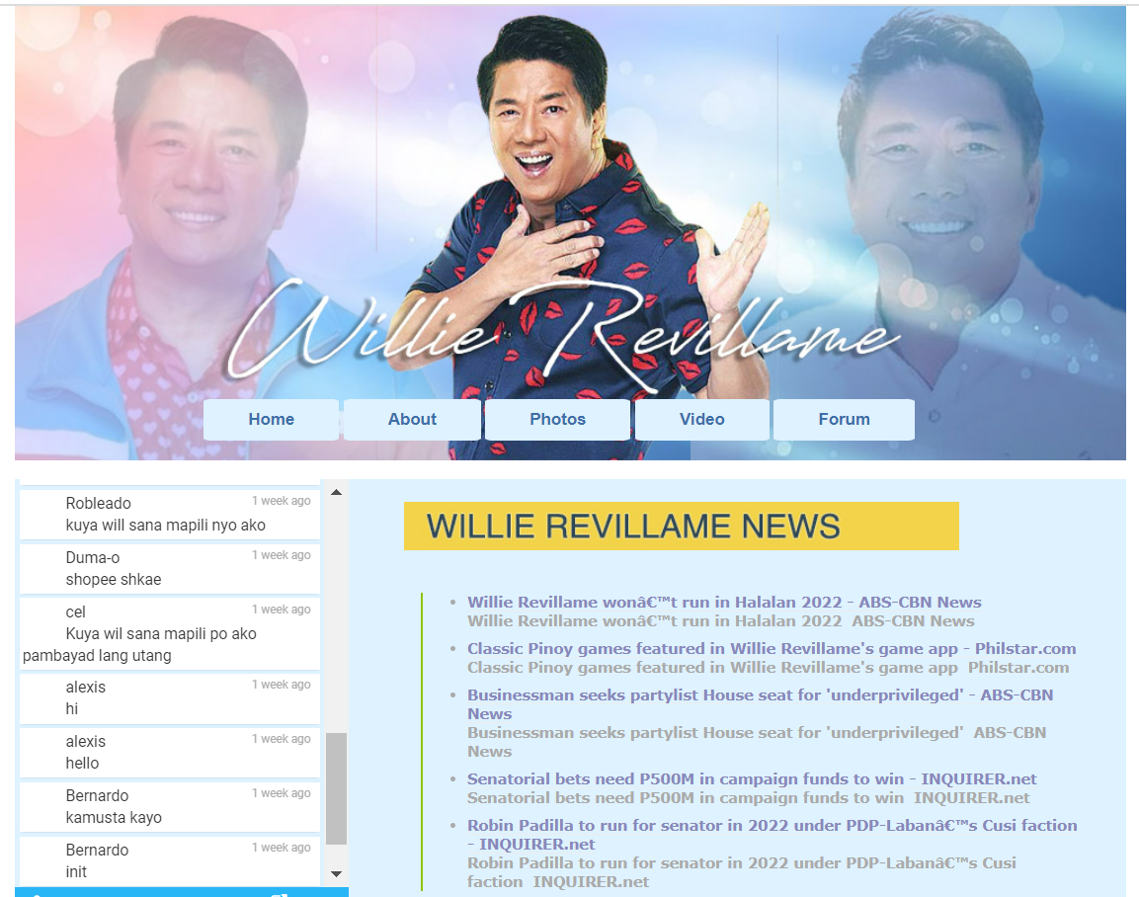

**Prepared by: Supervisor’s Signature:**

Erl Bryan Malindog

Carlos Lim