

Arellano University

School of Computer Science

**OJT Weekly Report**

Week No. 4

Date: July 5 – July 9

**No. Hours Rendered: 13 hours**

**Task Performed**

**Day 1**

When I’m done finishing the webpage, I uploaded it on a hosting site to make sure if it’s working. Then I submitted to the supervisor.

**Day 2**

Then, the next day the supervisor mentioned that the shoutbox doesn’t has a widget feature which is why the message was overlaping. So research it again to find another shoutbox.

**Day 3**

The instructions that the supervisor said was to revert it to normal which is impossible because the moment I tried to access with that shoutbox, my ISP was blocked by that shoutbox and also with other devices.

**Day 4**

Today, I found a shoutbox. First I created an account to have an access then after that I checked if it’s able to embed that shoutbox. After that I designed it using css. And import some existing messages.

**Day 5**

This Friday, I tested it out if the message would overlap if I expand the width and the height. Fortunately, it can! It has a widget feature. So I quickly uploaded it to hosting site then it’s working finally.

**Proof:**

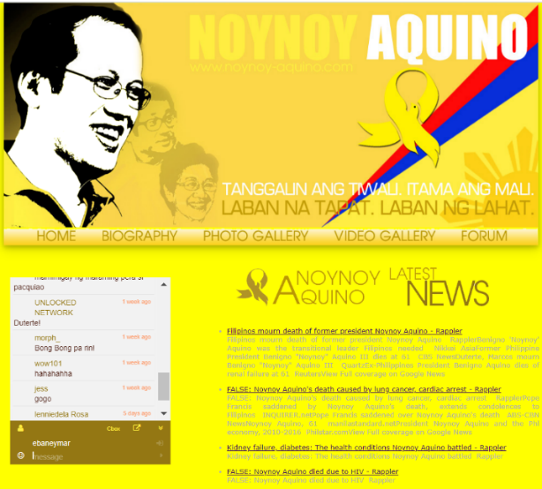

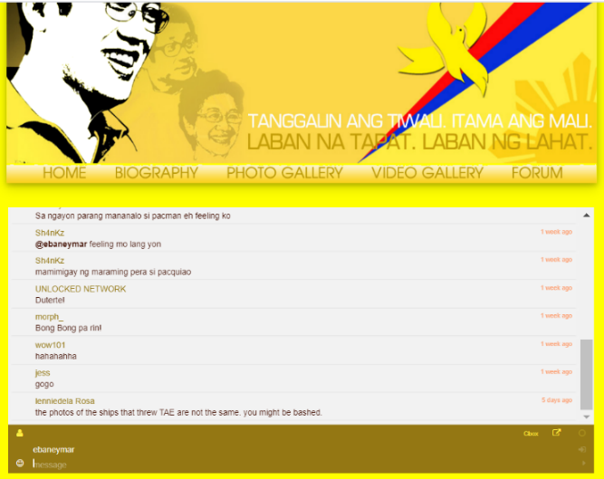

**Prepared by:**  **Supervisor’s Signature:**



Carlos Lim

Erl Bryan Malindog