

Arellano University

School of Computer Science

**OJT Weekly Report**

Week No. 9

Date: August 9 – August 13

**No. Hours Rendered: 9.33 hours**

**Task Performed**

**Day 1**

After I submitted the project that I had. I also fixed the photo gallery of that fan website. Because when I clicked the image the popup was still smaller instead it should be bigger image.

**Day 2**

The next day, I tried to save images as many as I should because all of the photos in the index directory was small.

**Day 3**

Btw, I have a new task which is to improve the google rating of company’s website. After the deep searching on how can I do what have told me, It seems like this is SEO type. Since this is new to me, I watched videos, read articles and etc.

**Day 4**

For the mean time, I submitted again the mock up sample for robin padilla’s fan site. And I’m waiting to send it to me the credentials for FTP server.

**Day 5**

As of today, I’m still searching on how to improve the google rating of the main site. I know why google ratings is so important it’s because the more high number of your rating, then the more business owners will recognize to your site and more customers will try to engage with their customers. For now, I’ll show the photo gallery. The left side is the original and all of the images is smaller whereas the right side, I just enlarge the sizes because nowadays people browsing using an android phone.

**Proof:**

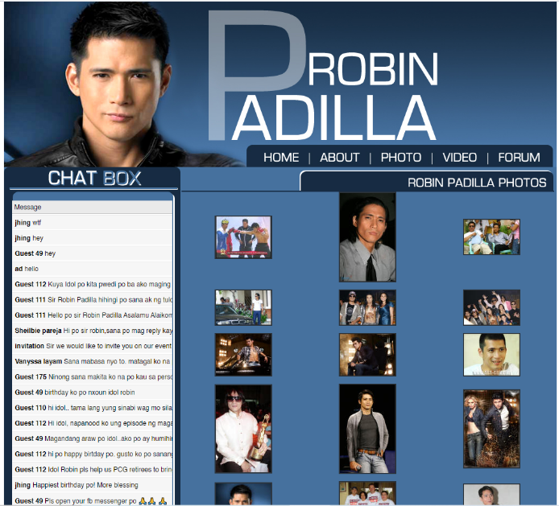

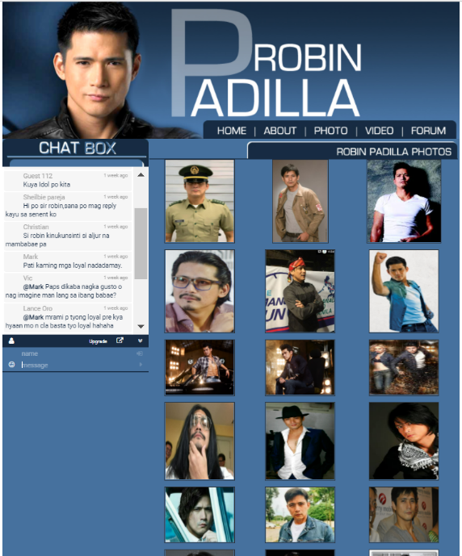

**Prepared by:**  **Supervisor’s Signature:**



Carlos Lim

Erl Bryan Malindog