

Arellano University

School of Computer Science

**OJT Weekly Report**

Week No. 15

Date: September 20 – September 24

**No. Hours Rendered: 11 hours**

**Task Performed**

**Day 1**

Today, my main goal is to make certain that the websites on my supervisor's list are fully operational.

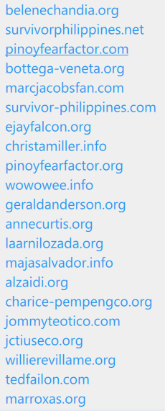

**Day 2**

The next site is annecurtis.org, I start to view the design to see if the problem is the same as in my previous project. Upon checking, it’s really the same so that I’ll arrange the folder at my hosting site to fasten the uploading.

**Day 3**

As asual, I fix first the orientation of the site because it’s not centered. And then I add new code for RSS feed to make it functionable.

**Day 4**

Since the photos are old, I downloaded new photos of Anne Curtis, and then I encoded to become visible. I also added new videos of Anne, and once again, I created a new shoutbox and uploaded it to the hosting site to make a sample.

**Day 5**

After that, I changed the banner because she appeared so young on it. I collected photos of her and edited in Photoshop.

**Proof:**

Before After

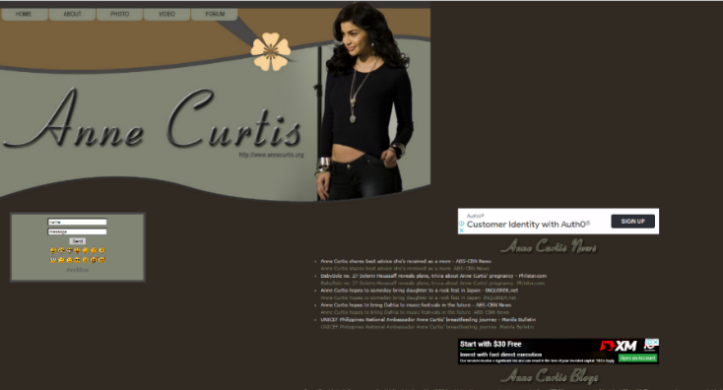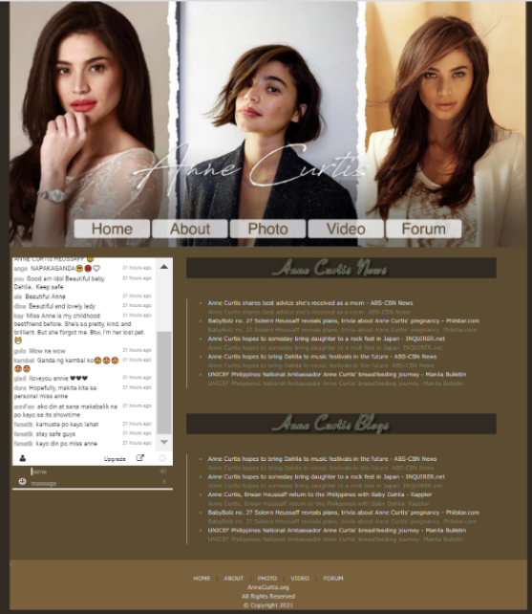

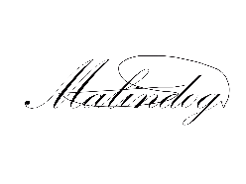**Prepared by:**  **Supervisor’s Signature:**



Carlos Lim

Erl Bryan Malindog