

Arellano University

School of Computer Science

**OJT Weekly Report**

Week No. 18

Date: October 11 – October 15

**No. Hours Rendered: 12.8 hours**

**Task Performed**

**Day 1**

I start with basics, just download the file of next web page. I collect the home page first and also the information on what the inside.

**Day 2**

Then, I edit the pictures of mar roxas, because he’s the cover on this web page. After that I add some information in about page of mar roxas using Wikipedia.

**Day 3**

And I create new file for photo section wherein that photos should update what’s new on mar roxas.

**Day 4**

When I finished the photo page, Move on to the video page which is to collect videos of him in different sites.

**Day 5**

The last thing is the forum page, which is to create a shoutbox. I use the cbox for this web page so that I can import some message about mar roxas. This is troublesome because I’m lacking some information that I can add to forum page. I don’t have clues where I can get the messages, What I do is to search on facebook and try find message about mar roxas and also try to paste the link of cbox on the comment section then if a person click it they will redirect to cbox of mar roxas and they can type anything about mar roxas.

**Proof:**

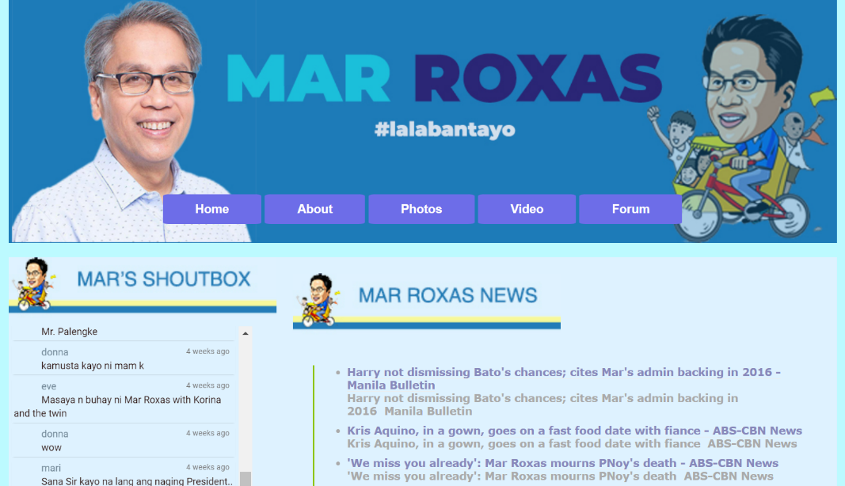

**Prepared by:**  **Supervisor’s Signature:**



Carlos Lim

Erl Bryan Malindog