**WAIVER**

TO WHOM IT MAY CONCERN:

This is to certify that I am participating in on-the-job training program for Computer Science students with ***Information Managers Inc.***

*(Name of Company)*

This is in compliance with the requirement for graduation in the degree – Bachelor of Science in Computer Science.

I understand that should any accident or untoward incident occur within the stipulated period I would not instigate a cause against the company.

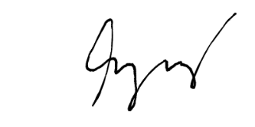 I further understand that my OJT training does not warrant any honorarium of any kind from the participating company.

**BLESILA MALINDOG** **ERL BRYAN P. MALINDOG** ______________________________

(Parent or Guardian) Student

Conformed:

______________________________

Geraldine M. Rilles

Program Chair, School of Computer Science