**Certificate of participation**

**is given to**

MALINDOG, ERL BRYAN P.

for attending the webinar

**TECHTUTOR 2021**

**The New Digital Life**

DATE: OCTOBER 16 , 2021

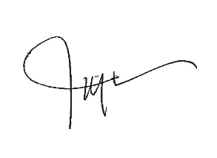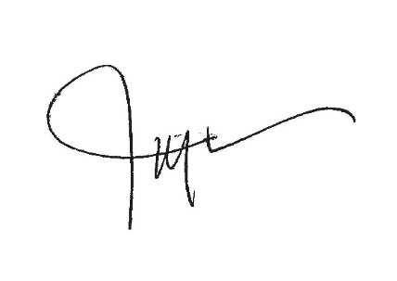

OCTOBER 23 , 2021

**JERRY LIAO**

COO - POWERTIPS