NetLogo Worksheet #1

NetLogo and Agent-Based Models

Jericho McLeod

CSI 500

Spring 2019

# Problem #1: NetLogo Model Library

Using your NetLogo installation, go through the Models Library and locate a model that has potential applicability to your field of study. If you can't find one appropriate for your field, choose one that you think is interesting. Open the model, and experiment with the settings.

Provide a short 1 paragraph discussion of why you think this model is or is not applicable for your field of study, or why you found it interesting.

The computational social science model “Team Assembly” is similar to, but not directly applicable, to my current studies. In this model a force-directed graph is created for teamwork, with some fading out of nodes who have not participated in a team in *T* ticks, team size *N*, *P* probability of choosing an existing node for a team, and *Q* probability of choosing a prior collaborator for a new team. This graph grows to show how a network can form in an organization driven by team projects.

I am currently working on studying player behavior in a game with a large, but high cost, sample space of approximately n=15000, where k items are chosen in some quantity between 1 and 30. There is, additionally, a subset of the sample space where n is much reduced, but which influences choices in the larger sample space, as the cost is largely attributable to the subset.

At present, I am constructing a model of the sample space using a dataset of player decisions that is published periodically. Within my model, I am likely going to employ some amount of fuzzy matching between player choices to bin results, and then build a set over time to view behaviors. Once a reasonable set of observations is obtained, the resulting model of movements may somewhat resemble the team assembly model, as new selections of the sample space will appear, they are linked to closely related sets of selections, and those falling out of use will disappear over time. Creating an agent-based model to mimic observed behavior will allow me to understand the weight of various factors, and speak to it in a quantitative manner.

This is the core component of what I hoped to gain from this course, and it is rather delightful to see an existing model that is so similar to what I will be constructing, and in such an easy to use system.

# Problem #2: Extending the Fox and Hounds Model

In the lectures, we went thru coding up the basic fox and hounds model. Try to make the following extensions to your NetLogo model. For this exercise, we will add sliders to manage the number of foxes and the number of hounds.

From the main interface tab, select the "button" pulldown, then choose "slider". Click on some open space on the interface page. Fill in the slider as follows.

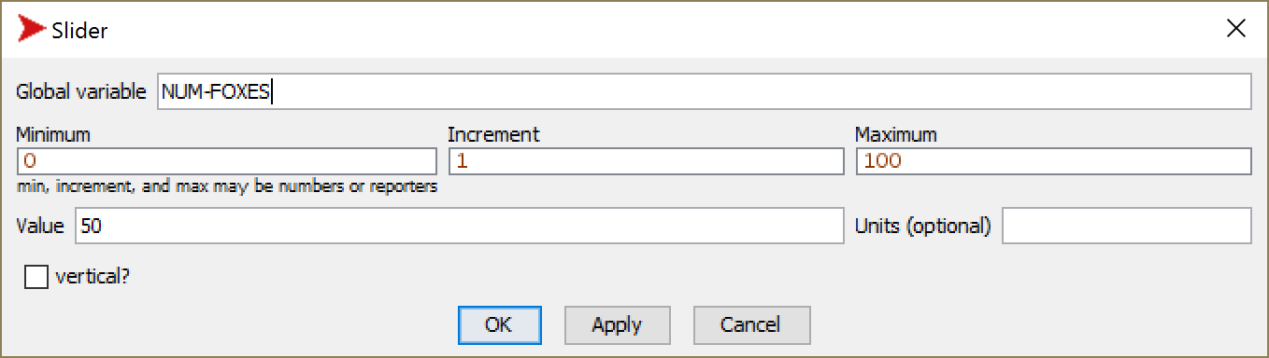

Press OK.

Now do the same thing to create a slider to manage the number of hounds.

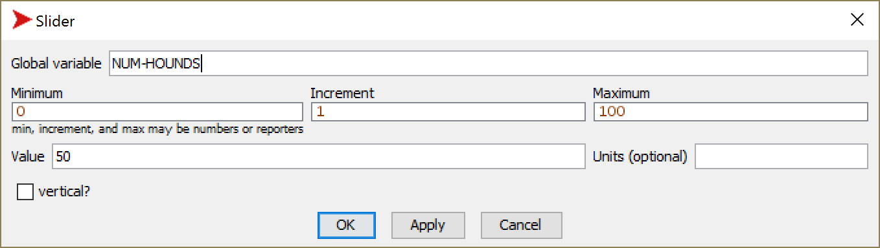

press OK.

Now go into the Code tab. Update the code used to setup-foxes as follows.

to setup-foxes

;; create-turtles 10 [

**create-turtles NUM-FOXES [**

set color red

set size 0.75

set shape "circle"

set species "fox"

setxy random-pxcor random-pycor

]

end

Now do the same thing for the code used to setup-hounds.

to setup-hounds

**;; create-turtles 10 [**

**create-turtles NUM-HOUNDS [**

set color brown

set size 1

set shape "circle"

set species "hound"

setxy random-pxcor random-pycor

]

end

Now go to the main interface tab, and select some number of foxes and hounds (you may use the default value of 50). When you press Setup, did you get the expected number of foxes and hounds?

Provide a screen shot of your updated interface tab. It should look something like this.

(your screenshot)

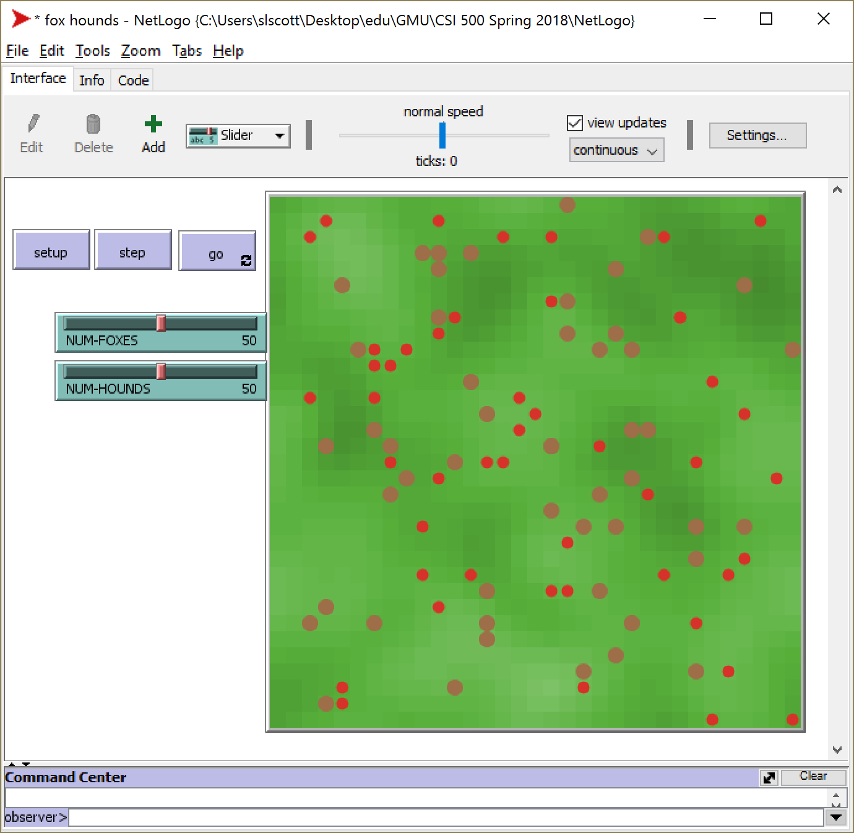

(my screenshot – updated #foxes and #hounds)

