**Document Management System in Market**

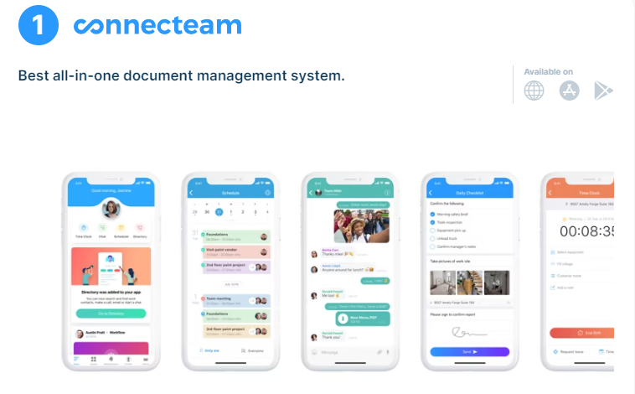**1. Connecteam** is an **award-winning, document management system** that allows SMBs and large enterprises to organize and share documents that easily reach their workforce.

This **all-in-one software, loved by 36,000+ businesses just like yours,** has a wide range of document management features that will benefit your business. Here are some of them:

* You can **easily upload all kinds of documents to the app**. Minimal storage will be used on employees’ devices, meaning they can use features smoothly and quickly on their smartphones.
* Employees can [**collaborate and communicate**](https://connecteam.com/employee-communication-app/)**easily**, sharing any relevant documents (as well as images, videos, all file types) across the company.
* Employees no longer need to peruse through Dropbox, Google Drive or emails, as they can simply **access all documents from one place: their smartphone app**.
* You can **select and restrict which documents *you* want specific or groups of employees to see**, ensuring that data is always protected.
* You can create an easy, [affordable training experience](https://connecteam.com/employee-training-software/), ensuring that **document management features are labeled and customized** in the company’s tone and voice.

**Connecteam** guarantees that all documents are easy to find for you and your employees. Spending tons of time writing long documents out of pen and paper will quickly become a thing of the past. And **documents are easily accessible** **no matter where and when employees are working**.

**For Whom?**

**Connecteam** is the perfect document management system for the [mobile workforce](https://connecteam.com/mobile-workforce-management-app-management-just-got-easy/) (including remote workers and deskless teams). This all-in-one solution’s document sharing features are used by tens of thousands of companies (of varying sizes) from more than 90 different industries. These include cleaning, retail, staffing, construction, to name a few.

**Key Features**

* Attach documents to updates
* Share documents via chat
* Training courses
* Attach documents to shifts/tasks
* Customize document management
* Store documents in folders/subfolders
* Document search
* Read and sign forms
* Reminders and notifications
* Track progress with visual insights
* Data protection
* Accessible on mobile and desktop

**Pros**

* Based on customer reviews
* Easily access all documents
* Features are easy to customize
* Data uses minimal storage space
* Intuitive and user-friendly
* Documents are easy to share
* All data is protected

**Cons**

* Some longer files aren’t user-friendly on mobile

**Pricing**

Starts at **just $29/month** for the first 30 users **Free** 14-day trial **Free** plan available

2. **Hightail** is a document management system that makes it easy for managers to keep teams on track, share large documents, collect feedback, all on one device. Admins can also assign and [manage tasks](https://connecteam.com/free-task-management-software/), monitor project activity and keep content secure with just a few clicks.

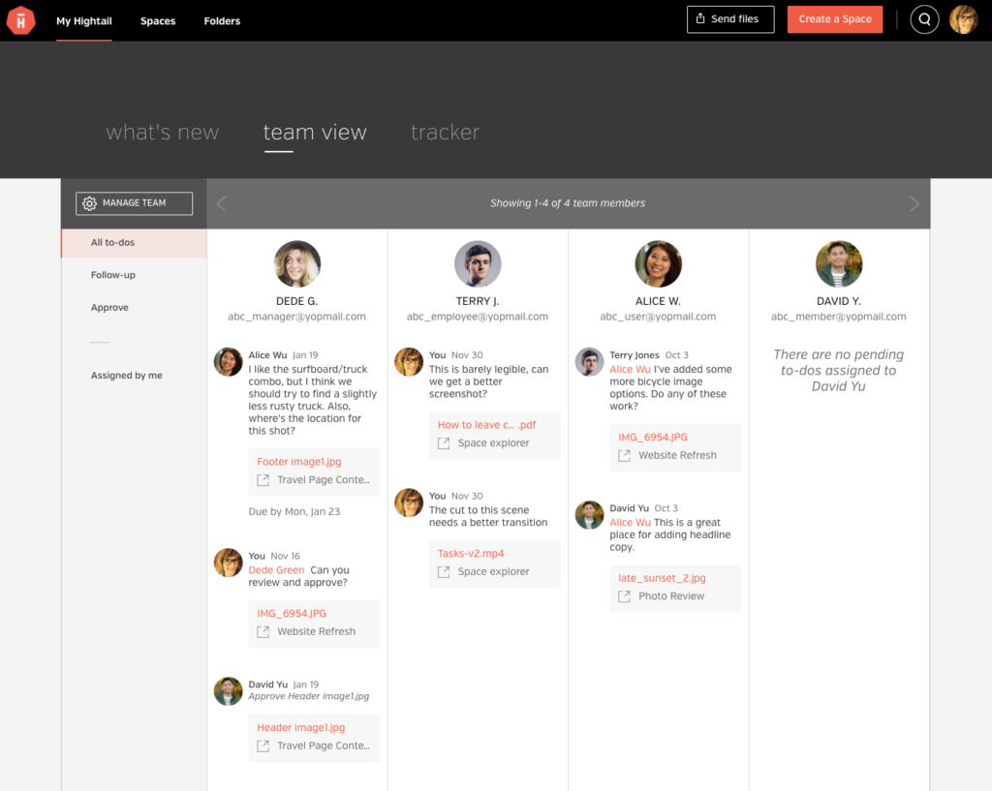

**For Whom?**

**Hightail** is an ideal solution for teams that need to share, edit and receive large documents. Specifically designed for creative and marketing teams, Hightail is also an effective [software solution for construction teams](https://connecteam.com/top-10-construction-scheduling-software-solutions/). It also benefits companies in industries such as retail and education.

**Key Features:**

* Document sharing
* Creative collaboration
* Project management
* Drag & drop
* Activity Dashboard
* Apps and integration

**Pros**

* Easy to share documents of all sizes
* Protects all data

**Cons**

* Poor customer support
* Expensive solution
* Lacks customization

**Pricing**

Teams plan is $24/user per month (available for 1-30 users) Free trial? 14-day Free plan? Yes

3. **KnowledgeOwl** is a document management system that helps managers build knowledge bases for employees. They can also create PDFs, FAQs and integrate with other apps easily. This cloud-based software boasts very useful customization features, making [employee training](https://connecteam.com/the-best-online-employee-training-software/) easier.

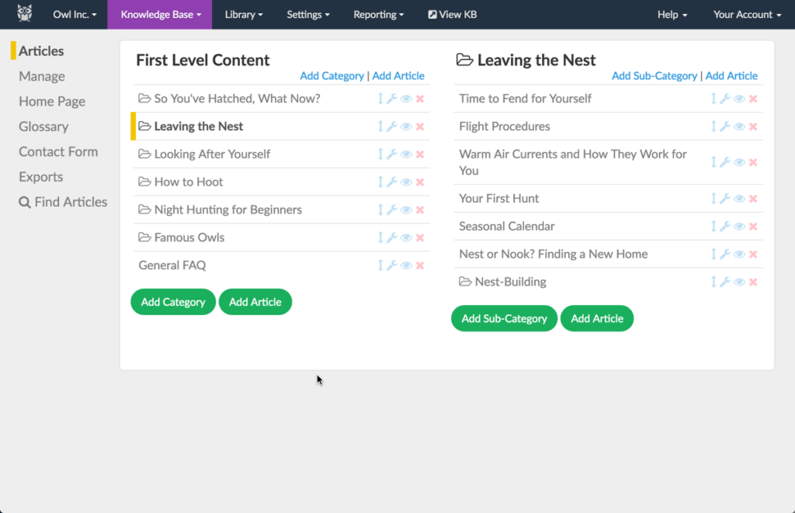

For Whom?

**KnowledgeOwl** is an ideal document management system for companies where time is of the essence when it comes to sharing information with employees. Non-profit organizations, SaaS companies and [small businesses](https://connecteam.com/small-business-management-software/) benefit from the app’s document management capabilities.

**Key Features**

* Workflow management
* Collaboration tools
* Drag and drop reordering
* Document library
* Customizable templates
* Categorization features

**Pros**

* Good customer support
* Functional and easy to use

**Cons**

* Slow loading times
* Difficult to organize documents
* Lack of detailed reporting

**Pricing**

Flex plan is $20/author per month Free trial? 30-day Free plan? No

4. **ClickUp** is a document management system that makes it easy to collaborate on document editing, task management, and more. Managers can share documents, set reminders, and [plan and schedule projects](https://connecteam.com/best-planner-apps-employees/), amongst other things. This cloud-based software is completely customizable.

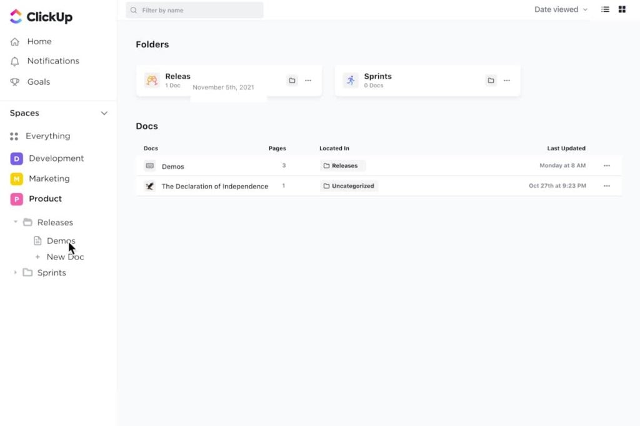

**For whom?**

**ClickUp** is useful for teams that want to work more efficiently, whether on site or while [working remotely](https://connecteam.com/best-remote-work-software-solutions/). Companies that work in industries such as healthcare, non-profit, and marketing, amongst others.

**Key Features**

* Folders and lists
* Customizable Tasks
* Subtasks and checklists
* Customizable features
* Collaboration tools
* Reporting dashboard

**Pros**

* Very easy to use
* Quick to customize

**Cons**

* Unattractive user interface
* Poor email notification process
* Poor customer support

**Pricing**

Unlimited plan is $5 per user/month Free trial? 30-day Free plan? Yes

5. **Confluence** is a document management software solution that helps businesses collaborate without the need for paper, pens and spreadsheets. This cloud-based technology is useful for companies, regardless if employees are [working on-site or remotely](https://connecteam.com/onboarding-new-employees-remotely/).

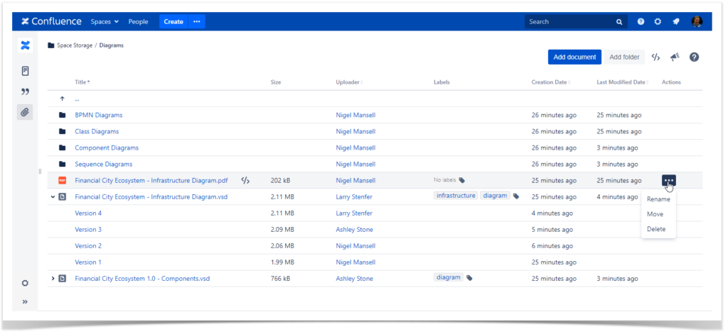

**For Whom?**

Companies of various sizes (remote teams included) benefit from Confluences document management and collaboration capabilities. An ideal [HR software solution](https://connecteam.com/best-free-hr-software-solutions/), other relevant industries include marketing, HR, finance, as well as technical and project management teams.

**Key Features**

* Advanced search
* Customizable templates
* Real-time editing/commenting
* Reminders/notifications
* Drag and drop
* Status tracking

**Pros**

* Easy to use
* Great for collaboration

**Cons**

* Limited exporting integrations
* Flaws in co-editing feature
* Difficult to train employees

**Pricing**

Standard plan is $5.50 per user/month Free trial? 7-day Free plan? Yes

6. **Quip** is a document management software solution where managers can create, upload, and share documents with all employees. All data (whether in documents or spreadsheets) can be stored in the same platform. This app also includes internal chat to [improve communication](https://connecteam.com/communication-solutions-for-deskless-workers/).

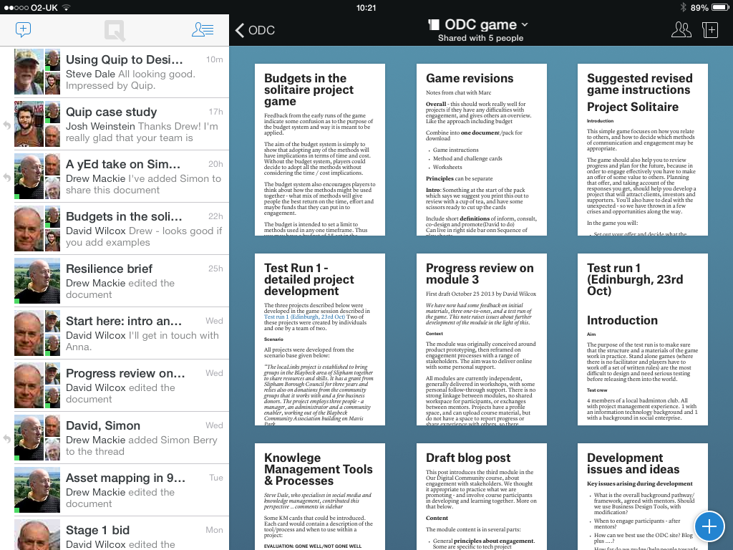

**For Whom?**

**Quip** is a useful document management system for companies that aim to include information transparency across departments. [Manufacturing management](https://connecteam.com/best-manufacturing-management-software-solutions/) teams will work more effectively and efficiently because of Quip document-sharing features.

**Key Features**

* Document storage
* Export, import and protect data
* Customizable templates
* Virtual private cloud
* Collaborative features
* Calendar management

**Pros**

* Organized and easy to use
* Ideal for collaborating

**Cons**

* Limited documentation options
* Faulty undo command
* Confusing user interface

**Pricing**

Starter plan is $10/user per month Free trial? 14-day Free plan? Yes

7. **Box** is a document management system that allows managers to [maximize productivity](https://connecteam.com/increase-workplace-productivity/)and eliminate data risks. Easily manage the lifecycles of content that are integral to business processes. Users can collaborate over shared documents, [automate workflows](https://connecteam.com/workflow-automation-saves-time-money/) and easily access the content cloud without hassle.

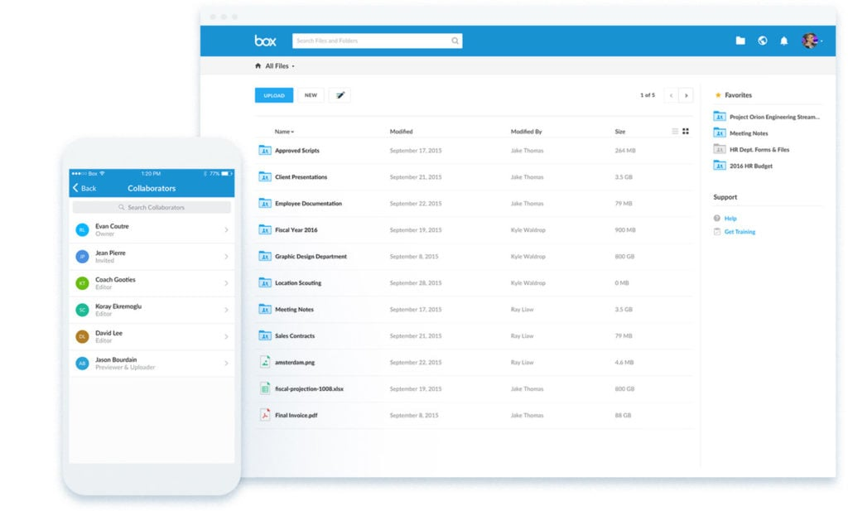

**For Whom?**

Many industries benefit from Box’s document management features, including retail, healthcare, and construction, amongst others. It is a useful cloud-based app for businesses of all sizes, including [small businesses](https://connecteam.com/the-14-must-have-free-tools-to-run-your-small-business/) and global enterprises.

**Key Features**

* Document collaboration
* Data protection
* Content cloud
* Workflow automation
* App integrations
* E-signature feature

**Pros**

* Simple to use
* Transfer documents easily

**Cons**

* Unattractive user interface
* Expensive solution
* Some syncing issues

**Pricing**

Business plan is $20 per user/month (minimum of 3 users) Free trial? 14-day Free plan? No

8. **PandaDoc** is a document management system that allows managers to create documents, [manage employees](https://connecteam.com/top-10-employee-management-tools/), and to eSign incoming documents such as contracts, quotes and proposals. Companies can use PandaDoc to simplify document-focused processes and improve efficiency, in general.

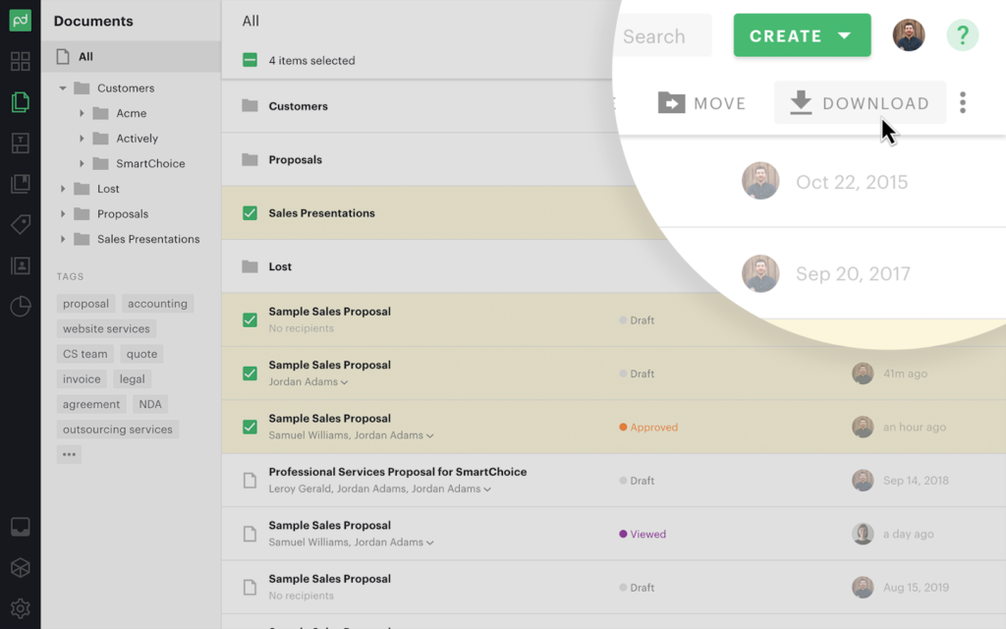

**For Whom?**

**PandaDoc** serves companies of all sizes (SMB to enterprise) from a wide range of industries. An effective [construction management software solution](https://connecteam.com/construction-management-software-solutions/) – healthcare and manufacturing also use this cloud-based app to streamline document processes.

### Key Features

* Upload documents
* Document analytics
* Drag and drop document editor
* Document storage
* Legally binding eSignatures
* Automated workflows

**Pros**

* Easy to use and train staff
* Responsive customer support

**Cons**

* Poor upgrades
* Loading time can be long
* Prone to bugs/crashes

**Pricing**

Essentials plan is $19 per user/month Free trial? 14-day Free plan? Yes

9. **Docebo** is a document management system that helps managers customize training programs easily, deliver training and manage content. A cloud-based solution that allows [remote teams](https://connecteam.com/how-to-manage-a-remote-team/) to easily access document libraries, Docebo integrates well with other apps.

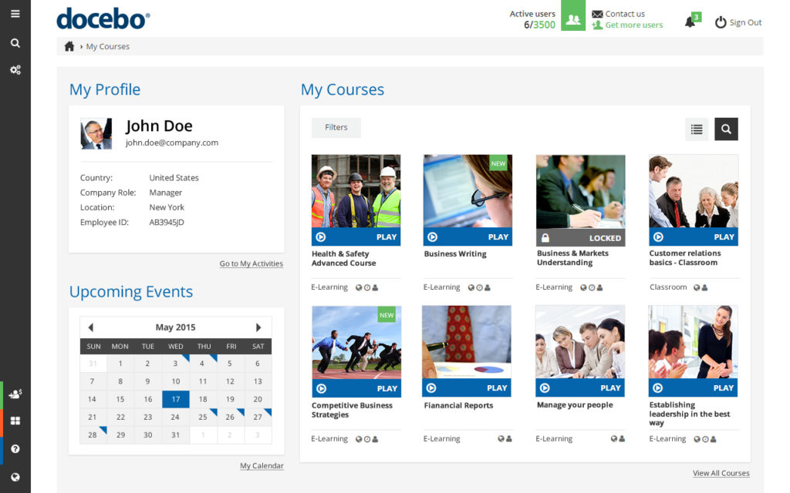

**For Whom?**

Docebo benefits a wide range of industries, and is especially successful as a [bartender training app](https://connecteam.com/free-bartender-training-manual/). Healthcare and retail are industries that also benefit from Docebo’s document management capabilities.

**Key Features**

* Automated tasks
* Customization tools
* Tests/assessments
* Learning analytics
* Gamification features
* Virtual classroom

**Pros**

* Integrates with multiple apps Attractive user interface
* Attractive user interface

**Cons**

* Lack of pricing transparency
* Some users might find it too complex
* Poor customer support

**Pricing**

Contact a Docebo sales representative for pricing Free trial? 14-day Free plan? No