**DOKUMEN BERITA ACARA COMMISSIONING TEST**

|  |  |
| --- | --- |
| **PROYEK** | **: PEKERJAAN CAPEX PT2 TREG III Batch-1, 2 Tahun 2025** |
| **KONTRAK** | **: K.TEL.002235/HK.810/T3R-0A000000/2025, Tanggal 7 Agustus 2025** |
| **WITEL** | **: YOGYA JATENG SELATAN** |
| **DISTRICT** | **: MAGELANG** |
| **LOKASI** | **: {NAMA LOP}** |
| **PELAKSANA** | **: TELKOM AKSES** |



**ANTARA**

**PT TELKOM INDONESIA (PERSERO) Tbk**

**DENGAN**

**PT TELKOM AKSES**

**CHECKLIST VERIFIKASI BERITA ACARA COMMISSIONING TEST**

|  |  |
| --- | --- |
| **PROYEK** | **: PEKERJAAN CAPEX PT2 TREG III Batch-1, 2 Tahun 2025** |
| **KONTRAK** | **: K.TEL.002235/HK.810/T3R-0A000000/2025, Tanggal 7 Agustus 2025** |
| **WITEL** | **: YOGYA JATENG SELATAN** |
| **DISTRICT** | **: MAGELANG** |
| **LOKASI** | **: {NAMA LOP}** |
| **PELAKSANA** | **: TELKOM AKSES** |

|  |  |  |  |  |  |
| --- | --- | --- | --- | --- | --- |
| **No.** | **ITEM YG DI PERIKSA** | | **STATUS** | | **KETERANGAN** |
| **OK** | **NOK** |
| 1 | BA CT dan Laporan CT | |  |  |  |
|  | A | Judul BACT | Checkmark with solid fill |  |  |
|  | B | Daftar Hadir | Checkmark with solid fill |  |  |
| 2 | Lampiran | |  |  |  |
|  | A | Laporan Pekerjaan 100% | Checkmark with solid fill |  |  |
|  | B | BA Barang Tiba & Evidence |  |  |  |
|  | C | BACT | Checkmark with solid fill |  |  |
|  | D | BOQ CT | Checkmark with solid fill |  |  |
|  | E | Form OPM + Evidence | Checkmark with solid fill |  |  |
|  | F | OTDR + Evidence |  |  |  |
|  | G | Evidence CT + Foto Material Terpasang | Checkmark with solid fill |  |  |
|  | H | BA Lapangan |  |  |  |
|  | I | ABD Red Line + KML | Checkmark with solid fill |  |  |

|  |
| --- |
| **MAGELANG,** |
| **PT. TELKOM INDONESIA**  **YAN ANDI SAIFUDIN**  **NIK. 740113** |

**BERITA ACARA COMMISSIONING TEST OSP**

|  |  |
| --- | --- |
| **PROYEK** | **: PEKERJAAN CAPEX PT2 TREG III Batch-1, 2 Tahun 2025** |
| **KONTRAK** | **: K.TEL.002235/HK.810/T3R-0A000000/2025, Tanggal 7 Agustus 2025** |
| **WITEL** | **: YOGYA JATENG SELATAN** |
| **DISTRICT** | **: MAGELANG** |
| **LOKASI** | **: {NAMA LOP}** |
| **PELAKSANA** | **: TELKOM AKSES** |

Pada hari ini tanggal bulan tahun ***DUA RIBU DUA PULUH LIMA,*** Yang bertanda tangan dibawah ini:

Nama/ NIK Waspang : YAN ANDI SAIFUDIN / 740113

Jabatan : WASPANG TELKOM

Dalam hal ini bertindak untuk dan atas nama PT. Telkom Indonesia Tbk, telah melaksanakan Commisioning Test dan pengecekan fisik pada PEKERJAAN CAPEX PT2 TREG III Batch-1, 2 Tahun 2025**.** Dengan rincian lokasi sebagai berikut :

|  |  |  |  |  |  |
| --- | --- | --- | --- | --- | --- |
| **NO** | **WITEL** | **iHLD LoP ID** | **eProposal LoP ID** | **STO** | **NAMA LOKASI** |
| 1 | YOGYA JATENG SELATAN | {IHLD LoP ID} | {eProposal LoP ID} | {STO} | **{NAMA LOP}** |

Adapun hasil pemeriksaan dan penilaian sebagai berikut :

1. Pelaksanaan pekerjaan telah selesai dilaksanakan sesuai dengan syarat-syarat atau Spesifikasi teknik yang ditentukan dalam kontrak.
2. Hasil pekerjaan **dapat** diterima dan **layak/~~tidak layak~~** untuk diajukan Uji Terima.

Demikian Berita Acara ini dibuat dengan keadaan yang sebenarnya untuk dipergunakan seperlunya.

|  |  |
| --- | --- |
|  | **MAGELANG,** |
|  |  |
| **PT TELKOM** | **PT TELKOM AKSES** |
| **WASPANG TELKOM** |  |
| **YAN ANDI SAIFUDIN**  **NIK. 740113** | **MUHAMMAD ZULFIKAR PRADANA**  **NIK. 17960877** |

**DAFTAR HADIR COMMISSIONING TEST**

|  |  |
| --- | --- |
| **PROYEK** | **: PEKERJAAN CAPEX PT2 TREG III Batch-1, 2 Tahun 2025** |
| **KONTRAK** | **: K.TEL.002235/HK.810/T3R-0A000000/2025, Tanggal 7 Agustus 2025** |
| **WITEL** | **: YOGYA JATENG SELATAN** |
| **DISTRICT** | **: MAGELANG** |
| **LOKASI** | **: {NAMA LOP}** |
| **PELAKSANA** | **: TELKOM AKSES** |

|  |  |  |  |
| --- | --- | --- | --- |
| **NO** | **I T E M** | **STATUS** | **KETERANGAN** |
| 1 | **Personil yang terlibat**   1. WASPANG 2. PELAKSANA HARIAN | Ada / ~~Tidak ada~~  Ada / ~~Tidak ada~~ |  |

|  |  |
| --- | --- |
|  | **MAGELANG,** |
| **PT TELKOM INFRASTRUKTUR INDONESIA** | **PT TELKOM AKSES** |
| **WASPANG** |  |
| **MUHAMAD RIDHO MAULANA MUSTAQIM**  **NIK. 960433** | **MUHAMMAD ZULFIKAR PRADANA**  **NIK. 17960877** |

**LAPORAN HASIL PEKERJAAN SELESAI 100%**

|  |  |
| --- | --- |
| **PROYEK** | **: PEKERJAAN CAPEX PT2 TREG III Batch-1, 2 Tahun 2025** |
| **KONTRAK** | **: K.TEL.002235/HK.810/T3R-0A000000/2025, Tanggal 7 Agustus 2025** |
| **WITEL** | **: YOGYA JATENG SELATAN** |
| **DISTRICT** | **: MAGELANG** |
| **LOKASI** | **: {NAMA LOP}** |
| **PELAKSANA** | **: TELKOM AKSES** |

1. Menunjuk:
2. Kontrak : K.TEL.002235/HK.810/T3R-0A000000/2025, Tanggal 7 Agustus 2025.
3. Bersama ini kami informasikan bahwa telah dilaksanakan CommisioningTest OSP (hasil terlampir) dan pencapaian progress dengan rincian lokasi sebagai berikut :

|  |  |  |  |  |  |
| --- | --- | --- | --- | --- | --- |
| **NO** | **WITEL** | **iHLD LoP ID** | **eProposal LoP ID** | **STO** | **NAMA LOKASI** |
| 1 | YOGYA JATENG SELATAN | {IHLD LoP ID} | {eProposal LoP ID} | {STO} | **{NAMA LOP}** |

Lokasi tersebut di atas sudah selesai 100% dan siap untuk dilakukan Uji Terima.

1. Demikian kami sampaikan, atas perhatian dan kerjasamanya kami ucapkan terima kasih.

|  |  |
| --- | --- |
|  | **MAGELANG,** |
| **PT TELKOM INFRASTRUKTUR INDONESIA** | **PT TELKOM AKSES** |
| **WASPANG** |  |
| **MUHAMAD RIDHO MAULANA MUSTAQIM**  **NIK. 960433** | **MUHAMMAD ZULFIKAR PRADANA**  **NIK. 17960877** |

**LAMPIRAN COMMISSIONING TEST**

**BOQ (BILL OF QUANTITY)**

|  |  |
| --- | --- |
| **PROYEK** | **: PEKERJAAN CAPEX PT2 TREG III Batch-1, 2 Tahun 2025** |
| **KONTRAK** | **: K.TEL.002235/HK.810/T3R-0A000000/2025, Tanggal 7 Agustus 2025** |
| **WITEL** | **: YOGYA JATENG SELATAN** |
| **DISTRICT** | **: MAGELANG** |
| **LOKASI** | **: {NAMA LOP}** |
| **PELAKSANA** | **: TELKOM AKSES** |

Berikut lampiran BOQ Aktual :

| **NO** | **DESIGNATOR** | **URAIAN PEKERJAAN** | **SATUAN** | **{NAMA LOP}** | | | |
| --- | --- | --- | --- | --- | --- | --- | --- |
| **KONTRAK** | **AKTUAL** | **TAMBAH** | **KURANG** |
| 1 |  |  |  |  |  |  |  |
| 2 |  |  |  |  |  |  |  |
| 3 |  |  |  |  |  |  |  |
| 4 |  |  |  |  |  |  |  |
| 5 |  |  |  |  |  |  |  |
| 6 |  |  |  |  |  |  |  |
| 7 |  |  |  |  |  |  |  |
| 8 |  |  |  |  |  |  |  |
| 9 |  |  |  |  |  |  |  |
| 10 |  |  |  |  |  |  |  |
| 11 |  |  |  |  |  |  |  |
| 12 |  |  |  |  |  |  |  |

|  |  |
| --- | --- |
|  | **MAGELANG,** |
| **PT TELKOM INFRASTRUKTUR INDONESIA** | **PT TELKOM AKSES** |
| **WASPANG** |  |
| **MUHAMAD RIDHO MAULANA MUSTAQIM**  **NIK. 960433** | **MUHAMMAD ZULFIKAR PRADANA**  **NIK. 17960877** |

**DOKUMENTASI COMMISSIONING TEST**

|  |  |  |  |  |  |  |  |  |  |  |  |  |  |  |  |  |  |  |  |  |  |  |  |  |  |  |
| --- | --- | --- | --- | --- | --- | --- | --- | --- | --- | --- | --- | --- | --- | --- | --- | --- | --- | --- | --- | --- | --- | --- | --- | --- | --- | --- |
| |  |  |  |  | | --- | --- | --- | --- | | **PROYEK** | **:** | **PEKERJAAN CAPEX PT2 TREG III Batch-1, 2 Tahun 2025** | **Pekerjaan CAPEX PT2 TREG III BATCH-3 TAHUN 2024 (JATENG)** | | **KONTRAK** | **:** | **K.TEL.002235/HK.810/T3R-0A000000/2025, Tanggal 7 Agustus 2025** | **K.TEL.006431/HK.810/T3R-0A000000/2024 TANGGAL : 24 DESEMBER 2024** | | **WITEL** | **:** | **YOGYA JATENG SELATAN** | **YOGYA JATENG SELATAN** | | **DISTRICT** | **:** | **MAGELANG** | **MAGELANG** | | **LOKASI** | **:** | **{NAMA LOP}** | **PT2 SUB DISTRICT MAGELANG / {NAMA LOP}** | | **PELAKSANA** | **:** | **TELKOM AKSES** | **TELKOM AKSES** |   **{NAMA LOP}** | | |
| {#foto_odp}{%foto_odp}{/foto_odp} | {#klem_ring}{%klem_ring}{/klem_ring} | {#pipa}{%pipa}{/pipa} |
| ODP-PB-8-8 Solid lengkap | KLEM-RING-5-LUBANG | Pipa paralon |
| {#closure}{%closure}{/closure} | {#in_odc}{%in_odc}{/in_odc} | {#testcom}{%testcom}{/testcom} |
| SC-OF-SM-24 | Redaman Input ODC | TESTCOM |

|  |  |
| --- | --- |
|  |  |
| **PT TELKOM INFRASTRUKTUR INDONESIA** | **PT TELKOM AKSES** |
| **WASPANG** |  |
| **MUHAMAD RIDHO MAULANA MUSTAQIM**  **NIK. 960433** | **MUHAMMAD ZULFIKAR PRADANA**  **NIK. 17960877** |

|  |
| --- |
| **FOTO PENGUKURAN OPM**  **{NAMA LOP}** |

|  |  |  |
| --- | --- | --- |
| {#port1}{%port1}{/port1} | {#port2}{%port2}{/port2} | {#port3}{%port3}{/port3} |
| PORT 1 | PORT 2 | PORT 3 |
| {#port4}{%port4}{/port4} | {#port5}{%port5}{/port5} | {#port6}{%port6}{/port6} |
| PORT 4 | PORT 5 | PORT 6 |
| {#port7}{%port7}{/port7} | {#port8}{%port8}{/port8} | {#in_odp}{%in_odp}{/in_odp} |
| PORT 7 | PORT 8 | IN ODP |

|  |  |
| --- | --- |
|  |  |
| **PT TELKOM INFRASTRUKTUR INDONESIA** | **PT TELKOM AKSES** |
| **WASPANG** |  |
| **MUHAMAD RIDHO MAULANA MUSTAQIM**  **NIK. 960433** | **MUHAMMAD ZULFIKAR PRADANA**  **NIK. 17960877** |

|  |
| --- |
| **DOKUMENTASI PEKERJAAN**  **{NAMA LOP}** |

|  |  |  |
| --- | --- | --- |
| {#label_odp}{%label_odp}{/label_odp} | {#termin}{%termin}{/termin} | {#barcode}{%barcode}{/barcode} |
| LABEL ODP | TERMINASI | BARCODE |
| {#splitter}{%splitter}{/splitter} | {#distri}{%distri}{/distri} | {#feeder}{%feeder}{/feeder} |
| SPLIITER 1:4 | PANEL DISTRIBUSI | FEEDER |
| {#odc}{%odc}{/odc} | {#survey}{%survey}{/survey} | {#survey2}{%survey2}{/survey2} |
| FOTO ODC | SURVEY | SURVEY |

|  |  |  |
| --- | --- | --- |
| {#branching}{%branching}{/branching} |  |  |
| SAMBUNGAN BRANCHING |  |  |

|  |  |
| --- | --- |
|  |  |
| **PT TELKOM INFRASTRUKTUR INDONESIA** | **PT TELKOM AKSES** |
| **WASPANG** |  |
| **MUHAMAD RIDHO MAULANA MUSTAQIM**  **NIK. 960433** | **MUHAMMAD ZULFIKAR PRADANA**  **NIK. 17960877** |

|  |
| --- |
| **FORM OPM**  **{NAMA LOP}** |

{#end_to_end}{%end_to_end}{/end_to_end}

|  |  |
| --- | --- |
|  |  |
| **PT TELKOM INFRASTRUKTUR INDONESIA** | **PT TELKOM AKSES** |
| **WASPANG** |  |
| **MUHAMAD RIDHO MAULANA MUSTAQIM**  **NIK. 960433** | **MUHAMMAD ZULFIKAR PRADANA**  **NIK. 17960877** |

**FILE ABD (PETLOK, SKEMA, MANCORE) – VALID 4**

**{NAMA LOP}**

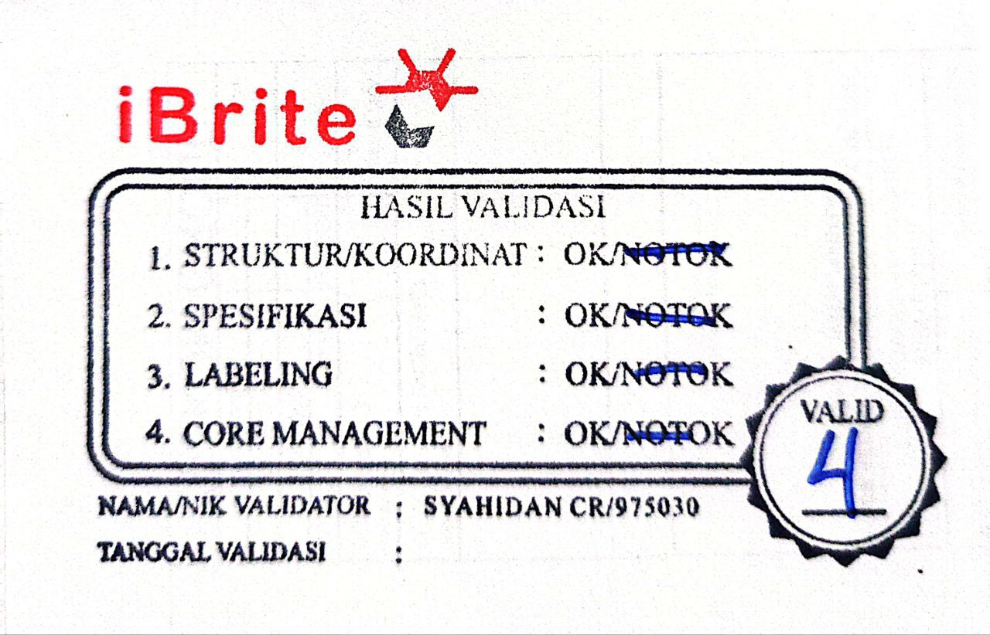{#mancore}{%mancore}{/mancore}

{#peta}{%peta}{/peta}