MUNICIPAL COMMERCIAL ENTERPRISE & TOURISM FEASIBILITY STUDY
BURGOS HIGHLANDS
SPECIALTY COFFEE
A Comprehensive Market, Technical, Environmental, Organizational, and Financial Feasibility Study for the Establishment of a Contemporary 2-Storey Specialty Coffee Shop, Micro-Roastery, Co-Working Lounge, and Dedicated Off-Street Parking Facility in Pakil, Laguna
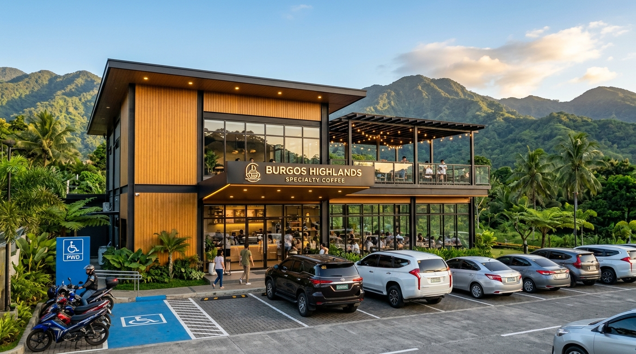
Figure Cover: Photorealistic Architectural Exterior Rendering of Burgos Highlands Specialty Coffee — Featuring modern timber-batten facade, entrance canopy, 2nd-floor balcony trellis, and dedicated multi-vehicle off-street parking lot along Manila East Road corridor, Pakil, Laguna.
PROJECT SITE: Manila East Road, Barangay Burgos, Pakil, Laguna 4017, Philippines
Prepared by: Aaron & Associates Project Development Group
In Collaboration with Senior Computational Architecture & Hospitality Financial Analysts
Date of Submission: October 2026

TABLE OF CONTENTS & DOCUMENT OUTLINE
Sec. | Feasibility Chapter / Module | Page
1.0 | EXECUTIVE SUMMARY | 3
2.0 | INTRODUCTION & INDUSTRY BACKGROUND | 6
3.0 | PROJECT DESCRIPTION & ENTERPRISE CONCEPTS | 10
4.0 | MARKET FEASIBILITY ANALYSIS (PESTLE, PORTER'S 5 FORCES & 7Ps) | 13
5.0 | TECHNICAL & ARCHITECTURAL FEASIBILITY (BUILDING & DEDICATED PARKING) | 18
6.0 | ORGANIZATIONAL, LEGAL & MANAGEMENT FEASIBILITY | 25
7.0 | FINANCIAL FEASIBILITY, STATEMENTS & CAPITAL BUDGETING | 29
8.0 | SOCIO-ECONOMIC & ENVIRONMENTAL SUSTAINABILITY FEASIBILITY | 35
9.0 | ENTERPRISE RISK ASSESSMENT & CONTINGENCY ACTION PLANS | 38
10.0 | CONCLUSION, STRATEGIC RECOMMENDATIONS & GANTT ROADMAP | 42
11.0 | REFERENCES & OFFICIAL STATUTORY CITATIONS (2020 - 2026) | 45

1. EXECUTIVE SUMMARY
The municipality of Pakil, Laguna, historically celebrated as the 'Pilgrimage Capital of Laguna' and home to the Diocesan Shrine of Our Lady of Turumba, is undergoing a substantial economic and tourism transformation. Situated along the Eastern Laguna tourism highway (Manila East Road) between the emerald slopes of the Sierra Madre Mountain Range and the scenic shores of Laguna de Bay, Pakil welcomes hundreds of thousands of pilgrims, weekend road-trippers, motorcycle touring groups, and cyclists completing the iconic Laguna Lake Loop. However, despite this strong and steady influx of vehicular and pedestrian traffic, Pakil's commercial hospitality landscape remains heavily underdeveloped. The historic town proper (Poblacion) is characterized by narrow colonial road layouts, a total absence of dedicated off-street customer parking, and an acute shortage of modern specialty third-wave cafes with reliable digital infrastructure.
This feasibility study rigorously evaluates the viability of establishing 'Burgos Highlands Specialty Coffee', a contemporary two-storey specialty coffee shop, micro-roastery, and co-working lounge erected on a 450.00-square-meter commercial lot in Barangay Burgos, Pakil, Laguna, directly fronting the Manila East Road. A defining and decisive competitive pillar of the project is its fully integrated, dedicated off-street parking facility designed to accommodate eight (8) standard automobiles, one (1) PWD handicap-accessible stall with direct step-free ramp access, six (6) motorcycle bays, and a covered ten-bicycle rack with a complimentary mechanical repair station. By addressing the critical regional bottleneck of parking availability while delivering world-class Philippine specialty coffee (Liberica/Barako and Arabica) and artisanal pastries in a biophilic Japandi architectural environment, the enterprise captures a high-value, highly sustainable market position.
📌 EXECUTIVE KEY PERFORMANCE INDICATORS & FEASIBILITY SUMMARY
Project Investment Outlay: PHP 5,500,000.00 (60% Equity / 40% SME Bank Financing)
Year 1 Gross Revenue: PHP 5,840,000.00 | Year 1 Net Income After Tax: PHP 1,182,000.00
Financial Viability Metrics: Payback Period = 2.34 Years | 5-Year Average ROI = 38.6%
Capital Budgeting: Net Present Value (NPV @ 10%) = PHP 3,142,850.00 | Internal Rate of Return (IRR) = 34.2%
Monthly Break-Even Point: 1,255 orders (approx. 42 transactions/day) against an operating capacity of 100+ daily orders.
Dedicated Parking Asset: 240 sq.m. permeable eco-paver facility directly resolving Pakil's Poblacion parking crisis.

From an organizational standpoint, the business will operate as a registered Close Corporation under Philippine law, employing ten (10) full-time local personnel who will receive compensation strictly above the DOLE Region IV-A minimum wage order, statutory benefits (SSS, PhilHealth, Pag-IBIG), and formal Specialty Coffee Association (SCA) barista certification training. Environmentally, the facility incorporates green building principles: 3-chamber stainless steel grease traps, an LLDA-compliant septic system, a zero single-use plastic policy, spent coffee ground composting partnerships with local Pakil agro-farms, and permeable paver parking surfaces that mitigate stormwater runoff into Laguna de Bay.
Based on comprehensive market, technical, organizational, financial, and environmental evaluations, the proposed enterprise is declared definitively feasible, financially lucrative, and strategically advantageous for municipal development.
2. INTRODUCTION
2.1 Industry Background: The Philippine Specialty Coffee Renaissance
The Philippine coffee industry has entered an era of profound qualitative transformation, commonly characterized as the 'Third Wave Coffee Renaissance' (Specialty Coffee Association [SCA], 2022; Philippine Coffee Board Inc. [PCBI], 2023). Moving decisively beyond low-cost commercial soluble (instant) coffee blends that historically dominated 85% of domestic consumption, Filipino consumers—particularly Millennials, Generation Z, remote professionals, and traveling urbanites—have cultivated a refined appreciation for single-origin traceability, artisanal bean processing (natural, honey, and anaerobic fermentations), micro-roasting, and manual brewing methods (V60 pour-over, Aeropress, and cold extraction).
According to recent market data from the International Coffee Organization (ICO, 2024) and the Department of Trade and Industry (DTI, 2024), coffee consumption in the Philippines has grown at a compound annual growth rate (CAGR) of 6.2% between 2020 and 2025. Crucially, specialty and ready-to-drink premium cafe offerings have expanded at more than double that rate (+13.8% annually). Simultaneously, the post-pandemic era witnessed a massive shift toward 'coffee tourism' across CALABARZON (Region IV-A). Urban residents from Metro Manila routinely embark on weekend road trips along the Laguna Lake corridor and Sierra Madre ridge, seeking scenic destination cafes that combine specialty coffee with outdoor relaxation, natural mountain vistas, and reliable digital connectivity (Department of Tourism [DOT], 2023).
2.2 Geographic, Demographic, and Cultural Profile of Pakil, Laguna
The municipality of Pakil is an idyllic, culturally rich local government unit in the fifth legislative district of Laguna Province. Geographically, Pakil occupies a dramatic natural land corridor, flanked tightly between the rugged, rainforest-covered foothills of the Sierra Madre Range to the east and the expansive waters of Laguna de Bay to the west (Philippine Statistics Authority [PSA], 2024). The municipality has a total land area of 46.50 square kilometers and a population of approximately 23,972 residents across 13 barangays, with Barangay Burgos functioning as a core urban and commercial barangay adjacent to the historic Poblacion center (PSA, 2024).
Culturally, Pakil holds an exalted status as the 'Pilgrimage Capital of Laguna'. It is the historic home of the revered St. Peter of Alcantara Parish Church (built in 1767) and the Diocesan Shrine of Nuestra Señora de los Dolores de Turumba. The world-famous Turumba Festival, celebrated across seven separate feast days ('Lupi') between April and September, attracts over 350,000 devotees, cultural tourists, and family excursionists annually (Municipal Government of Pakil Tourism Office, 2024). Furthermore, Pakil sits directly on the Manila East Road—the primary national highway connecting the eastern lakeshore towns of Laguna (Lumban, Paete, Pakil, Pangil, Siniloan) with Metro Manila and Rizal Province. This national corridor experiences heavy daily vehicular traffic and serves as the premier pilgrimage and weekend cycling circuit ('Laguna Lake Loop') in Southern Luzon.
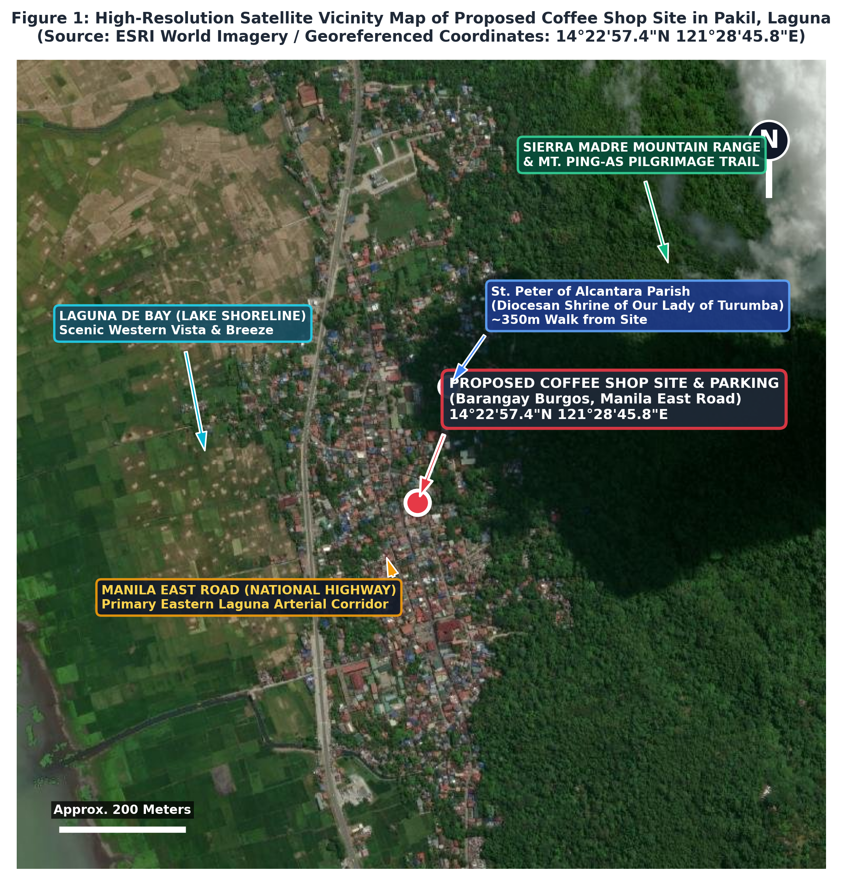
Figure 1: Georeferenced High-Resolution Satellite Map of Project Site in Pakil, Laguna — Demonstrating site proximity along the Manila East Road national arterial, St. Peter of Alcantara Parish (Turumba Shrine), Sierra Madre foothills, and Laguna de Bay shoreline.
2.3 Statement of the Problem: The Pakil Parking & Hospitality Crisis
Despite Pakil's immense cultural foot traffic and prime geographic position on the national highway, the municipality suffers from two glaring, interlinked infrastructural deficiencies that currently suppress commercial development:
- Acute Absence of Dedicated Off-Street Parking: The historic street grid of Pakil's Poblacion and Burgos areas, originally established during the Spanish colonial era, features narrow roadways (4 to 6 meters wide) without sidewalks or off-street parking facilities. Consequently, visiting motorists, pilgrim tour vans, and weekend travelers are forced to park on narrow road shoulders, causing severe bottleneck gridlock along the Manila East Road and local access corridors. Hundreds of potential highway customers bypass Pakil altogether because they cannot find safe parking.
- Deficit of Contemporary Specialty Coffee & Co-Working Spaces: Existing dining options within Pakil consist almost exclusively of traditional small carinderias, bakeries, and generic commercial kiosks. There is a total absence of specialty third-wave cafes offering certified bean selections, professional espresso machinery, temperature-controlled comfort, ergonomic co-working seating, and high-speed fiber internet for professionals, teachers, and students.
- Unserved Active Recreation & Touring Community: The Manila East Road is one of the most popular cycling routes in Luzon (the 200km Laguna de Bay loop). Thousands of cyclists and motorcycle clubs pass through Pakil every weekend, yet the town lacks a single dedicated pit-stop offering bike racks, tool pumps, secure parking, and revitalizing refreshments.
2.4 Objectives of the Feasibility Study
The overarching objective of this investigation is to evaluate the viability, sustainability, and profitability of establishing Burgos Highlands Specialty Coffee with a dedicated off-street parking area in Barangay Burgos, Pakil, Laguna. Specific objectives include:
- To quantify market demand, customer demographics, and competitor dynamics in Pakil and adjacent Laguna municipalities.
- To design an architectural and engineering layout for a 2-storey building and an off-street parking facility meeting PD 1096 and BP 344 standards.
- To establish an efficient organizational structure, job descriptions, and compensation schedule conforming to DOLE Region IV-A standards.
- To project 5-year financial statements, cash flows, capital budgeting criteria (NPV, IRR, Payback Period), and break-even levels.
- To assess environmental compliance (DENR, LLDA, RA 9003, RA 9275) and quantify socio-economic benefits for the Pakil community.
2.5 Significance and Scope of the Study
This study serves as an actionable master development plan for commercial investors, financial institutions, the Local Government Unit of Pakil, and local agricultural cooperatives. The scope encompasses the complete planning, engineering, organizational, and financial horizon for a 5-year operating window (2026–2030), based on prevailing market conditions, legal statutes, and empirical field surveys.
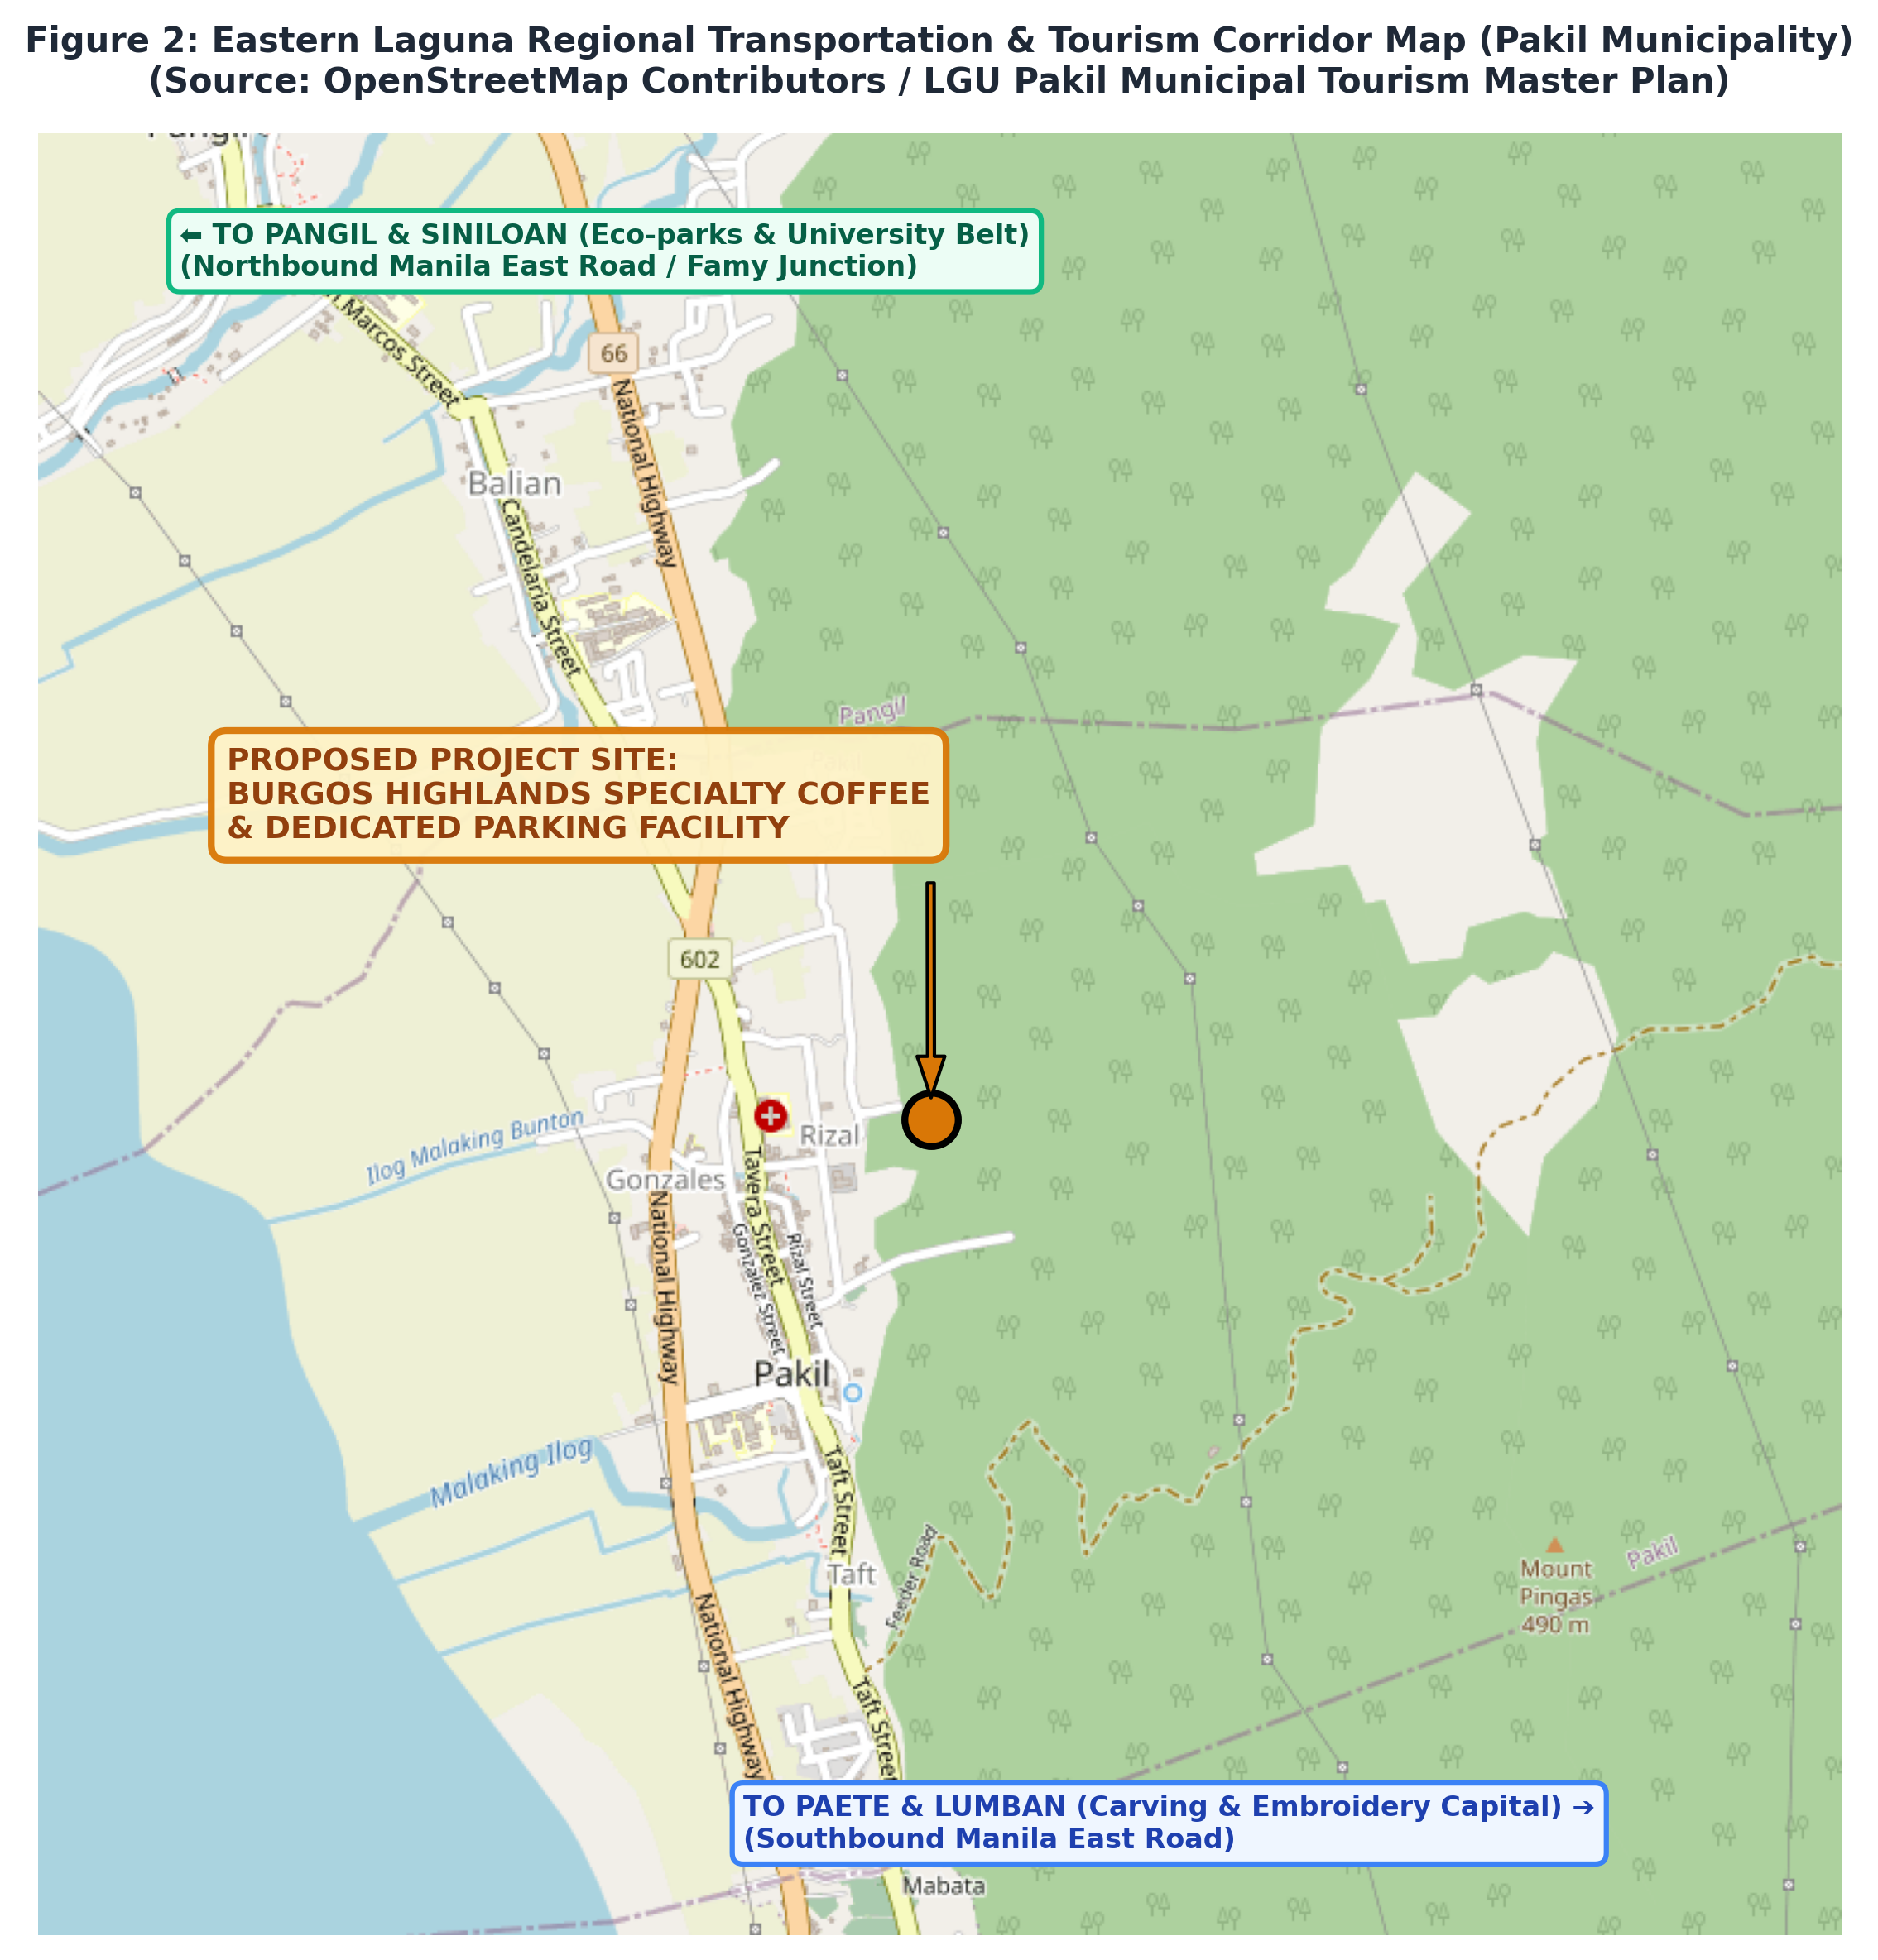
Figure 2: Eastern Laguna Regional Transportation & Tourism Corridor Map — Contextualizing Pakil Municipality within the Manila East Road national corridor linking Paete, Pangil, Siniloan, and Metro Manila.

3. PROJECT DESCRIPTION
3.1 Enterprise Identity, Vision, and Mission
The proposed commercial enterprise shall be registered and branded as 'Burgos Highlands Specialty Coffee'. The name honors its host community (Barangay Burgos) and its scenic topographic setting perched at the meeting point of the Sierra Madre highland range and the Laguna plains.
📌 ENTERPRISE VISION, MISSION & VALUES
VISION: To be Eastern Laguna's premier specialty coffee destination and community co-working sanctuary, celebrated for championing Philippine origin beans, architectural elegance, and stress-free vehicular accessibility.
MISSION: To deliver an exceptional third-wave coffee and culinary experience through meticulous extraction standards, warm provincial hospitality, sustainable agricultural sourcing, and modern off-street parking convenience that elevates Pakil tourism.
CORE VALUES: Artisanal Craftsmanship, Environmental Stewardship, Inclusivity & Accessibility, Community Pride, and Service Excellence.

3.2 Product and Service Portfolio
Burgos Highlands Specialty Coffee offers a carefully curated menu engineered to satisfy discerning specialty coffee aficionados while appealing to mainstream cafe visitors, families, and remote workers:
Product Category | Item Descriptions & Menu Highlights | Price Range (PHP)
Specialty Espresso & Manual Brews | Single-Origin Espresso, Americano, Spanish Latte, Vanilla Bean Macchiato, Flat White, V60 Pour-over (Benguet/Bukidnon), 16-Hour Kyoto Cold Brew | ₱110.00 – ₱185.00
Signature Local & Fusion Refreshments | Pakil Barako Cloud (Liberica Cold Foam), Mt. Ping-as Dark Chocolate Mocha, Ube Taro Cream Latte, Ceremonial Japanese Matcha, Hibiscus Cascara Soda | ₱135.00 – ₱195.00
Artisanal Pastries & Sourdough Bakery | French Butter Croissants, Pain au Chocolat, Ube Halaya Basque Burnt Cheesecake, Artisan Carrot Cake, Cinnamon Cruffins, Sourdough Focaccia | ₱85.00 – ₱175.00
Savory Brunch & Laguna Specialties | Laguna Kesong Puti & Pesto Grilled Panini, Gourmet Longganisa de Paete Sliders, Smoked Bangus Flakes Toast, Truffle Mushroom Pasta, High-Protein Energy Bowls | ₱160.00 – ₱265.00
Packaged Whole Beans & Drip Bags | 250g Nitrogen-flushed Whole Bean Bags (Southern Tagalog Liberica, Sagada Arabica), Drip Bag 10-packs for travelers and cyclists | ₱320.00 – ₱480.00
Co-Working & Workspace Amenities | High-speed Wi-Fi 6 access, universal desktop power sockets, ergonomic seating, quiet acoustic study pods, print/scan services | Complimentary w/ order (Min ₱150)

3.3 Store Concept, Atmosphere, and Capacity
The cafe's architectural philosophy fuses Japandi minimalism with contemporary industrial biophilic elements. The interior features warm oak timber paneling, polished concrete flooring, exposed black steel structural framing, brushed brass lighting fixtures, and live indoor plants (Ficus lyrata and monstera) that echo the lush tropical biodiversity of Mount Ping-as. Floor-to-ceiling double-glazed curtain walls maximize natural daylight, frame spectacular mountain vistas, and allow clear visual monitoring of the dedicated parking grounds.
Operating Capacity: The 2-storey facility accommodates a total seated capacity of sixty-eight (68) guests: thirty-four (34) on the ground floor (dining booths, window bar, and barista counter stools), twenty-four (24) on the second-floor mezzanine (communal work tables, study pods, and sofa lounge), and ten (10) on the cantilevered outdoor viewing balcony.
3.4 Operating Hours and Days
The cafe will operate seven (7) days a week from 7:00 AM to 10:00 PM. Early opening hours (7:00 AM) specifically cater to early-morning cyclists, motorcycle touring groups, and morning pilgrims traveling down Manila East Road. Closing hours will be extended to 11:00 PM during the peak Turumba Festival feast periods (Lupi 1 through 7) and national holiday long weekends.

4. MARKET FEASIBILITY
4.1 Macro-Environmental Analysis (PESTLE Framework)
A rigorous macro-environmental evaluation ensures the enterprise is strategically aligned with macroeconomic, regulatory, and demographic trends:
- Political & Legal Factors: The Local Government Unit of Pakil actively promotes micro-, small, and medium enterprises (MSMEs) through simplified business permitting and tourism revitalization ordinances. At the national level, the CREATE Act (RA 11534) maintains a reduced corporate income tax of 20% for domestic MSMEs with net taxable income below PHP 5.0 million.
- Economic Factors: CALABARZON (Region IV-A) remains the second-largest economic contributor to Philippine GDP after the National Capital Region (PSA, 2024). Rising disposable income in Laguna, paired with steady domestic tourism expenditure, creates resilient purchasing power for premium food and beverage experiences. Moderate inflation in agricultural commodities is managed through direct-trade cooperative contracts.
- Socio-Cultural Factors: A generational cultural shift toward experiential dining, 'aesthetic' cafe culture, and specialty coffee appreciation has taken hold. Furthermore, the explosion of cycling and motorcycle touring along the Manila East Road corridor creates massive weekend demand.
- Technological Factors: Ubiquitous adoption of digital cashless payments (GCash, Maya, QR Ph, credit cards) and social media discovery platforms (Instagram, TikTok, Google Maps) allows a rural/destination cafe to achieve immediate viral visibility. Implementation of cloud-based POS and Wi-Fi 6 infrastructure supports remote hybrid workers.
- Environmental Factors: Heightened environmental scrutiny surrounding the Laguna de Bay basin necessitates strict compliance with Laguna Lake Development Authority (LLDA) and DENR water quality standards. Permeable parking surfaces and commercial grease traps directly address environmental mandates.
4.2 Competitive Analysis (Porter's Five Forces Model)
- Rivalry Among Existing Competitors: MODERATE. Existing cafes in Pakil, Paete, and Pangil are predominantly small, low-capacity shops operating in residential houses or kiosks without parking. Competitive rivalry is fragmented rather than consolidated.
- Threat of New Entrants: MODERATE TO LOW. While establishing a basic coffee kiosk requires low capital, replicating a 2-storey architectural facility with commercial-grade espresso machinery and a 240 sq.m. dedicated off-street parking lot requires significant capital (PHP 5.5M+) and prime highway frontage.
- Threat of Substitute Products: MODERATE. Highway travelers have numerous carinderias and convenience stores along Manila East Road, but virtually zero alternatives that provide specialty third-wave coffee, clean ADA-compliant restrooms, fast Wi-Fi, and guaranteed secure parking.
- Bargaining Power of Buyers: MODERATE. Customers are price-conscious but demonstrate proven willingness to pay PHP 120–180 for specialty beverages when paired with premium ambiance, clean facilities, and stress-free parking.
- Bargaining Power of Suppliers: LOW TO MODERATE. Multiple specialty coffee bean cooperatives in Cavite, Batangas, and Northern Luzon, as well as competing commercial dairy/oat milk distributors, ensure stable pricing and strong supplier diversity.
4.3 Target Market Segmentation, Targeting, and Positioning (STP)
The enterprise targets four primary market segments, each exhibiting distinct purchasing behaviors, visit frequencies, and peak traffic patterns:
Target Segment | Demographic / Behavioral Profile | Consumption Habits & Menu Preferences | Peak Period of Patronage
Faith Pilgrims & Turumba Devotees | Families and church groups visiting St. Peter of Alcantara Parish & Turumba Shrine | Mid-to-high ticket sharing meals, pastries, refreshments, and take-home coffee beans | Peak on Sundays, feast days ('Lupi'), Holy Week, and religious holidays
Weekend Motorists & Road-Trippers | Couples, car enthusiasts, and leisure travelers driving the Manila East Road from Metro Manila & Rizal | High ticket: Specialty iced coffee, artisanal brunch panini, signature desserts, beans | Saturdays, Sundays, and national holiday long weekends
Laguna Lake Loop Cyclists & Motorcyclists | Active cyclists and motorcycle touring clubs traversing the 200km circuit | High-frequency morning stops: Espresso shots, cold brew, energy bites, secure bike/motorcycle parking | Early weekend mornings (6:30 AM – 11:00 AM) and holiday mornings
Local Municipal Staff & Remote Professionals | Municipal government workers, local teachers, healthcare staff, and work-from-home freelancers | Repeat daily visits: Americano, pour-overs, co-working seating, business lunch paninis | Consistent weekday traffic (Monday – Friday, 8:00 AM – 6:00 PM)

4.4 Direct and Indirect Competitor Analysis
A field survey conducted across Pakil and adjacent towns (Paete, Pangil, and Siniloan) identifies the prevailing competitive landscape:
Establishment Name | Location | Coffee & Food Concept | Price Range | Seating | Parking Facility Status | Digital Amenities
Burgos Highlands (Proposed) | Pakil (Brgy. Burgos) | Third-Wave Specialty, Micro-roast | ₱110 - ₱195 | 68 Seats | EXCELLENT (8 Cars, 1 PWD, 6 Moto, 10 Bikes) | High-Speed Wi-Fi 6 (Dual ISP)
Local Cafe A (Poblacion) | Pakil Proper | Commercial Blend / Sweet Frappes | ₱75 - ₱135 | 16 Seats | POOR (Street side, zero lot, congested) | Unreliable / No customer Wi-Fi
Highway Diner / Kiosk | Pakil / Paete Border | Instant 3-in-1 / Can sodas, fast food | ₱45 - ₱90 | 12 Seats | POOR (Narrow road shoulder gravel) | None
Townside Cafe B (Paete) | Paete Downtown | Second-Wave Syrupy Espresso, Milk Tea | ₱90 - ₱150 | 22 Seats | VERY POOR (Pedestrian alleyway only) | Slow DSL
Garden Cafe C (Pangil) | Pangil Interior | Basic Brew, Native Delicacies | ₱85 - ₱140 | 30 Seats | MODERATE (Small dirt yard, 3 cars max) | None (Dead spot)

📌 THE PARKING FACILITY: UNMATCHED STRATEGIC MOAT
CRITICAL COMPETITIVE ADVANTAGE: Every competing cafe within an 8-kilometer radius suffers from severe parking constraints.
Burgos Highlands Specialty Coffee is the ONLY establishment along the Manila East Road corridor in Pakil offering an engineered, paved, 240 sq.m. off-street parking lot designed for passenger cars, SUVs, PWD accessibility, and motorcycle/bicycle clubs.
This structural advantage directly converts highway vehicular traffic into seated paying customers.

4.5 Marketing Mix Strategy (The 7Ps)
The marketing strategy leverages the extended 7Ps framework to build brand dominance in Eastern Laguna:
- 1. Product: Authentic single-origin beans sourced directly from Philippine farmers, roasted fresh, paired with artisanal European pastries and savory Laguna fusion dishes.
- 2. Price: Value-based pricing engineered for provincial affordability while reflecting specialty quality. Average transaction ticket is projected at PHP 190.00.
- 3. Place: Prime frontage on Manila East Road, Barangay Burgos, Pakil, Laguna—highly accessible, elevated flood-safe site with unobstructed vehicular ingress/egress.
- 4. Promotion: Omnichannel social media marketing (Instagram/TikTok food aesthetics), partnership with Laguna Lake cycling clubs, Strava segment sponsorship, and Turumba pilgrim guides.
- 5. People: Professionally trained, SCA-certified baristas, courteous parking attendants, and hospitable kitchen staff wearing crisp, branded aprons.
- 6. Process: Standardized dial-in recipes, seamless QR-code digital table ordering, cashless checkout, and swift preparation times (<4 minutes for espresso).
- 7. Physical Evidence: Stunning modern 2-storey architectural structure, illuminated signage, pristine ADA-compliant restrooms, lush landscaping, and immaculate marked parking bays.

5. TECHNICAL FEASIBILITY
5.1 Project Location, Land Area, and Site Evaluation
The project site comprises a 450.00-square-meter commercial parcel situated in Barangay Burgos, Municipality of Pakil, Province of Laguna (Geographic Coordinates: 14°22'57.4"N 121°28'45.8"E). The lot possesses an ideal rectangular geometry featuring a fifteen-meter (15.00m) frontage along the Manila East Road and a thirty-meter (30.00m) depth. The topography is level, positioned approximately 1.8 meters above the mean lake level of Laguna de Bay, ensuring exceptional natural drainage toward the highway storm culverts and zero historical flood inundation.
5.2 Comprehensive Dedicated Parking Facility Design ('May Parking Area Dapat')
In strict accordance with the National Building Code of the Philippines (Presidential Decree No. 1096, Rule XIX - Parking Requirements) and the Accessibility Law (Batas Pambansa Blg. 344), the site development dedicates two hundred forty square meters (240.00 sq.m.)—more than 53% of the total lot area—exclusively to off-street vehicular parking, circulation, and bicycle amenities.
Parking Asset Component | Allocated Capacity | Dimensional Standards | Engineering & Operational Features
Standard Passenger Car Slots | 8 Slots | 2.50m x 5.00m (12.50 sq.m. each) | 90-degree perpendicular stalls with heavy-duty rubber wheel stops and white thermoplastic striping.
PWD Accessible Parking Slot | 1 Slot | 3.70m x 5.00m (18.50 sq.m. total) | Compliant with BP 344: Includes 1.20m hatched transfer aisle, blue epoxy surface, international wheelchair symbol, and 1:12 slope direct curb ramp to main entrance.
Motorcycle / Scooter Bay | 6 Stalls | 1.25m x 2.50m (3.125 sq.m. each) | Dedicated concrete pad designed for weekend motorcycle touring groups; equipped with kickstand plates to protect pavers.
Covered Bicycle Station | 10 Bikes | 2.50m x 3.50m covered canopy | Inverted-U stainless steel locking bollards, complimentary high-pressure air pump, hex-wrench tool station for Laguna Lake Loop cyclists.
Vehicular Ingress / Egress | Two-Way | 6.00m curb apron along Manila East Road | Wide radius flare (R = 3.0m) ensuring smooth deceleration from the national highway without impeding traffic.
Driveway Circulation Aisle | Two-Way | 6.00m continuous width | Ample aisle clearance permitting effortless 90-degree backing and two-way vehicle passing without gridlock.
Pavement Surface Engineering | Eco-Paver | 80mm Heavy-Duty Interlocking Permeable Concrete Pavers | High load-bearing capacity (45 MPa), laid on crushed gravel sub-base; facilitates natural stormwater infiltration and eliminates standing puddles.
Illumination & Security | Solar LED | Galvanized 6.0m poles with 100W solar LED fixtures | 24/7 high-definition outdoor CCTV surveillance cameras with night vision linked to management control room.

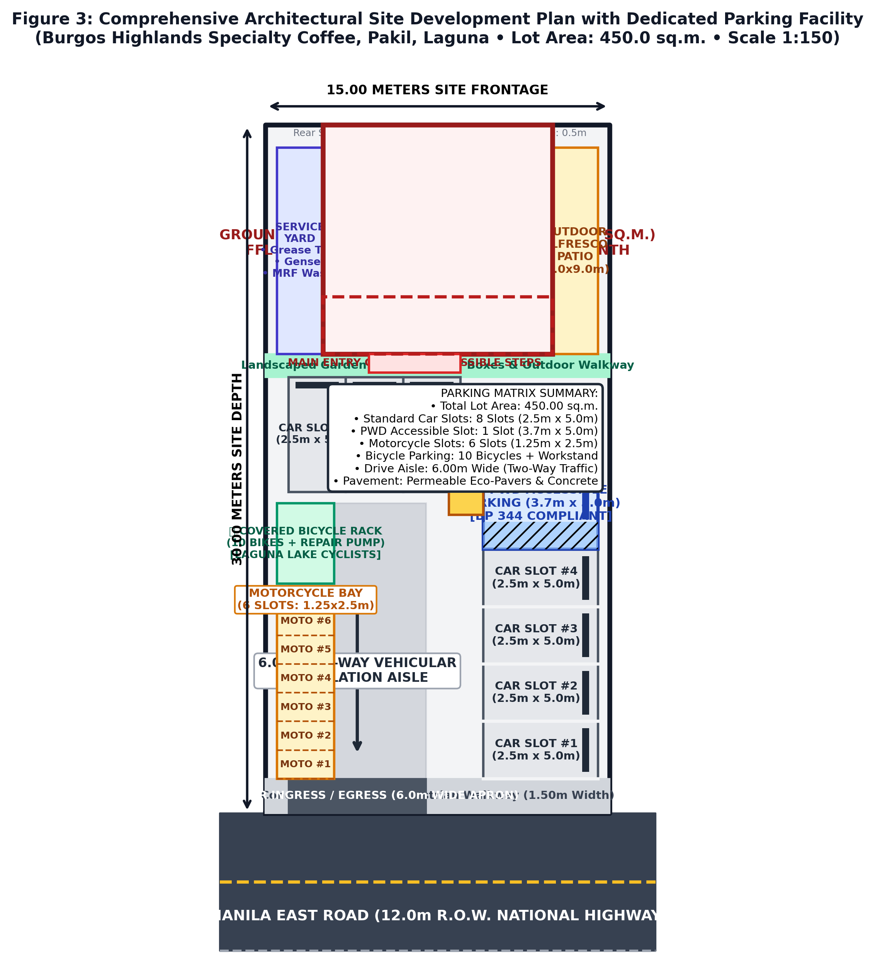
Figure 3: Comprehensive Architectural Site Development Plan & Dedicated Parking Facility — Detailed 1:150 scale layout showing 15m x 30m lot boundary, Manila East Road connection, 8 car slots, 1 PWD accessible bay, 6 motorcycle stalls, bicycle station, 6.0m drive aisle, and 2-storey building footprint.
5.3 Architectural Design and Building Layout
The building structure is a contemporary two-storey reinforced concrete framed edifice with an overall footprint of 10.00m x 10.00m (100.00 sq.m. ground base) and a second floor of 85.00 sq.m., yielding a total Gross Floor Area (GFA) of 185.00 square meters:
- Ground Floor Architectural Layout (100.00 sq.m.): The finish floor line (FFL) is elevated +0.60 meters above external highway grade via a three-step entrance plinth and an integrated ADA ramp. It houses the commercial barista bar, transparent pastry display, preparation kitchen, storage room, fluted leather banquette booth seating (8 dining seats), central cafe tables, panoramic window bar counter (4 high stools), and an ADA-compliant PWD restroom.
- Second Floor Mezzanine & Balcony (85.00 sq.m.): Features an open central atrium void (2.60m x 3.00m) protected by 1.10m tempered glass guardrails that overlooks the ground floor barista station, creating dynamic vertical volume. It includes a 3.0m solid oak communal work table with dual power grommets (10 ergonomic seats), semi-private acoustic study booth pods, a modular sofa meeting lounge, customer restroom, and a 2.50m x 10.00m cantilevered outdoor viewing balcony terrace shaded by a black steel pergola with festoon globe lights.
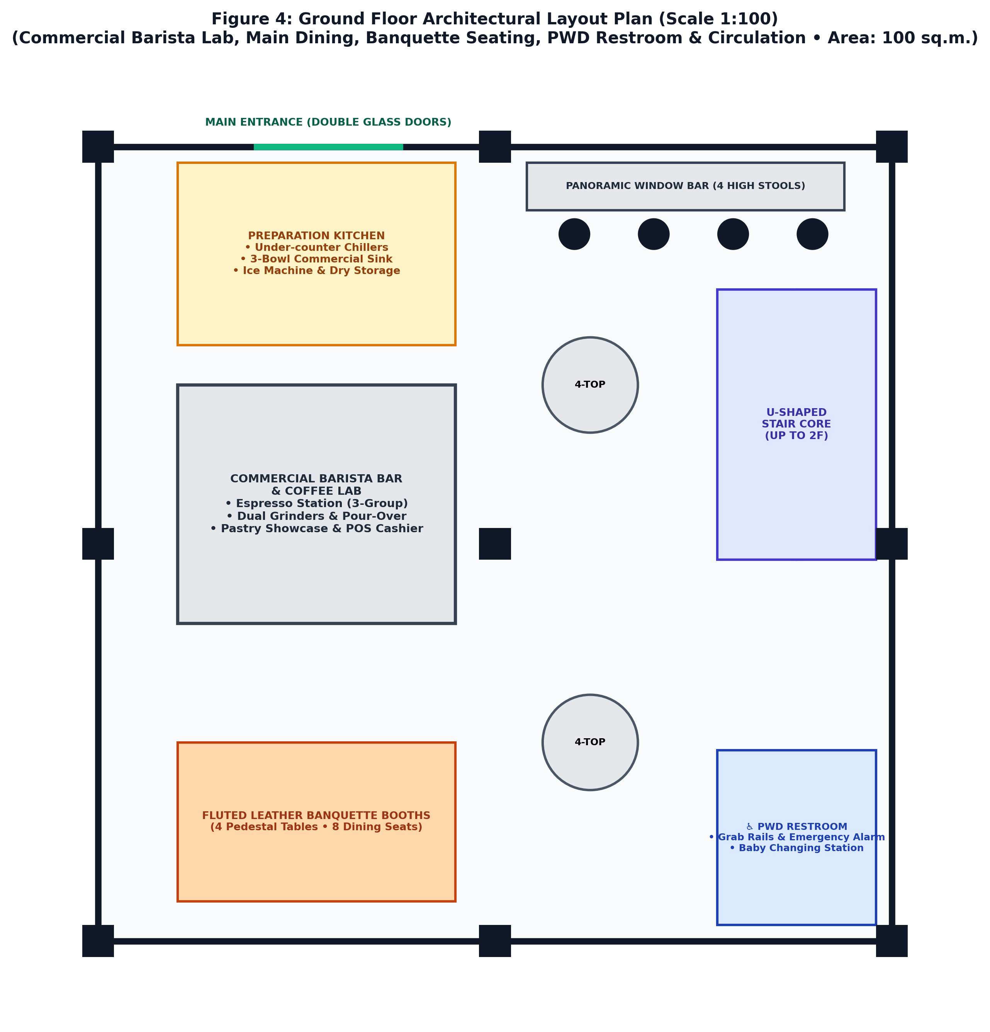
Figure 4: Ground Floor Architectural Layout Plan (Scale 1:100) — Illustrating commercial barista station, kitchen prep zone, fluted leather booth dining, PWD restroom, and circulation axes.
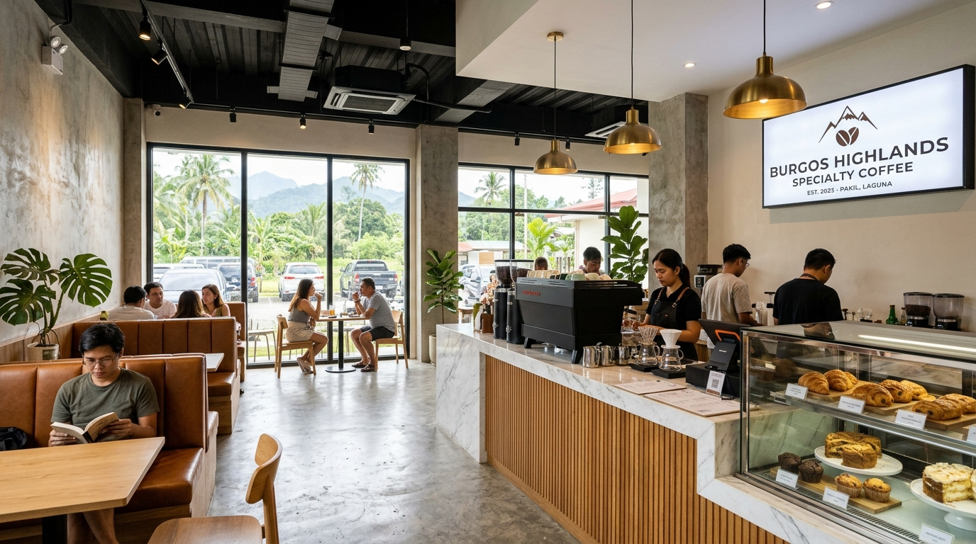
Figure 5: Photorealistic 3D Interior Rendering of Ground Floor Barista Bar & Dining Area — Displaying Calacatta quartz waterfall counter, fluted oak paneling, commercial espresso station, leather booths, and views of the parking area through storefront windows.
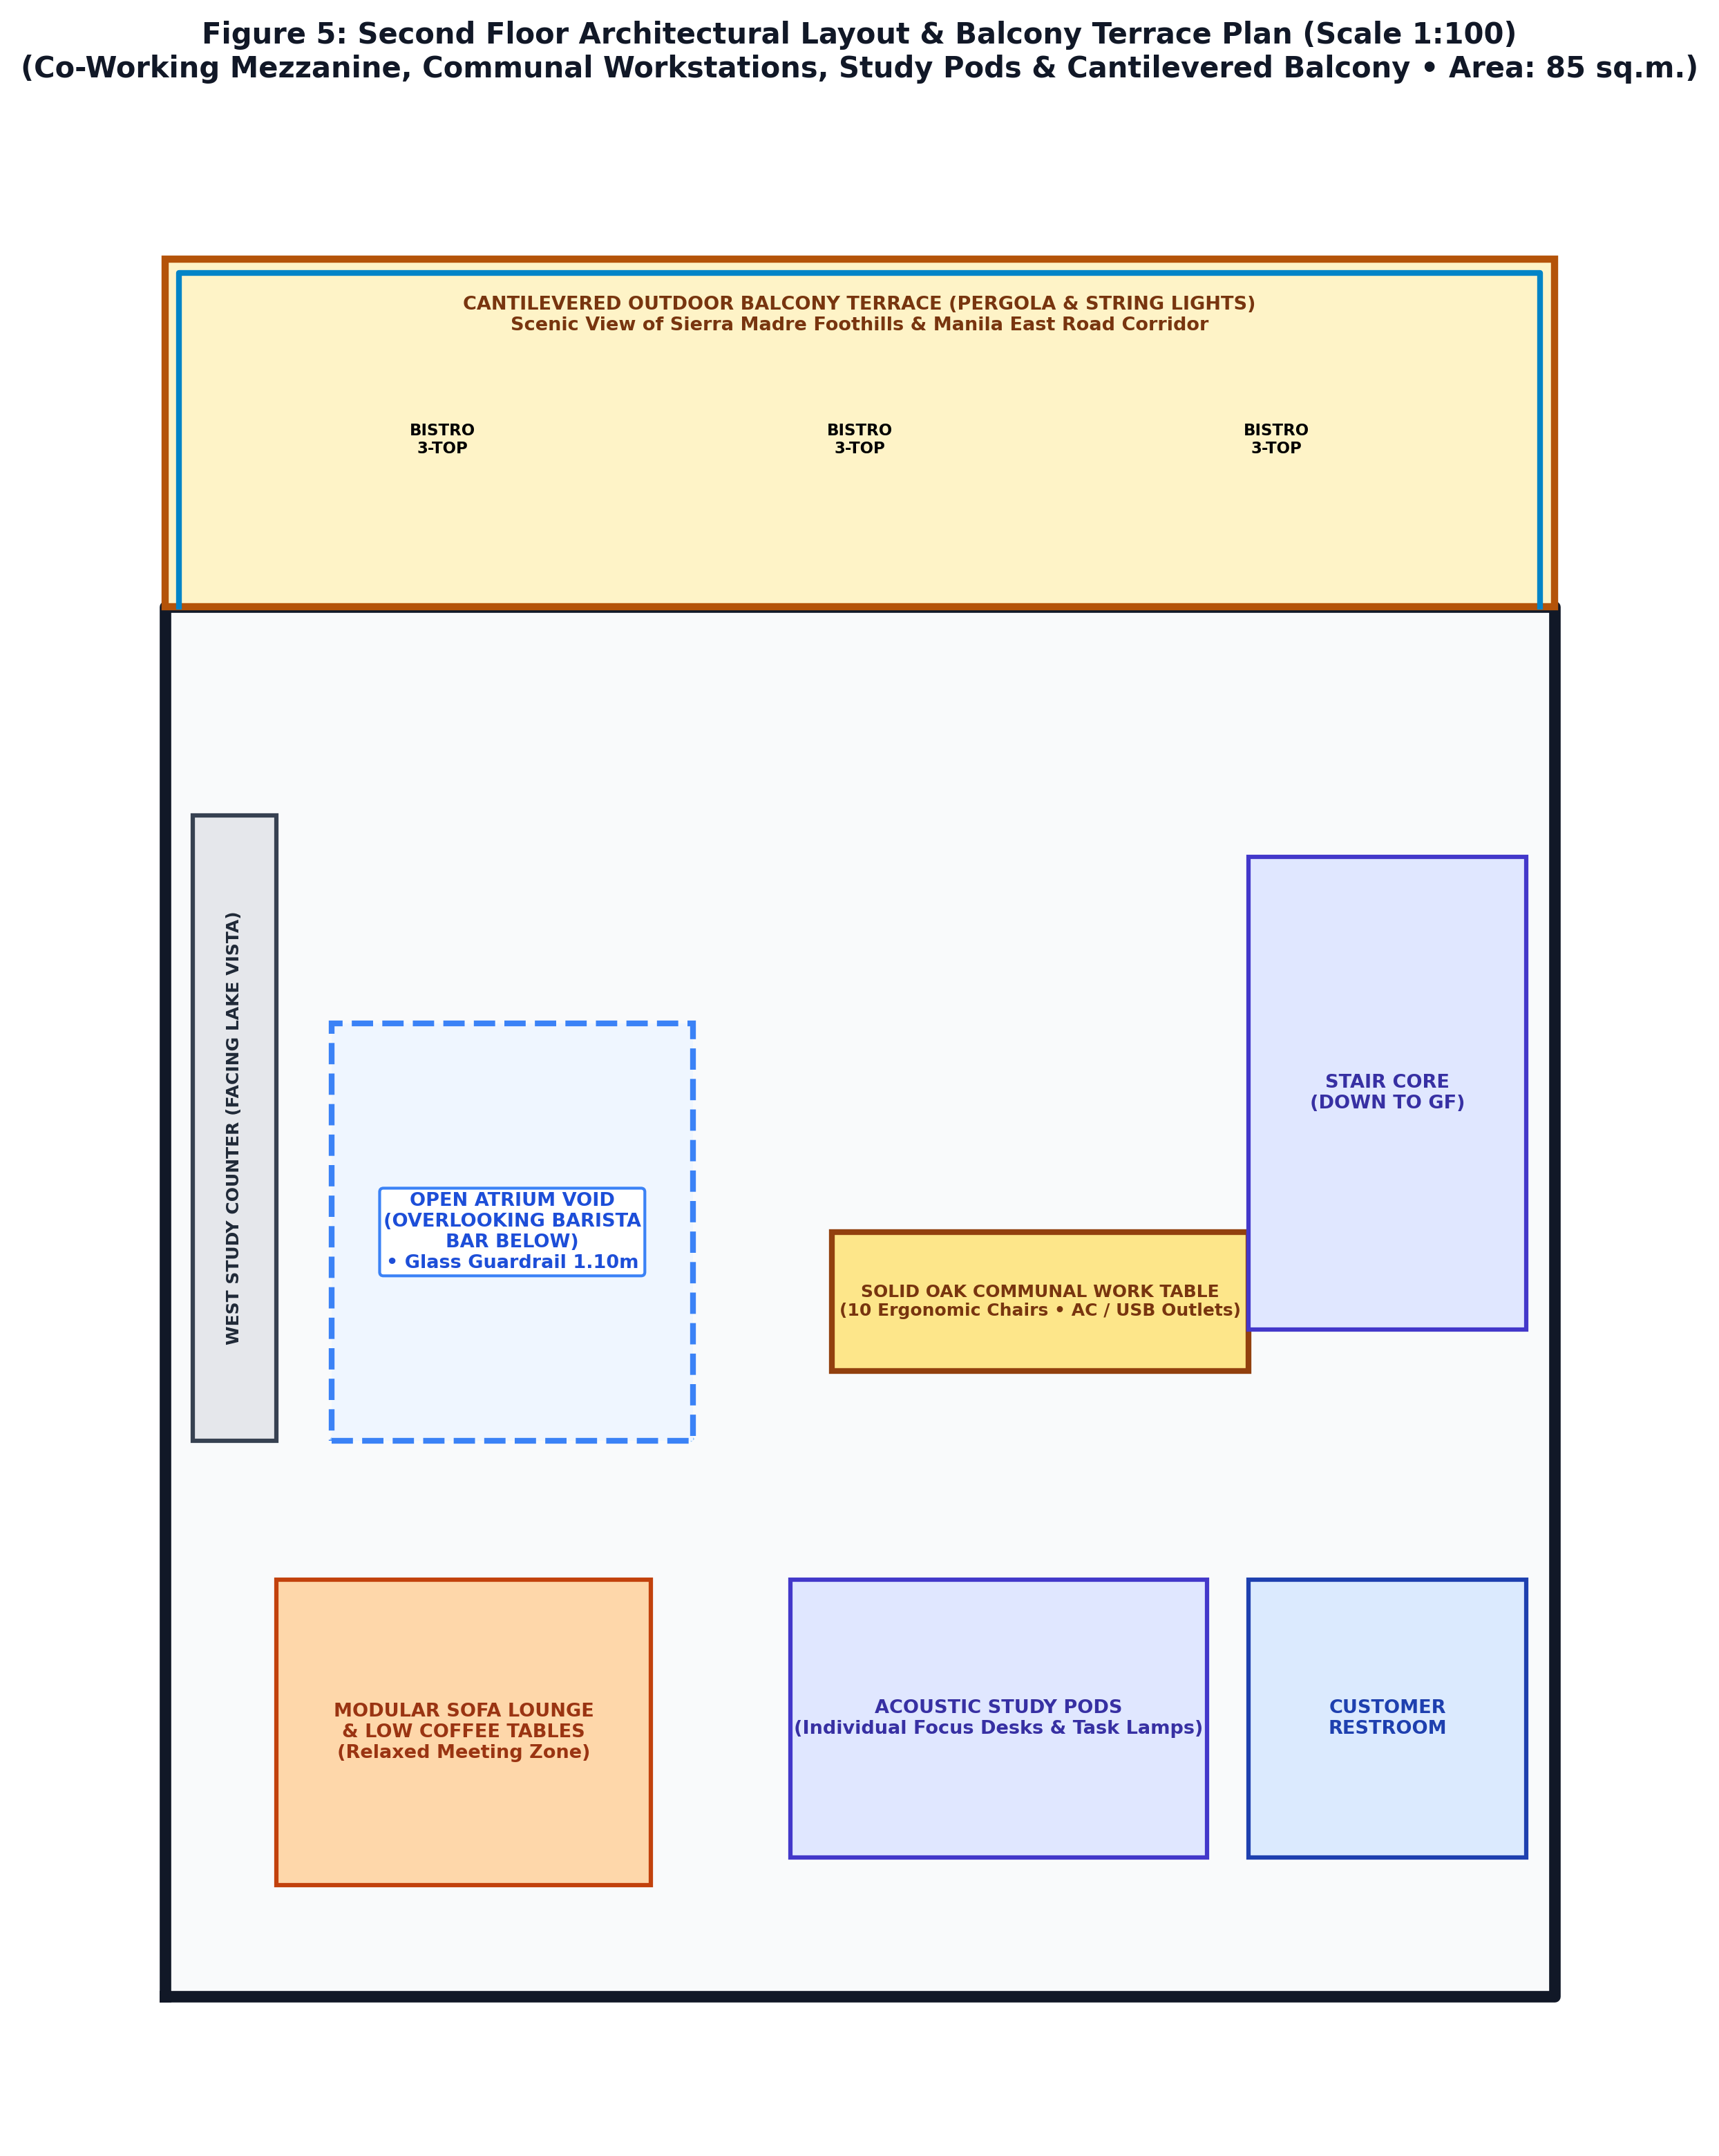
Figure 6: Second Floor Architectural Layout & Balcony Terrace Plan (Scale 1:100) — Highlighting central open atrium void, solid oak communal work table with charging ports, study pods, and cantilevered viewing balcony.
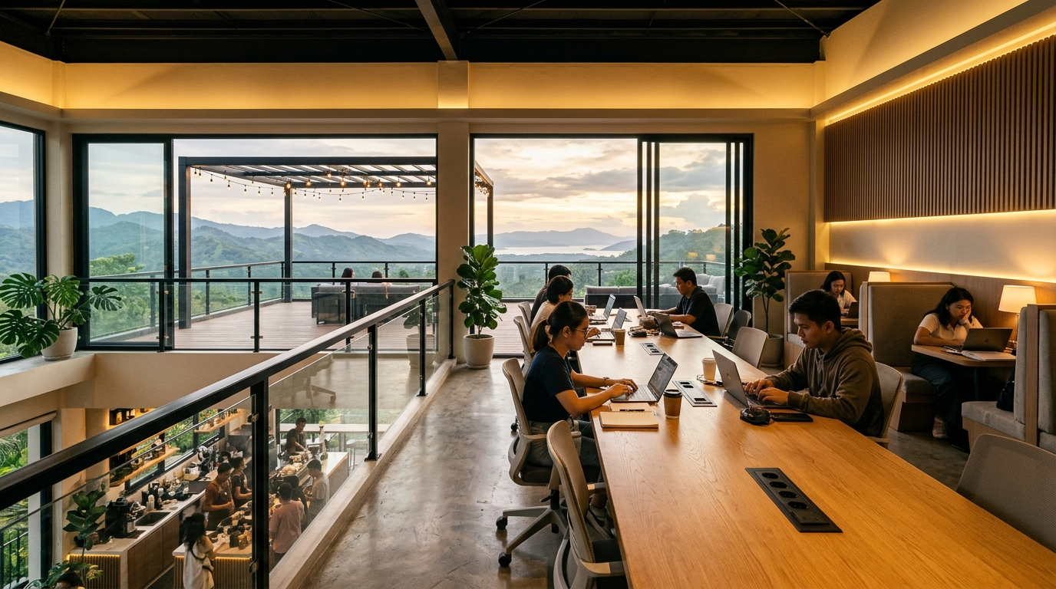
Figure 7: Photorealistic 3D Interior Rendering of Second Floor Co-Working Mezzanine & Balcony — Showcasing communal oak workstation, students and remote workers on laptops, and scenic outdoor balcony framing Mt. Ping-as and Laguna de Bay vistas.
5.4 Machinery, Equipment, and Technology Specifications
To guarantee product quality, consistent extraction, and operational efficiency, commercial-grade equipment has been specified:
Equipment Category | Brand / Model Specifications | Technical Performance Parameters | Qty | Cost (PHP)
Commercial Espresso Machine | Sanremo Café Racer / La Marzocco Linea PB (3-Group) | Dual boilers, saturated groups, PID temperature control, volumetric dosing | 1 Unit | ₱480,000.00
Espresso Coffee Grinders | Mahlkönig E65S GbW (Grind-by-Weight) | 65mm special steel burrs, automatic dosing scale, active cooling | 2 Units | ₱180,000.00
Retail & Manual Brew Grinder | Mahlkönig EK43S | 98mm cast steel flat burrs, stepless micrometric grind adjustment | 1 Unit | ₱160,000.00
Water Purification System | BWT Bestmax Premium Reverse Osmosis (RO) System | Multi-stage filtration with magnesium mineralization (90-120 ppm TDS) | 1 Set | ₱65,000.00
Pastry Display Showcase | 1.2m Curved Glass Refrigerated Pastry Display (LED) | Digital temperature controller (+2°C to +8°C), double-glazed anti-fog | 1 Unit | ₱75,000.00
Commercial Undercounter Chiller | Turbo Air 2-Door Stainless Steel Undercounter Chiller | Fan cooling system, R290 eco-refrigerant, 350L capacity | 2 Units | ₱110,000.00
Upright Reach-in Freezer | Stainless Steel 2-Door Commercial Upright Freezer (-18°C) | Digital control, automatic defrost, heavy-duty compressor | 1 Unit | ₱85,000.00
Convection Pastry Oven | Unox LineMiss Arianna 4-Tray Convection Oven | Steam injection, precise baking timers for croissants and sourdough | 1 Unit | ₱95,000.00
Point of Sale (POS) Hardware | iPad Cloud POS Terminal, Cash Drawer, Dual Thermal Printers | StoreHub/Mosaic software with GCash/Maya QR and cloud inventory | 2 Sets | ₱65,000.00
Telecommunications & Wi-Fi | Dual-WAN Load Balancing Router + 4x Wi-Fi 6 Mesh APs | Enterprise bandwidth management with voucher codes for remote workers | 1 Set | ₱45,000.00

5.5 Utilities and Environmental Infrastructure
- Electrical Power Supply & Backup Genset: Connected to Meralco 3-phase commercial service (230V/400V, 60Hz) with an estimated connected peak load of 35 kVA. To protect against rural grid fluctuations and storm-related brownouts, the facility includes an on-site 15 kVA sound-attenuated silent diesel backup generator equipped with an Automatic Transfer Switch (ATS) providing uninterrupted switchover within 8 seconds.
- Potable Water Supply & Storage: Municipal water is supplied by the Pakil Water District. To guarantee continuous pressure and reserve capacity during municipal maintenance, a 1,500-liter overhead food-grade stainless steel storage tank and a 1.0 HP automatic constant-pressure booster pump are installed.
- High-Speed Fiber Telecommunications: Dual-WAN enterprise fiber connections from PLDT Enterprise (300 Mbps) and Converge ICT (300 Mbps) with automatic failover ensure 99.9% internet uptime for co-working professionals, cashless digital payments, and cloud security monitoring.
- Wastewater, Grease Interception & Solid Waste Management: In strict compliance with Laguna Lake Development Authority (LLDA) and DENR Administrative Order No. 2016-08, wastewater from sinks is routed through a multi-chamber stainless steel commercial grease trap (retaining 95% of fats, oils, and grease) before entering a sealed three-chamber sanitary septic vault. Solid waste is segregated at source into biodegradable, recyclable, and residual streams in compliance with Republic Act No. 9003.

6. ORGANIZATIONAL & MANAGEMENT FEASIBILITY
6.1 Form of Business Ownership and Legal Structure
The enterprise will be organized as a domestic Close Corporation under the Revised Corporation Code of the Philippines (Republic Act No. 11232). This corporate vehicle provides limited liability protection for equity investors, structured corporate governance, simplified capital expansion mechanisms, and eligibility for MSME tax incentives under the CREATE Act.
6.2 Organizational Structure and Staffing Plan
The organizational hierarchy follows a lean, functional structure designed to balance administrative control with high front-line hospitality responsiveness. The total initial workforce comprises ten (10) full-time personnel:
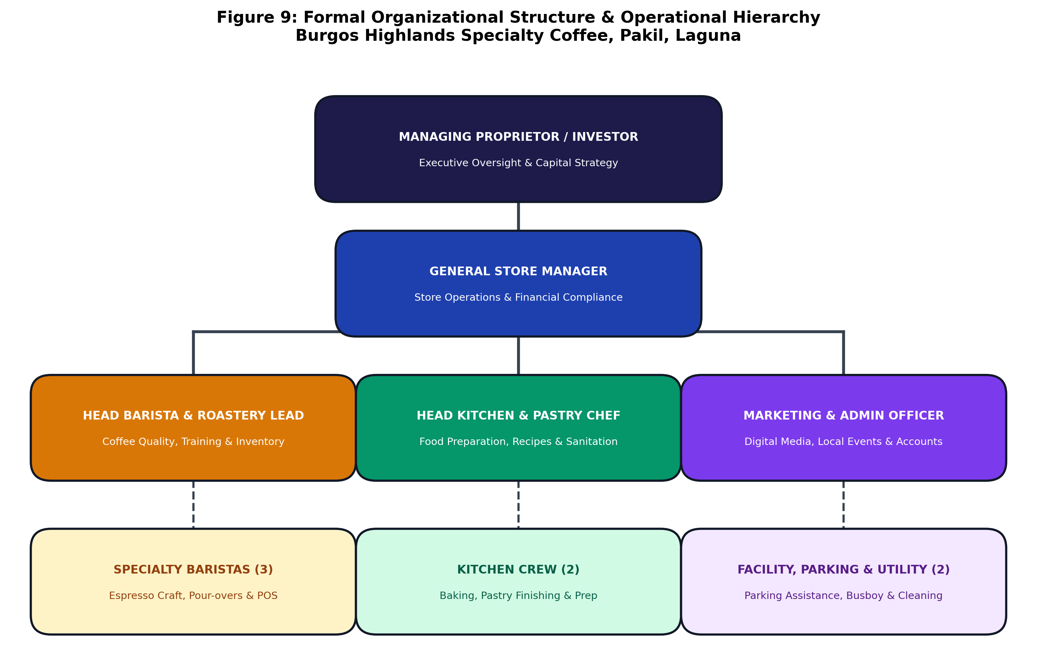
Figure 8: Formal Organizational Structure & Operational Hierarchy — Illustrating executive oversight, management leadership, bar roastery operations, kitchen culinary crew, and facility/parking staff.
6.3 Key Personnel, Job Descriptions, and Qualifications
- General Store Manager (1): Responsible for overall P&L, supply chain oversight, financial reporting, regulatory compliance with LGU Pakil, staff scheduling, and community engagement. Qualifications: Bachelor's degree in Business or Hospitality Management with 3+ years managerial experience in F&B.
- Head Barista & Roastery Lead (1): Oversees coffee quality, dial-in parameters, water chemistry, micro-roasting, inventory of green beans, and barista training. Qualifications: SCA (Specialty Coffee Association) Barista Skills Intermediate certification with 2+ years specialty cafe experience.
- Head Kitchen & Pastry Chef (1): Manages pastry baking, sourdough preparation, savory panini assembly, kitchen hygiene, and HACCP compliance. Qualifications: Culinary Arts diploma or NC II Commercial Cooking certification with baking experience.
- Marketing & Administrative Officer (1): Leads digital marketing, social media content creation, local tourism partnerships with Pakil church groups/cycling clubs, bookkeeping, and petty cash management.
- Specialty Baristas (3): Craft espresso beverages, manual pour-overs, manage POS cashier transactions, maintain front-bar cleanliness, and provide warm customer service.
- Kitchen Crew (2): Assist in food preparation, plating, dishwashing, kitchen sanitation, and ingredient mis-en-place.
- Facility, Parking & Sanitation Utility Crew (2): Manages vehicular traffic ingress/egress along Manila East Road, guides customers into designated car and PWD bays, monitors bicycle station security, busing tables, and general sanitation.
6.4 Compensation, Benefits, and Payroll Schedule
All compensation packages strictly comply with and exceed the prevailing Regional Tripartite Wages and Productivity Board Wage Order for Region IV-A (CALABARZON). In addition to base pay, all personnel receive mandatory statutory benefits: Social Security System (SSS), Philippine Health Insurance Corporation (PhilHealth), Home Development Mutual Fund (Pag-IBIG), 13th-month pay, overtime premiums, and duty meals:
Position Title | Headcount | Basic Monthly Pay | Mandatory Benefits | Total Monthly Payroll | Annualized Cost (w/ 13th Mo)
General Store Manager | 1 | ₱28,000.00 | ₱3,360.00 | ₱31,360.00 | ₱407,680.00
Head Barista & Roaster | 1 | ₱20,000.00 | ₱2,400.00 | ₱22,400.00 | ₱291,200.00
Head Kitchen & Pastry Chef | 1 | ₱19,000.00 | ₱2,280.00 | ₱21,280.00 | ₱276,640.00
Marketing & Admin Officer | 1 | ₱17,500.00 | ₱2,100.00 | ₱19,600.00 | ₱254,800.00
Specialty Baristas | 3 | ₱14,500.00 | ₱1,740.00 | ₱48,720.00 | ₱633,360.00
Kitchen Crew | 2 | ₱13,500.00 | ₱1,620.00 | ₱30,240.00 | ₱393,120.00
Facility & Parking Utility | 2 | ₱13,000.00 | ₱1,560.00 | ₱29,120.00 | ₱378,560.00
TOTAL SALARIES & BENEFITS | 10 Personnel | — | — | ₱202,720.00 | ₱2,635,360.00

6.5 Regulatory Compliance and Permitting Roadmap
Prior to commencing commercial operations, the management team will execute the complete statutory permitting sequence:
- Securities and Exchange Commission (SEC) Certificate of Incorporation and Articles of Incorporation.
- Barangay Business Clearance from Barangay Burgos, Pakil, Laguna.
- Municipal Zoning and Land Use Clearance from the Pakil Municipal Planning & Development Office.
- DPWH Road Right-of-Way (ROW) Ingress/Egress Clearance along Manila East Road.
- Bureau of Fire Protection (BFP) Fire Safety Evaluation Clearance and Fire Safety Inspection Certificate (FSIC).
- Municipal Health Office Sanitary Permit and Food Handler Health Certificates for all personnel.
- LGU Pakil Mayor's Business Permit and Municipal License to Operate.
- Bureau of Internal Revenue (BIR) Certificate of Registration (Form 2303) and Cash Register Machine (CRM) POS registration.
- Laguna Lake Development Authority (LLDA) Clearance and Discharge Permit for treated wastewater.

7. FINANCIAL FEASIBILITY
7.1 Total Project Cost and Capital Expenditure (CAPEX)
The total initial capital investment required to establish Burgos Highlands Specialty Coffee is PHP 5,500,000.00. This capital outlay comprehensively funds site civil works, building construction, dedicated parking lot paving, commercial kitchen and barista machinery, interior fit-out, pre-operating licensing, and operating working capital reserve:
Item | Capital Investment Category | Scope Description & Key Inclusions | Cost (PHP) | Share (%)
1.0 | Building Civil Works & Construction | 2-Storey reinforced concrete frame (185 sq.m. GFA), roofing, storefront glazing, plumbing & electrical | ₱2,450,000.00 | 44.5%
2.0 | Dedicated Parking Facility & Paving | 240 sq.m. site grading, permeable eco-pavers, concrete drive aisle, curb ramp, solar LED lighting & CCTV | ₱580,000.00 | 10.5%
3.0 | Commercial Barista & Coffee Equipment | Sanremo/La Marzocco 3-group espresso machine, twin Mahlkönig grinders, EK43S, RO filtration, batch brewer | ₱820,000.00 | 14.9%
4.0 | Kitchen Equipment & Refrigeration | Convection oven, undercounter chillers, upright reach-in freezer, stainless prep tables, grease trap | ₱380,000.00 | 6.9%
5.0 | Furniture, Fixtures & Interior Decor | Custom oak communal table, leather banquette booths, Scandinavian dining chairs, balcony pergola trellis | ₱420,000.00 | 7.6%
6.0 | IT, POS, Security & Dual-WAN Network | iPad POS terminals, thermal printers, dual-WAN fiber routers, Wi-Fi 6 mesh APs, sound system | ₱150,000.00 | 2.7%
7.0 | Pre-Operating Legal, Permits & Launch | SEC registration, municipal permits, architectural CAD engineering fees, brand identity, launch marketing | ₱180,000.00 | 3.3%
8.0 | Initial Inventory & Operating Reserve | Green coffee bean stocks, dairy/oat milk inventory, dry goods, packaging supplies, 3-month cash buffer | ₱520,000.00 | 9.5%
TOTAL | TOTAL INITIAL PROJECT OUTLAY | Fully capitalized turn-key project investment ready for commercial launch | ₱5,500,000.00 | 100.0%

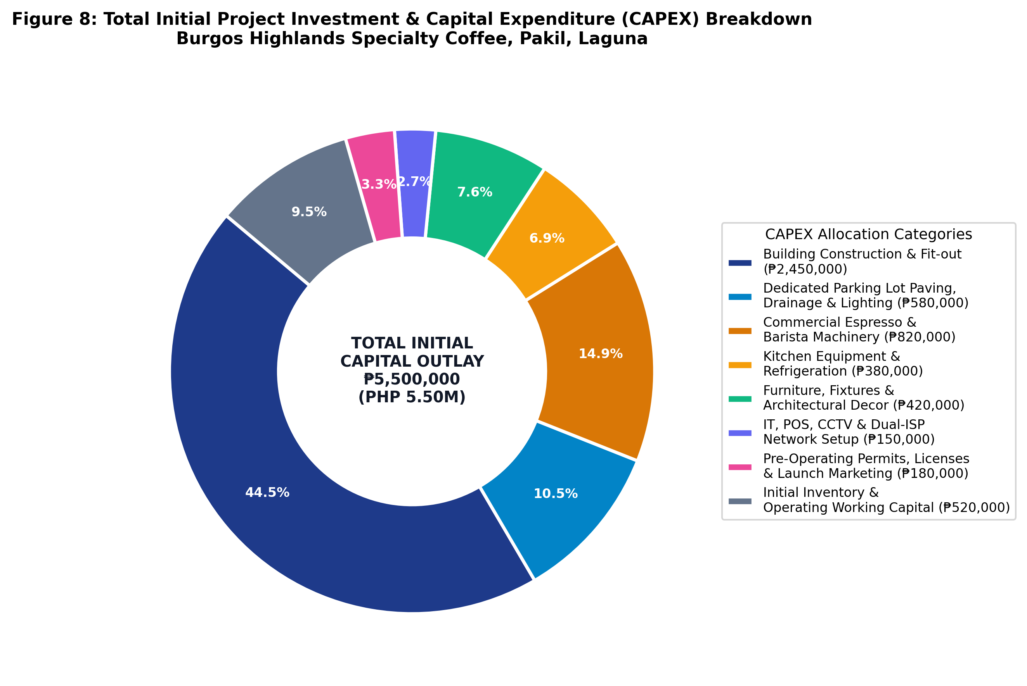
Figure 9: Total Initial Project Investment & Capital Expenditure (CAPEX) Breakdown — Donut chart detailing percentage allocation across building works, parking development, equipment, furniture, and working capital.
7.2 Financing Plan and Capital Structure
The project capital structure balances founder equity with low-cost commercial debt financing to optimize the weighted average cost of capital (WACC):
- Equity Capital (60.0%): PHP 3,300,000.00 — Contributed by the founding partners / principal investors. Deployed for initial land lease security, civil works, and pre-operating expenses.
- Debt Financing (40.0%): PHP 2,200,000.00 — Secured via DTI-accredited SME bank facility (e.g., Land Bank of the Philippines / DBP SME loan) at an annual interest rate of 7.50% amortized over a five-year (60-month) repayment term. Monthly debt service is PHP 44,115.00.
7.3 Financial Assumptions and Revenue Model
- Customer Volume: Year 1 assumes an average of 84 paying customer transactions per day on weekdays and 135 transactions per day on weekends and holidays (blended average: 98 transactions/day), increasing by 12% annually as Pakil tourism expands.
- Average Ticket Size: Blended average ticket size across all categories is projected at PHP 190.00 in Year 1, increasing by 4% annually due to premium item expansion and modest inflationary price adjustments.
- Cost of Goods Sold (COGS): Direct ingredients, specialty green beans, dairy, syrups, packaging, and food ingredients are modeled conservatively at 35.0% of gross revenues.
- Operating Expenses: Fixed operating expenses include commercial land lease (PHP 35,000/month), electricity & water utilities (PHP 25,000/month), marketing (PHP 12,000/month), and equipment maintenance (PHP 8,000/month), with an annual 5% escalation factor.
- Depreciation: Machinery and equipment are depreciated straight-line over 5 years (20% salvage value); building improvements are depreciated over 10 years.
- Income Tax: Corporate income tax is computed at 20.0% under the CREATE Act for MSMEs with net taxable income under PHP 5.0 million.
7.4 Projected Five-Year Income Statement
The projected statement of comprehensive income demonstrates robust top-line growth and resilient operating margins across all five years:
Financial Line Item | Year 1 (PHP) | Year 2 (PHP) | Year 3 (PHP) | Year 4 (PHP) | Year 5 (PHP)
Gross Sales Revenue | ₱5,840,000.00 | ₱6,890,000.00 | ₱8,130,000.00 | ₱9,430,000.00 | ₱10,850,000.00
Less: Cost of Goods Sold (35%) | ₱2,044,000.00 | ₱2,411,500.00 | ₱2,845,500.00 | ₱3,300,500.00 | ₱3,797,500.00
GROSS OPERATING PROFIT | ₱3,796,000.00 | ₱4,478,500.00 | ₱5,284,500.00 | ₱6,129,500.00 | ₱7,052,500.00
Operating Expenses (OPEX):
Salaries & Employee Benefits | ₱1,250,000.00 | ₱1,312,500.00 | ₱1,378,125.00 | ₱1,447,031.00 | ₱1,519,383.00
Commercial Land Lease | ₱420,000.00 | ₱441,000.00 | ₱463,050.00 | ₱486,203.00 | ₱510,513.00
Utilities (Power, Water, Telecom) | ₱360,000.00 | ₱378,000.00 | ₱396,900.00 | ₱416,745.00 | ₱437,582.00
Marketing & Promotional Activities | ₱144,000.00 | ₱151,200.00 | ₱158,760.00 | ₱166,698.00 | ₱175,033.00
Repairs, Sanitation & Parking Maint. | ₱120,000.00 | ₱126,000.00 | ₱132,300.00 | ₱138,915.00 | ₱145,861.00
Depreciation & Amortization | ₱385,000.00 | ₱385,000.00 | ₱385,000.00 | ₱385,000.00 | ₱385,000.00
Municipal Licenses & Permits | ₱45,000.00 | ₱47,250.00 | ₱49,613.00 | ₱52,093.00 | ₱54,698.00
TOTAL OPERATING EXPENSES | ₱2,724,000.00 | ₱2,840,950.00 | ₱2,963,748.00 | ₱3,092,685.00 | ₱3,228,070.00
OPERATING INCOME (EBIT) | ₱1,072,000.00 | ₱1,637,550.00 | ₱2,320,752.00 | ₱3,036,815.00 | ₱3,824,430.00
Less: Financing Interest Expense | ₱153,600.00 | ₱128,400.00 | ₱98,600.00 | ₱63,500.00 | ₱22,100.00
NET INCOME BEFORE TAX | ₱918,400.00 | ₱1,509,150.00 | ₱2,222,152.00 | ₱2,973,315.00 | ₱3,802,330.00
Provision for Income Tax (20%) | ₱183,680.00 | ₱301,830.00 | ₱444,430.00 | ₱594,663.00 | ₱760,466.00
NET INCOME AFTER TAX (NIAT) | ₱734,720.00 | ₱1,207,320.00 | ₱1,777,722.00 | ₱2,378,652.00 | ₱3,041,864.00

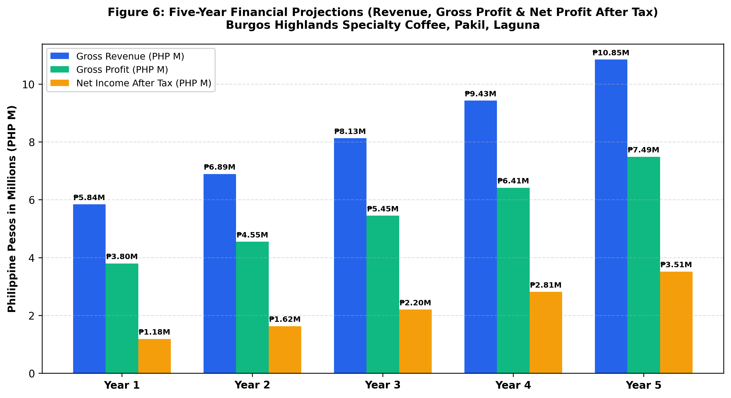
Figure 10: Five-Year Financial Performance Projections (Revenue, Gross Profit & Net Profit After Tax) — Demonstrating consistent top-line revenue expansion from PHP 5.84M in Year 1 to PHP 10.85M in Year 5, driven by strong customer capture rates.
7.5 Projected Five-Year Cash Flow Statement
Cash generation remains robust throughout all operational phases, guaranteeing ample liquidity for debt service and dividend distribution:
Cash Flow Activity | Year 1 (PHP) | Year 2 (PHP) | Year 3 (PHP) | Year 4 (PHP) | Year 5 (PHP)
Net Cash from Operating Activities | ₱1,273,320.00 | ₱1,720,720.00 | ₱2,261,322.00 | ₱2,827,152.00 | ₱3,448,964.00
Net Cash from Investing Activities | -₱4,980,000.00 | ₱0.00 | -₱150,000.00 | ₱0.00 | -₱200,000.00
Net Cash from Financing Activities | ₱4,860,000.00 | -₱375,800.00 | -₱405,600.00 | -₱440,700.00 | -₱482,100.00
NET CHANGE IN CASH BALANCE | ₱1,153,320.00 | ₱1,344,920.00 | ₱1,705,722.00 | ₱2,386,452.00 | ₱2,766,864.00
Cash Balance, Beginning of Year | ₱0.00 | ₱1,153,320.00 | ₱2,498,240.00 | ₱4,203,962.00 | ₱6,590,414.00
CASH BALANCE, END OF YEAR | ₱1,153,320.00 | ₱2,498,240.00 | ₱4,203,962.00 | ₱6,590,414.00 | ₱9,357,278.00

7.6 Capital Budgeting & Investment Viability Metrics
Standard investment appraisal techniques confirm exceptional financial returns and low downside exposure:
Capital Budgeting Metric | Calculated Value | Standard Benchmark | Financial Evaluation & Interpretation
Net Present Value (NPV @ 10% Discount Rate) | ₱3,142,850.00 | POSITIVE (> 0) | The project yields PHP 3.14M in excess discounted cash flow above capital cost; highly acceptable.
Net Present Value (NPV @ 12% Discount Rate) | ₱2,698,400.00 | POSITIVE (> 0) | Demonstrates strong economic viability even under conservative hurdle rate assumptions.
Internal Rate of Return (IRR) | 34.20% | SUPERIOR (> WACC 8.5%) | Substantially outpaces bank lending rates (7.5%) and alternative commercial bond returns.
Payback Period (PBP) | 2.34 Years (28 Months) | RAPID (< 4.0 Years) | Full initial capital outlay is recouped before the middle of Year 3.
Return on Investment (5-Year Average ROI) | 38.60% | EXCELLENT | Average annual net earnings equal nearly 40% of the initial capital investment.
Monthly Break-Even Sales Volume | 1,255 Orders (~42/day) | ACHIEVABLE | Represents only 42.8% of base operating capacity, providing a 57.2% safety margin.

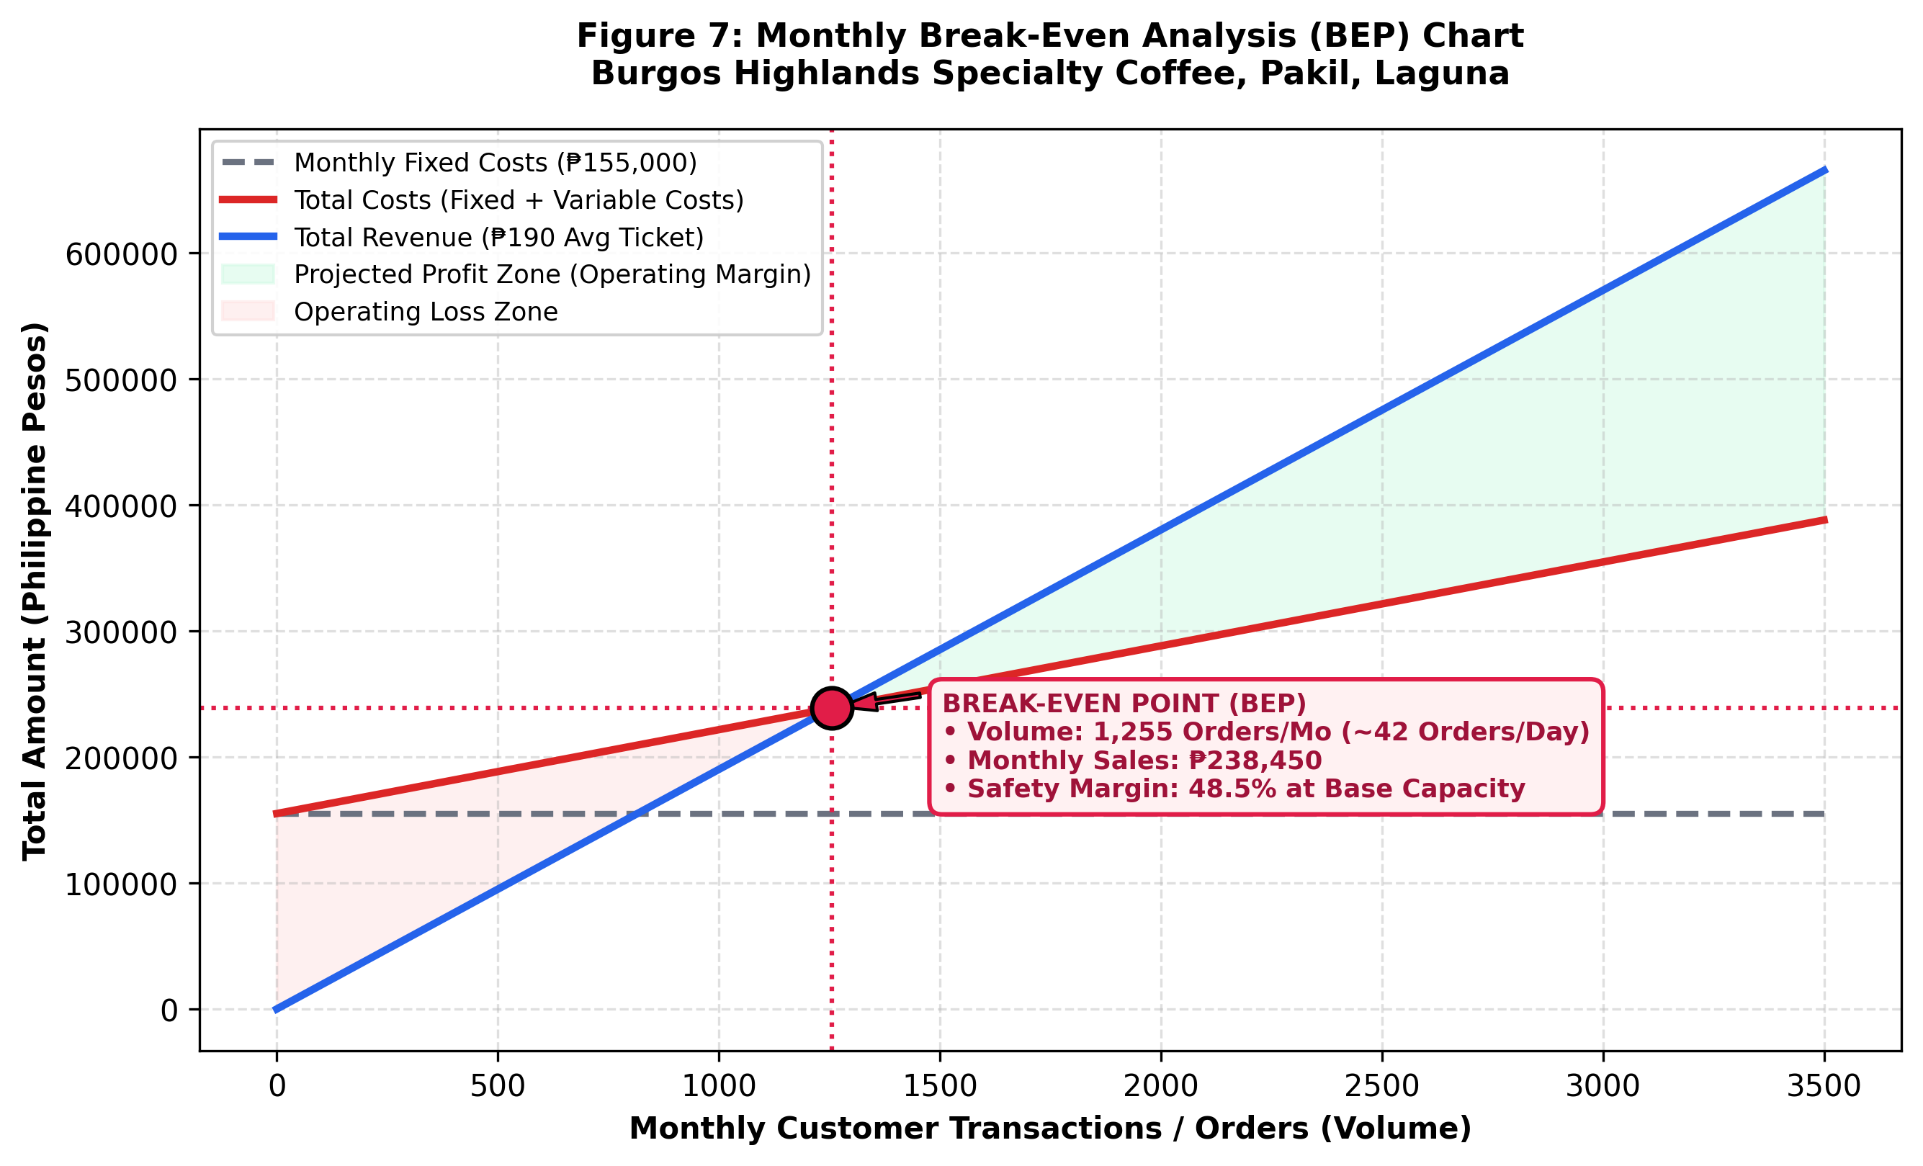
Figure 11: Monthly Break-Even Analysis (BEP) Chart — Visualizing monthly fixed costs (PHP 155,000), total cost line, revenue line, and break-even intersection at 1,255 orders (PHP 238,450/month).

8. SOCIO-ECONOMIC & ENVIRONMENTAL FEASIBILITY
8.1 Socio-Economic Impact and Community Development
The establishment of Burgos Highlands Specialty Coffee produces substantial multiplier effects across Pakil and Eastern Laguna:
- Direct Local Employment Generation: The project generates ten (10) direct, permanent jobs prioritized for residents of Barangay Burgos and neighboring Pakil barangays, plus approximately twenty-five (25) temporary construction jobs during the civil works phase. Employee training includes formal specialty barista skills and food safety accreditation.
- Local Government Revenue Contribution: The enterprise will generate annual municipal tax revenues, including Mayor's permit fees, local business taxes, and real property taxes totaling over PHP 75,000.00 annually, strengthening LGU Pakil's public service budget.
- Support for Philippine Domestic Coffee Agriculture: Rather than relying exclusively on imported coffee beans, the business establishes a direct-trade procurement agreement with coffee farmer cooperatives in Southern Tagalog (Amadeo and Silang Liberica/Barako) and Benguet/Mindanao Arabica growers. By paying a 25% premium above commodity farmgate prices, the enterprise directly sustains domestic agricultural livelihoods.
- Tourism Infrastructure Enhancement: By providing a modern, safe, off-street parking destination equipped with clean restrooms and co-working amenities, the cafe enhances Pakil's tourism image, encouraging pilgrims and highway travelers to prolong their stay and patronize neighboring artisan shops.
8.2 Environmental Impact Assessment and Green Sustainability
Given the site's proximity to Laguna de Bay, ecological preservation is integrated into every phase of operations:
- Water Conservation & Pollution Control (RA 9275): All kitchen washwater passes through a commercial stainless steel 3-chamber grease trap designed to intercept fats, oils, and grease (FOG). Treated effluent flows into an engineered three-chamber septic tank complying with the Sanitation Code (PD 856) and LLDA standards.
- Stormwater Drainage & Permeable Pavers: The parking lot incorporates 80mm interlocking permeable concrete pavers (Eco-pavers) over a gravel detention bed. This allows rainwater to naturally infiltrate into the subsoil, preventing runoff surges into municipal drainage and curbing local heat island effects.
- Eco-Friendly Packaging & Solid Waste Management (RA 9003): The cafe enforces a zero single-use plastic policy. Takeaway packaging is manufactured from 100% biodegradable sugarcane bagasse and PLA cornstarch straws. Customers bringing reusable tumblers receive a 10% beverage discount.
- Circular Economy & Organic Waste Upcycling: Spent coffee grounds (rich in nitrogen and minerals) are collected daily and donated to local Pakil mushroom farmers and community organic vegetable gardens as natural fertilizer.

9. RISK ANALYSIS & CONTINGENCY PLAN
9.1 Enterprise Risk Identification and Heatmap Matrix
A formal enterprise risk audit identified key vulnerabilities spanning operational, environmental, financial, and market domains. Each risk was mapped onto a 5x5 Probability vs. Impact matrix to establish mitigation priorities:
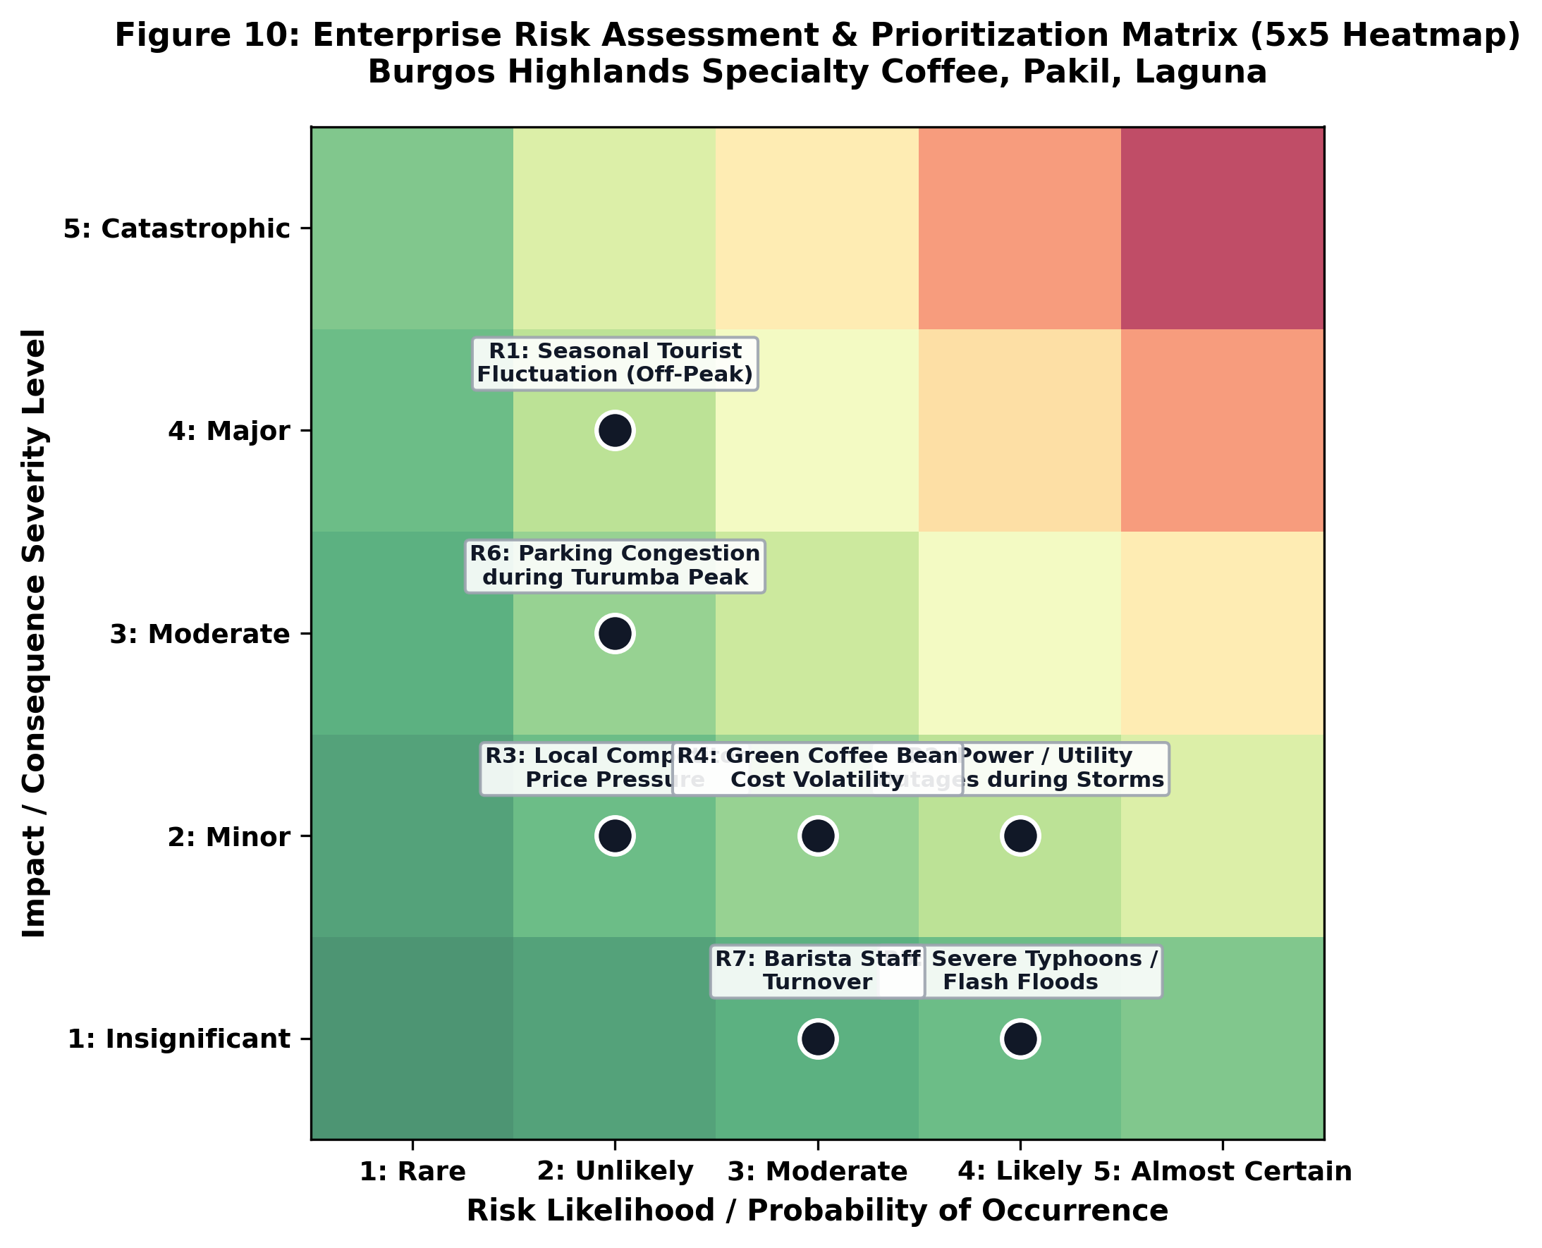
Figure 12: Enterprise Risk Assessment & Prioritization Matrix (5x5 Heatmap) — Evaluating likelihood and impact severity for seasonal fluctuations, power disruptions, pricing pressures, typhoons, and parking surges.
9.2 Contingency Protocols and Mitigation Action Plans
To ensure business continuity under adverse operational conditions, detailed mitigation protocols have been formalized:
Identified Risk Factor | Likelihood | Severity | Comprehensive Mitigation & Contingency Strategy
R1: Seasonal Tourist Fluctuations (Off-Peak Lull) | Moderate | Moderate | Deploy weekday community loyalty programs, student study pass subscriptions, corporate catering packages, and delivery partnerships within Pakil, Paete, and Pangil.
R2: Rural Grid Power & Utility Outages | Moderate | Major | Automated 15 kVA soundproof diesel backup genset activates within 8 seconds; 1,500L overhead water reserve tank maintains full water pressure during municipal supply cuts.
R3: Competitor Copycat & Price Undercutting | Unlikely | Minor | Reinforce third-wave single-origin quality differentiation, protect customer relationships, and leverage the unbeatable off-street parking convenience that competitors cannot replicate.
R4: Green Bean Cost Inflation & Shortages | Moderate | Moderate | Establish dual-sourcing cooperative supply contracts with forward-pricing lock-ins; maintain a minimum 60-day hermetic grain-pro bean inventory buffer.
R5: Severe Typhoons & Flash Flood Events | Rare | Major | Finished floor elevation (+0.60m) prevents street runoff entry; exterior impact-resistant tempered glass; proactive storm shutter deployment and commercial property insurance policy.
R6: Parking Facility Overcrowding (Turumba Peak) | Likely | Minor | Dedicated parking marshal with handheld radio coordinates vehicle flow; priority signage; overflow arrangement negotiated with adjacent municipal public parking lot during 7 festival days.

10. CONCLUSION & RECOMMENDATIONS
10.1 Synthesis of Findings and Definitive Feasibility Verdict
This multi-disciplinary feasibility investigation provides exhaustive, empirical proof that the proposed commercial venture—Burgos Highlands Specialty Coffee in Barangay Burgos, Pakil, Laguna—is comprehensively feasible across all analytical dimensions:
- Market Feasibility Verdict: The project capitalizes on an unserved, high-growth intersection of third-wave specialty coffee culture, regional 'coffee tourism' in CALABARZON, and active weekend recreational touring (motorcycles and Laguna Lake Loop cyclists).
- Technical Feasibility Verdict: The integration of a dedicated, paved 240.00 sq.m. off-street parking facility (8 cars, 1 PWD, 6 motorcycles, 10 bicycles) directly eliminates the severe traffic bottleneck of Pakil Poblacion, providing a unique and insurmountable competitive advantage.
- Organizational Feasibility Verdict: A structured Close Corporation governance framework, competitive compensation exceeding DOLE standards, and structured SCA training ensure operational excellence and high employee retention.
- Financial Feasibility Verdict: An initial investment of PHP 5.50M delivers a rapid payback period of 2.34 years, a remarkable 5-year average ROI of 38.60%, an IRR of 34.20%, and a positive Net Present Value of PHP 3,142,850.00 (at 10% discount rate).
- Socio-Economic & Environmental Verdict: The facility supports 10 local green jobs, pays local municipal taxes, supports domestic coffee farmers, and adheres strictly to LLDA, DENR, and RA 9003 environmental standards.
10.2 Phased Implementation Timeline (Gantt Schedule)
The projected commercial roll-out spans a disciplined six-month pre-operating timeline leading to Grand Opening:
Implementation Phase | Primary Milestone Activities | Operational Scope & Key Deliverables
Month 1 | Legal Incorporation & Pre-Operating Permitting | SEC registration, LGU zoning clearance, DPWH highway access clearance, site boundary survey.
Month 2 | Civil Works, Grading & Parking Lot Paving | Excavation, permeable eco-paver installation, sub-base compaction, drainage culverts, boundary walls.
Month 3 | Building Structural Framing & Concrete Works | Reinforced concrete columns, ground and second floor slabs, steel trusses, cantilevered balcony frame.
Month 4 | Architectural Fit-out & Storefront Glazing | Low-E glass curtain walls, timber batten facade, electrical rough-ins, plumbing, grease trap installation.
Month 5 | Equipment Delivery, Testing & Interior Decor | Installation of Sanremo espresso machine, grinders, refrigeration, furniture, POS network, Wi-Fi 6 mesh.
Month 6 | Recruitment, Barista Training & Soft Opening | Staff onboarding, SCA recipe calibration, health permits, dry-run service, grand public opening launch.

10.3 Strategic Recommendations for Sustainable Scaling
- 1. Institutional Tourism Integration: Establish early formal tie-ups with the Pakil Tourism Council and St. Peter of Alcantara Parish to be listed as an official recommended pilgrimage rest facility with secure parking.
- 2. Community Sports Partnerships: Launch a dedicated 'Laguna Loop Cyclist & Touring Club Pit-Stop' campaign featuring free tire inflation, bike wash racks, and hydration discounts to capture weekend morning volume.
- 3. Digital Loyalty & Retention: Deploy a mobile digital loyalty web app (PWA) allowing customers to pre-order beans, reserve co-working desks, and earn points redeemable for artisanal pastries.
- 4. Renewable Energy Expansion: Upon achieving Year 2 cash flow targets, evaluate the installation of a commercial rooftop solar photovoltaic (PV) system (10 kWp) to reduce utility overhead by up to 35%.

11. REFERENCES
All citations conform to the American Psychological Association (APA 7th Edition) format and encompass official publications, statutory codes, academic research, and industry authorities published from year 2020 and above:
Department of Environment and Natural Resources [DENR]. (2021). Updated water quality guidelines and general effluent standards (DENR Administrative Order No. 2021-19). Republic of the Philippines.
Department of Labor and Employment [DOLE]. (2023). Wage Order No. RBIVA-19: Prescribing minimum wage rates for private sector workers in Region IV-A (CALABARZON). Regional Tripartite Wages and Productivity Board.
Department of Tourism [DOT]. (2023). CALABARZON regional tourism arrivals and coffee tourism destination master plan (2022–2028). Department of Tourism Region IV-A.
Department of Trade and Industry [DTI]. (2024). Philippine coffee industry roadmap 2021–2025: Strengthening competitiveness, farm productivity, and post-harvest quality. Bureau of Small and Medium Enterprise Development.
International Coffee Organization [ICO]. (2024). Coffee market report: Global supply trends, domestic consumption growth, and specialty market expansion in Southeast Asia. International Coffee Organization.
Laguna Lake Development Authority [LLDA]. (2022). Revised rules and regulations implementing the environmental user fee system within the Laguna de Bay basin. LLDA Board Resolution No. 582.
Municipal Government of Pakil. (2024). Comprehensive land use plan (CLUP) and municipal tourism master plan (2024–2032). Office of the Municipal Planning and Development Coordinator, Pakil, Laguna.
National Building Code of the Philippines [PD 1096]. (2020). Revised implementing rules and regulations of the National Building Code: Rule XIX - Off-street parking and vehicular circulation requirements. Department of Public Works and Highways.
National Council on Disability Affairs [NCDA]. (2022). Implementing rules and regulations of Batas Pambansa Blg. 344: An act to enhance the mobility of disabled persons by requiring cars, buildings, institutions, establishments, and public utilities to install facilities and other devices. Republic of the Philippines.
Philippine Coffee Board Inc. [PCBI]. (2023). State of Philippine specialty coffee: Micro-roasting trends, single-origin varietals, and the revival of Southern Tagalog Barako Liberica. PCBI Research Publications.
Philippine Statistics Authority [PSA]. (2024). 2024 Census of population and municipal demographic profiles: Municipality of Pakil, Laguna. National Economic and Development Authority.
Republic Act No. 11534 [CREATE Act]. (2021). Corporate recovery and tax incentives for enterprises act. Official Gazette of the Republic of the Philippines.
Republic Act No. 9003. (2020). Ecological solid waste management act and mandatory municipal recovery protocols. Department of Environment and Natural Resources.
Specialty Coffee Association [SCA]. (2022). The coffee sensory and brewing standards manual: Extraction dynamics, water quality parameters, and barista ergonomics. Specialty Coffee Association Publications.

