***Explaining & Predicting***

***Consumers’ Purchase Behavior***

***Before and After COVID-19 for***

***Frozen Meals***

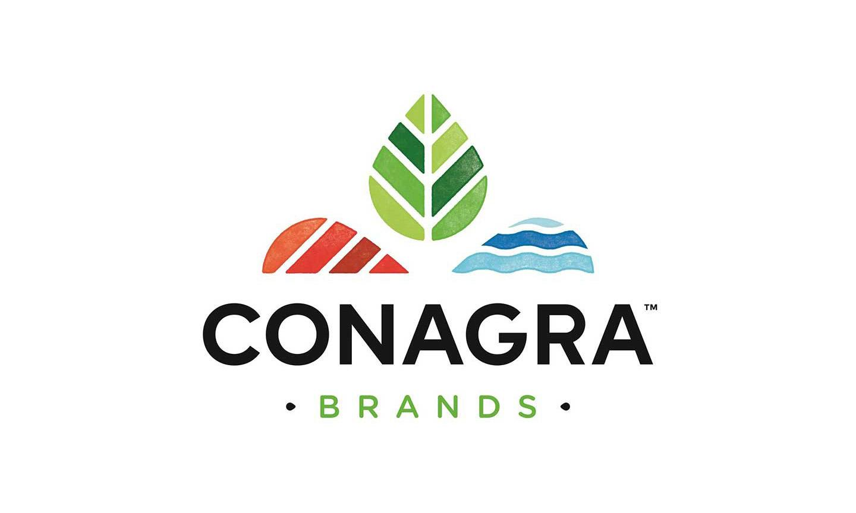

**BUAN 6337.002 - Predictive Analytics using SAS**

**Group 7**

Esther Cha

Dheera Dammanna

Jerin Jose

Tejaswini Seelam

Vaishnavi Tirumani

**Table of Contents**

**I. Introduction** **2**

**II. Data Cleaning and Exploration** **2**

Data Exploration 2

Parent Firms 2

Brands 2

Product Type 2

Packaging Group 3

Flavors 3

Data Preparation 3

Effect of COVID 3

Frozen Meals General Analysis 3

Frozen Meals Analysis by Region 3

Parent Firms - Which companies gained more? 5

Brands by Parent Firms - Which brands gained more? 5

Brand Size - Did Small or Large brands gain more? 6

Did national brands or private labels gain more? 6

Frozen Meals Analysis by Top 10 Product Types 6

Packaging Groups - Which packaging gained more? 7

Flavor/Scent - Which flavors gained more? 7

**III. Data Analysis and Model** **8**

Regional Analysis 8

What parents increase or decrease in revenue on a regional level during pre and post COVID? 8

What brands increase or decrease in revenue on a regional level during pre and post COVID? 8

What products increase or decrease in revenue on a regional level during pre and post COVID? 9

What flavors increase or decrease in revenue on a regional level during pre and post COVID? 9

Is there a relationship between flavor and product? 9

Is there a relationship between packaging and product? 9

Which flavor and product combo generates the highest revenue by region? 9

Which package and product combo generates the highest revenue by region? 10

Forecasting Monthly Revenue and Unit sales for Major Parents and Brands 10

**IV. Conclusion** **11**

Findings and Recommendations 11

Insights from Forecasting 11

# **I. Introduction**

The U.S. frozen meals industry has been on a consistent rise as the lifestyle of the consumers change towards demanding more convenience. What’s so good about the frozen meals? Frozen meals are easy to store, easy to use, and easy to carry with long shelf life. They only require minimum preparation before consumption. All these factors have been helping the industry grow in the past years.

Major companies in the frozen food industry include Conagra Brands, Tyson Foods, Nestle, Kraft Heinz Company, and General Mills. For this report, we were provided with the frozen meals dataset from Conagra Brands to analyze the consumer sales data and provide recommendations and strategies to support decision making in the post-COVID era.

Conagra Brands, headquartered in Chicago, is one of the major packaged food companies that operates in two large segments: Consumer Foods and Commercial Foods. Within the two large segments it’s divided into smaller segments such as Grocery and Snacks, Refrigerated and Frozen, International, Foodservice, and Pinnacle Foods.

The objective of this report is to understand the changes in demand pre and post COVID and forecast future sales for the top companies. The objectives of the project include:

1. Find differences in revenue pre-post COVID in parent, brand, product category, packaging group, and flavors
2. Identify factors that contribute to/explain revenue with respect to regions, and
3. Perform time series analysis to forecast sales in a post COVID world.

Our goal is to provide information about the change of customer preferences overall and with COVID-19. We want to highlight the key factors that contribute to revenue so the top parent firms can receive a data-driven solution to increase their revenue.

# **II. Data Cleaning and Exploration**

## **Data Exploration**

All figures and tables mentioned in our report are included in the appendix section attached as a separate file.

### **Parent Firms**

The parent firms with the top market share are Parents 2, 203, and private label. Parents 2 and 203 hold a significant percent of market share within the frozen meals category (Figure 1).

### **Brands**

The top brands within the identified parents and manufacturers include brands 286, 322, 301, 284, 312, 299, 321, 305, and private label. Brand 286 associated with parent firm 203 is the leader brand, staying as the top brand by revenue from 2018 to 2020, followed by private label (Figure 2).

### **Product Type**

The top 10 out of 30 product types based on the identified parents and brands are Entree, Pocket Sandwich, Dinner, Sandwich, Cheeseburger, Corn Dog, Burrito, Chimichanga, Taco, and Slider. The sales of these 10 product types account for 99% of the total sales at an amount of $41,141,764.72. However, most of the revenue is really coming from one product type, Entree (Figure 3). Just Entree contributes about 76% of the total sales which makes Entree very significant product type in terms of sales .

### **Packaging Group**

Out of eight different packaging types, the most revenue generating packaging type is Box followed by Bag and Tray. These three packaging types account for about 88% of the total sales at an amount of $36,433,959.87. As represented in the graph (Figure 4), Box has consistently remained at the top of the graph contributing about 64% of the total sales by itself.

### **Flavors**

There are a total of 20 flavors in the list and the top 10 flavors contributed about 96% of the total sales. Top 10 flavors include meat, poultry, all other flavors, cheese, tangy, asian, herb & spice, hot/spicy, fruit, and vegetable. Meat and poultry is easily noticeable at the top of the figure, indicating these two are the most revenue generating flavors, contributing about 36% and 20% of the total sales (Figure 5).

## **Data Preparation**

From the initial analysis on SAS, Excel, and Tableau, the top players in each category were identified by pulling the total sales for each item in the category. With this information, we identified the top parents. Furthermore, we identified the major brands under the parent and narrowed the remaining data set to create a sample to use for further concise analysis such as calculating the average percent difference for the provided years to see the sales before COVID and during COVID.

## **Effect of COVID**

To evaluate the effects of COVID on several categories, we used a **sample dataset** that included the top 3 parents, 5 manufacturers, 9 major brands, 9 brands, 10 product types, 3 packaging types, and 10 flavors**.**

COVID was declared as a global pandemic on March 13th, 2020. For comparison, we only included data from March 13th to December 6th for each year of 2018, 2019, and 2020.

### **Frozen Meals General Analysis**

The frozen food industry has seen steady growth since COVID-19 began, as people gravitated towards foods with longer shelf lives. COVID increased the sales of the frozen meals category by 6.38%.

|  |  |  |  |  |
| --- | --- | --- | --- | --- |
| **Table 1: General** | | | | |
|  | **Total Sales ($)** | **Avg % Diff 20-19** | **Avg % Diff 19-18** | **Net % Change** |
| Frozen Meals | $ 25,996,155.85 | -0.12% | -6.50% | 6.38% |

### **Frozen Meals Analysis by Region**

Overall, there is a positive net percentage change in sales from 2018 to 2020. Region 3 has the highest net percent change while Region 2 has the lowest. Regions 3 and 2 also have the highest and lowest sales respectively across this time period. In all regions, the average percentage difference in sales decreased from 2018 to 2019, and from 2019 to 2020, it decreased in regions 3 and 4 as well. Because the time period observed is late March through early December for each year, the average percentage increase revenue in regions 1 and 2 and decrease in regions 3 and 4 may be a result of COVID-related effects.

|  |  |  |  |  |
| --- | --- | --- | --- | --- |
| **Table 2: Avg Percent Change in Sales by Region** | | | | |
|  | **Total Sales ($)** | **Avg % Diff 20-19** | **Avg % Diff 19-18)** | **Net % Change** |
| Region 1 | $6,258,929.81 | 0.59% | -5.16% | 5.76% |
| Region 2 | $3,608,151.12 | 2.98% | -1.73% | 4.71% |
| Region 3 | $10,599,498.21 | -0.25% | -8.24% | 8.00% |
| Region 4 | $5,529,576.71 | -2.08% | -7.00% | 4.92% |

*Figure 6: Region 1 Percent Difference in Revenue Figure 7: Region 2 Percent Difference in Revenue*

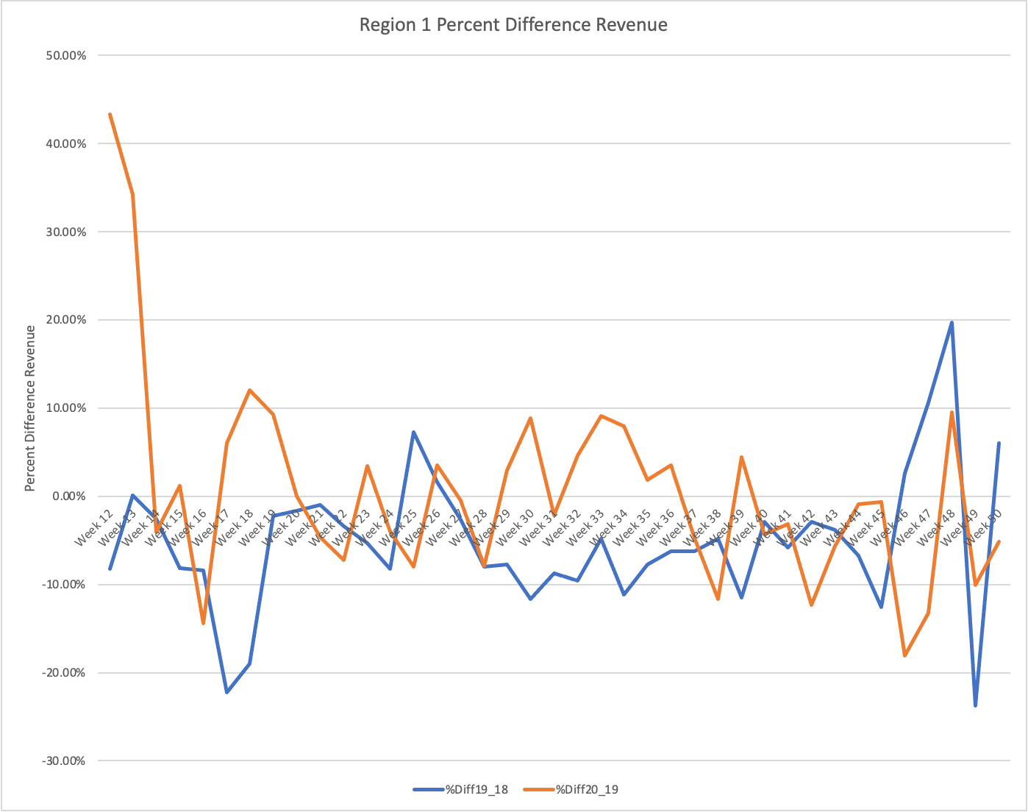 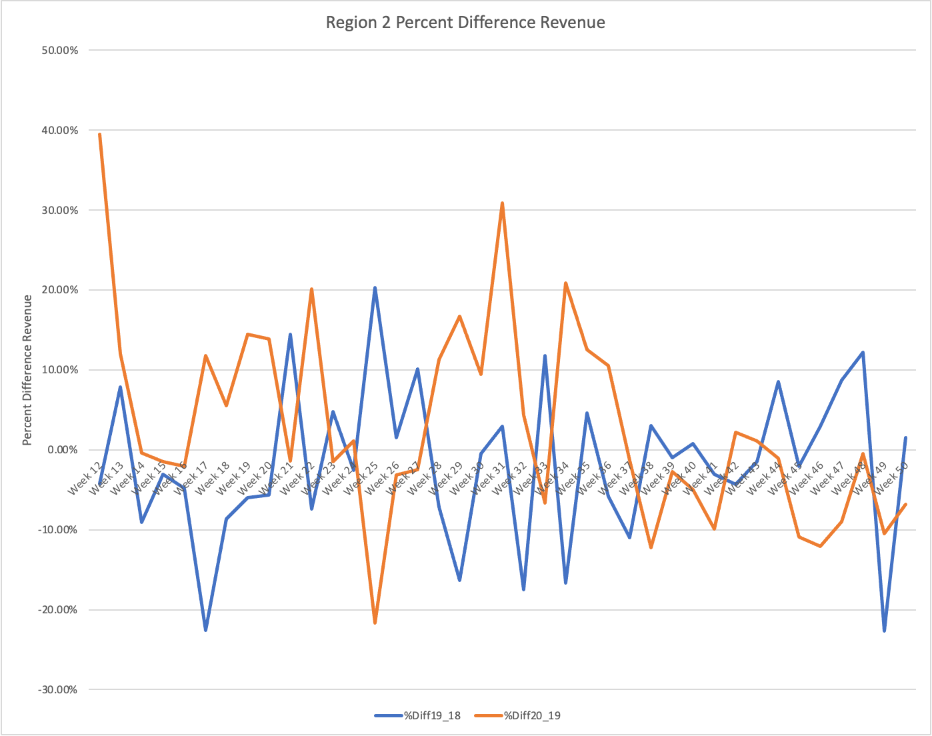

*Figure 8: Region 3 Percent Difference in Revenue Figure 9: Region 4 Percent Difference in Revenue*

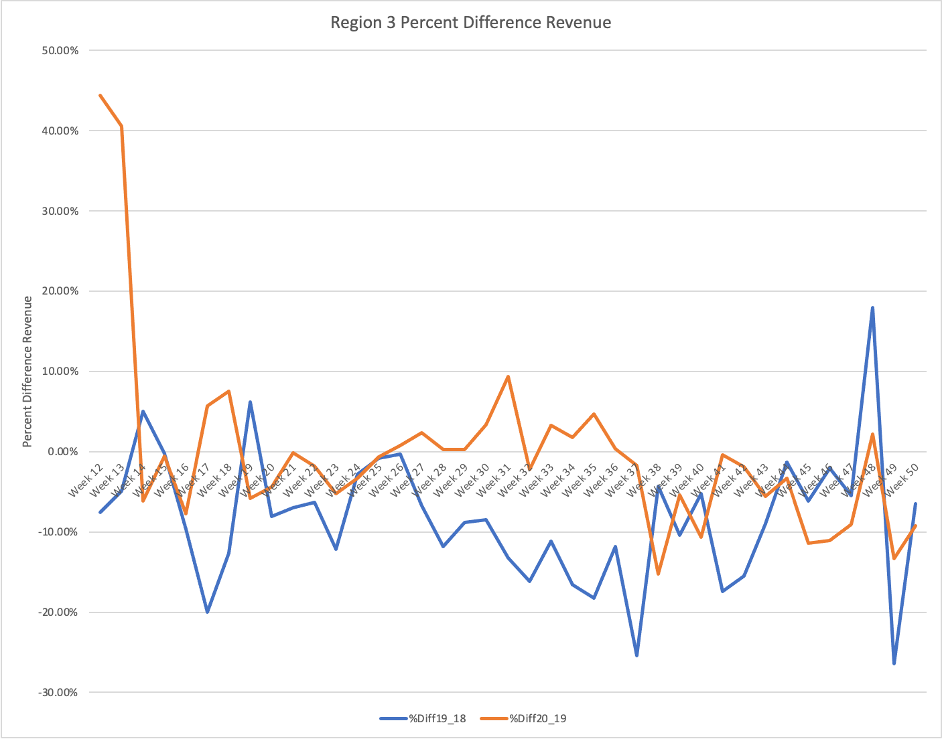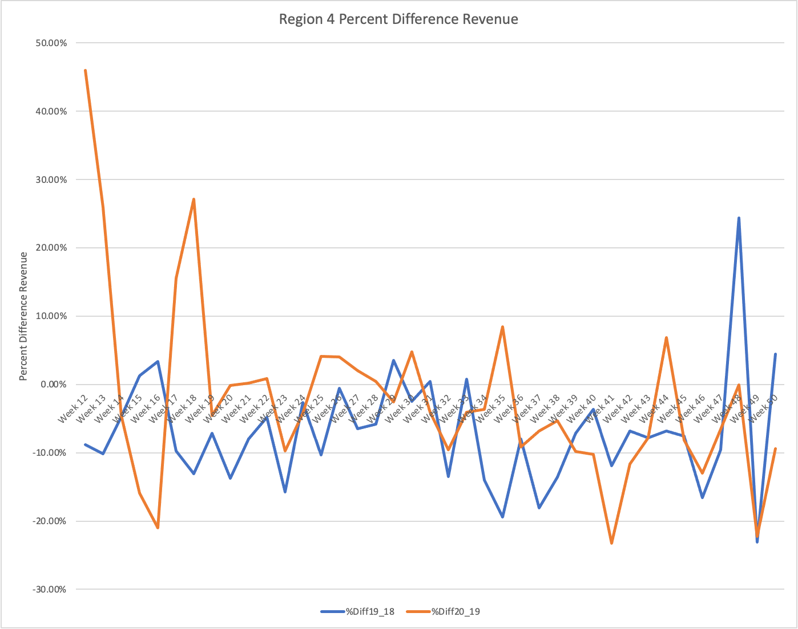

In Region 1, (Figure 6) the average percentage difference from 2018-2019 dips around Weeks 18, 33, and 49. It had its highest peak around weak 47. The average percentage difference from 2019-2020 has a steep decline from Weeks 12-13, picks up again around Week 18, and moderately fluctuates the rest of the year. Region 2 (Figure 7) saw a significant decrease in percentage change in sales around Week 18 from 2018 to 19 at around 20 percent and again around Week 49. Region 2’s highest percentage increase from 2019-2020 was around 30 weeks around 30%. Region 3’s (Figure 8) lowest average percentage change was a little over 25% from 2018-2019. 2019-2020 did not have as high a decrease in percentage revenue difference, and it did have a slight increase around 31 weeks around 10%. Region 4’s (Figure 9) highest percentage differences in revenue for 2018-2019 were around 25% at Week 48. It’s lowest percentage change was around -20% around Week 36. From 2019-2020, Region 4 had a very high percentage increase in revenue around Week 18 around 30% and a percentage decrease around 20% in Week 16.

### **Parent Firms - Which companies gained more?**

All of the top parent firms had increases in sales with COVID, but private label increased the most proportionally in comparison to the others. Private labels saw a decreasing trend from 2018 to 2019, but the sales increased by 8.89% with COVID.

|  |  |  |  |  |
| --- | --- | --- | --- | --- |
| **Table 3: Parent Firms** | | | | |
|  | **Total Sales ($)** | **Avg % Diff 20-19** | **Avg % Diff 19-18** | **Net % Change** |
| Parent 203 | $ 11,020,649.64 | 4.91% | 0.02% | 4.89% |
| Parent 2 | $ 10,030,887.23 | -3.06% | -9.08% | 6.02% |
| Private Label | $ 4,944,618.98 | -4.53% | -13.42% | 8.89% |

### **Brands by Parent Firms - Which brands gained more?**

All but one of the top brands saw increases in sales with COVID. Brand 299 with the parent 2 firm saw a decrease in sales by 1.03% during COVID. COVID also helped recover a lot of brands, such as brand 301, 321, 284, and 305, that were decreasing in sales before (2018 to 2019) within the parent firm 2. It also helped recover brand 322 under parent 203 and private label.

|  |  |  |  |  |
| --- | --- | --- | --- | --- |
| **Table 4A: Parent 203** | | | | |
|  | **Total Sales ($)** | **Avg % Diff 20-19** | **Avg % Diff 19-18** | **Net % Change** |
| Brand 286 | $ 8,805,372.94 | 6.93% | 0.72% | 6.22% |
| Brand 322 | $ 2,215,276.70 | -0.13% | -1.96% | 1.83% |

|  |  |  |  |  |
| --- | --- | --- | --- | --- |
| **Table 4B: Parent 2** | | | | |
|  | **Total Sales ($)** | **Avg % Diff 20-19** | **Avg % Diff 19-18** | **Net % Change** |
| Brand 301 | $ 2,933,465.08 | -6.34% | -10.92% | 4.59% |
| Brand 312 | $ 1,926,025.01 | 8.33% | 0.65% | 7.68% |
| Brand 321 | $ 1,804,250.00 | -8.81% | -12.72% | 3.91% |
| Brand 284 | $ 1,698,244.52 | -3.51% | -11.37% | 7.86% |
| Brand 305 | $ 841,893.43 | 14.31% | -3.98% | 18.29% |
| Brand 299 | $ 827,009.19 | -7.78% | -6.75% | -1.03% |

|  |  |  |  |  |
| --- | --- | --- | --- | --- |
| **Table 4C: Private Label** | | | | |
|  | **Total Sales ($)** | **Avg % Diff 20-19** | **Avg % Diff 19-18** | **Net % Change** |
| Private Label | $ 4,944,618.98 | -4.53% | -13.42% | 8.89% |

### **Brand Size - Did Small or Large brands gain more?**

Out of the top 9 brands, there are 3 large brands that contribute to 64.2% of revenue within the top 9 and 6 small brands that contribute to 35.8%. The large brands include Brand 286, Private Label, and Brand 301 while the small brands include Brand 322, 312, 321, 284, 305, and 299.

Overall, large and small brands on average were experiencing a decrease in sales compared to previous years, but COVID helped increase the sales of both types of brands. The increase in sales were relatively comparable, with large brands seeing a slightly higher percentage in sales than small brands.

|  |  |  |  |  |
| --- | --- | --- | --- | --- |
| **Table 5: Brand Size** | | | | |
|  | **Total Sales ($)** | **Avg % Diff 20-19** | **Avg % Diff 19-18** | **Net % Change** |
| Large Brands | $ 16,683,457.00 | -1.31% | -7.88% | 6.56% |
| Small brands | $ 9,312,698.85 | 0.40% | -6.02% | 6.42% |

### **Did national brands or private labels gain more?**

Private-labels saw a higher increase in sales with COVID. However, prior to COVID, private labels were performing relatively worse compared to the national brands. Generally, private labels market share goes up when the economy is suffering and down in stronger economic periods, which reflects the trends seen in the data and graphs below. This trend can be explained because of the lower price and high quality offered by private labels, and national brands struggling to compete with those prices because of supply chains (Figures 10 and 11).

|  |  |  |  |  |
| --- | --- | --- | --- | --- |
| **Table 6: Parent Firms** | | | | |
|  | **Total Sales ($)** | **Avg % Diff 20-19** | **Avg % Diff 19-18** | **Net % Change** |
| National Brand | $ 21,051,536.87 | 0.98% | -4.63% | 5.61% |
| Private Label | $ 4,944,618.98 | -4.53% | -13.42% | 8.89% |

### **Frozen Meals Analysis by Top 10 Product Types**

Sandwich, burrito, dinner, corn dog, entree, and pocket sandwich dropped in revenue in 2019 compared to 2018.) However, COVID has helped increase revenue for these products in 2020. All except for tacos and sliders had a higher percentage difference in 2020-2019 compared to 2019-2018. Which means even though tacos and sliders have had steady positive growth in sales from 2018-2020, the percentage increase in revenue from 2019 to 2020 was far less compared to the percentage increase in revenue from 2018 to 2019 [44.55% vs 72.96%] & [29.69% vs 105.72%]. Thus, COVID has curbed the revenue growth for tacos and sliders but had a positive impact on all other product types.

|  |  |  |  |  |
| --- | --- | --- | --- | --- |
| **Table 7: Product Types** | | | | |
|  | **Total Sales ($)** | **Avg % Diff 20-19** | **Avg % Diff 19-18** | **Net % Change** |
| Entree | $ 20,613,463.92 | -0.83% | -6.06% | 5.23% |
| Dinner | $ 2,451,397.41 | 7.20% | -11.14% | 18.34% |
| Pocket Sandwich | $ 2,212,608.23 | 0.18% | -1.71% | 1.89% |
| Sandwich | $ 224,935.68 | 7.84% | -18.39% | 26.22% |
| Corn Dog | $ 184,993.27 | 2.15% | -6.35% | 8.51% |
| Cheeseburger | $ 133,780.71 | 10.31% | 3.53% | 6.79% |
| Burrito | $ 107,600.50 | 11.38% | -14.74% | 26.12% |
| Taco | $ 38,407.18 | 44.55% | 72.96% | -28.41% |
| Slider | $ 25,823,42 | 29.69% | 105.72% | -76.03% |
| Chimichanga | $ 3,155.53 | 154.25% | 34.66% | 119.59% |

### **Packaging Groups - Which packaging gained more?**

Out of a total 8 different packaging groups, we found that Box, Bag, and Tray are the top 3 packaging types that contribute about 88% of the grand total sales. Based on the below table that indicates the average percent difference for years between 2018 to 2019 and 2019 to 2020, we can say that these packaging types were overall in the decreasing trend with the negative percentages for average percent differences in both 2018 to 2019 and 2019 to 2020 except for Tray in 2020 with positive percentage. With the net percent change all being positive, it's referring to the fact that sales in 2020-2019 (COVID) were better than sales in 2019-2018.

|  |  |  |  |  |
| --- | --- | --- | --- | --- |
| **Table 8: Packaging Group** | | | | |
|  | **Total Sales ($)** | **Avg % Diff 20-19** | **Avg % Diff 19-18** | **Net % Change** |
| Box | $19,076,953.98 | -0.34% | -4.92% | 4.59% |
| Bag | $3,789,847.00 | -9.47% | -13.93% | 4.46% |
| Tray | $3,138,354.87 | 14.37% | -5.41% | 19.78% |

### **Flavor/Scent - Which flavors gained more?**

The below 10 flavors were taken into consideration to calculate the average percent difference for the flavor/scent category. These 10 flavors account for about 96% of the grand total sales and it is easily noticeable that meat is the main contributor even during COVID year with the highest percent for the average percent difference 20-19 and the net percent change.

Highlighted in pink (All Other and Hot Spicy) are the flavors that showed negative for the net percent change which means the sales in 2019-2018 was better than the sales in 2020-2019 (COVID) while all other flavors/scents had better sales in 2020-2019 (COVID) when compared to sales in 2019-2018.

|  |  |  |  |  |
| --- | --- | --- | --- | --- |
| **Table 9: Flavor/Scent** | | | | |
|  | **Total Sales ($)** | **Avg % Diff 20-19** | **Avg % Diff 19-18** | **Net % Change** |
| Meat | $9,572,055.64 | 4.44% | -10.89% | 15.33% |
| Poultry | $5,693,255.26 | 2.09% | -9.18% | 11.27% |
| All Other | $3,059,930.51 | -7.48% | 36.80% | -44.28% |
| Cheese | $2,602,273.52 | -13.19% | -13.26% | 0.06% |
| Tangy | $2,212,138.67 | 1.92% | -2.71% | 4.64% |
| Asian | $867,345.43 | 5.38% | -2.44% | 7.82% |
| Herb & Spice | $842,305.31 | -9.14% | -19.04% | 9.90% |
| Fruit | $498,515.08 | 20.18% | -14.98% | 35.16% |
| Vegetable | $443,996.07 | 14.69% | 0.86% | 13.84% |
| Hot Spicy | $204,340.36 | -4.30% | -3.88% | -0.41% |

# **III. Data Analysis and Model**

## **Regional Analysis**

### **What parents increase or decrease in revenue on a regional level during pre and post COVID?**

(Appendix Figure 12)

|  |  |  |
| --- | --- | --- |
| **By Region** | **Revenue increase during COVID** | **Revenue decrease during COVID** |
| Region 1 and 2 | Private, Parent 2 and Parent 203 | None |
| Region 3 and 4 | Private and Parent 203 | Parent 2 |

### **What brands increase or decrease in revenue on a regional level during pre and post COVID?**

(Appendix Figure 13)

|  |  |  |
| --- | --- | --- |
| **By Region** | **Revenue increase during COVID** | **Revenue decrease during COVID** |
| Region 1 | 286, 301, 305, 312, 322 and private | 284, 299 and 321 |
| Region 2 | 284, 286, 301, 305, 312, 322 and private | 299 and 321 |
| Region 3 | 286, 299, 301, 305, 312, 322 and private | 284 and 321 |
| Region 4 | 284, 286, 305, 322 and private | 299, 301, 312, 321 |

### **What products increase or decrease in revenue on a regional level during pre and post COVID?**

(Appendix Figure 14)

|  |  |  |
| --- | --- | --- |
| **By Region** | **Revenue increase during COVID** | **Revenue decrease during COVID** |
| Region 1 | chimichanga, dinner, entree, pocket sandwich, slider and tacos. | burrito, cheeseburger, corn dog and sandwich |
| Region 2 | burrito, chimichanga, cheeseburger, dinner, entree, pocket sandwich, sandwich, slider | corn dog and taco |
| Region 3 | chimichanga, cheeseburger, corn dog, dinner, entree, pocket sandwich, sandwich, slider and taco | burrito |
| Region 4 | cheeseburger, corn dog, dinner, entree, pocket sandwich, sandwich. | burrito and taco |

### **What flavors increase or decrease in revenue on a regional level during pre and post COVID?**

(Appendix Figure 15)

|  |  |  |
| --- | --- | --- |
| **By Region** | **Revenue increase during COVID** | **Revenue decrease during COVID** |
| Region 1 & 2 | asian, cheese, fruit, hot spicy, meat, other, poultry, tangy and vegetable. | herb & spice |
| Region 3 | asian, fruit, meat, other, poultry, tangy and vegetable. | cheese, hot spicy, herb & spice. |
| Region 4 | cheese, fruit, meat, other, poultry, tangy. | asian, hot spicy, herb & spice. |

### **Is there a relationship between flavor and product?**

(Appendix Figure 16) Yes. We conducted a chi sq test to confirm there is a relationship between flavor and product type.

### **Is there a relationship between packaging and product?**

(Appendix Figure 17) Yes. We conducted a chi sq test to confirm there is a relationship between packaging and product type.

### **Which flavor and product combo generates the highest revenue by region?**

(Appendix Figure 18) Threshold for being classified as a “high revenue” generator for Region 1: mean dollar amt >= 200. Region 2: mean dollar amt >= 125. Region 3: mean dollar amt >= 250.

Region 4: mean dollar amt >= 150.

|  |  |  |  |
| --- | --- | --- | --- |
| **Region** | **Entree** | **Dinner** | **Pocket Sandwich** |
| Region 1 | Entree & [asian, hot spicy, herb & spice, meat, tangy]. | Dinner & [meat, other, poultry]. | Pocket sandwich & [tangy]. |
| Region 2 | Entree & [cheese, fruit, meat, tangy]. | Dinner & [meat, other, poultry] | Pocket sandwich & [tangy]. |
| Region 3 | Entree & [hot spicy, meat, tangy]. | Dinner & [meat, other, poultry] | Pocket sandwich & [tangy]. |
| Region 4 | Entree & [fruit, meat, tangy]. | Dinner & [meat, other, poultry] | Pocket sandwich & [tangy]. |

### **Which package and product combo generates the highest revenue by region?**

(Figure 19) Threshold for being classified as a “high revenue” generator: mean dollar amt >= 100.

|  |  |  |  |
| --- | --- | --- | --- |
| **Region** | **Box** | **Bag** | **Entree** |
| Region 1 & 3 | Box & [Dinner, Entree, Pocket Sandwich] | Bag & Entree. | Tray & Entree. |
| Region 2 | Box & [Dinner, Entree, Pocket Sandwich] | None | Tray & Entree. |
| Region 4 | Box & [Dinner, Entree, Pocket Sandwich, Taco] | Bag & Entree. | Tray & [Entree, Dinner]. |

## **Forecasting Monthly Revenue and Unit sales for Major Parents and Brands**

We predicted the revenue for 3 parents: Parents 2, 201 and Private Label using the monthly cumulative sales data from January 2018 to November 2020. These companies were selected because they are the top revenue generators in this period. For forecasting revenue and unit sales, we created different datasets for each Parent and Brand. The monthly forecasts for 2021 for certain brands and parents are given in the appendix.

For all the selected parents, their major brands, and brands we found a pattern where the monthly sales data exhibited both trend and seasonality. We know that Holt-Winters Exponential Smoothing is used for forecasting time series data that exhibits both a trend and a seasonal variation. We used both the Additive and Multiplicative Holt-Winters’ methods based on model fit for our forecasting because in all the forecasting these methods were giving us low Root Mean Square Error(RMSE) and less than 10% MAPE while other forecasting methods either did not fit the model or gave huge errors.

For predicting 2021 revenue and unit sales, we excluded the data for December 2017 and 2020 during modeling because the data for those months was incomplete and only had sales for some weeks of the month. The training data was all the monthly cumulative numbers from January 2018 to November 2020, validation data was also the same.

# **IV. Conclusion**

## **Findings and Recommendations**

Overall, the effect of COVID-19 improved frozen food sales with a net percent increase of 6.38%.

* Brands: For parent 2, COVID helped recover several brands, such as brand 301, 321, 284, and 305, that were decreasing in sales before (2018 to 2019). For parent 203, brand 286 contributed to the majority of the revenue and had the highest net increase in revenue.
* Product Type: Based on our analysis, COVID had a positive impact on all of the top 10 product types except for Taco and Slider. Chimichanga had the most positive impact for the net percent change followed by Sandwich and Burrito.
* Packaging Group: All packaging types for the top 3 had positive impact during COVID with an average of 9.61% for the net percent change.
* Flavor/Scent: All flavors in the top 10 had positive net percent change except for all other flavors and hot spicy. Fruit had the most positive impact followed by meat and vegetable.
* Product Flavor Combinations: Of all 4 regions, the following product & flavor combinations resulted in high revenue generation. Pocket sandwich & tangy flavor. Dinner & [meat, other, poultry] flavors. Entree & [meat and tangy] flavors.
* Product Packaging Combinations: For 3 out of 4 regions, the following product & packaging combinations resulted in high revenue generation. Box & [Dinner, Entree, Pocket Sandwich]. Bag & Entree. Tray & Entree.
* All Regions: All 4 regions saw a net increase in frozen food sales with Region 3 having the highest net increase at 8%, followed by Region 1 at 5.76%.

Based on the overall analysis and insights, we suggest Conagra focus on increasing the inventory for the best performing products/items above to fulfill the consumer demand especially in region 3 and decreasing the inventory for the lower performing products to save costs on storage. Conagra can also invest in marketing efforts for the best performing products above to increase the actual sales and provide promotions/discounts on the less contributing products to drive more sales volume, and attract new customers.

## **Insights from Forecasting**

The forecast shows that the parents 203, 2, and Private Label will have the highest sales in the next year during the months of March, September, and December (Figure 23). Therefore, companies should focus on efficient inventory management and supply chain and increase stock of Parent 2’s Brand 301 top products (above) in these months. The forecasting confirms a seasonal model for the parents above with certain months having higher forecasted revenue compared to other months. The company can look at the unit sales forecasts for different brands and take the forecasts as a demand management tool (Figure 24).