**ESE-3014 Lab 2**

Submitted By Jerin Joy – C0755173 Shinu Raj -C0749116

**Q1. Create a 2D plot of the sine function between 0 and 2π.**

x=0:.01:2*pi;  
y=sin(x);  
plot(x,y)

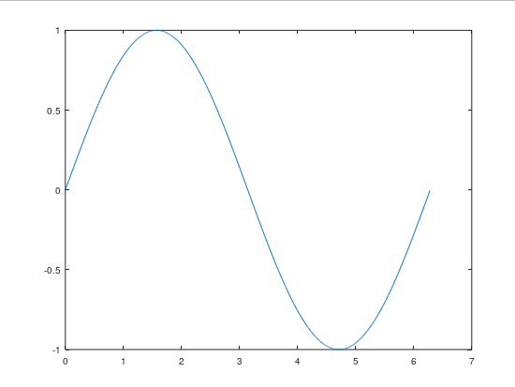

**Q2. Create a 3D plot of a surface by creating a grid along the X and Y axes and plotting the Z-coordinate according to the exponential function.**

[x,y]=meshgrid(5:.2:10);

z=exp(x.^5 - y.^10);

surf(x,y,z);

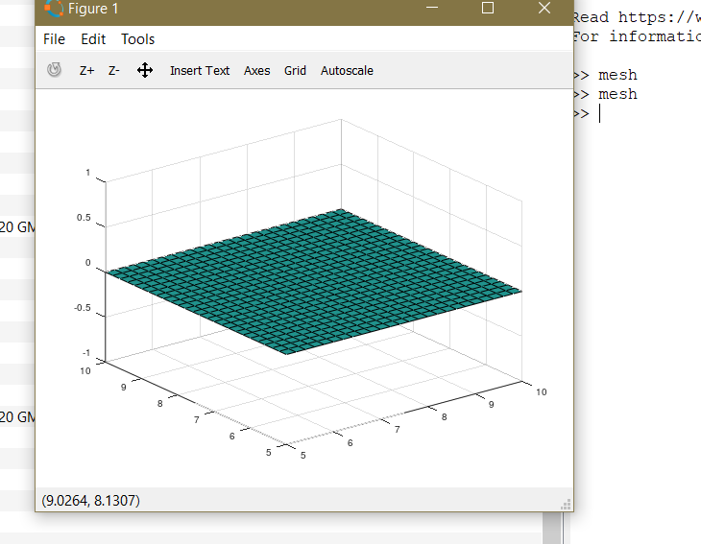

**Q3. Write a script to apply if and if-else statements.**

y= input("enter the number")  
minrange=0;  
maxrange=1000;  
if (y >= minrange) && (y <= maxrange)  
    disp('within specified range')  
    elseif (y >maxrange)  
    disp('=beyond the specified range')  
else  
    disp('Value is below minimum value.')  
  end

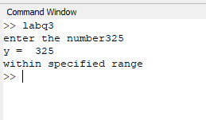

**Q4. Write a script to apply conditional logic switch**

num= input("enter the case")  
 x=input("enter the first number")  
 y=input("enter the second number")  
switch num  
  case 1  
     
    z=x+y  
   
  case 2  
    z= x-y  
     
     
endswitch

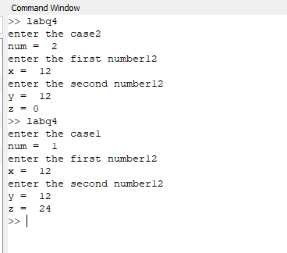

**Q5. Write a script to perform loop with a while condition.**

y= input("enter the number")  
while(y >= 0)  
    disp('the number is positive')  
    break  
  end  
  disp("nummber is negative")

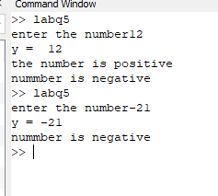

**Q6. Write a script to plot a vector of random data. Draw a horizontal line at the mean. Save the script and run it from the command line.**

x=randi(10,1,5);  
z=(mean(x))  
line([0,z],[z,z])

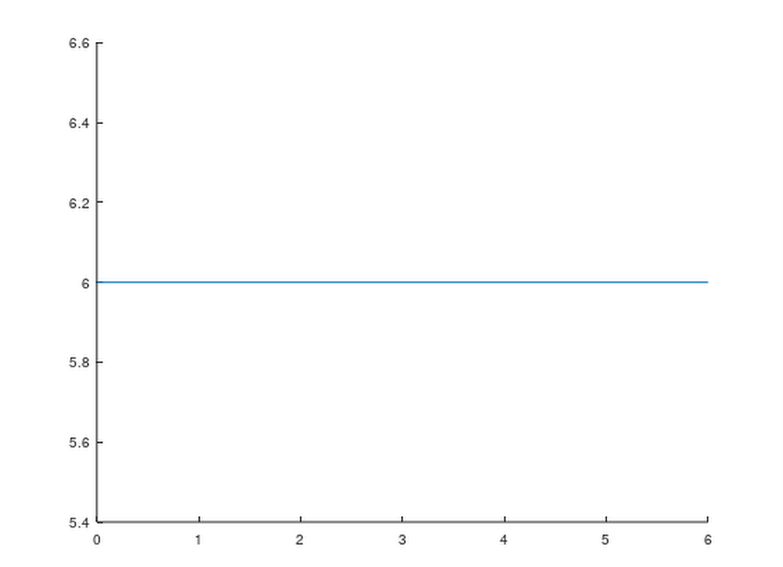

**Q7. Write a script that calculates the mean of five samples of data from a vector of random data. Calculate the overall mean. Use a for loop to perform the calculations. For each iteration of the loop print out the intermediate results. Use an if..else control block to display the results depending on whether the mean of the samples is less than, greater than or equal to the overall mean.**

x=randi(10,1,10);  
c=mean (x);  
for i=0:1:5  
  w=randi(10,1,5);  
y=mean(w);  
if (y >=c)  
  disp('greater than the overall mean ')  
elseif (y=c)  
  disp('mean of the samples is equal to overall mean.')  
else  
  disp('mean of the samples is lessthan the overall mean..')  
end  
end

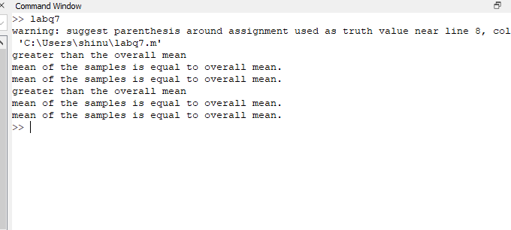

**Q8. Create a function that calculates the area of a circle with the radius as input in command window. Call this function from the MATLAB command line or in a MATLAB script (.m).**

function circle= area (radius)  
  radius=input("enter the radius")  
  circle=pi*(radius.^2)  
endfunction

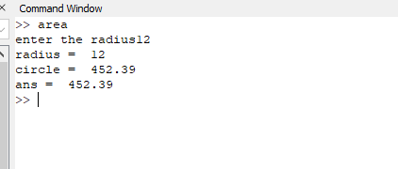

**Q9. Create a function that calculates the sum of an arbitrary number of sinusoidal terms. Call this function from the MATLAB command line or in a MATLAB script (.m).**