**ESE-2014**

Submitted By

Jerin Joy – C0755173

1 . Design a bandpass filter using the Hamming window design technique.

The specifications are.

Lower stopband edge: 0.3π

Upper stopband edge: 0.6π As = 50 dB

Lower passband edge: 0.4π

Upper passband edge: 0.5π Rp = 0.5 dB

Plot the impulse response and the magnitude response (in dB) of the designed filter. Do not use the f ir1 function.

ws1 = 0.3*pi; wp1 = 0.4*pi; wp2 = 0.5*pi; ws2 = 0.6*pi; As = 50;

tr_width = min((wp1-ws1),(ws2-wp2));

M = ceil(6.6*pi/tr_width) + 1

n=[0:1:M-1]; wc1 = (ws1+wp1)/2; wc2 = (wp2+ws2)/2;

hd = ideal_lp(wc2,M) - ideal_lp(wc1,M);

w_bla = (hamming(M))';

h = hd .* w_bla;

[db,mag,pha,grd,w] = freqz_m(h,[1]); delta_w = 2*pi/1000;

Rp = -min(db(wp1/delta_w+1:1:wp2/delta_w))

As = -round(max(db(ws2/delta_w+1:1:501)))

subplot(2,2,1)

subplot(2,2,[2 4])

freqz(h)

impz(h)

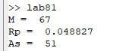

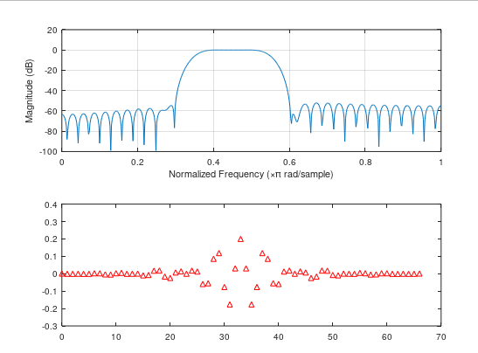

2. Design a linear-phase bandpass filter using the Hann window design technique. The specifications are.

Lower stopband edge: 0.2π

Upper stopband edge: 0.75π As = 40 dB

Lower passband edge: 0.35π

Upper passband edge: 0.55π Rp = 0.25 dB

Plot the impulse response and the magnitude response (in dB) of the designed filter. Do not use the f ir1 function.

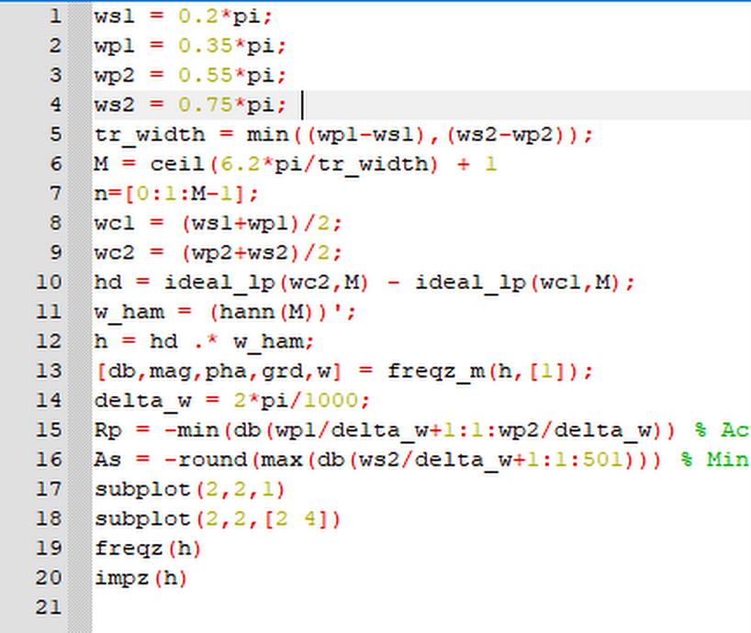

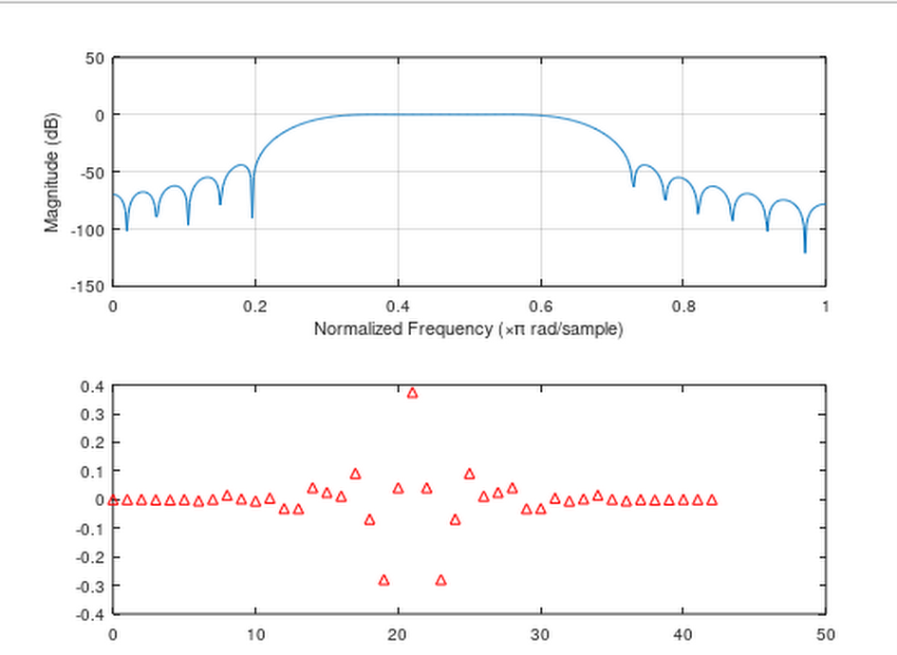

3. Design a bandstop filter using the Hamming window design technique. The specifications are

Lower stopband edge: 0.4π

Upper stopband edge: 0.6π As = 50 dB

Lower passband edge: 0.3π

Upper passband edge: 0.7π Rp = 0.2 dB

Plot the impulse response and the magnitude response (in dB) of the designed filter. Do not use the f ir1 function.

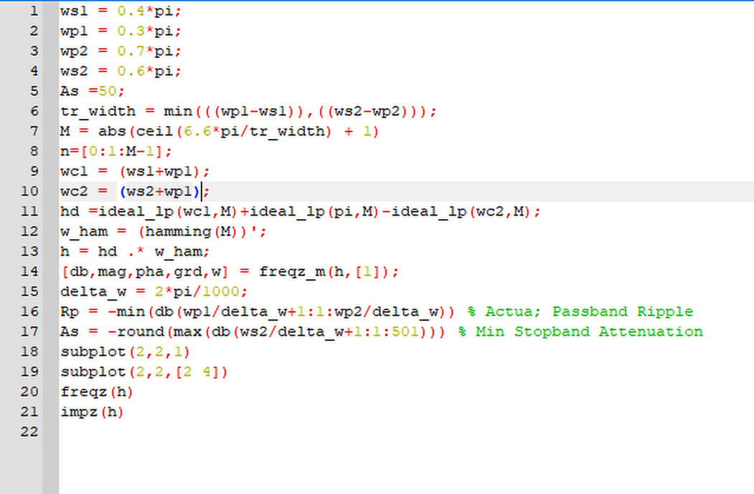

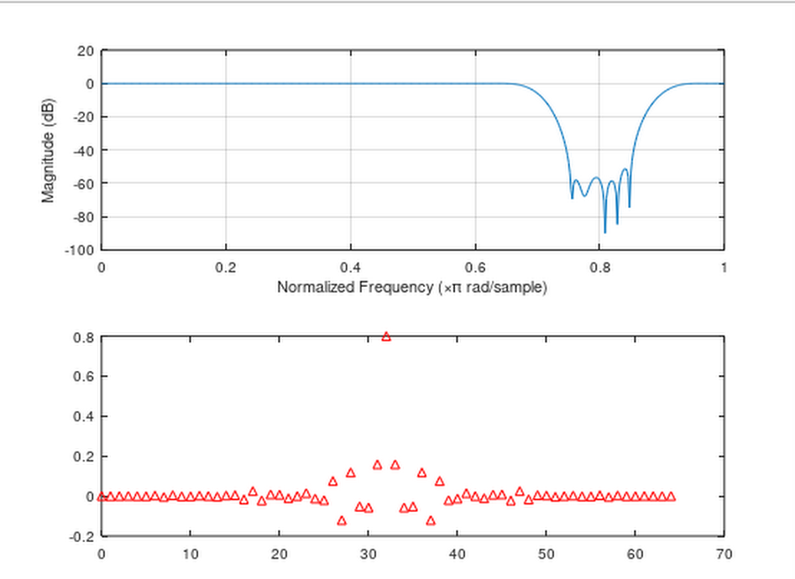

4. Design a highpass filter using one of the fixed window functions. The specifications are.

Stopband edge: 0.4π, As = 50 dB

Passband edge: 0.6π, Rp = 0.004 dB

Plot the zoomed magnitude response (in dB) of the designed filter in the passband to verify the passband ripple Rp . Do not use the f ir1 function.

