1. **AIM**

Define a class ‘product’ with data members pcode, pname and price. Create 3 objects of

the class and find the product having the lowest price.

**Source Code**

public class product

{

int pcode;

String pname;

double price;

double lowest;

void data(int c, String n, double p){

pcode=c;

pname=n;

price=p;

}

void display(){

System.out.println(pcode+"\t\t"+pname+"\t\t"+price);

}

static void findLowest(double price1,double price2, double price3){

if(price1<=price2 && price1<=price3){

System.out.println("\nProduct 1 is of the lowest price!");

}

else if(price2<=price1 && price2<=price3){

System.out.println("\nProduct 2 is of the lowest price!");

}

else{

System.out.println("\nProduct 3 is of the lowest price!");

}

}

public static void main(String[] args){

product obj1 = new product();

product obj2 = new product();

product obj3 = new product();

obj1.data(1,"RICE",1000.0);

obj2.data(2,"FISH",200.0);

obj3.data(3,"CHICKEN",1700.0);

System.out.println("JERIN JOSE,NO:35,13-02-2024,PRGRM-1 PRODUCT");

System.out.println("ProductInformation:\n Product_Code\tProduct_Name\tProduct_Price");

obj1.display();

obj2.display();

obj3.display();

findLowest(obj1.price,obj2.price,obj3.price);

}

}

**Output**

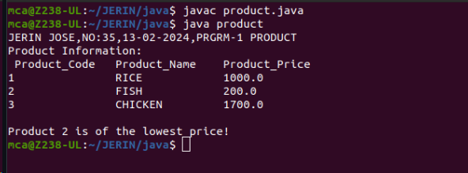

1. **AIM**

Read 2 matrices from the console and perform matrix addition.

**Source Code**

import java.util.Scanner;

public class add_matrix {

public static void main(String args[])

{

int row, col,i,j;

Scanner in = new Scanner(System.in);

System.out.println("JERIN JOSE,NO:35,13-02-2024,PRGRM-2 ADD MATRIX");

System.out.println("Enter the number of rows");

row = in.nextInt();

System.out.println("Enter the number columns");

col = in.nextInt();

int mat1[][] = new int[row][col];

int mat2[][] = new int[row][col];

int res[][] = new int[row][col];

System.out.println("Enter the elements of matrix 1");

for ( i= 0 ; i < row ; i++ )

{

for ( j= 0 ; j < col ;j++ )

mat1[i][j] = in.nextInt();

System.out.println();

}

System.out.println("Enter the elements of matrix 2");

for ( i= 0 ; i < row ; i++ )

{

for ( j= 0 ; j < col ;j++ )

mat2[i][j] = in.nextInt();

System.out.println();

}

for ( i= 0 ; i < row ; i++ )

for ( j= 0 ; j < col ;j++ )

res[i][j] = mat1[i][j] + mat2[i][j] ;

System.out.println("Sum of matrices:-");

for ( i= 0 ; i < row ; i++ )

{

for ( j= 0 ; j < col ;j++ )

System.out.print(res[i][j]+"\t");

System.out.println();

}

}

}

**Output**

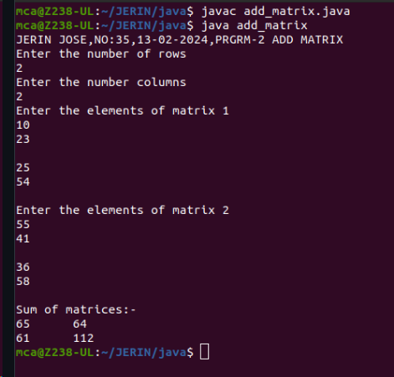

1. **AIM**

Add complex numbers

**Source Code**

public class complex {

int r;

int i;

complex(int real,int img){

r=real;

i=img;

}

void display(){

System.out.println(r+"+"+i+"i");

}

static void add(int r1,int i1,int r2,int i2 ){

r1=r1+r2;

i1=i1+i2;

System.out.println("After Addition = "+r1+"+"+i1+"i");

}

public static void main(String[] args) {

complex first=new complex(5,4);

complex second=new complex(7,9);

System.out.println("JERIN JOSE,NO:35,13-02-2024,PRGRM-3 COMPLEX");

System.out.println("Complex Numbers are:");

first.display();

second.display();

add(first.r,first.i,second.r,second.i);

}

}

**Output**

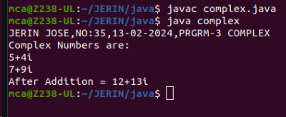

1. **AIM**

Read a matrix from the console and check whether it is symmetric or not.

**Source Code**

import java.util.Scanner;

public class symmetric {

public static void main(String[] args) {

Scanner sc = new Scanner(System.in);

System.out.println("JERIN JOSE,NO:35,14-02-2024,PRGRM-4 SYMMETRIC");

System.out.println("Enter the Number of rows of the Matrix");

int row = sc.nextInt();

System.out.println("Enter the Number of Columns of the Matrix");

int col = sc.nextInt();

int matrix[][] = new int[row][col];

int i,j;

boolean state=true;

for(i=0;i<row;i++){

for(j=0;j<col;j++){

System.out.println("Enter the Element at M("+i+","+j+")");

matrix[i][j] = sc.nextInt();

}

}

for(i=0;i<row;i++){

for(j=0;j<col;j++){

if(matrix[i][j]!=matrix[j][i]){

state=false;

break;

}

}

}

if(state){

System.out.println("Matrix is Symmetric");

}

else{

System.out.println("Matrix is Antisymmetric");

}

}

}

**Output**

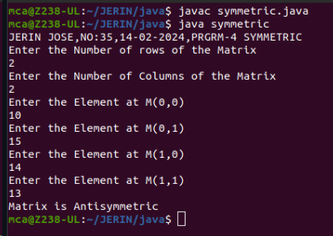

1. **AIM**

Create CPU with attribute price. Create inner class Processor (no. of cores, manufacturer) and static nested class RAM (memory, manufacturer). Create an object of CPU and print information of Processor and RAM.

**Source Code**

public class cpu{

int price;

class processor{

int cores;

String producer;

processor(int noC, String manu){

cores=noC;

producer=manu;

}

void display(){

System.out.println("JERIN JOSE,NO:35,14-02-2024,PRGRM-3CPU");

System.out.println("\nProcessor info");

System.out.println("No. of Cores = "+cores);

System.out.println("Manufacturer = "+producer+"\n");

}

}

static class ram{

int mem;

String manuf;

ram(int memory,String producer ){

mem=memory;

manuf=producer;

}

void display(){

System.out.println("\nRAM info");

System.out.println("Memory = "+mem+" GB");

System.out.println("Manufacturer = "+manuf+"\n");

}}

public static void main(String[] args) {

cpu.ram obj1= new cpu.ram(8,"Intel");

cpu obj2 = new cpu();

cpu.processor obj3 = obj2.new processor(8,"Samsung");

obj1.display();

obj3.display();

}

}

**Output**

